SQL JOINS

SQL JOIN is a clause that is used to combine multiple tables and retrieve data based on a common field in relational databases.

# Left Join

Retrieves all records from the left table and matching records from the right table. If there is no match, NULL values are displayed for the columns from the right table.

# Right Join

Retrieves all records from the right table and matching records from the left table. If there is no match, NULL values are displayed for the columns from the left table.

Example:

Table: Employees Table : Departments

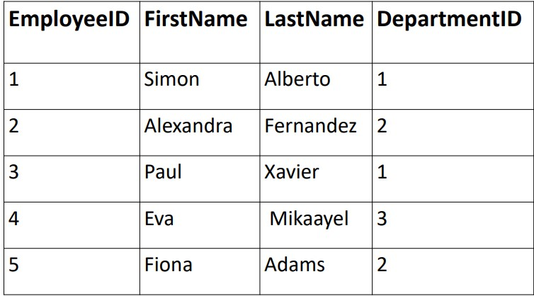

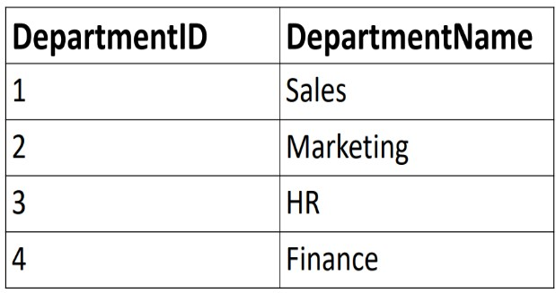

Left Join

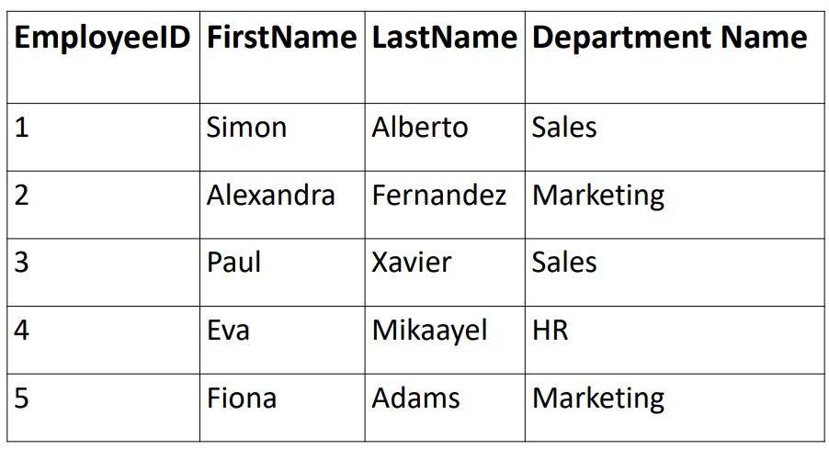

The left join retrieves all records from the left table (Employees) and matching records from the right table (Departments). If there is no match in the right table, NULL values are displayed for the columns from the right table.

Right Join

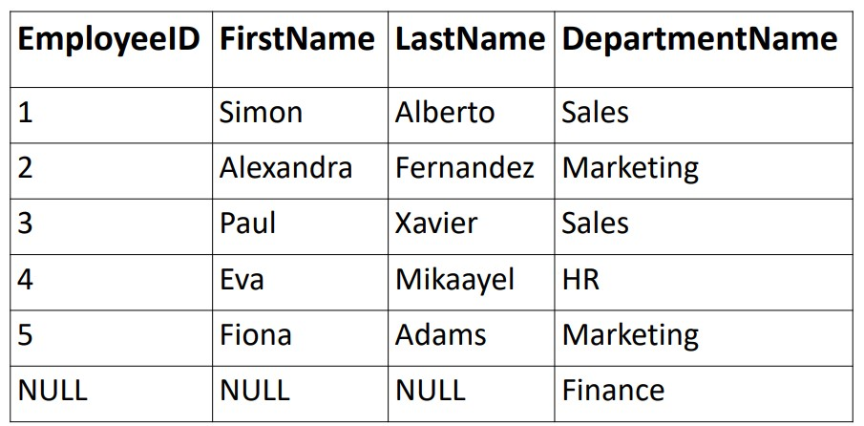

The right join retrieves all records from the right table (Departments) and matching records from the left table (Employees). If there is no match in the left table, NULL values are displayed for the columns from the left table.