**Amazon prime**

**Comparison 1**

Movie Name vs Maturity Rating

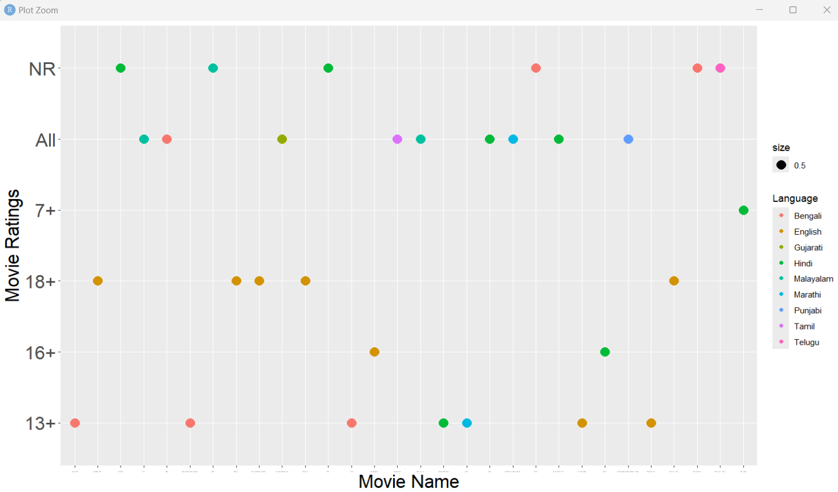

**Comparison 2**

Title vs imdb ratings

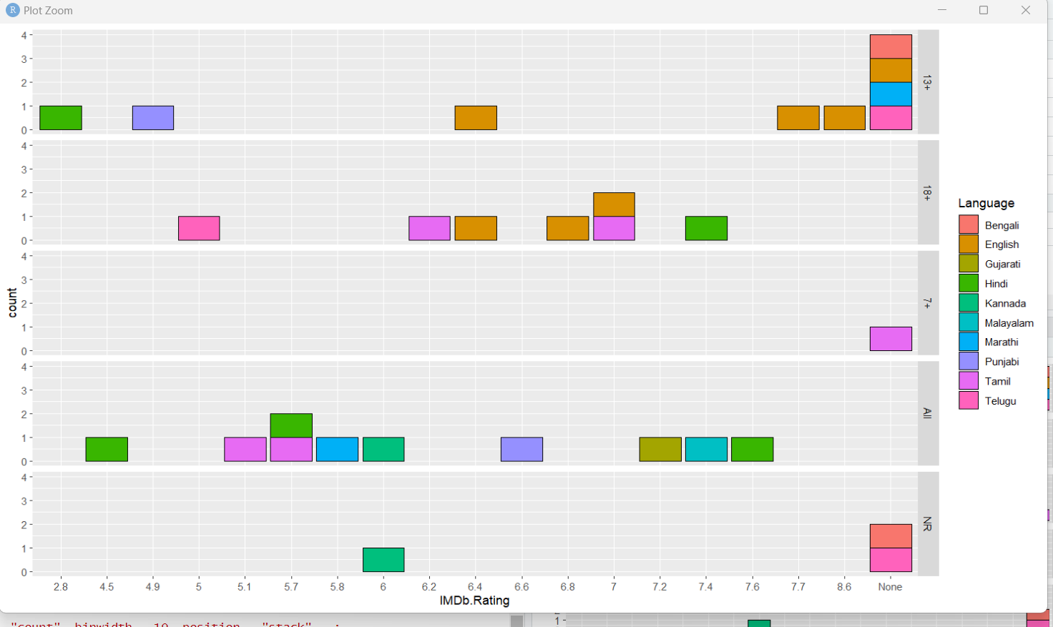

**Comparison 3**

Title vs date added

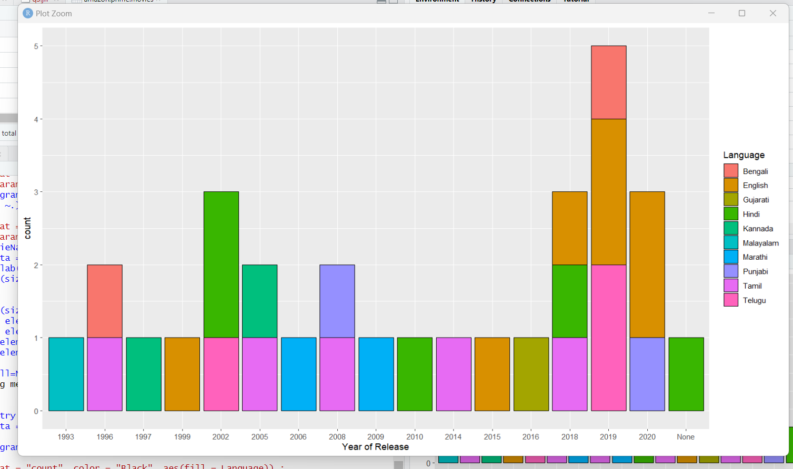

**Disney_plus_hotstar**

**Comparison 1**

Title vs IMDB Rating

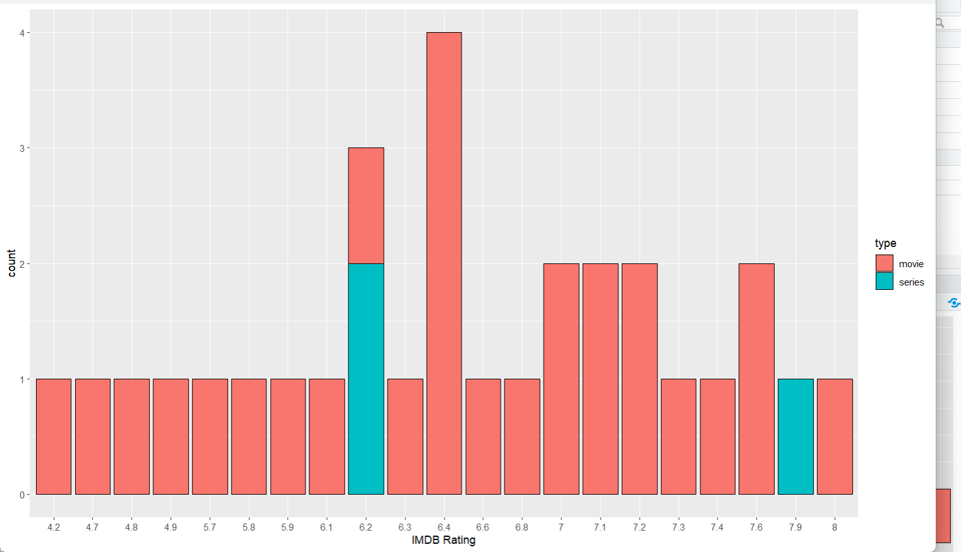

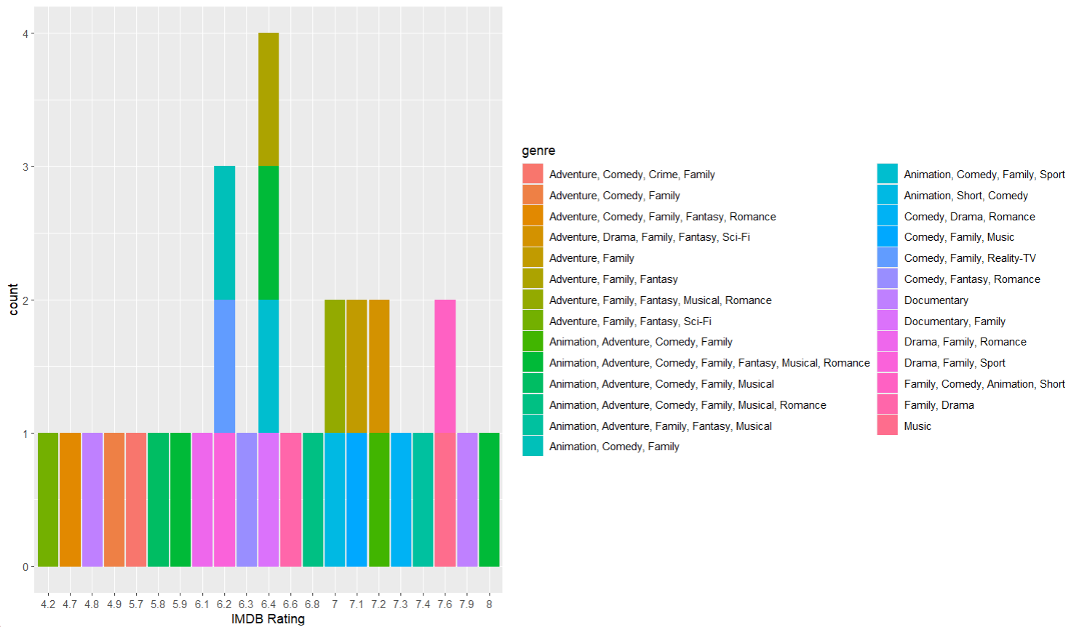

**Comparison 2**

Tile vs Awards

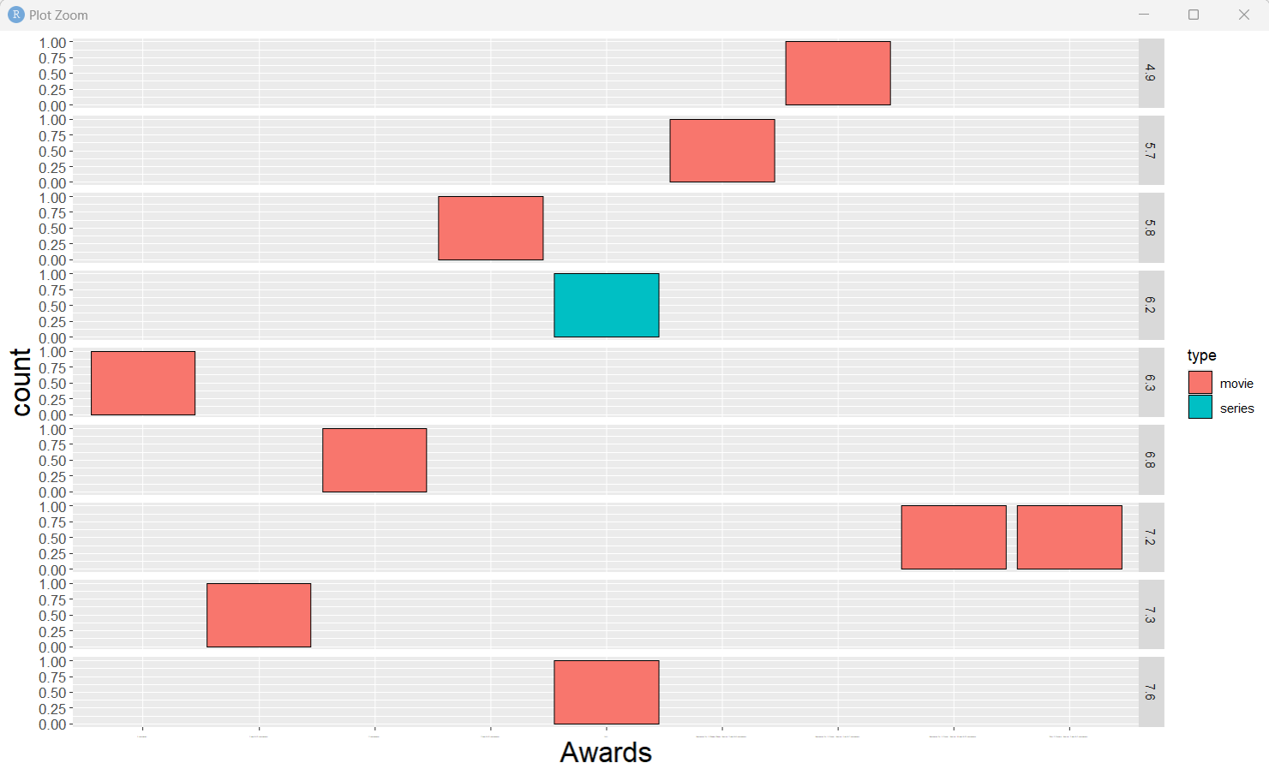

**Comparison 3**

Title vs IMDB Votes

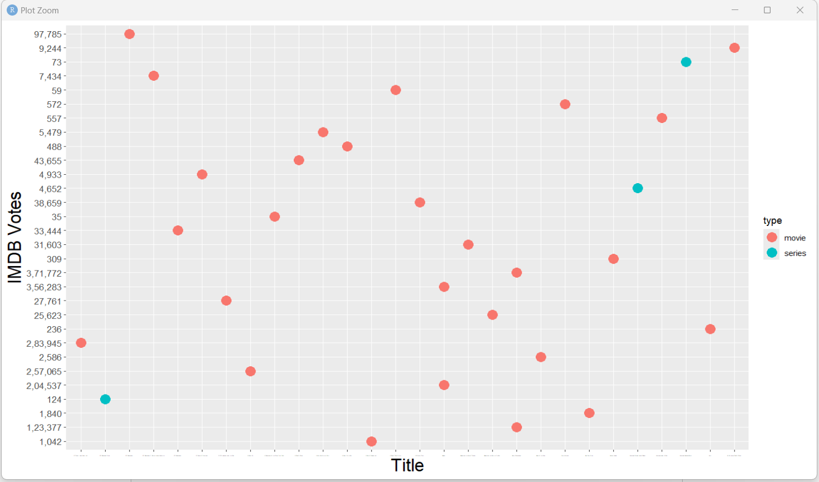

**Comparison 4**

Rated comparison

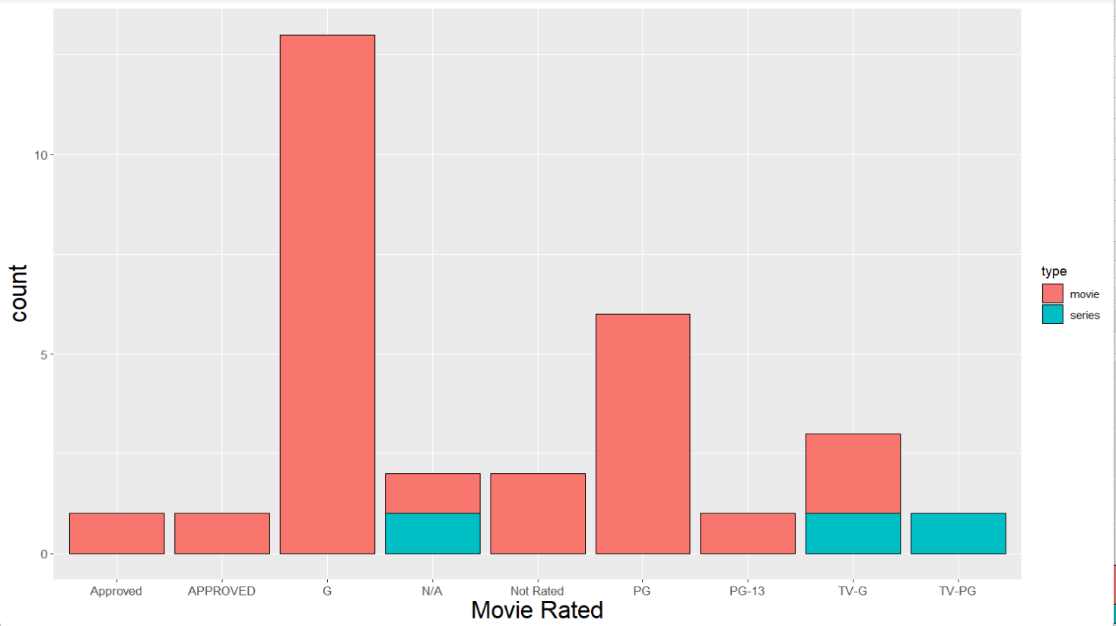

**Netflix**

**Comparison 1**

Title vs Rating

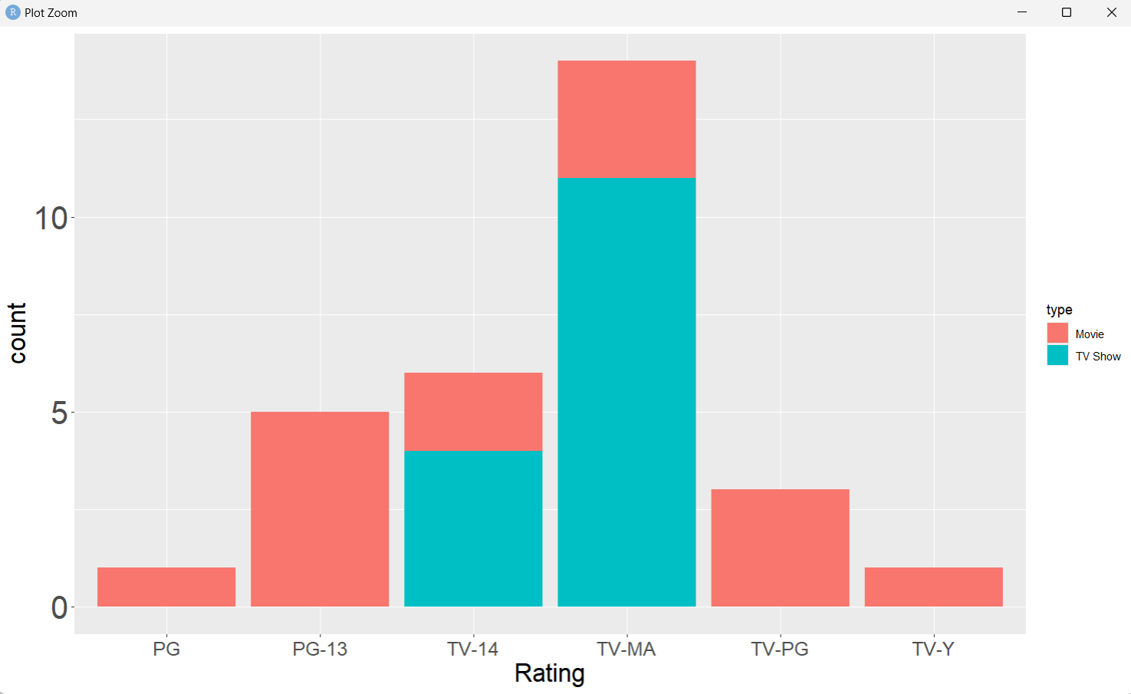

**Comparison 2**

Rating vs Type

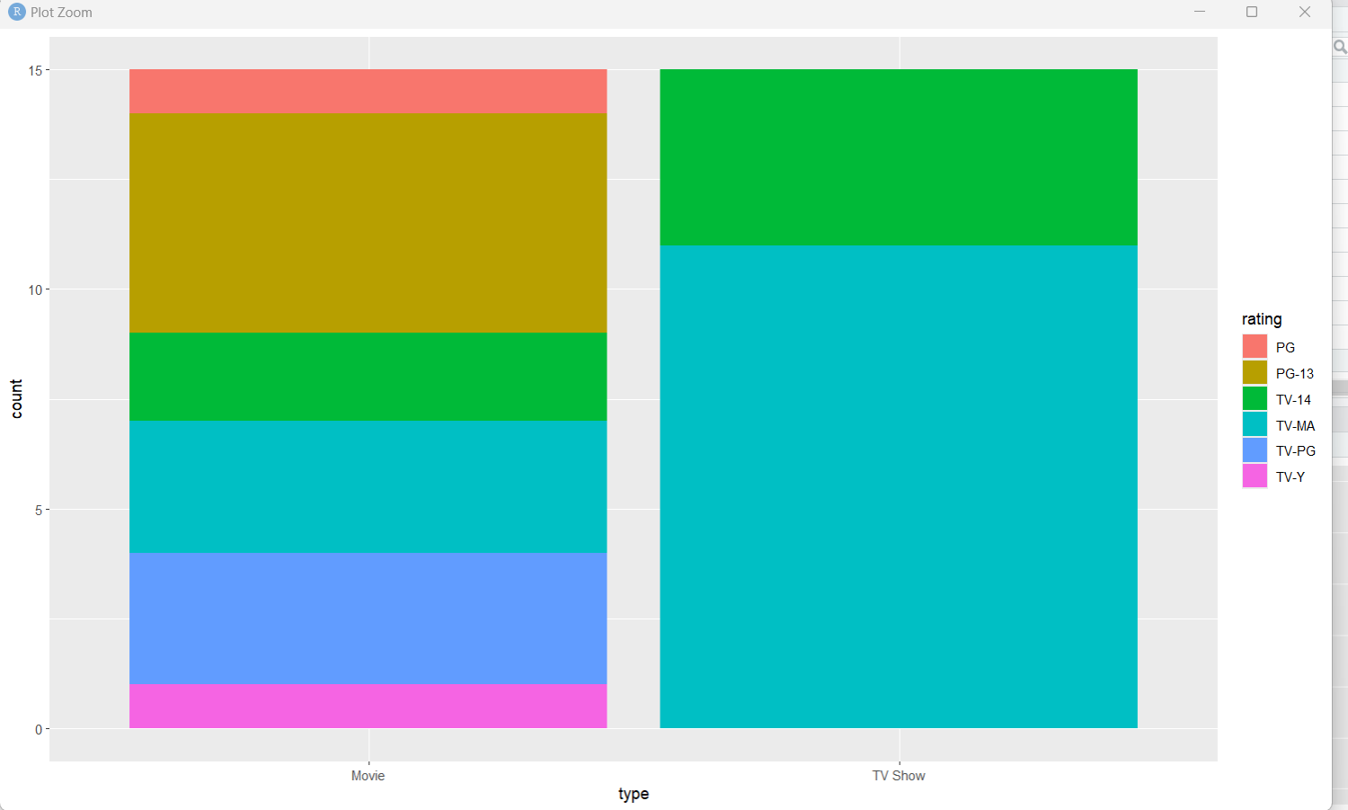

**Comparison 3**

Title vs Date Added

