**SMPS(Switched Mode Power Supply)**

**SMPS** stands for **Switched Mode Power Supply** is an electronic circuit that converts power using switching devices that are turned on and off at high frequencies, and storage components such as inductors or capacitors to supply power when the switching device is in its non-conduction state. It is an electronic gadget or module that comprises a combination of inductors, capacitors and semiconductor gadgets like diodes and MOSFETs. It is utilized to change over a specific DC voltage to another DC voltage level. It is utilized rather than straight or ohmic converters since of higher efficiency It works by employing a semiconductor switch like MOSFET to switch on-off the supply voltage at a specific exchanging recurrence to control the yield voltage. Varying the exchanging recurrence will alter the yield voltage

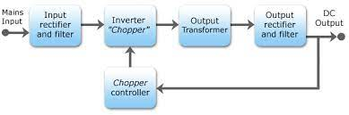

**Type of SMPS**

* DC-DC Converter
* Forward Converter
* Flyback Converter
* **Self-oscillating Flyback Converter**

**Advantages**

* The switch mode power supply encompasses a smaller in size.
* The switch mode power supply has light weight.
* It includes a way better power effectiveness ordinarily 60 to 70 percent.
* It features a solid against interference.
* SMPS has wide yield range.

**Disadvantages**

* The switch mode power supply is complex.
* The SMPS has higher yield swell and its control is worse.
* It can be utilized as it were as a step down regulator.
* It has as it were one output voltage.