Exp_3

**Aim: Create a HTML page with different types of frames floating frame navigation frame and mixed frames.**

**Source code:**

**Iframe**

<html>

<head>

<title>contact</title>

<body bgcolor=”blue”>

<iframe src="arm.html" height="300" width="300"></iframe>

</body>

</html>

**Outputs:**



**Mixed frame**

<html>

<head>

<title>frame</title>

</head>

<frameset cols="60,40">

<frame src="exp2.html">

<frameset rows="40,60">

<frame src="regform.html">

<frame src="iframe.html">

</frameset>

</frameset>

</html>

**Outputs:**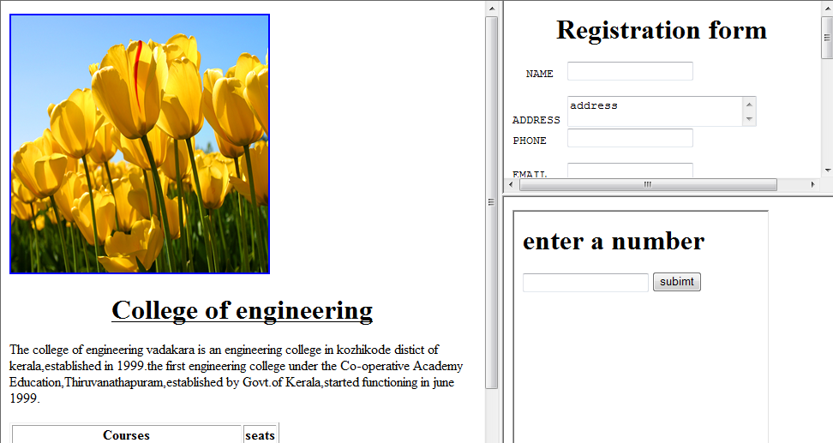

**Navigation frame**

<html>

<head>

<title>frame</title>

</head>

<body>

<a href="basictags.html" target="showframe">frame a</a><br>

<a href="regform.html" target="showframe">frame b</a>

</body>

</html>

**Saved as main.html**

**Output**

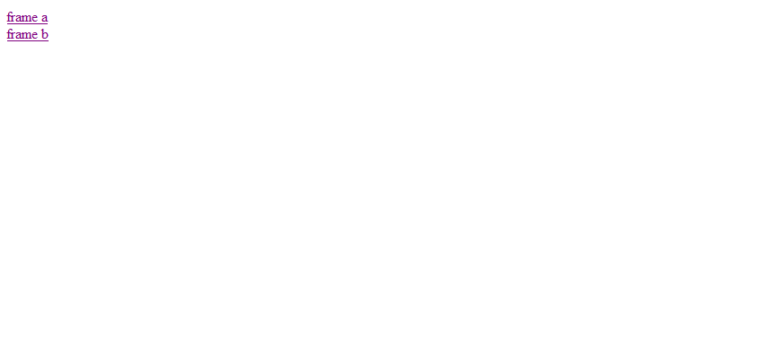

<html>

<head>

<title>register</title>

</head>

<frameset cols ="500,*">

<frame src ="main.html">

<frame src ="basictags.html" name="showframe">

<frame src="regform.html" name="showframe">

</frameset>

</html>

</frameset>

</body>

</html>

**Output**

