**Program no.4**

**Aim:** Analyze CSS by applying the different styles using Inline & internal CSS in HTML file.

**Source code:**

**Inline CSS**

<html>

<head>

<title>inlinecss</title>

</head>

<body style="background-color:blue">

<h1 style="color:yellow">College of engineering vadakara</h1>

<p style="color:brown">The college of engineering vadakara is an engineering college in kozhikode district of kerala ,established in 1999. The first engineering college under the Co-operative Academy Education , Thiruvanathapuram ,established by Govt.of Kerala, started functioning in june 1999.

CEV commited to the Government of india and Government of kerala policy of uplifting the weaker sections of society by imparting proffessional education to the students . Accordingly, CEV located in the society and educationally backward Malabar region of kerale state .CEV is located at the kurunthody in maniyur village 13km away from vadakara town along the palayad-maniyur road .

</p>

</body>

</html>

**Output:**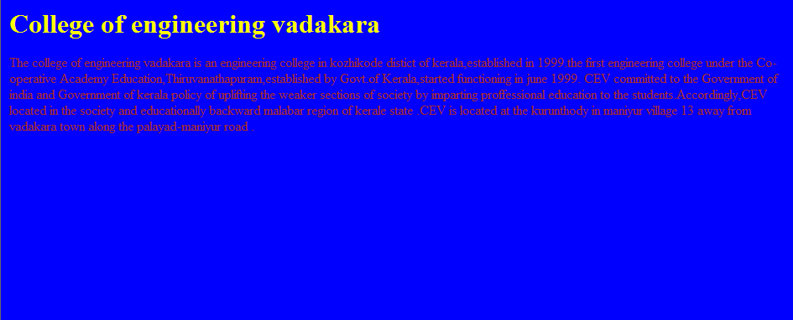

**Internal CSS**

<html>

<head>

<style>

h1

{

color:coral;

font-size:large;

font-family:ravie;

text-align:center;

}

p

{

color:darkgreen;

font-size:large;

}

body

{

background-color:yellow;

}

</style>

<body>

<h1>College engineering vadakara</h1>

<p>The college of engineering vadakara is an engineering college in kozhikode district of kerala, established in 1999.The first Vengineering college under the Co-operative Academy Education, Thiruvanathapuram,established by Govt.of Kerala ,started functioning in june 1999.

CEV committed to the Government of india and Government of kerala policy of uplifting the weaker sections of society by imparting professional education to the students . Accordingly ,CEV located in the society and educationally backward Malabar region of kerale state . CEV is located at the kurunthody in maniyur village 13KM away from vadakara town along the palayad-maniyur road .</p>

</body>

</html>

**Output**

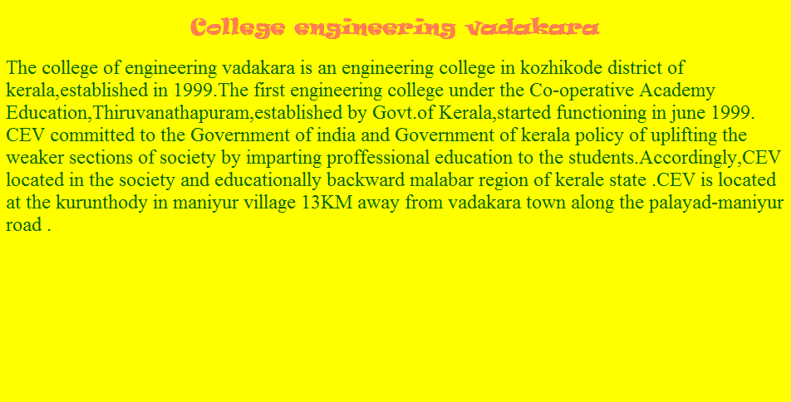

**External CSS**

<html>

<head>

<link rel="stylesheet" href="t.css">

</head>

<body>

<h1 align="center">College of engineering vadakara</h1>

<p>The college of engineering vadakara is an engineering college in kozhikode district of kerala ,established in 1999.The first engineering college under the Co-operative Academy Education, Thiruvanathapuram, established by Govt.of Kerala, started functioning in june 1999. CEV committed to the Government of india and Government of kerala policy of uplifting the weaker sections of society by imparting proffessional education to the students . Accordingly, CEV located in the society and educationally backward malabar region of kerale state .CEV is located at the kurunthody in maniyur village 13KM away from vadakara town along the palayad-maniyur road .

</p>

</body>

</html>

**t.css**

body{

background-color=#ff0123;

}

h1{

color:#1230ff;

padding:10px;

text-align:center;

}

p{

color:#873260;

font-size:30px;

text-align:justify;

margin-left:20px;

margin-right:20px;

}

**Output**

