Reg No.:VDA20MCA-2004__________

Name:_AISWARYA SP________________

**APJ ABDUL KALAM TECHNOLOGICAL UNIVERSIT**

First Semester MCA Regular Practical Examination April2021Course Code: 20MCA133 Course Name: WEB PROGRAMMING LAB

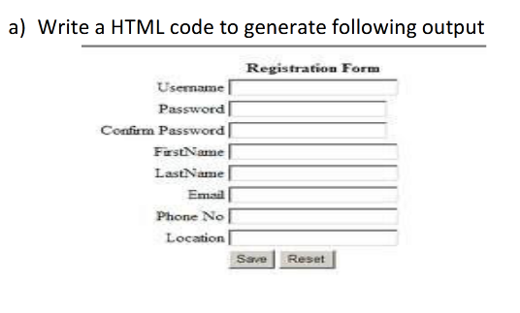

**Programme code:**

<html>

<head>

<title>form</title>

</head>

<body>

<center>

<h1>Registration Form</h1>

<pre>

<form >

Username<input type="text"><br>

Password<input type="password"><br>

Confirm Password<input type="password" ><br>

FirstName<input type="text"><br>

LastName<input type="text"><br>

Email<input type="text"><br>

Phone No<input type="text"><br>

Location<input type="text"><br>

<input type="submit" value="save"> <input type="reset" value="Reset">

</form>

</pre>

</body>

</html>

**Output:**

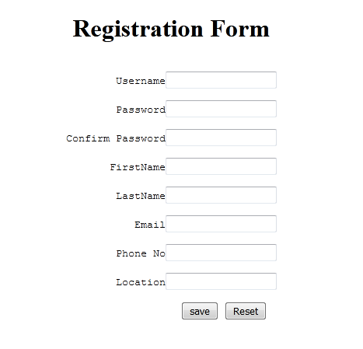

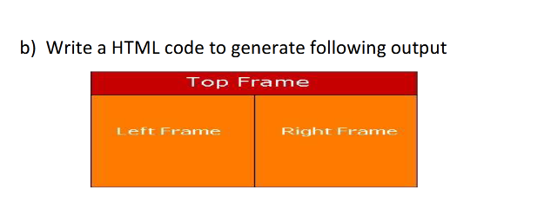

Programme code:

<html>

<head>

<title>frame</title>

</head>

<frameset rows="20%,*">

<frame src="basic.html">

<frameset cols="45%,*">

<frame src="java.html">

<frame src="cs.html">

</frameset>

</frameset>

</html>

Output:

