

**C O N T A C T M E A T**

Puthethu veedu, kurumandal, Paravur P.O Kollam

[bhagyalekshmi310@gmail.com](mailto:bhagyalekshmi310@gmail.com)

**S K I L L S S U M M A R Y**

C programming

Python,

HTML,Java

Microsoft Office

**S O F T S K I L L S**

Multitasking Typing Skill

Time Management Leadership

Communication

**P E R S O N A L D E T A I L S**

DOB : 22-11-2001

Mobile : 7994175158

Martial Status : Single Nationality : Indian

Religion : Hindu

Languages Known: English,Malayalam,

Hindi

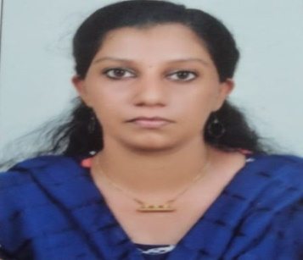

BHAGYA LEKSHMI S

**C A R E E R O B J E C T I V E**

Looking for an opportunity to utilise my acquired skills and knowledge to learn and grow with the organisation.

**W O R K E X P E R I E N C E**

Fresher

**E D U C A T I O N A L H I S T O R Y**

# Primary Education

SNVGHS Paravur

Percentage- 79%

Passing year- 2017

# Higher Secondary Education

GHSS Paravur

Percentage- 75%

Passing year- 2019

# Bachelor Of Computer Application

CHMM College,Chavarcode

Percentage- Nill Passing year- 2022

**P R O J E C T**

MEDICARE

Medicare can provide the patients can select the doctors from the different hospitals and connect the different branches. After taking appointments the patients can chat with the doctor.

**D E C L A R A T I O N**

I hereby declare that the information furnished above is true to the best of my knowledge.

Place Your Sincerely

Kollam Bhagya Lekshmi S