**CSC186 OBJECT ORIENTED PROGRAMMING**

**EXERCISES**

**CHAPTER 2 – UML (CLASS DIAGRAM & USE CASE DIAGRAM)**

**Question 1**

Veterinary System - Read and understand this UML diagram

1

1..*

**Pet**

**Pet Owner**

**Question 2**

Library System – explain the UML diagram.

Patron == customer/user

**Question 3**

Banking System – explain the UML diagram below.

**Question 4**

Draw a UML class diagram that models the relationships between the classes in each of the following lists.   Model using aggregation, association, composition and inheritance relationships.

a.    Oak Tree, Maple Tree, Branch, Leaf, Tree

b.    Bank, Saving Account, Loan, Customer, Current Account, Account

**Question 5**

Computer System

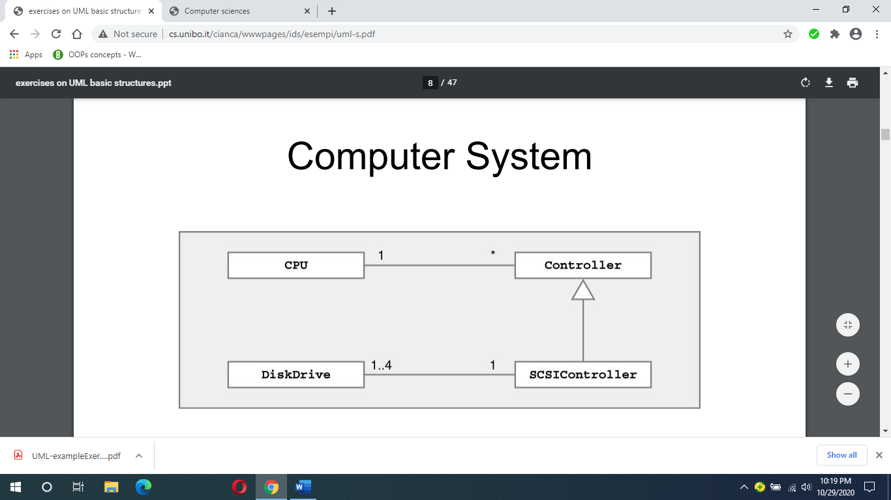

Based on the above class diagram, how do you describe computer system?

**Question 6**

Order Processing System

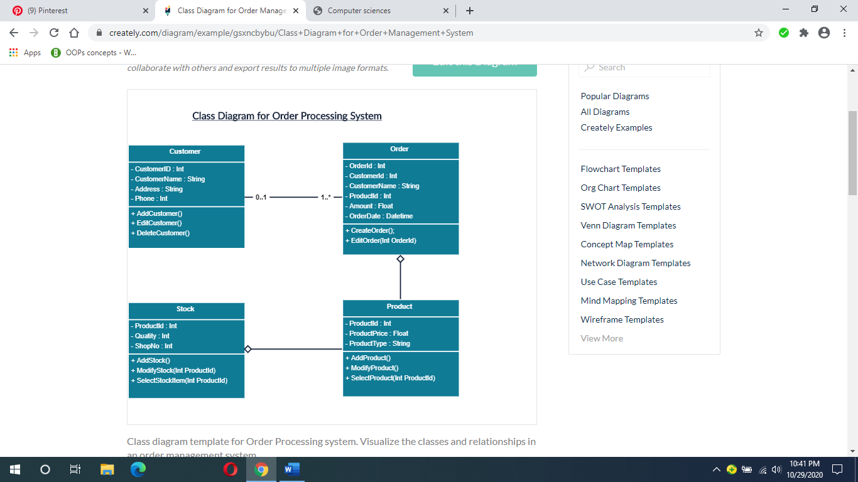

Based on the above class diagram, describe the Order processing system.

**Question 7**

Bank system

A bank system contains data on customers (identified by name and address) and their accounts. Each account has a balance and there are 2 type of accounts: one for savings which offers an interest rate, the other for investments, used to buy stocks. Stocks are bought at a certain quantity for a certain price (ticker) and the bank applies commission on stock orders. Draw class diagram and use case diagram.

**Question 8**

A company consists of departments. Departments are located in one or more offices. One office acts as a headquarter. Each department has a manager who is recruited from the set of employees. Your task is to model the system for the company.

Draw a class diagram which consists of all the classes in your system their attributes and operations, relationships between the classes, multiplicity specifications, and other model elements that you find appropriate.

**Question 9**

AMW Sdn Bhd is the appointed Toyota distributor that sells Toyota car models. Customer can purchase any model of the new car such as Toyota Vios, Camry, Avanza, Estima and many more. In order to provide efficient services, the company is planning to upgrade the existing system. The new system will be able to store information of the car sold, store information of the customer and calculate on-the-road car price. On-the-road car price is the sum of selling price, road tax and insurance. The company provides special Toyota Insurance Package to all customers with an 8.3% discount of insurance amount for the first year.

The system can store information for customer IC, customer name and sum insured. Information about car are model, cubic capacity (CC) and selling price of the car.

Draw class diagram and use case diagram.

**Question 10**

A KonaKuni bookstore started its operation by selling physical and digital books. Each book has its ISBN, title and quantity. The company is planning to develop an application that can calculate an estimate price of books to forecast the profit. Estimated price for digital books depending on the size of memory (in kilobyte) consumed. A 10% discount is given to all digital books for every purchase on 22nd July annually in conjunction with digital awareness day. Estimated price of physical books is related to the number of pages and book’s hardcover.

Customer can purchase many books. System can store customer’s information such as customer name and telephone number.

Draw a class diagram and use case diagram.

**Use Case Diagram**

**Question 1**

[Restaurant use](https://www.uml-diagrams.org/restaurant-uml-use-case-diagram-example.html) case diagram

***Purpose****: Two alternative examples of business use case diagram for a Restaurant - external and internal business views of a restaurant.*

***Summary****: Several business actors having some needs and goals as related to the restaurant and business use cases expressing expectations of the actors from the business.*

**Question 2**

[Bank ATM use case diagram](https://www.uml-diagrams.org/bank-atm-uml-use-case-diagram-example.html?context=uc-examples)

***Purpose****: Describe use cases that an automated teller machine (ATM) or the automatic banking machine (ABM) provides to the bank customers.*

***Summary****: Customer uses a bank ATM to check balances of his/her bank accounts, deposit funds, withdraw cash and/or transfer funds (use cases). ATM Technician provides maintenance and repairs to the ATM.*

**Question 3**

[Online shopping use case diagram](https://www.uml-diagrams.org/examples/online-shopping-use-case-diagram-example.html?context=uc-examples)

***Purpose****: Provide top level use cases for a web customer making purchases online.*

***Summary****: Web customer*[***actor***](https://www.uml-diagrams.org/use-case-actor.html)*uses some web site to make purchases online. Top level*[***use cases***](https://www.uml-diagrams.org/use-case.html)*are****View Items****,****Make Purchase****and****Client Register****.*

**Question 4**

Car Rental System

**Question 5**

**Course registration**

The following should be textually analyzed and a use case diagram created containing several use cases. Identify the actors, use cases and associations.

At the start of each semester a student can request a prospectus containing a course list. Information about a course is provided, such as the tutor, department and pre-requisites.

The new system will allow students to create a schedule, then select four courses. Each student chooses two others in case their first choices become full or are cancelled. No course can have more than 10 students. No course can have less than 3 students or it will be cancelled. This will be the same functionality as available to other internal users of the system.

When registration is complete, the registration system sends a message to the billing system to send out a bill to the student. Tutors use the system to find which classes they are teaching and who the students are. The registrar will administer the system.

For a period at the beginning of the semester the student can change their schedule. Students must be allowed to access the system during this time to add or delete courses.

Draw use case diagram.