Couto_Assignment_04_02

Mcouto

2023-07-20

# Markdown Basics

## Favorite Foods

1. Sushi
2. Desserts
3. Filipino Cuisine

## Images

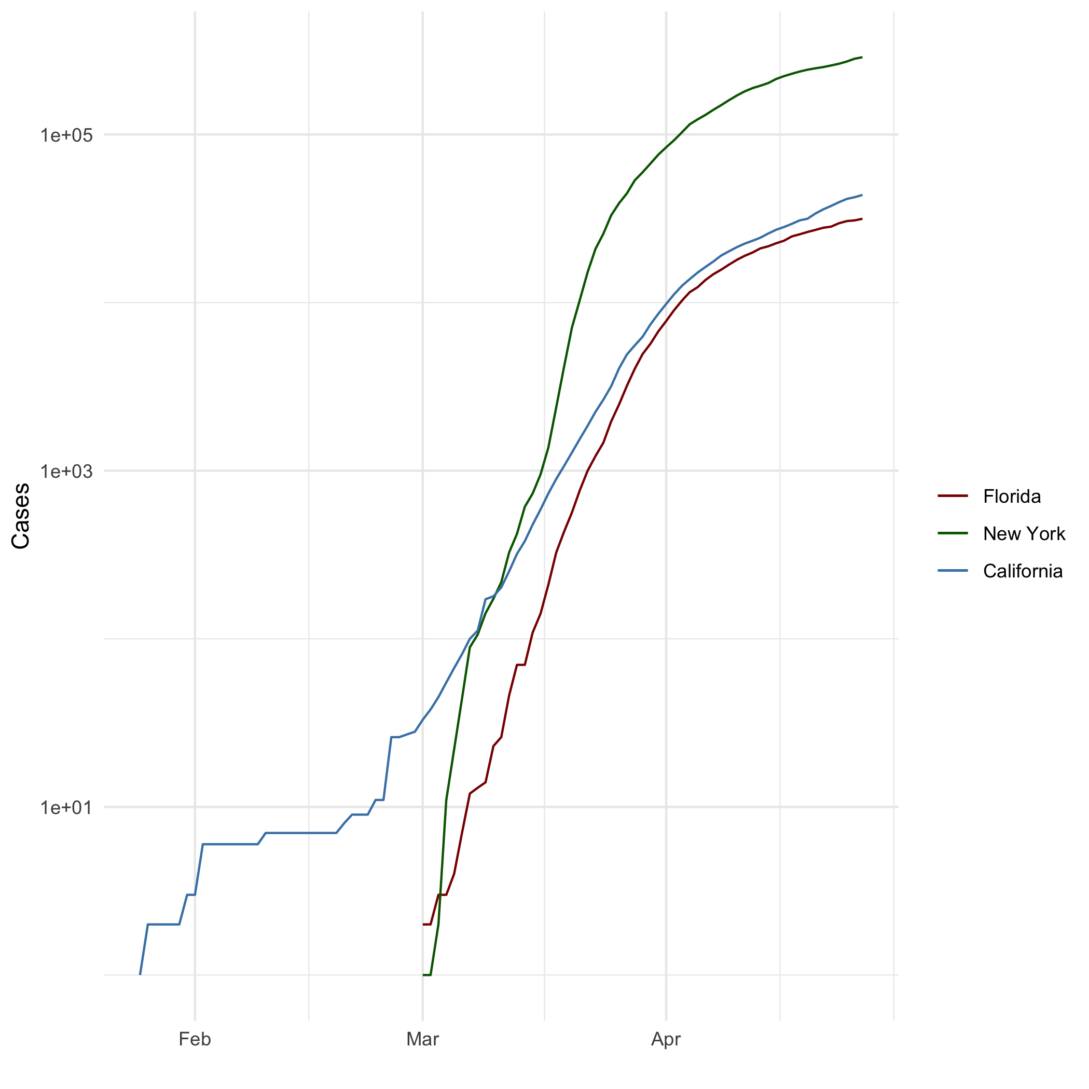 ## Add a Quote

“If more of us valued food & cheer & song above hoarded gold, it would be a merrier world.” - Thorin, Chapter 18

## Add an Equation

$$

E = mc^2

$$

## Add a Footnote

[1]

## Add Citations

* R for Everyone Lander (2014)
* Discovering Statistics Using R Field, Miles, and Field (2012)

# Inline Code

## NY Times COVID-19 Data

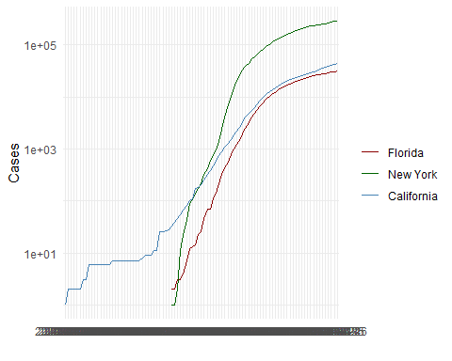

## R4DS Height vs Earnings

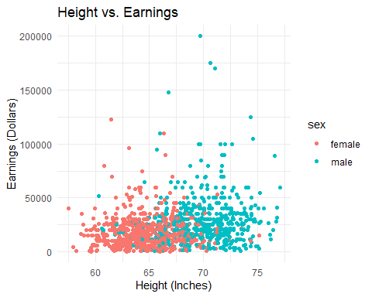

# Tables

## Knitr Table with Kable

One Ring to Rule Them All

| name | race | in_fellowship | ring_bearer | age |
| --- | --- | --- | --- | --- |
| Aragon | Men | TRUE | FALSE | 88 |
| Bilbo | Hobbit | FALSE | TRUE | 129 |
| Frodo | Hobbit | TRUE | TRUE | 51 |
| Galadriel | Elf | FALSE | FALSE | 7000 |
| Sam | Hobbit | TRUE | TRUE | 36 |
| Gandalf | Maia | TRUE | TRUE | 2019 |
| Legolas | Elf | TRUE | FALSE | 2931 |
| Sauron | Maia | FALSE | TRUE | 7052 |
| Gollum | Hobbit | FALSE | TRUE | 589 |

## Pandoc Table

Name Race In Fellowship? Is Ring Bearer? Age  
-------- -------- ---------------- ----------------- ------  
Aragon Men Yes No 88  
Bilbo Hobbit No Yes 129  
Frodo Hobbit Yes Yes 51  
Sam Hobbit Yes Yes 36  
Sauron Maia No Yes 7052  
  
Table: One Ring to Rule Them All

# References

Field, A., J. Miles, and Z. Field. 2012. *Discovering Statistics Using r*. SAGE Publications. <https://books.google.com/books?id=wd2K2zC3swIC>.

Lander, J. P. 2014. *R for Everyone: Advanced Analytics and Graphics*. Addison-Wesley Data and Analytics Series. Addison-Wesley. <https://books.google.com/books?id=3eBVAgAAQBAJ>.

1. This is a footnote.