CSCI218 Foundations of Artificial Intelligence
Group Project: Guidelines and Grading Criteria
Autumn 2026 | University of Wollongong in Dubai

1. Project at a Glance
Item | Details
Weight | 20% of the subject mark
Group size | 4–5 students; all members must belong to the same lab
Week 3 | Register your group, topic and (optional) industry partner with your lab instructor
Deadlines | Submission dates are shown on the Turnitin submission links on Moodle
Demonstration | Online, scheduled according to the instructor’s availability; includes the individual viva
Group deliverables | Report, code (Git repository), online demonstration
Individual deliverables | Contribution and reflection statement, viva
Mark structure | 80% group mark + 20% individual mark, plus up to 10% bonus (final mark capped at 100%)

2. General Guidelines
- You may choose any of the topics in Section 3 or propose your own project. Proposed projects must be approved by your lab instructor by Week 3.
- All topics carry the same maximum mark, although they differ in difficulty. It is harder to earn a high mark on an easier topic, because a stronger standard of depth, analysis and polish is expected.
- We strongly recommend choosing a real-world scenario and working through it to find a solution.
- Use a shared Git repository (e.g. GitHub or GitLab) from the start of the project. Commit history is used as evidence of individual contribution.
- Every member must understand the whole system, not only their own part. Each student will be questioned individually during the demonstration (see Section 6).
- Groups may optionally work with a real company or organisation for bonus marks (see Section 7).
- Report any contribution problems within your group to your lab instructor by Week 6.
- Check the subject descriptor for the rules on the use of AI tools in this assessment.

3. Project Topics
The topics below can be used as they are or as inspiration for your own project. Working on a real-world example is strongly recommended.

Topic 1: Adding AI to a Simple Game
Overview
Choose a classic or simple game, such as Fighter Jet, Space Invaders, Tank Game, Monaco GP or Spaceheir, and enhance it by integrating AI to control game elements or improve gameplay dynamics. The AI can be used to:
- Control enemy behaviour
- Adapt difficulty based on player performance
- Make decisions for non-player characters (NPCs)
AI techniques to choose from
- Finite State Machines (FSM): define states such as patrol, attack and retreat, with transitions based on game conditions.
- Behaviour Trees: structure complex decision-making hierarchically for more flexible AI.
- Fuzzy Logic Rules: handle uncertainty and approximate reasoning (e.g. deciding when to attack based on distance and health).
- Q-learning: use reinforcement learning to let game agents learn optimal strategies through experience.
Outcome
A playable game demo showing intelligent behaviour through one or more AI techniques, improving realism and challenge.

Topic 2: Interactive Robot Programming in Webots with Environmental Awareness
Overview
Use the Webots robot simulator (cyberbotics.com) to download, install and modify the behaviour of a sample robot. Choose from simpler models such as K-Team (Khepera), EPFL robots or Lego Mindstorms (Rover), all available in the Webots sample library.
Your task is to enhance the robot's program so it reacts intelligently to its environment, for example by avoiding obstacles, following paths or responding to sensor input. You will modify the control logic to add new actions and behaviours.
Optional extension
Implement Q-learning so the robot learns from its environment and improves its performance over time.
Outcome
A working Webots simulation in which the robot shows adaptive behaviour based on environmental input.

Topic 3: Cooking Schedule Optimisation as a Constraint Satisfaction Problem
Overview
You must plan the preparation of N dishes on a K-burner stove using a limited number of pans (typically fewer than N). Each dish needs a clean pan and must cook for a specific, uninterrupted duration. A pan that is reused must be cleaned first, which takes extra time. Schedule the cooking so that:
- All dishes are completed.
- The use of burners and pans is optimised.
- Dishes are served as hot as possible (i.e. the time between cooking and serving is minimised).
Model the problem as a Constraint Satisfaction Problem (CSP) with constraints including burner availability, pan-cleaning time and dish cooking durations.
Optional extension
Implement Q-learning or another optimisation technique to improve scheduling efficiency and dish temperature at serving time.
Outcome
An algorithm or simulation that produces an optimised cooking schedule, showing effective resource management and constraint handling.

Topic 4: Multi-Layered Search
Overview
Consider a simulated office robot that lives in a grid world. A sample world is shown in Figure 1. This is only a sample; your solution must be general enough to apply to any world that meets the specification below.
The two-dimensional grid world is divided into cells, shown as individual squares. Black cells are walls or obstacles and the robot cannot pass through them. The perimeter of the world is always enclosed by blocked cells. The robot can move to any non-blocked cell adjacent to its current cell.
The grid in Figure 1 is small enough to search exhaustively. Now imagine scaling it up to a map of an entire floor of a UOWD building at Dubai Knowledge Park, with grid cells one square inch in size. Such a grid could represent obstacles to within an inch, but searching it exhaustively would be very expensive.
One way to plan paths over such a large grid is a two-tiered approach. First, an easier search is performed in a more abstract space (one with less detail than the original). The path found by the abstract search is then used to guide a more limited search in the original, detailed space.
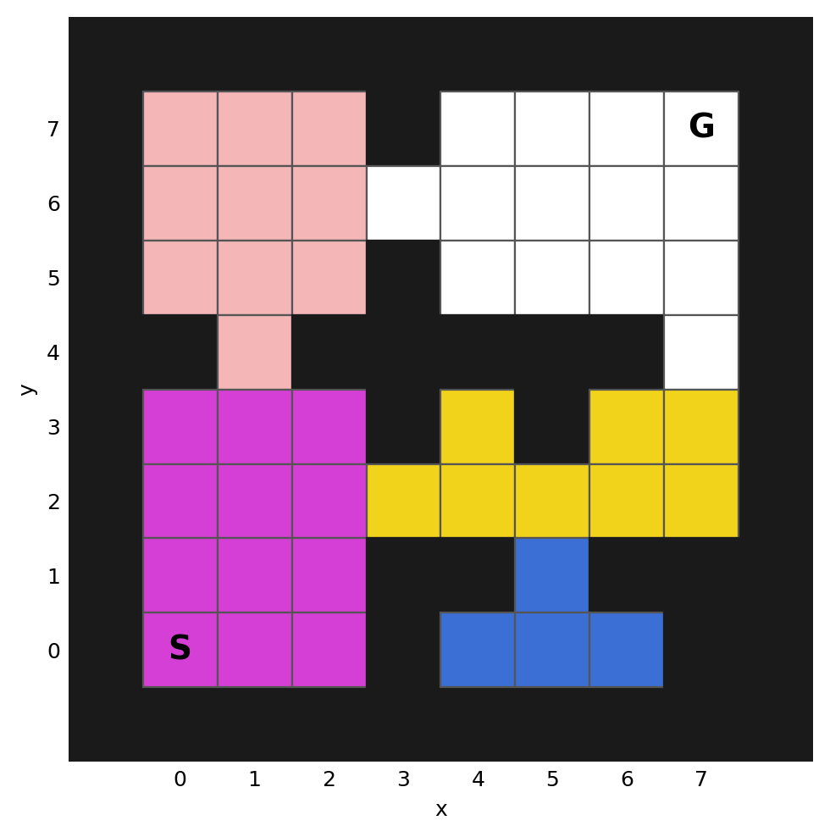
Figure 1: A sample grid world partitioned into areas (S = start (0,0), G = goal (7,7))
To support the abstract search, the world is partitioned into a number of areas. An area is simply a group of adjacent cells; a room or a hallway could be an area, for example. In Figure 1, each area has a different colour, and a change of colour marks a boundary between two areas. You can assume every non-blocked cell belongs to some area.
Consider planning a path from the lower-left corner (0,0) to the upper-right corner (7,7). At the abstract level, this is the problem of getting from the magenta area to the white area, either through the yellow area or through the light-pink area. At the detailed level, if the yellow area is chosen, the problem becomes: get from (0,0) to the nearest yellow cell (3,2); then from (3,2) to the nearest white cell (7,4); and finally from (7,4) to (7,7).
In this project, you will formalise, implement and analyse this idea.
Outcome
An implementation of two-tiered search, compared with a flat (single-level) search such as A* on grids of increasing size, using measures such as nodes expanded, runtime and path cost.

Topic 5: Automatic Parallel Parking Using Fuzzy Logic
Overview
Simulate a car performing parallel parking between two parked vehicles using fuzzy logic. The system controls steering and speed based on inputs such as the distance to obstacles and the angle of approach.
Simulation tool
To simplify vehicle dynamics, implement the project in Unity, which provides a realistic and manageable environment for simulating car movement.
Fuzzy logic controller
- Inputs: distance to the front and rear cars, angle, lateral position
- Outputs: steering angle, speed
- Components: rule base, inference engine, defuzzification
Outcome
A Unity simulation showing intelligent, autonomous parallel parking using fuzzy logic.

Topic 6: Simulated Robot Task Execution Using AI Techniques
Overview
Design a robot simulation using a platform such as Gazebo (gazebosim.org), VRobotSim (vrobotsim.org) or Unity Robotics. The aim is to teach a robot to perform a specific task, such as navigation, object manipulation or obstacle avoidance, using the following AI approaches:
- Reinforcement Learning: the robot learns optimal actions through trial and error based on rewards.
- Fuzzy Logic: the robot makes decisions using approximate reasoning, suited to uncertain or imprecise environments.
- Finite State Automata (FSA) or Behaviour Trees: structured, rule-based control for task execution and decision-making.
Outcome
A working simulation showing how AI techniques can guide robot behaviour in a realistic environment, demonstrating adaptability and intelligent control.

Topic 7: Robotics Project
Overview
Work on one of the projects below using an available physical robot. You must coordinate these projects with your lab instructor. Example ideas:
- Obstacle avoidance and pathfinding: use search algorithms and behaviour trees to navigate around obstacles in real time.
- Autonomous navigation with reinforcement learning: teach the robot to follow a specific path or reach a destination.
- Object detection and manipulation: use image recognition to identify and interact with specific objects on the robot's path or in front of it.
Robotics projects have additional report requirements, described in Section 4.2.

Topic 8: Intelligent Pathfinding Using Dijkstra and A* Search
Overview
Design and implement a simulation in which an agent (e.g. a robot, vehicle or character) must find the shortest or most efficient path through a grid-based environment with obstacles.
Project scope
- Create a 2D grid world with blocked and unblocked cells.
- Implement Dijkstra's algorithm and A* search to find optimal paths.
- Compare the performance of both algorithms in terms of speed and path efficiency.
- Optional: add dynamic elements such as moving obstacles or changing terrain costs.
Suggested tools
- Python with libraries such as pygame, matplotlib or networkx
- Unity (for visual simulation)
- Jupyter Notebook (for algorithm analysis and visualisation)
Optional extensions
- Visualise the search process step by step.
- Allow user interaction to place start/end points and obstacles.
- Extend to 3D environments or real-world maps using APIs (e.g. OpenStreetMap).

Topic 9: Travelling Salesman Problem Using Genetic Algorithms
Overview
Explore the application of Genetic Algorithms (GAs) to the Travelling Salesman Problem (TSP), a classic optimisation problem in computer science and operations research.
Objectives
- Understand the principles of selection, crossover, mutation and fitness evaluation in evolutionary algorithms.
- Implement a GA-based solution that finds near-optimal tours for the TSP.
- Compare its performance with brute-force and greedy algorithms.
Implementation steps
- Define a set of cities with coordinates or distances.
- Initialise a population of random tours.
- Implement a fitness function based on total tour distance.
- Apply selection, crossover and mutation operators to evolve the population.
- Visualise the best tour found over the generations.
Suggested tools
- Python with libraries such as matplotlib, numpy and random
- Jupyter Notebook for visualisation and experimentation

Topic 10: AI Escape Room (Intelligent Agent for Dynamic Puzzle Solving)
Overview
Design an interactive AI-based escape room in which an intelligent agent must navigate an environment, overcome obstacles, solve simple challenges and reach a final goal. The environment can be a grid world, maze, virtual room or simple game environment. Use at least two AI techniques covered in the subject to control the agent and support its decision-making. Possible techniques include:
- A* or other search algorithms for navigation and path planning
- Constraint Satisfaction to handle rules, resources or puzzle constraints
- Finite State Machines or Behaviour Trees to control the agent's behaviour
- Fuzzy Logic for decisions when information is uncertain
- Reinforcement Learning so the agent improves its behaviour through experience
The environment must include dynamic elements: for example, an obstacle changes position, a route becomes unavailable or a constraint changes during execution. The agent must respond appropriately rather than relying on a fixed sequence of actions.
Outcome
A working simulation or interactive application showing an intelligent agent that can plan, make decisions and adapt to changes in its environment. Evaluate your solution using suitable measures such as completion time, path cost, number of states explored or success rate.

Topic 11: Dubai Humanitarian Use Cases
Overview
Work on a real-world use case based on challenges faced by Dubai Humanitarian, the humanitarian logistics hub in Dubai. The list of available use cases is published in the accompanying Excel sheet on the subject site. Refer to it for the details of each use case and choose one for your project.
This topic is well suited to the industry engagement bonus described in Section 7.

Your Own Project
You may propose your own project. It must apply at least one AI technique covered in the subject to a clearly defined problem, and it must be approved by your lab instructor by Week 3.

4. Deliverables

4.1 Group Report (all projects)
Submit a detailed report on your design and implementation with the following structure:
- Executive summary
- Motivation
- Technical requirements
- Main constructs (aspects or components)
- Implementation (with screenshots and code excerpts)
- Experiments and results (metrics, repeated runs, comparison with a baseline)
- Limitations, difficulties and constraints
- Conclusion and discussion
- References
- Appendices
The appendices must include:
- Appendix A: link to the Git repository and the team contribution table (template in Appendix A of this document).
- Appendix B (bonus only): industry meeting log and the completed mentor feedback form (templates in Appendices B and C).

4.2 Additional Requirements for Robotics Projects (Topic 7)
Robotics groups (Topic 7) follow the report structure in 4.1 and must also include the following:
- Literature review (new section after b) Motivation): review relevant AI algorithms, methods and applications related to the project objective. Reference at least three books or academic journal articles from the recommended reading list.
- In d) Main constructs and e) Implementation: explain how the chosen algorithms (e.g. finite state machines, behaviour trees, search algorithms, reinforcement learning models) were adapted to the robot’s sensors and actuators. Implement them in Python or MATLAB, depending on your team’s skills and the robot’s requirements, and show how you handle constraint satisfaction where applicable.
- In f) Experiments and results: report data from multiple trials on the physical robot to assess efficiency, accuracy and overall functionality, and discuss the differences between expected and real-world behaviour.

4.3 Code
Submit the complete source code through the Git repository link, with a README explaining how to install and run it. The repository history must show contributions from all members.

4.4 Demonstration and Viva
Each group gives a live online demonstration of the working system, scheduled according to the instructor’s availability, followed by individual viva questions for every member (see Section 6).

4.5 Individual Submissions
- Contribution and reflection statement (1–2 pages, submitted individually; see Section 6.2).

5. Assessment Overview
The project is marked out of 100%, which is then scaled to its 20% weight in the subject. Bonus marks (Section 7) are added on top, but the final project mark cannot exceed 100%.
Component | Criterion | Weight | Subtotal
Group (80%) | 1. Problem Understanding & Motivation | 10%
 | 2. Technical Depth & Algorithm Design | 25%
 | 3. Implementation Quality | 15%
 | 4. Results & Analysis | 10%
 | 5. Report Structure & Presentation | 10%
 | 6. Project Demonstration | 10% | 80%
Individual (20%) | 7. Individual Viva | 10%
 | 8. Contribution & Reflection Statement | 10% | 20%
Total |  |  | 100%
Bonus | Industry engagement | up to +10% | Capped at 10%

Performance bands
Each criterion is scored using the bands below. The percentage is applied to that criterion's weight (e.g. 80% on a 25% criterion gives 20 marks).
Band | Range | Meaning
Excellent | 85–100% | Exceeds expectations; rigorous, complete and well justified
Good | 70–84% | Meets expectations with minor gaps
Satisfactory | 50–69% | Meets basic expectations; noticeable gaps or weaknesses
Needs Improvement | 0–49% | Does not meet expectations; major errors or missing components

5.1 Group Criteria

1. Problem Understanding & Motivation (10%)
- Clearly defines the problem and its significance (e.g. complexity, real-world relevance).
- States measurable objectives and scope; places the work within AI foundations.
- Explains why the chosen approach suits the problem better than the alternatives.

2. Technical Depth & Algorithm Design (25%)
- Correct, complete formulation of the algorithms (e.g. fitness functions, heuristics, state spaces, rule bases, data structures).
- Justifies design choices (e.g. heuristic selection, cost models, selection/crossover/mutation, membership functions, reward design).
- Discusses trade-offs, complexity and limitations; refers to standard variants or hybrids.

3. Implementation Quality (15%)
- Modular, readable code with a consistent style and meaningful comments or docstrings.
- Reproducible: fixed random seeds, configuration files, listed dependencies, a clear README.
- Tested and validated (functional tests, edge cases); reasonable runtime efficiency.

4. Results & Analysis (10%)
- Reports meaningful metrics (e.g. path cost, nodes expanded, runtime, convergence, success rate).
- Uses a fair experimental setup with multiple runs and summary statistics (mean, standard deviation).
- Interprets results against a baseline and acknowledges threats to validity.

5. Report Structure & Presentation (10%)
- Clear organisation, concise writing and correct terminology; follows the structure in Section 4.
- Professional formatting with consistent citations and references; data sources disclosed.
- Readable, captioned figures and tables; replication materials (e.g. CSV files, notebooks) provided.

6. Project Demonstration (10%)
- The system runs live and reliably, showing its key AI behaviours (including dynamic or adaptive features where relevant).
- The demonstration is well organised, within time, and clearly links what is shown to the design and results.
- The group answers questions about the system accurately and confidently.

5.2 Group Performance Descriptors
Criterion | Excellent (85–100%) | Good (70–84%) | Satisfactory (50–69%) | Needs Improvement (0–49%)
Problem Understanding & Motivation | Compelling, precise problem framing; strong real-world motivation; clear, measurable objectives. | Clear problem statement and motivation; minor gaps in objectives or context. | Basic understanding; vague objectives; limited context or relevance. | Problem misunderstood or poorly framed; weak or no motivation.
Technical Depth & Algorithm Design | Sound, rigorous design; correct algorithms; justified choices; explores variants or hybrids. | Correct design; mostly justified; mentions some alternatives. | Partial or standard design; limited justification; some gaps in correctness. | Major errors; missing components; design not justified.
Implementation Quality | Clean, modular, well-documented code; reproducible; appropriate tests; efficient. | Generally clean; some documentation and tests; mostly reproducible; acceptable efficiency. | Works but messy; minimal documentation or tests; hard to reproduce; inefficient. | Unreliable; undocumented; cannot be reproduced; poor performance.
Results & Analysis | Robust experiments; multiple runs; statistical analysis; strong interpretation against baselines. | Good experiments; some repetition; reasonable interpretation. | Minimal experiments; single run; superficial interpretation. | Inadequate or incorrect analysis; unsupported claims.
Report Structure & Presentation | Professional, clear and concise; high-quality visuals; proper citations. | Well structured; minor issues; visuals generally clear. | Acceptable structure; several formatting or clarity issues. | Disorganised; poor visuals; missing citations.
Project Demonstration | Runs flawlessly; key AI behaviours clearly shown; well paced; questions answered with confidence. | Runs with minor issues; main behaviours shown; most questions answered well. | Partly working or unclear; key behaviours only partly shown; weak answers. | Does not run or is not shown; cannot explain the system.

6. Individual Assessment (20%)
The individual component ensures each student's mark reflects their own understanding and contribution, not only the group's output.

6.1 Individual Viva (10%)
After the group demonstration, each student answers 2–3 short questions. At least one question will be about a part of the system the student did not present. Example questions:
- Why did your team choose this heuristic (or reward function, or rule base)?
- What happens if the environment changes, for example a route becomes blocked?
- How would the performance change if the grid (or population, or state space) doubled in size?
Band | Descriptor
Excellent (85–100%) | Explains the algorithms and design choices accurately; reasons confidently about changes and trade-offs, including parts built by others.
Good (70–84%) | Explains their own part well; understands the rest of the system in general terms.
Satisfactory (50–69%) | Can describe what the system does but struggles to explain how or why it works.
Needs Improvement (0–49%) | Cannot explain their own contribution or the core AI techniques used.

Viva cap rule
A student who is placed in the Needs Improvement band for the viva because they cannot explain their own contribution will have their group mark capped at the top of the Satisfactory band, i.e. a maximum of 55 out of 80 for the group component.

6.2 Contribution & Reflection Statement (10%)
Each student submits a 1–2 page statement covering:
- What you personally built or wrote, with evidence (e.g. Git commits, specific functions, report sections).
- One technical decision you made or influenced, and why.
- One problem you faced and how you solved it.
- What you would do differently next time.
- How you worked with your team: how tasks were shared, how you communicated and how any disagreements were resolved.
- (Bonus groups only) What you learned from working with the industry partner.
Band | Descriptor
Excellent (85–100%) | Specific, evidenced contribution; insightful reflection on decisions, problems and lessons learned.
Good (70–84%) | Clear contribution with some evidence; reasonable reflection.
Satisfactory (50–69%) | Contribution described in general terms; limited evidence; mostly descriptive rather than reflective.
Needs Improvement (0–49%) | Vague or unsupported contribution; little or no reflection; claims contradicted by the repository.

7. Bonus Marks (up to +10%)
Bonus marks are available only for working with a real-world industry partner (Section 7.1). The bonus is capped at 10%, and the final project mark cannot exceed 100%.
Bonus source | Maximum | Applies to
Industry engagement & validation | +10% | Any topic, with an approved industry partner

7.1 Industry Engagement & Validation
Groups may work with a real company or organisation that acts as their client. This gives the project a real stakeholder, real constraints and an external check on the results.
Eligibility
- Groups may find their own partner or use one suggested by the instructor (e.g. Dubai Humanitarian for Topic 11).
- The partner organisation and the staff mentor from that organisation must be approved by the instructor by Week 3.
- The group must hold at least two meetings or interviews with the mentor during the project and record them in the meeting log (Appendix B).
- The mentor completes the feedback form (Appendix C) at or just before the final demonstration.
Bonus criteria
Criterion | Max | Evidence
Stakeholder engagement | 4% | Meeting log with dates, attendees, agenda, and the decisions and actions from each meeting; at least two meetings.
Requirements & responsiveness | 3% | Requirements traced back to the interviews; examples of how mentor feedback changed the design.
Validation of results | 3% | Validation criteria agreed with the partner; completed mentor feedback form; the group's response to any gaps identified.
Total | 10%

Criterion | Excellent (85–100%) | Good (70–84%) | Satisfactory (50–69%) | Needs Improvement (0–49%)
Stakeholder engagement | Regular, well-prepared meetings; clear agendas and actions; all members involved. | Consistent engagement; log mostly complete. | Few or poorly documented meetings. | Little or no engagement; no usable log.
Requirements & responsiveness | Requirements clearly come from the stakeholder; feedback visibly shaped the solution. | Most requirements linked to the stakeholder; some feedback acted on. | Weak link between stakeholder input and design. | Requirements assumed rather than gathered; feedback ignored.
Validation of results | Results validated against agreed criteria; gaps openly discussed and addressed. | Results validated with the partner; some discussion of gaps. | Informal or partial validation. | No validation.
How the partner's input is used
- The partner's feedback is evidence, not a grade. The instructor awards all marks; the mentor's form informs that judgement.
- Groups are marked on what they control: preparation, engagement and how they acted on feedback. A group will not lose marks because a mentor was unavailable, provided the group's attempts to engage are documented.
- Mentor comments may be quoted in the written feedback returned to the group.

Appendix A: Team Contribution Table
Git repository link: ______________________________________________
Student name & ID | Main contributions (code, report sections, experiments) | Est. share (%) | Signature

Appendix B: Industry Meeting Log (bonus only)
Partner organisation: ______________________ Mentor name & role: ______________________
# | Date | Attendees | Agenda / questions | Decisions & actions
1
2
3
4
5

Appendix C: Industry Mentor Feedback Form
Group: ________ Organisation: ________________ Mentor: ________________ Date: ________
Please rate each statement from 1 (strongly disagree) to 5 (strongly agree).
Statement | 1 | 2 | 3 | 4 | 5
The team understood our problem and constraints.
The team communicated professionally and met its commitments.
The team acted on our feedback.
The solution meets the requirements we agreed.
The results would be useful or feasible in our context.

What did the team do particularly well?
______________________________________________________________________________
______________________________________________________________________________
What should the team improve?
______________________________________________________________________________
______________________________________________________________________________
Mentor signature: ______________________

