Can a Search Algorithm Beat My TrackMania PB?
Searching inside real game physics on TrackMania Nations Forever, map B01-Race
CSCI218 Foundations of Artificial Intelligence, Group Project, Autumn 2026, UOWD
[Team members and student IDs]
[Lab group] · [Date]
DRAFT generated from the project's result files. Check every [bracketed] item, rewrite in the team's own words, and follow the subject descriptor's rules on the use of AI tools.

1. Executive summary
We built an AI agent that searches for a faster way to drive a TrackMania Nations Forever track than a team member's personal best (PB). The game itself is the simulator: a plugin we wrote for TMInterface saves and restores the full car state, steps the physics in 10 ms ticks and reports the result to Python over TCP, so every candidate run is evaluated with the real game physics. On the map B01-Race the PB is 27.82 s, 0.02 s short of the gold medal (27.80 s). A time-layered beam search guided by the PB's own trajectory reached 27.66 s in 20 minutes; stochastic local search (hill climbing over the key presses) then reached 27.42 s, and four parallel local-search workers reached 27.28 s, 0.54 s faster than the PB and faster than gold. Every time reported was verified by re-running the inputs from the start line in the game. Starting instead from the human world record (25.23 s by oli10), which our pipeline re-drives exactly, local search found a 25.21 s run after 24,846 candidate runs (35 minutes on four game instances).
We compared beam search (widths 1-40) with A* and weighted A* under two heuristics on the same budget of game steps: no A* variant reached the finish, every beam search did, and only the widest beam improved on the PB. Repeated runs of local search from the PB (5 seeds) gave 27.282 ± 0.143 s (mean ± standard deviation).

2. Motivation
Racing games are a clean testbed for search: the goal is unambiguous (cross the line sooner), the dynamics are complex (momentum, grip, drifting, jumps) and a skilled human gives a strong, measurable baseline. TrackMania Nations Forever adds two properties that make search practical. Its physics is deterministic, so the same inputs from the same state always produce exactly the same run, and the TMInterface tool can save and restore the complete simulation state. Together they turn a video game into a perfect, rewindable simulator: a search node is a saved game state and expanding it means holding some keys for a few ticks.
The question is simple and measurable: can an AI that only presses the same four keys as the player find a faster run than the player's PB on the same map? We chose search rather than reinforcement learning because the game runs at roughly 120-150 simulated steps per second per instance: an RL agent would need millions of episodes, while search can exploit determinism and save states directly, and its decisions can be inspected and explained input by input.
Objectives:
- O1. Beat the PB (27.82 s) and the gold medal (27.80 s) on B01-Race with runs that are verified in the game.
- O2. Compare search algorithms covered in the subject (beam search, A*, weighted A*, local search) on the same problem and budget, against the human PB and a greedy baseline.
- O3. Report repeated runs with mean and standard deviation for the stochastic method.
- O4. Explain what the AI changed, in terms a driver understands.

3. Technical requirements
Table 1. Software, hardware and data.
Item | What we used
Game | TrackMania Nations Forever (Steam), patched to 2.11.26
Tool-assisted interface | TMInterface 2.2.1, loaded through TrackMania ModLoader 1.0.1
Our plugin | plugin/SearchBridge.as (AngelScript, runs inside TMInterface)
Search code | Python 3.14, package tmsearch (numpy, matplotlib; pygbx + lzallright for replay files)
Hardware | AMD Ryzen 7 7735HS (8 cores / 16 threads), 64 GB RAM, Windows 11
Throughput | ~150 game steps (expansions) per second per game instance with rendering off; ~120/s while another CPU-heavy job was running (overnight experiments)
Map and data | B01-Race (official map, extracted from the PB replay); the PB replay; oli10's world-record replay from TMNF-Exchange (track 2282)

Constraints: TMInterface runs only offline, so every run here is tool-assisted and is never uploaded. Our plugin blocks the finish while it is in control and parks the car on the start line when the search disconnects, so the game never registers a searched run as a record.

4. Main constructs

4.1 The problem as a search problem
Table 2. State space formulation.
Element | Definition
State | The complete simulation state at one physics tick (a TMInterface save state, about 9 KB). Python sees race time, position, velocity, orientation, checkpoint count and wall contact.
Actions | 8 key combinations: throttle, throttle+left, throttle+right, nothing, left, right, brake+left, brake+right, each held for 5 ticks (50 ms). Analog steering for the WR replay.
Transition | Rewind the game to the parent's state, hold the action, step the real physics.
Goal | Crossing the finish line (after both checkpoints).
Cost | Race time; the finish time is exact to 10 ms.
Size | A 27.8 s run is ~556 decisions with 8 choices: 8^556 ≈ 10^502 action sequences.

4.2 Telemetry and the reference line
We parse the PB replay (key events, checkpoint and medal times) and re-drive it tick by tick through the plugin. It finishes at exactly 27.820 s with matching checkpoint times, which validates our timing (a replay event at time t acts from race time t - 10 ms). The recorded positions form the reference line. Projecting a car position onto it gives progress s (metres along the line), the distance from the line, and the time the PB needed to reach that progress, so 'ms ahead of the PB ghost' can be measured at any point.

4.3 Pruning and duplicate detection
- Off-line: more than 12 m from the reference line.
- Pace: more than 600 ms behind the PB ghost at the same progress.
- Checkpoint: passed a checkpoint's position without registering it.
- Near-duplicates: states in the same 1 m cell, 6° heading bin and 1.5 m/s speed bin are merged (this cell-plus-continuous-state idea is the core of Hybrid A* used in vehicle path planning).

4.4 Algorithms
Beam search through time. All nodes in a layer share the same race time. Each node is expanded with all 8 actions; children are ranked by how far ahead of the PB ghost they are, projected 0.3 s ahead using their speed along the track, with a small penalty for wall contact, and the best B are kept. The PB's own run is carried along in every layer as a safety net, so the result can never be slower than the PB. Complexity: O(B · 8) expansions per 50 ms layer, about 556 · 8 · B game steps per run.
A* and weighted A*. Best-first search with f(n) = g(n) + w · h(n), where g is the race time so far. We tested two heuristics. (1) Distance: remaining reference length divided by 1000 km/h, the game's speed cap. The car cannot cover the rest of the track faster, so h never overestimates (admissible) and is consistent; a unit test checks this against both the PB and the world-record runs. (2) PB time left: the time the PB still needed from the node's progress. It is far better informed but not admissible, since the PB is not optimal (the world record needs more than a second less on parts of the track). w = 1 gives A*; w > 1 trades optimality for speed. A node is a duplicate if another node in its cell is no later, at least as far along and at least as fast along the track. Each open node holds a game state, so the open list is capped at 20,000 nodes (memory-bounded A*).
Local search (hill climbing). The run is a list of per-tick inputs. A move changes it locally: shift a key press or release by 10-40 ms, tap or release a key briefly, lift off the throttle for 50-400 ms, coast instead of braking, or (with analog steering) steer a few percent more or less, or earlier or later, over a short window. The candidate is simulated from a cached state just before the change to the finish and accepted only if it finishes earlier (or equally early but further past the line one tick before). Candidates more than 150 ms behind the current best are abandoned early. Time warp: after an early change, the rest of the run is shifted in time so later inputs still line up with the track. Parallel workers on separate game instances share their best run through a file, each focusing on one section of the track.

5. Implementation
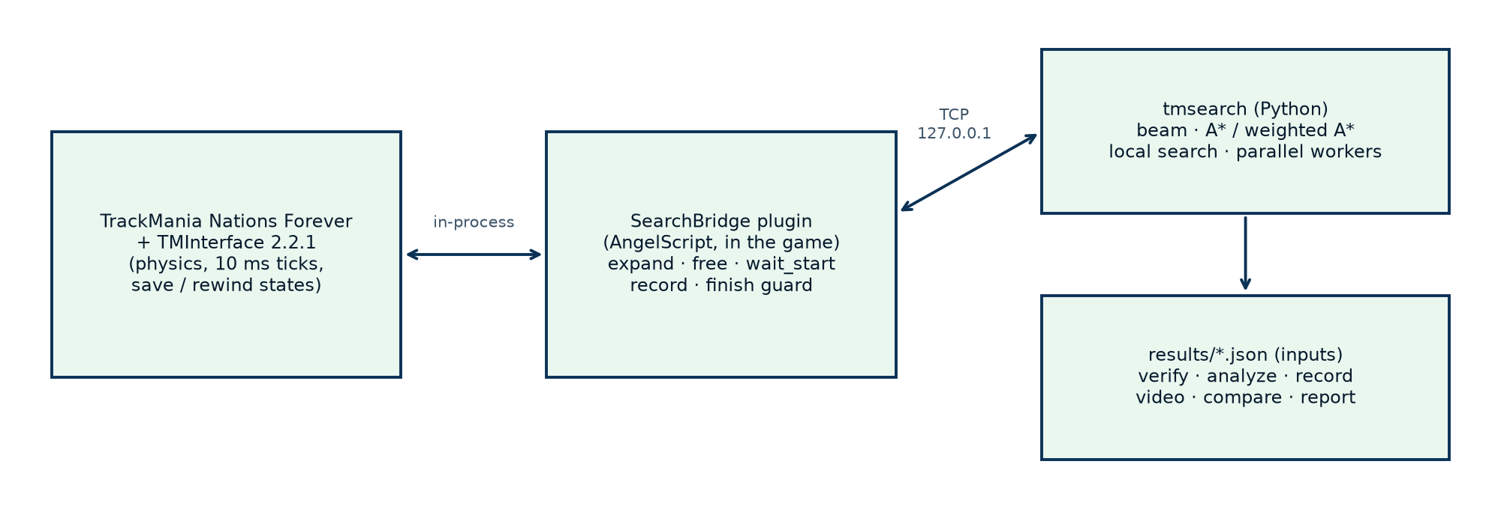
Figure 1. System architecture. The search runs in Python; the game is the simulator.
The plugin (565 lines) keeps saved states in an array and serves commands while the game is paused inside its per-tick callback, which keeps Python and the physics in lock-step. An expansion rewinds to the parent state, applies the inputs and steps the game:
case C_EXPAND: {
int parent = client.ReadInt32();
int ticks = client.ReadInt32();
inUp = client.ReadUint8() != 0; inDown = client.ReadUint8() != 0;
inLeft = client.ReadUint8() != 0; inRight = client.ReadUint8() != 0;
inSteer = client.ReadInt32();
sm.RewindToState(states[parent], false);
sm.PreventSimulationFinish(); // a searched run is never registered as a finish
ApplyInputs(sm);
stepsLeft = ticks;
mode = MODE_STEPPING; // the node is sent back when stepsLeft reaches 0
return true;
}
In Python, A* differs from the beam search only in how nodes are ordered and kept:
def h(self, sn):
if self.heuristic == "pb": # PB's time left (not admissible)
return max(self.ref.race_time - sn.proj.t_ref, 0.0)
return max(self.ref.length - sn.proj.s, 0.0) / self.v_max * 1000.0 # admissible
def f(self, sn):
if sn.node.finished:
return float(sn.node.finish_time)
return sn.t + self.weight * self.h(sn)
The local search accepts a candidate only on a strictly better (or equal-time but further) finish:
finish, s_tie, used = self.evaluate(cand, first, last)
better = finish > 0 and (finish < self.best_finish or
(finish == self.best_finish and s_tie > self.best_tiebreak + 1e-3))
if better:
self.accept(used, first) # becomes the new best; state cache refreshed from here
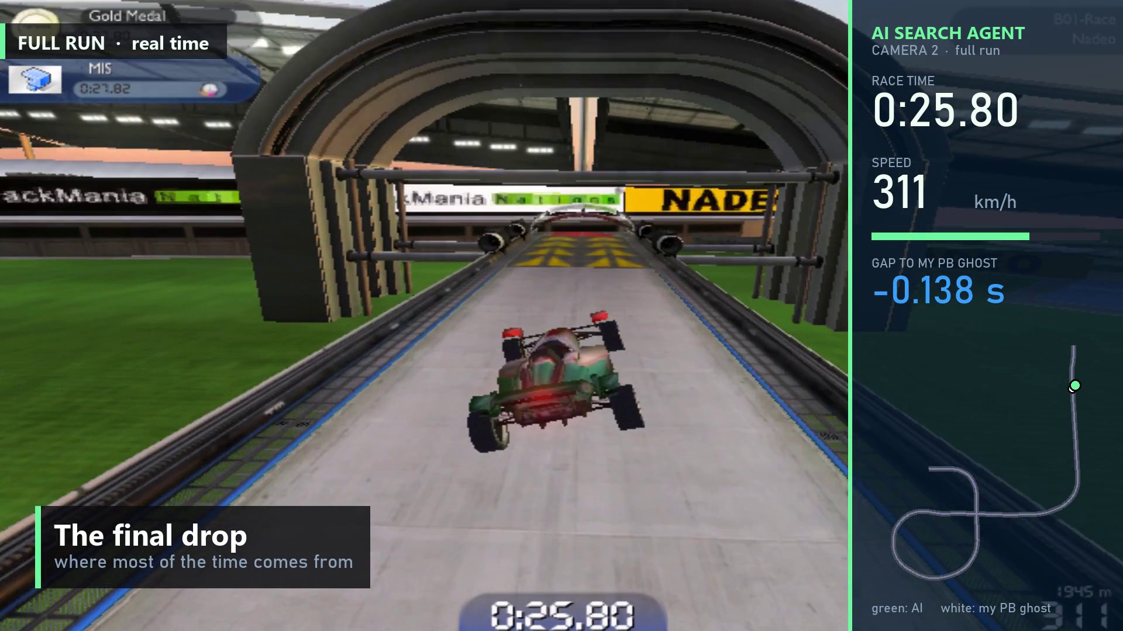
Figure 2. The AI's run recorded in the game with our data panel: race time, speed, gap to the PB ghost and a mini-map. Frames are captured once per physics tick by the plugin.
Testing and reproducibility. tests/test_offline.py (17 tests, no game needed) checks replay parsing, the input timeline, the reference projection, script export, that local-search moves are reproducible with a fixed seed and only change inputs inside the reported window, that the distance heuristic never overestimates and that the PB heuristic does. tests/test_game.py replays saved runs in the game and checks their finish times and that the same inputs give the same result twice. All searches take a seed; all results are stored as input lists with their verified finish times; scripts/overnight.sh reruns the experiments.

6. Experiments and results
Metrics: verified finish time; game steps simulated (expansions or candidate evaluations), which is independent of machine load; wall-clock time; for runs that did not finish, how far along the track they got. Baselines: the human PB (27.82 s) and greedy beam search (width 1).

6.1 Main pipeline
Table 3. From the PB to 27.28 s. All times verified by replaying the inputs from the start in the game.
Stage | Result | vs PB | Work
My PB (human baseline) | 27.82 s | - | -
Beam search, width 40 | 27.66 s | -0.16 s | 177,163 expansions, 20 min
Local search from the beam result | 27.42 s | -0.40 s | 4,723 candidates, 125 accepted, 30 min
Parallel local search (4 game instances) | 27.28 s | -0.54 s | ≈29,400 candidates, 129 kept
Gold medal | 27.80 s | -0.02 s | -

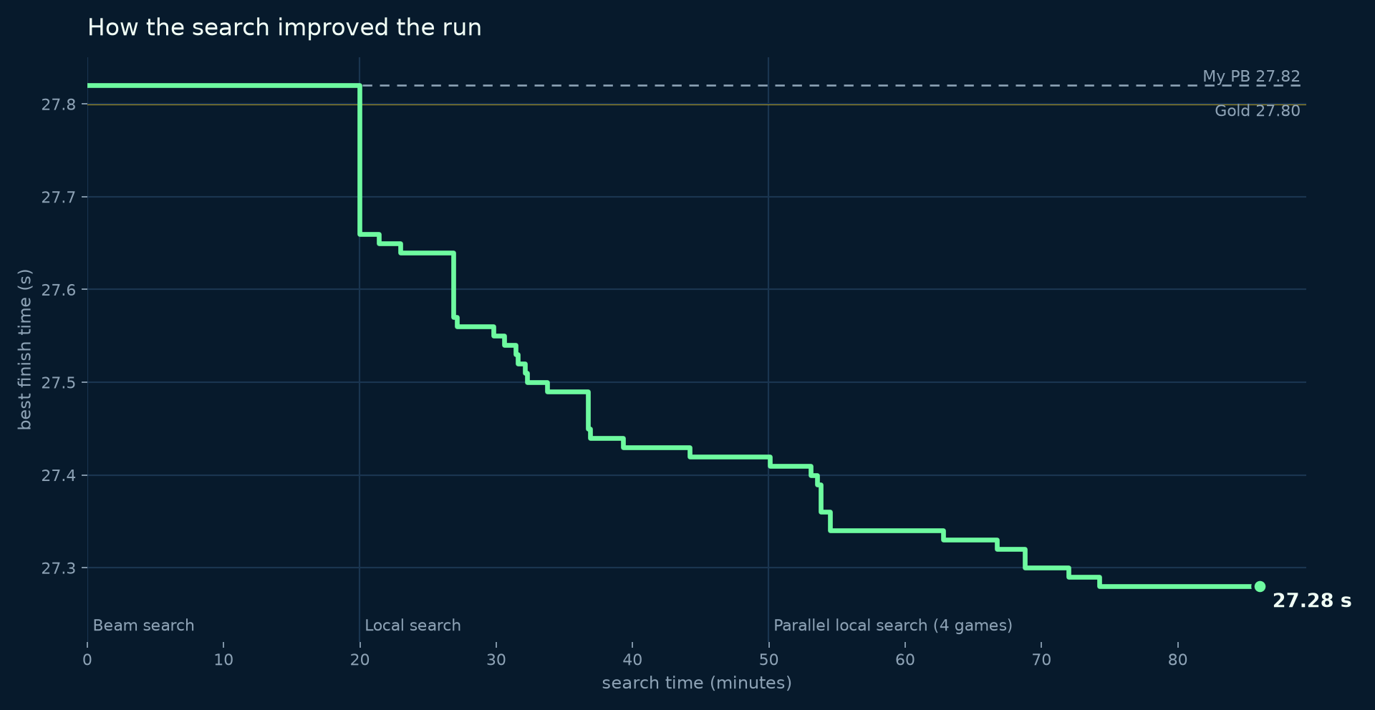
Figure 3. Best verified time against search time across the three stages (27.82 → 27.28 s in 86 minutes).
Where the time came from. Beam search followed the PB line for the first ~1,900 m; its 0.16 s came from the final drop, where a short brake and coast before landing avoids the PB's large speed loss. It was myopic: leads of 45 ms (at 5 s) and 96 ms (at 22 s) vanished within a second because ranking by short-term progress rewards carrying speed into a corner. Local search judges every change by the finish time instead. Workers restricted to the first 20 s kept nothing; almost all gains are throttle timing in the last six seconds (Table 3).
Table 4. The largest changes kept by the parallel local search (full list: results/tweaks.md).
Saved | At | Change
30 ms | 21.55 s | throttle back on 20 ms earlier
20 ms | 25.50 s | stay on the throttle 40 ms longer before the drop
20 ms | 25.62 s | stay on the throttle 40 ms longer
10 ms | 23.85 s | release the brake 10 ms earlier
10 ms | 25.60 s | a 20 ms throttle tap while coasting

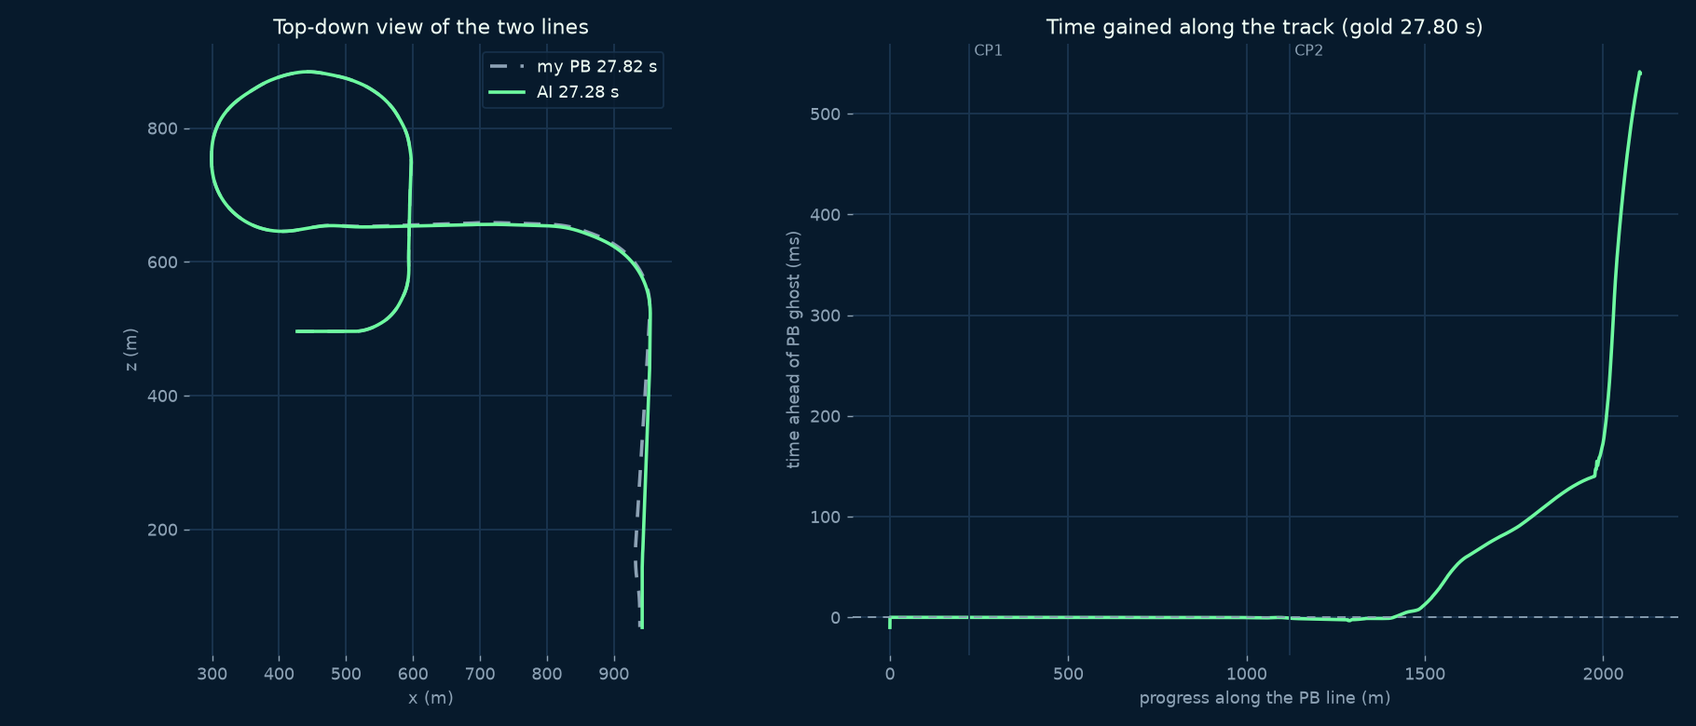
Figure 4. The AI's line against the PB (left) and time gained along the track (right): nothing until the last corners, then 0.54 s.

6.2 Search algorithms compared
Table 5. Algorithms on the same problem, actions and pruning. A* budget: 180,000 game steps (what beam width 40 needed). Overnight runs shared the CPU with another job, so compare game steps, not minutes.
Method | Heuristic / ranking | Result | vs PB | Game steps | Time
Beam search, width 1 (greedy) | PB ghost (ranking) | 27.82 s | +0.00 s | 11,182 | 1.5 min
Beam search, width 10 (run 1) | PB ghost (ranking) | 27.82 s | +0.00 s | 49,534 | 6.5 min
Beam search, width 10 (run 2) | PB ghost (ranking) | 27.82 s | +0.00 s | 49,534 | 6.5 min
Beam search, width 20 | PB ghost (ranking) | 27.82 s | +0.00 s | 92,174 | 12.2 min
Beam search, width 40 (main run) | PB ghost (ranking) | 27.66 s | -0.16 s | 177,163 | 19.9 min
A* | distance / 1000 km/h | no finish (3% of track) | - | 180,000 | 23.5 min
Weighted A* (w = 5) | distance / 1000 km/h | no finish (5% of track) | - | 180,000 | 23.7 min
Weighted A* (w = 20) | distance / 1000 km/h | no finish (11% of track) | - | 180,000 | 23.4 min
A* + PB heuristic | PB time left | no finish (9% of track) | - | 180,000 | 24.2 min
Weighted A* (w = 1.5) + PB heuristic | PB time left | no finish (12% of track) | - | 180,000 | 23.8 min
Weighted A* (w = 2) + PB heuristic | PB time left | no finish (11% of track) | - | 180,000 | 25.4 min

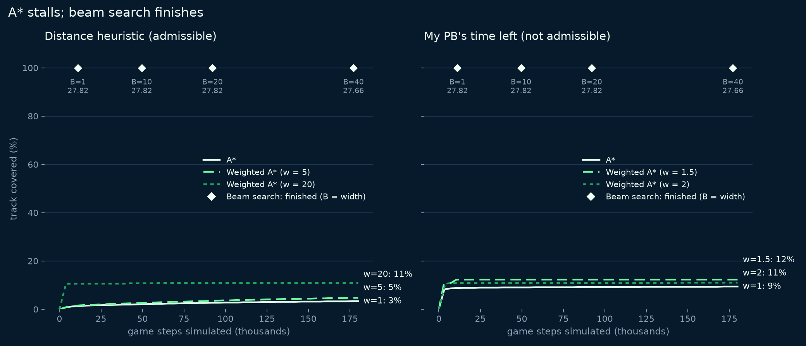
Figure 5. Track covered against game steps simulated, for A* and weighted A* with both heuristics; diamonds mark where each beam search finished.
Determinism check: beam search with width 10 was run twice and produced identical inputs, finish time and expansion count.
Interpretation. No A* variant reached the finish within 180,000 game steps, while every beam search finished with fewer steps. Three different failure modes explain this.
- Admissible but weak heuristic. Dividing the remaining distance by 1000 km/h underestimates the remaining time about four-fold (the PB averages 273 km/h), so f grows along every path and A* expands states in order of race time - almost a uniform-cost, breadth-first search through time. The number of distinct states per 50 ms layer grows quickly, so plain A* was still about 3 s into a 27.8 s race when its budget ran out. Raising the weight to 5 or 20 helps only a little.
- Weighted A* dives. A large weight prefers deeper nodes even when they are slower. Those branches eventually fall 600 ms behind the PB ghost and are pruned, and the search then backtracks through a huge number of slow branches around the first corner (200-260 m, about 6.5 s into the race).
- Informed but not admissible: plateaus. With the PB's remaining time as h, f = g + h is almost exactly the PB's time for every state that keeps the PB's pace. Thousands of states tie at f ≈ 27.82 s and A* must expand all of them before it can go deeper.
- Beam search avoids all three by fixing the work per 50 ms layer (linear in the race length) and ranking states with the same information as the PB heuristic. The price is completeness: widths 1, 10 and 20 never found anything faster than the PB, and only width 40 kept the branch that gained 0.16 s at the final drop.
The lesson for this problem: with a 10 ms clock and a 556-step horizon, the bottleneck is not whether the heuristic is admissible but how the frontier is bounded. A*'s optimality guarantee is also moot here, because the action discretisation (8 actions held for 50 ms) and the pruning already exclude the true optimum. This is why we moved from tree search to beam search plus local search over whole runs.

6.3 Repeated runs
Beam search and A* are deterministic, so repeating them gives identical results. Local search is stochastic, so we repeated it from the PB with 5 seeds and the same budget of 1,500 candidate evaluations each: 27.282 ± 0.143 s (mean ± standard deviation), best 27.10 s, worst 27.43 s; 5 of 5 runs beat gold. Evaluations until gold was first beaten: 17 ± 14.
The best seed finished in 27.10 s after about 13 minutes on one game - faster than the 27.28 s that the 86-minute, four-instance pipeline of Section 6.1 reached. Seeds differ by up to 0.33 s on the same budget, so a single run of a stochastic search says little: the variance between runs is as important a result as the best time. Every seed found one large change worth 0.16-0.32 s somewhere between 17.1 and 22.3 s into the race (for example a 30 ms brake tap at 21.73 s, or releasing steer-left 10 ms earlier at 22.28 s), plus many smaller refinements worth 10-100 ms each: of the 61 time-saving smaller changes, 36 adjusted steering, 15 the brake and 10 the throttle.
Table 6. Local search from the PB, one row per seed.
Seed | Finish | vs PB | Accepted | Evaluations | First beat gold
1 | 27.41 s | -0.41 s | 46 | 1,500 | 6 evaluations
2 | 27.10 s | -0.72 s | 68 | 1,500 | 20 evaluations
3 | 27.18 s | -0.64 s | 47 | 1,500 | 39 evaluations
4 | 27.43 s | -0.39 s | 25 | 1,500 | 2 evaluations
5 | 27.29 s | -0.53 s | 55 | 1,500 | 18 evaluations
mean ± std | 27.282 ± 0.143 s | -0.538 s

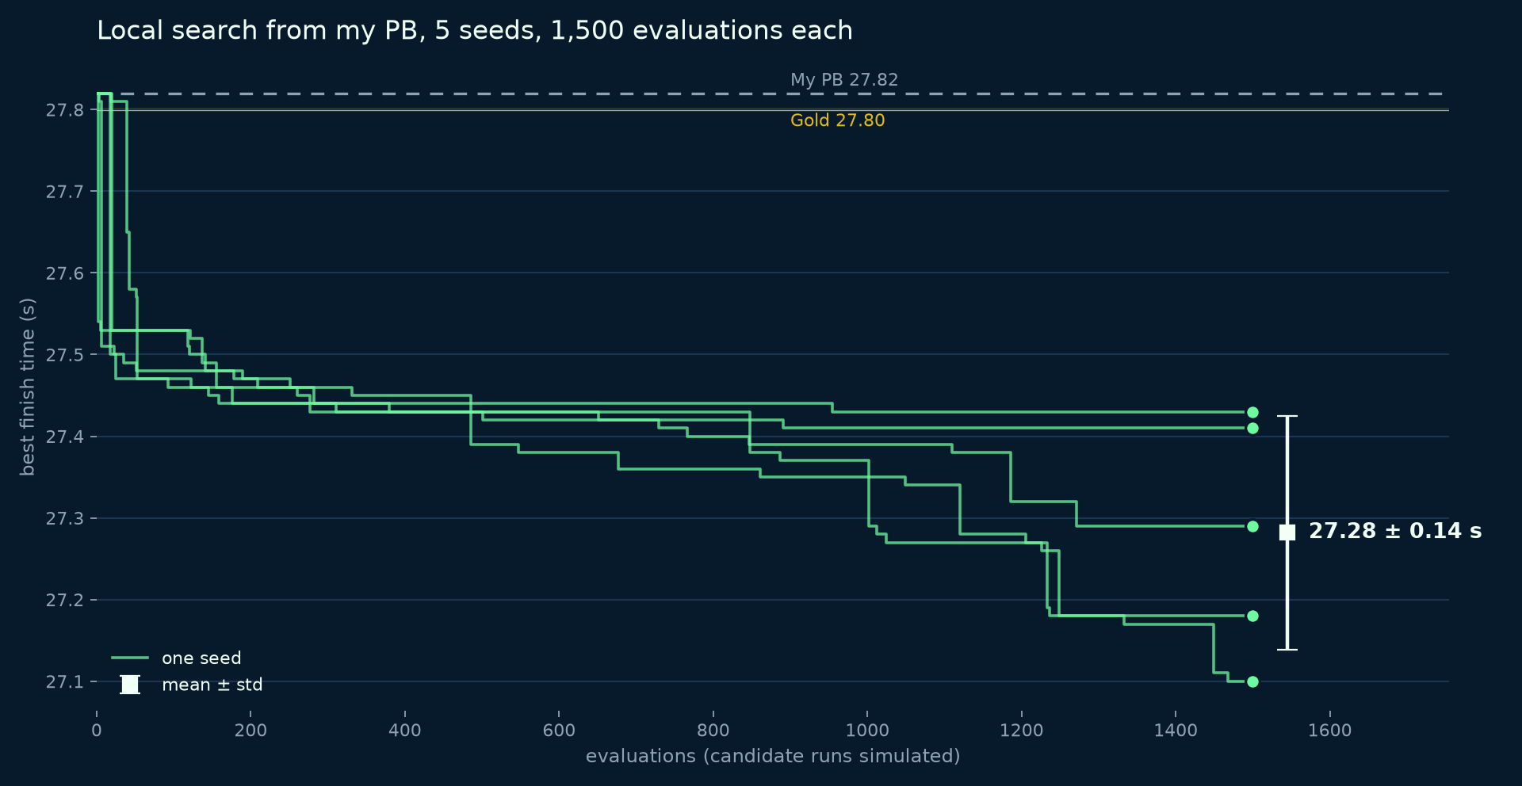
Figure 6. Best time against evaluations for each seed, with the mean ± standard deviation of the final times.

6.4 The world record
To test the method on a much stronger starting point we downloaded the human world record, 25.23 s by oli10 (a normal, non tool-assisted run). It uses an analog gamepad, so we added analog steering and found that replays store steering with the opposite sign to TMInterface. Re-driven through our pipeline it finishes at exactly 25.230 s. Four local-search workers then refined it: the first faster run came after 941 candidates (1.3 min) from "steer 3% more to the left for 280 ms at 19.69 s", and after 24,846 candidates (75 accepted, 35 min) the best run was 25.21 s, 20 ms under the record. This is the human's line refined with machine precision; it is tool-assisted and not a record.
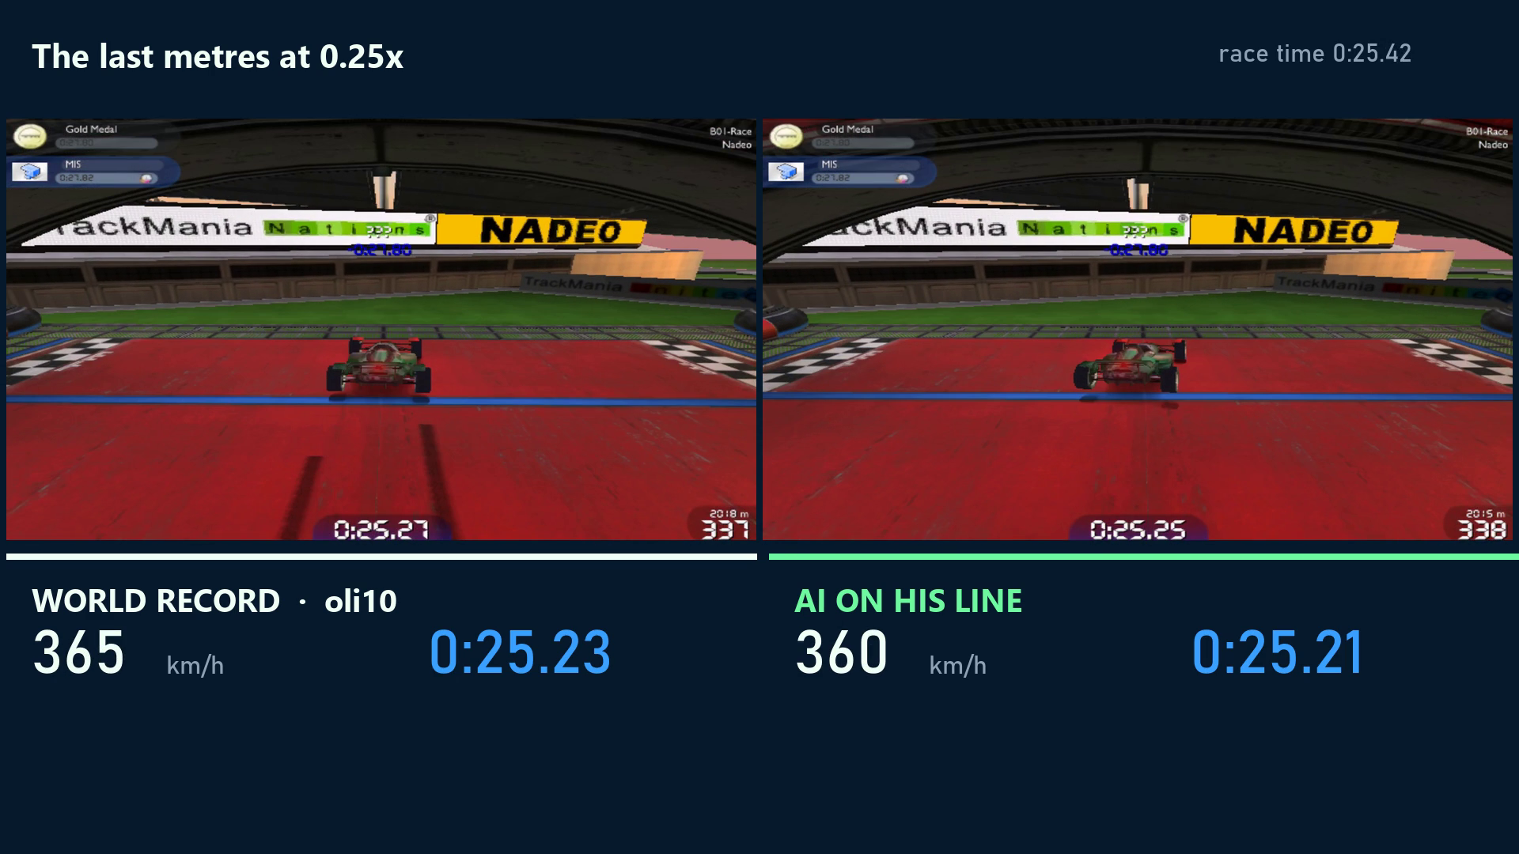
Figure 7. oli10's world record (left) and the AI's refinement of it (right) at the same moment of the race.

7. Limitations, difficulties and constraints
Threats to validity:
- One map and one PB: no evidence yet that the results generalise to other tracks or surfaces.
- The searches are tied to a reference line (for ranking and pruning). Local search refines a line but does not discover new routes: from the PB's line the AI is still 2.05 s off the world record.
- Pruning thresholds (12 m, 600 ms) were set by hand; they shape what every algorithm can find.
- Wall-clock times depend on machine load (the overnight experiments shared the CPU), so game steps are the fair cost measure.
- Repeated runs used a smaller budget (1,500 evaluations) than the main local search runs.
Difficulties we solved:
- A searched finish was once registered as a real record and overwrote the PB's autosaved replay: TMInterface's PreventSimulationFinish only works inside the checkpoint callback. We restored the replay from a backup, added a finish guard and park the car at the start whenever the search disconnects.
- TMInterface input scripts exported from our runs desync at every timing offset we tried, so runs are always verified and replayed through our plugin instead.
- A loaded input script silently overrides the plugin's inputs; the plugin now unloads scripts.
- Analog steering in replays has the opposite sign to TMInterface's input.
- A* duplicate detection first threw away almost every node at the start: in the first half-second the car is still settling on its suspension and braking rolls it backwards, so 'earlier and faster' wrongly marked real progress as a duplicate. Dominance now also requires being at least as far along the track, using speed along the track.
- Each open A* node holds a 9 KB game state in a 32-bit game, so the open list had to be capped.
- Several game instances only accept inputs after each window has been focused once.
Deviation from the proposal: we planned custom tarmac maps of increasing length and a grid-A* plus path-following baseline. We used the official map the PB was set on instead, and the human PB and greedy beam search as baselines. [Confirm wording with the team.]

8. Conclusion and discussion
Search inside the real game physics beat the PB by 0.54 s (27.82 → 27.28 s) and the gold medal, and, starting from the human world record, found a run 0.02 s faster than it. The decisive design choices were using the game as an exact, rewindable simulator; a reference line that turns raw positions into progress and time gained; and judging changes by the final finish time rather than short-term progress. The algorithm comparison showed why: A* and weighted A* could not bound their frontier on a 556-step horizon, while time-layered beam search could; and the repeated runs showed that local search from the PB is reliable (every seed beat gold) but has a wide spread (0.4-0.7 s gained), so a single run says little and more seeds or parallel workers pay off. Next steps: more maps; search that is not tied to one reference line (to find new routes); and using these optimised runs as training data for a learned driving policy.

9. References
- Hart, P. E., Nilsson, N. J. and Raphael, B. (1968) 'A formal basis for the heuristic determination of minimum cost paths', IEEE Transactions on Systems Science and Cybernetics, 4(2), pp. 100-107.
- Pohl, I. (1970) 'Heuristic search viewed as path finding in a graph', Artificial Intelligence, 1(3-4), pp. 193-204.
- Lowerre, B. T. (1976) The HARPY Speech Recognition System. PhD thesis, Carnegie Mellon University.
- Russell, S. (1992) 'Efficient memory-bounded search methods', Proceedings of the 10th European Conference on Artificial Intelligence (ECAI-92), pp. 1-5.
- Russell, S. and Norvig, P. (2021) Artificial Intelligence: A Modern Approach. 4th edn. Pearson.
- Dolgov, D., Thrun, S., Montemerlo, M. and Diebel, J. (2008) 'Practical search techniques in path planning for autonomous driving', Proceedings of the First International Symposium on Search Techniques in Artificial Intelligence and Robotics (STAIR-08). [check]
- donadigo. TMInterface (tool-assisted interface for TrackMania Nations Forever), version 2.2.1. https://donadigo.com/tminterface [check URL and access date]
- TrackMania ModLoader (TMLoader), version 1.0.1. [add URL and access date]
- TrackMania Nations Forever Exchange (TMNF-X). B01-Race, track 2282; world-record replay by oli10. https://tmnf.exchange/trackshow/2282 [access date]
- pygbx: Python parser for GameBox files. https://github.com/donadigo/pygbx [check]

Appendix A: Git repository and team contributions
Git repository: [link]
Table 7. Team contribution table (template from the guidelines).
Student name & ID | Main contributions (code, report sections, experiments) | Est. share (%) | Signature
[ ] | [ ] | [ ]
[ ] | [ ] | [ ]
[ ] | [ ] | [ ]
[ ] | [ ] | [ ]
[ ] | [ ] | [ ]

Appendix B: Industry engagement
Not applicable (no industry partner).

Appendix C: Reproducing the results
.venv\Scripts\python -m unittest discover -s tests -v # offline tests
.venv\Scripts\python -m tmsearch.reproduce data\replays\MIS_B01-Race.Replay.gbx
.venv\Scripts\python -m tmsearch.search --beam 40
.venv\Scripts\python -m tmsearch.local --start results\b40_s5_full_27660.json --budget 1800 --seed 218
.venv\Scripts\python -m tmsearch.astar --heuristic pb --weight 2 --budget 180000
bash scripts/overnight.sh # comparison + repeated runs
.venv\Scripts\python -m tmsearch.compare # tables, charts, summary
.venv\Scripts\python report\make_report.py # this report

Appendix D: Use of AI tools
[Describe how AI tools were used in this project, as required by the subject descriptor.]

