**UML**

**High Level:**

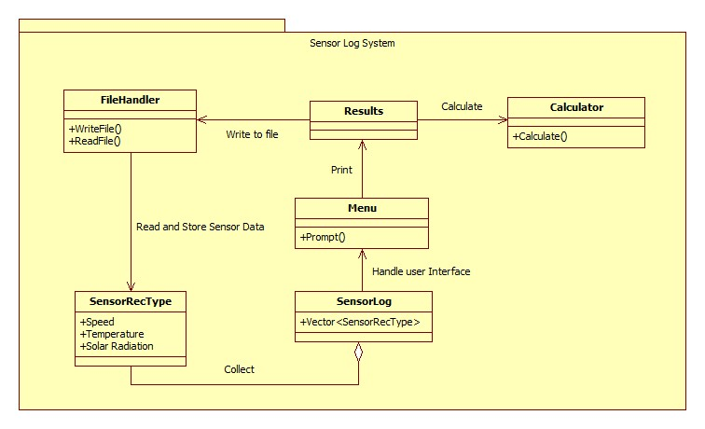

**Low Level**

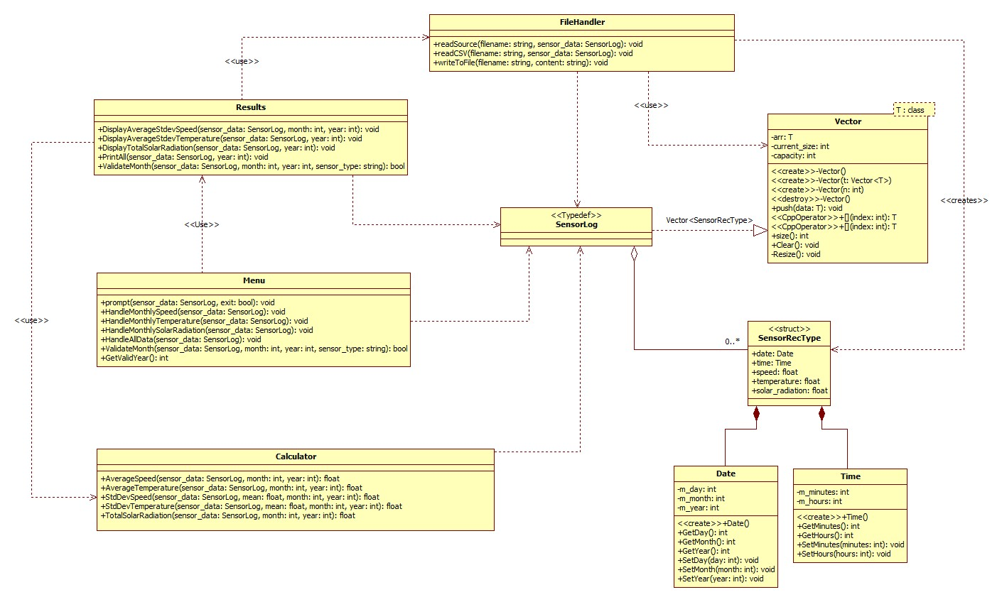

**Data Dictionary**

**Vector.h**

|  |  |  |  |
| --- | --- | --- | --- |
| **Function/Member** | **Description** | **Type** | **Protection** |
| **Vector()** | Initialize an empty vector with default capacity, and current_size and allocates initial memory. | Constructor | public |
| **Vector(const Vector <T> t)** | Copy constructor, creates a deep copy of the vector. | Copy  Constructor | public |
| **Vector(int n)** | Creates a vector with an initial capacity defined by the int parameter. | Constructor | public |
| **~Vector()** | Destructor, destroy all memory used by the vector | Destructor | public |
| **const T operator[int index] const** | Provides const/read-only access to element specified by the integer index parameter | Template class <T> | public |
| **T operator[int index]** | Provides access to element specified by the integer index parameter and allows for modification. | Template class <T> | public |
| **push(T data)** | Add an element at the end of the Vector and calls a Resize routine if number of elements exceed capacity. | void | public |
| **Resize()** | Double the capacity of the vector when called. | void | private |
| **Clear()** | Removes all elements from the vector and resets the vector to it’s initial empty state. | void | public |
| **arr** | Array that holds the elements | Template class <T> | private |
| **current_size** | Number of elements currently | Int | private |
| **capacity** | Total capacity of allocated memory | Int | private |

**Vector Rationale**

The **arr** private member allows the class to have an array to store elements into. The **current_size** and **capacity**, allows the class to track if it is time to resize the array. **Clear()** lets users reset the vector, this lets us reuse the Vector object without creating a new instance of it. **Resize()** is what makes our Vector a dynamic array, when it is called, it will resize the max capacity to allow for more data to be stored. The **push(T data)** allows for insertion of data into the dynamic array, and it also checks if **Resize()** should be called. The **operator[]** allows access to elements inside our Vector, The **const operator[] () const** is the same, but only provides read-only access which allows us to pass a const version of the vector into a parameter, this is helpful to prevent accidental modifications. **~Vector** is destructor that can prevent memory leaks. **Vector(int n)** is useful if you know how much data is going to be inside the Vector, this will reduce the number of times the vector needs to resize, and theoretically improve performance. **Vector(const Vector<T> &other** is a copy constructor the deep copies, which prevents issues when one vector is modified while the reference exists. **Vector()** is the default constructor that initializes the capacity to 1 to minimize memory usage for empty vectors.

**SensorRecType.h**

|  |  |  |  |
| --- | --- | --- | --- |
| **Function/Member** | **Description** | **Type** | **Protection** |
| **date** | Date of the sensor reading | Date | public |
| **time** | Time of the sensor reading | Time | public |
| **speed** | Wind Speed in m/s | float | public |
| **temperature** | Temperature in degrees Celsius | float | public |
| **solar_radiation** | Solar Radiation measurement in W/m^2 | float | public |

**SensorRecType Rationale**

This vector struct provides the storage for individual sensor readings. It contains **date** and **time** for the Date and time the sensor was recorded. It also contains the Speed, Temperature , Solar Radiation readings which is a requirement for this program.

**Date.h**

|  |  |  |  |
| --- | --- | --- | --- |
| **Function/Member** | **Description** | **Type** | **Protection** |
| **Date()** | Constructor that initializes Date with default values | int | public |
| **GetDay()** | Returns m_day value | int | public |
| **GetMonth()** | Returns m_month value | int | public |
| **GetYear()** | Returns m_year value | int | public |
| **SetDay(int day)** | Sets m_day value | void | public |
| **SetMonth(int month)** | Sets m_month value | void | public |
| **SetYear(int year)** | Sets m_year value | void | public |
| **m_day** | Contains the day value | int | private |
| **m_month** | Contains the month value | int | private |
| **m_year** | Contains the year value | int | private |

**Date Rationale**

Is a class that contains Setters and Getters to store or retrieve Day, Month, Year values of the recorded sensor readings.

**Time.h**

|  |  |  |  |
| --- | --- | --- | --- |
| **Function/Member** | **Description** | **Type** | **Protection** |
| **Time()** | Constructor that initializes Date with default values | int | public |
| **GetMinutes()** | Returns m_minutes value | int | public |
| **GetHours()** | Returns m_hours value | int | public |
| **SetMinutes(in)** | Returns m_minutes value | int | public |
| **SetHours()** | Sets m_hours value | void | public |
| **m_minutes** | Contains the minute value | int | private |
| **m_hours** | Contains the hour value | int | private |

**Time Rationale**

Is a class that contains Setters and Getters to store or retrieve hours and minute values of the recorded sensor readings.

**Calculator.h**

|  |  |  |  |
| --- | --- | --- | --- |
| **Function/Member** | **Description** | **Type** | **Protection** |
| **AverageSpeed (**  **Vector<float> &data) const;** | Calculates the average speed for the given month and year | float | Public |
| **AverageTemperature (**  **const Vector <float>&data) const** | Calculates the temperature speed for the given month and year | float | Public |
| **StdDevSpeed (**  **const Vector <float> &data, float mean) const** | Calculates the sample standard deviation of speed for the given month and year | float | Public |
| **StdDevTemperature (**  **const Vector<float> &data, float mean) const** | Calculates the sample standard deviation of temperature for the given month and year | float | Public |
| **TotalSolarRadiation(**  **const Vector<float> &data**  **) const** | Calculates the Total Solar Radiation for the given month and year | float | Public |

**Calculator Rationale**

Each function of this class has different statistical operations for the calculation of each sensor reading, Speed, Temperature, Solar Radiation. These statistical calculations is a requirement.

**Menu.h**

|  |  |  |  |
| --- | --- | --- | --- |
| **Function/Member** | **Description** | **Type** | **Protection** |
| **prompt(**  **const SensorLog &sensor_data, bool &exit) const** | Displays main menu and handles user input | void | public |
| **HandleMonthlySpeed (const SensorLog &sensor_data** | Gets and validate user input for specific month and year | void | public |
| **GetValidYear() const** | Gets and validates year input from user | int | public |

**Menu Rationale**

This class is responsible for user interaction. The **prompt()** function is responsible for displaying the Menu prompt, which handles user input and processes it into the function the user wishes to perform. The **HandleMonthlySpeed ()** is afunction is responsible for handling the user input for month, the rationale for creating a function like this is to maintain readable code. **GetValidYear()** is a function similar to **HandleMonthlySpeed()** where it prompts user and validates if the preconditions are correct before returning the year the user entered. My rationale for that function is to allow user to input a year without breaking the program, because if I use an int type to store user input, and they accidentally typed a non-digit character, the program will go into an infinite loop and break.

**Results.h**

|  |  |  |  |
| --- | --- | --- | --- |
| **Function/Member** | **Description** | **Type** | **Protection** |
| **DisplayAverageStdevSpeed(**  **const SensorLog &sensor_data, const int month,**  **const int year) const** | Calculates and displays average wind speed and standard deviation for specified month/year | void | public |
| **DisplayAverageStdevTemperature(**  **const SensorLog &sensor_data,**  **const int year) const** | Calculates and displays average temperature and standard deviation for each month of specified year | void | public |
| **DisplayTotalSolarRadiation(**  **const SensorLog &sensor_data,**  **const int year) const;** | Calculates and displays total solar radiation for each month of specified year | void | public |
| **PrintAll(**  **const SensorLog &sensor_data, const int year) const** | Writes wind speed, temperature and solar radiation data to WindTempSolar.csv | void | public |
| **ValidateMonth(**  **const SensorLog &sensor_data, const int month,**  **const int year,**  **const string sensor_type) const** | Checks if data exists for specified month and year | bool | public |

**Results Rationale**

Results class is responsible for displaying aggregated results by calling the Calculator class to perform a calculation. Each function Except for ValidateMonth() performs functions that is part of the requirement. ValidateMonth() is a helper function that checks if data exists. Helper functions reduce code duplication and allows for a more readable code.

**FileHandler.h**

|  |  |  |  |
| --- | --- | --- | --- |
| **Function/Member** | **Description** | **Type** | **Protection** |
| **readSource(**  **const string &filename, SensorLog &sensor_data) const** | Reads a source file containing a list of csv filenames | void | public |
| **readCSV(**  **const string &filename, SensorLog &sensor_data) const** | Reads and parses a CSV file containing sensor measurements | void | public |
| **writeToFile(const string &filename,**  **const string &content) const** | Writes content to a specified file | void | public |

**FileHandler Rationale**

This is responsible for any file handling operations. **readSource()** reads a list of filenames which can be processed into the vector struct by calling **readCSV**, this parses and inserts the sensor data and date into the struct which will then be pushed into a vector. The **writeToFile()** allows the insertion of data to be processed into a external csv file.

**Algorithm**

FUNCTION AverageSpeed(data)

Initialize sum to 0.0

Initialize data_count to 0

FOR each value IN data

Add value to sum

Increment data_count

END FOR

IF data_count is less than 2 THEN

RETURN 0

ELSE

Calculate average = sum / data_count

Round average to 1 decimal place

RETURN average

END IF

END FUNCTION

———————

FUNCTION AverageTemperature(data)

Initialize sum to 0.0

Initialize data_count to 0

FOR each value IN data

Add value to sum

Increment data_count

END FOR

IF data_count is less than 2 THEN

RETURN 0

ELSE

Calculate average = sum / data_count

Round average to 1 decimal place

RETURN average

END IF

END FUNCTION

————————-

FUNCTION StdDevSpeed(data, mean)

Initialize sum_square_diff to 0.0

Initialize data_count to 0

FOR each value IN data

Calculate diff = value - mean

Add (diff * diff) to sum_square_diff

Increment data_count

END FOR

IF data_count is less than 2 THEN

RETURN 0

ELSE

Calculate standard_deviation = square_root(sum_square_diff / (data_count - 1))

Round standard_deviation to 1 decimal place

RETURN standard_deviation

END IF

END FUNCTION

—————————

FUNCTION StdDevTemperature(data, mean)

Initialize sum_square_diff to 0.0

Initialize data_count to 0

FOR each value IN data

Calculate diff = value - mean

Add (diff * diff) to sum_square_diff

Increment data_count

END FOR

IF data_count is less than 2 THEN

RETURN 0

ELSE

Calculate standard_deviation = square_root(sum_square_diff / (data_count - 1))

Round standard_deviation to 1 decimal place

RETURN standard_deviation

END IF

END FUNCTION

———————————————-

FUNCTION TotalSolarRadiation(data)

Initialize totalRadiation to 0.0

Initialize data_count to 0

FOR each value IN data

IF value is greater than or equal to 100 THEN

Convert from W/m² to kWh/m²: kWh_conversion = value * (10/60) / 1000

Add kWh_conversion to totalRadiation

Increment data_count

END IF

END FOR

IF data_count is less than 2 THEN

RETURN 0

ELSE

Round totalRadiation to 1 decimal place

RETURN totalRadiation

END IF

END FUNCTION

————————————-

FUNCTION writeToFile(filename, content)

Initialize outputFile as file output stream

Open outputFile with filename

IF outputFile is not open THEN

Output error message to error stream: "Error: Could not open file 'filename' for writing."

RETURN

END IF

Write content to outputFile

Close outputFile

END FUNCTION

————————————

FUNCTION readSource(filename, sensor_data)

Initialize file as file input stream with filename

IF file is not open THEN

Output error message to error stream: "Error Opening file filename"

RETURN

END IF

Initialize temp_name as string

WHILE getline from file into temp_name succeeds

Call readCSV(temp_name, sensor_data)

END WHILE

Close file

END FUNCTION

——————

FUNCTION readCSV(filename, sensor_data)

Initialize variables:

token as empty string

line as empty string

S_Index as -1 // Speed column index

T_Index as -1 // Temperature column index

SR_Index as -1 // Solar Radiation column index

vecHeader as empty Vector of strings

Open file with path "data/" + filename

IF file is not open THEN

Output error message to error stream: "Error opening file filename"

RETURN

END IF

// Process header row

Read first line from file into line

Create string stream ss from line

WHILE getline from ss into token with delimiter ',' succeeds

Add token to vecHeader

END WHILE

Clear ss stream

// Find column indices in header

FOR i from 0 to vecHeader.size() - 1

Set header to vecHeader[i]

IF header equals "S" THEN

Set S_Index to i

END IF

IF header equals "T" THEN

Set T_Index to i

END IF

IF header equals "SR" THEN

Set SR_Index to i

END IF

END FOR

// Process data rows

WHILE getline from file into line succeeds

IF line is empty OR line contains only whitespace THEN

CONTINUE to next iteration

END IF

Create string stream ss from line

Initialize variables for current row:

s_speed, s_temperature, s_solar_radiation, skip as empty strings

sDate, sTime, sDay, sMonth, sYear, sHour, sMinute as empty strings

day, year, month, hours, minutes as 0

f_speed, f_temperature, f_solar_radiation as 0.0

// Process each column in the row

FOR i from 0 to vecHeader.size() - 1

IF i equals 0 THEN

// Process date/time column

Read from ss into sDate until space

Read from ss into sTime until comma

Create dateStream from sDate

Read from dateStream into sDay until '/'

Read from dateStream into sMonth until '/'

Read from dateStream into sYear to end

Create timeStream from sTime

Read from timeStream into sHour until ':'

Read from timeStream into sMinute to end

ELSE IF i equals S_Index THEN

// Process speed column

Read from ss into s_speed until comma

IF s_speed is empty THEN

Set s_speed to "0"

END IF

ELSE IF i equals T_Index THEN

// Process temperature column

Read from ss into s_temperature until comma

IF s_temperature is empty THEN

Set s_temperature to "0"

END IF

ELSE IF i equals SR_Index THEN

// Process solar radiation column

Read from ss into s_solar_radiation until comma

IF s_solar_radiation is empty THEN

Set s_solar_radiation to "0"

END IF

ELSE

// Skip unused column

Read from ss into skip until comma

END IF

END FOR

// Convert string values to numeric

Convert sDay to integer day

Convert sMonth to integer month

Convert sYear to integer year

Convert sHour to integer hours

Convert sMinute to integer minutes

IF s_speed is not empty THEN

Convert s_speed to float f_speed

ELSE

Set f_speed to 0.0

END IF

IF s_temperature is not empty THEN

Convert s_temperature to float f_temperature

ELSE

Set f_temperature to 0.0

END IF

IF s_solar_radiation is not empty THEN

Convert s_solar_radiation to float f_solar_radiation

ELSE

Set f_solar_radiation to 0.0

END IF

// Create Date object

Create date object

Set date.day to day

Set date.month to month

Set date.year to year

// Create Time object

Create time object

Set time.hours to hours

Set time.minutes to minutes

// Create SensorRecType record

Create tempData as SensorRecType

Set tempData.date to date

Set tempData.time to time

Set tempData.speed to f_speed

Set tempData.temperature to f_temperature

Set tempData.solar_radiation to f_solar_radiation

// Add to sensor_data collection

Add tempData to sensor_data

END WHILE

Close file

END FUNCTION

———————————————-

FUNCTION DisplayAverageStdevSpeed(sensor_data, month, year)

Initialize calculate as Calculator object

Initialize average to 0.0

Initialize standard_deviation to 0.0

Initialize data as empty Vector of floats

IF ValidateMonth(sensor_data, month, year, "S") THEN

FOR each record IN sensor_data

IF record.date.month equals month AND record.date.year equals year THEN

Add record.speed to data

END IF

END FOR

Set average to calculate.AverageSpeed(data)

Set standard_deviation to calculate.StdDevSpeed(data, average)

Output month, year, average speed, and standard deviation

ELSE

Output "month year: No Data"

END IF

END FUNCTION

——————————-

FUNCTION DisplayAverageStdevTemperature(sensor_data, year)

Initialize calculate as Calculator object

Initialize average to 0.0

Initialize standard_deviation to 0.0

Initialize month to 0

Initialize month_exist to false

Initialize data as empty Vector of floats

FOR each record IN sensor_data

IF record.date.year equals year THEN

Set month_exist to true

EXIT loop

END IF

END FOR

IF month_exist THEN

Output year

FOR month_index from 1 to 12

Set month to month_index

Clear data

FOR each record IN sensor_data

IF record.date.month equals month AND record.date.year equals year THEN

Add record.temperature to data

END IF

END FOR

IF ValidateMonth(sensor_data, month, year, "T") THEN

Set average to calculate.AverageTemperature(data)

Set standard_deviation to calculate.StdDevTemperature(data, average)

Output month name, average temperature, and standard deviation

ELSE

Output "month name: No Data"

END IF

END FOR

ELSE

Output "year: No data"

END IF

END FUNCTION

————————————

FUNCTION DisplayTotalSolarRadiation(sensor_data, year)

Initialize calculate as Calculator object

Initialize month to 0

Initialize total_solar_radiation to 0.0

Initialize data as empty Vector of floats

Initialize month_exist to false

FOR each record IN sensor_data

IF record.date.year equals year THEN

Set month_exist to true

EXIT loop

END IF

END FOR

IF month_exist THEN

Output year

FOR month_index from 1 to 12

Set month to month_index

Clear data

FOR each record IN sensor_data

IF record.date.month equals month AND record.date.year equals year THEN

Add record.solar_radiation to data

END IF

END FOR

IF ValidateMonth(sensor_data, month, year, "SR") THEN

Set total_solar_radiation to calculate.TotalSolarRadiation(data)

Output month name, total_solar_radiation

ELSE

Output "month name: No Data"

END IF

END FOR

ELSE

Output "year: No data"

END IF

END FUNCTION

——————————————————-

FUNCTION PrintAll(sensor_data, year)

Initialize calculate as Calculator object

Initialize handleFile as FileHandler object

Initialize output as string output stream

Initialize average_speed, stdev_speed, average_temperature, stdev_temperature, total_solar_radiation to 0.0

Initialize month to 0

Initialize month_exist to false

Initialize speed_data, temperature_data, solar_radiation_data as empty Vectors of floats

FOR each record IN sensor_data

IF record.date.year equals year THEN

Set month_exist to true

EXIT loop

END IF

END FOR

IF month_exist THEN

Add year to output stream

FOR month_index from 1 to 12

Set month to month_index

Clear speed_data, temperature_data, solar_radiation_data

Initialize empty_data to 0

FOR each record IN sensor_data

IF record.date.month equals month AND record.date.year equals year THEN

Add record.speed to speed_data

Add record.temperature to temperature_data

Add record.solar_radiation to solar_radiation_data

END IF

END FOR

Set average_speed to calculate.AverageSpeed(speed_data)

Set stdev_speed to calculate.StdDevSpeed(speed_data, average_speed)

Set average_temperature to calculate.AverageTemperature(temperature_data)

Set stdev_temperature to calculate.StdDevTemperature(temperature_data, average_temperature)

Set total_solar_radiation to calculate.TotalSolarRadiation(solar_radiation_data)

Add month name to output stream

IF average_speed not equals 0 THEN

Add average_speed to output stream

ELSE

Increment empty_data

END IF

IF stdev_speed not equals 0 THEN

Add stdev_speed to output stream

ELSE

Increment empty_data

END IF

IF average_temperature not equals 0 THEN

Add average_temperature to output stream

ELSE

Increment empty_data

END IF

IF stdev_temperature not equals 0 THEN

Add stdev_temperature to output stream

ELSE

Increment empty_data

END IF

IF total_solar_radiation not equals 0 THEN

Add total_solar_radiation to output stream

ELSE

Increment empty_data

END IF

IF empty_data equals 5 THEN

Add "No Data" to output stream

END IF

Add newline to output stream

END FOR

Call handleFile.writeToFile("WindTempSolar.csv", output.string)

END IF

END FUNCTION

——————————————-FUNCTION ValidateMonth(sensor_data, month, year, sensor_type)

IF sensor_type equals "S" THEN

FOR each record IN sensor_data

IF record.date.month equals month AND

record.date.year equals year AND

record.speed not equals 0 THEN

RETURN true

END IF

END FOR

END IF

IF sensor_type equals "T" THEN

FOR each record IN sensor_data

IF record.date.month equals month AND

record.date.year equals year AND

record.temperature not equals 0 THEN

RETURN true

END IF

END FOR

END IF

IF sensor_type equals "SR" THEN

FOR each record IN sensor_data

IF record.date.month equals month AND

record.date.year equals year AND

record.solar_radiation not equals 0 THEN

RETURN true

END IF

END FOR

END IF

RETURN false

END FUNCTION

——————————————————

FUNCTION int_to_month(month)

Initialize month_arr as array of strings:

["", "January", "February", "March", "April", "May", "June",

"July", "August", "September", "October", "November", "December"]

RETURN month_arr[month]

END FUNCTION