ICT292 Information Systems Management

# Lab 05: Workflows

Workflows in SharePoint are a mechanism for automating certain aspects of a task. For example, consider an employee holiday application process where an employee will fill in an application that will be sent to their supervisor for approval and then sent to the Human Resources department to process. This sort of workflow could be built in SharePoint using online forms and automatic forwarding of documents for approvals. In this lab, we will start by planning and documenting the process we wish to automate, and then look at some of the standard workflows that come with SharePoint.

## Aims:

The primary aims of this lab are for you to:

* Plan and document a business process workflow
* Build a workflow in SharePoint using a variety of tools

## To be prepared for this lab, you will need to:

* Be correctly enrolled in the unit
* Have access to: [ICT292 2024 TMA - Home (sharepoint.com)](https://murdochuniversity.sharepoint.com/sites/ICT2922024TMA)
* Have a SharePoint sub-site that you own and that you can use for this lab, and
* A web-browser ☺

## Introduction

There are many procedures that are involved in the day-to-day activities in any organization. Some of these need to be repeated over and over; for example, processing employee holiday applications, or processing purchasing approvals. Often, these procedures will involve a number of processes and staff. When the procedure is repeated in a predictable way, then it can be known as a *workflow*, and can be automated. An example of a workflow is show in the textbook in figure 13.6 (p.313-4). SharePoint allows us to create these automated workflows; however, at the basis of a successful workflow creation is an understanding of the workflow and it’s component processes and the roles of the people and systems involved. We will start this lab by examining and planning a simple workflow.

### Task 1: Plan and create a simple Workflow

The first workflow we are going to examine is a very simple one. It has only one thing to do, and that is to notify the owner of a list that a new item has been added to the list. Even though this workflow is VERY simple, it will still involve several steps:

1. A new item is added to the list that triggers the workflow to commence
2. Details of the new item, including the owner of the list need to be collected
3. The email needs to be sent to the owner of the list including detail of the new item.

When represented graphically, we can see that the workflow starts. When a new item is added to the list the workflow proceeds and then ends.

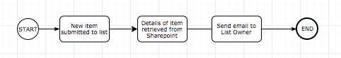

There are a number of tools that can be used to create Workflow diagrams; Visio is one. A free one (and the one used for this lab) is [www.draw.io](http://www.draw.io) now known as [diagrams.net](https://app.diagrams.net/)

1. Go to your own subsite (if you don’t have one, or can’t remember how to create one, go back to Lab 01 for instructions)
2. Go to (or recreate) the Demo List you created in the last lab
3. **If you are in Classic View, exit that by clicking “Exit Classic Experience**” at the bottom left corner

1. Select the ellipsis (three dots) “…” in the bar at the top, click “Integrate”, then “Power Automate” and “Create a flow”

1. Select “Send a customized email when a new SharePoint list item is added”

Once you have selected this workflow a new browser tab (or window) will open with the Microsoft Flow application and you may be prompted to log in again (using the same account you used to log in to SharePoint).

“*Microsoft Flow is cloud-based software that allows employees to create and automate workflows and tasks across multiple applications and services without help from developers. Automated workflows are called flows. To create a flow, the user specifies what action should take place when a specific event occurs.”* <https://searchcontentmanagement.techtarget.com/definition/Microsoft-Flow>

In the Flow tab you will see a list of permissions the workflow needs in order to use the template you chose:

1. Click “Create Flow”.

At this point, the workflow should work. Test it by going back to your list and adding a new item to the list and then check your email (i.e., the @student.murdoch.edu.au account).

1. In order to learn a little more about what is actually happening in this very simple workflow, select ‘My Flows’.

1. This will list all of your flows and allow you to edit and modify the flows you create.

1. If you hover your mouse pointer over the flow you just created, you will see a number of options:
2. Select Edit.
   1. Firstly, rename the workflow to something a bit shorter, such as “Demo List New Item Workflow” by clicking on the current workflow name at the top of the screen and click Save.

* 1. Click on the ellipsis (…) in the Send Email step and select Settings

* 1. You can ignore the first dialogue box that appears and click Cancel. This will present you with something that looks like this:

There are a number of things you could do here, for example, change the Subject of the email.

* 1. Modify the subject of the email to read, “New item added to Demo List”
  2. Click in an area of the email body and add dynamic content

Dynamic content refers to information held in the various objects in the workflow. For example in the ‘Get my profile section’, you can see fields such as ‘About Me’, ‘Birthday’ and so on. If you scroll down the list, you can see items associated with the workflow.

* 1. Add some Dynamic content to the workflow, by clicking in the area of the email where you want it to appear and then selecting the item from the list. In the example below, I have modified the body of the email message to show the favourite food and colour.

* 1. Click Save, and go back to your List, add a new entry and see what happens.

1. Go back to the Flow and view the Run History of the flow

* 1. You should see a listing of each time the Flow has run and whether or not it has succeeded.

1. To complete this task, work with another student to have them enter values into your list to see what happens in the workflow.

### Task 2: Challenge Task - Plan and create a more complex Workflow

You will now create a workflow that will process approvals on SharePoint list items. You want the approver (who will be you) to view requests for approvals. Once an item is approved or rejected, the person who created the item will be sent a confirmation email.

As with the first flow you created, while this is a relatively simple flow, it still involves several steps. For example, it might look something like this:

1. A new item is proposed to be added to the list that triggers the workflow to commence
2. Details of the proposed item need to be collected
3. The approver needs to be told there is an item that requires approval
   1. If the item is approved, its approval status will be set to Approved
4. If the item is rejected, its approval status will be set to Rejected
5. The item creator will be notified of the outcome by email.

A graphical representation of the workflow might look something like the one below. We will come back to Workflow modelling later.

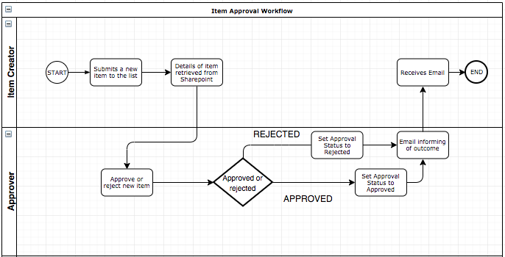

**With another student, create a new list and a workflow based on the “Start approval when a new item is added” template *(see image below)* for your new list. One of you take the role of Item Approver, and the other Item Creator. Test the flow works.**

Some hints:

* The new list you create will need to have the “Requires approval” setting selected. Go to list setting, then versioning settings

* Create workflow based on the “Start approval when a new item is added” template

The approver

Your list

Your subsite

* To set the Approval status for the item (i.e., to record the Accept or Reject status), you will need to use the “Set content approval status”
  + Click “add action”
  + Search and select “Set content approval status” (You will do this on the approve box and the reject box)
  + Choose your subsite and list
  + Click in box for “comments”, use “dynamic content”
  + Click save

## In the next lab:

We will be looking at some more complex workflows and the use of forms in the workflow.

Version 1.0: 30th August 2016

* 1. 7th September 2016 (Minor change)

2.0 25th May 2018

3.0 10th February 2019 (SPO/Flow Version)

3.1 30th August 2019 (S2/TS Version)

3.2 22nd May 2020 (TM Version)

3.3 16th July 2020 (S2 version)