ICT292 Information Systems Management

# Lab 06: Forms for Workflows

In the last lab, we met workflows; in this lab, we are going to use a form to make data entry easier for the user. The form we use will submit a new item to the list which, in a similar way to the workflow we created in Lab05, will start an approval workflow. In this lab, we will meet PowerApps.

## Aims:

The primary aims of this lab are for you to:

* Create a simple data entry form that triggers a workflow

## To be prepared for this lab, you will need to:

* Be correctly enrolled in the unit
* Have access to the unit SharePoint Site
* Have a SharePoint sub-site that you own and that you can use for this lab, and
* A web-browser ☺

## Introduction

Building on the approval workflows we met and created in the previous lab, this lab will look at creating an approval form. This will mean creating the list, then the form (which is linked to the list), and then the workflow to manage the approval process.

### Task 1: Create an Approval List

* You should work in your own subsite.
* Make sure that you go to List Settings/Versioning Settings and set the “Require content approval for submitted items” property to “Yes”. This will create the Approval Status column below.
* Add a column as below:
  + Approver
    - This should be a column of the type “Person or Group”

* My List looks like this:

### Task 2: Create the Basic Form

Now that you’ve created the list, you are now going to create a simple form that will allow users to enter data into the form.

* To create the form, we will be using Microsoft Power Apps. Select Power Apps from the tool bar of your Approval List and then Customize Forms from the options

* This will open the Power Apps application
  + To learn more about PowerApps, see: <https://docs.microsoft.com/en-us/powerapps/powerapps-overview>
  + As an aside, the fact that we opened PowerApps from the list means that the app is already linked to the List (this will save us some time later)
* To convince yourself that the form is linked to the list you created, go to View and look at the DataSource property:

* The PowerApps editing window has several sections which we will meet as we go along.
  + In the middle of the screen is the form that has been created for you:

* Add two buttons to the form by going to Insert and selecting Button. Put “Clear” on one, and “Submit” on the other

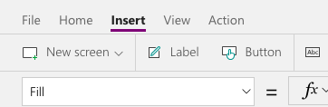

* You can drag the buttons around the screen and resize them. I put mine at the bottom of the screen. At the moment, these buttons don’t do anything. Graphical user interface, text, application

  Description automatically generated
* Click on the “Clear” button and enter ‘NewForm(‘ into the OnSelect Event in the formula bar:

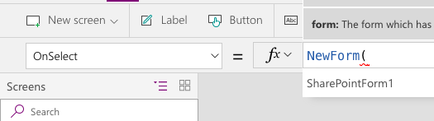

* A list of forms will appear and you can select from the list. In this case, the only choice I have is SharePointForm1. Select that and close the bracket. New form will create a new form when you click the button.



* To make the form reset to a blank form, you will need to insert a “ResetForm” command



* To see this work, select “Preview the App”

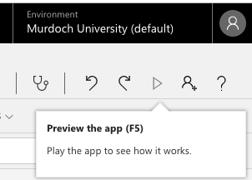

* If the form is blank when you open it, click the Clear button
* Enter your name in the Approver box (or your student number) and you should be able to select yourself from the list
* Click the Clear button again to convince yourself that it works.

In order for the user to submit the data they enter:

* Add a “SubmitForm” and “ResetForm” command to the OnSelect Event of the Submit button.



* Enter a record and then go back to your list to see if has been added to the list.

### Task 3: Create the WorkFlow

We want the flow to send an email to the approver letting them know they have an entry to approve.

* Go to Microsoft Flow from your list as you did in the previous lab (i.e., ‘Create a flow’)
* Select Start approval when a new item is added
* As per the Flow you created in the last lab, you will need to add the “Set content approval status” to the end of your workflow

* Save and test your flow.
* Go back to your list and select the most recent addition. Select the menu for the item: Select More

* You can then approve or reject the item by selecting Approve/Reject.

### Task 4: Save and Publish the Form

When you are happy that your form works, in PowerApps go to File and Save. Then Publish to Sharepoint. To see your App, go to your list and Add a new item to the list. You can now use the app to add new items to the list.

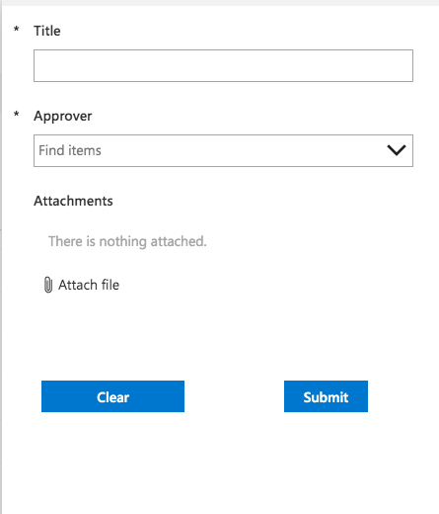

**Others**

* To use the default form
  + From your list in SharePoint, go to list setting
  + Under general settings, select Form Settings – here you can select between Use the default SharePoint form or Use a custom form created in Power Apps

* + You may also delete the custom form by selecting Use the default SharePoint form and then Select delete

## In the next lab:

We will go back to working with users and groups.