ELECTRONIC ASSIGNMENT COVERSHEET | 

Student Number: | 35282436
Surname: | Dela Cruz
Given name: | Kim Andrew
Email: | Kimandrew712@gmail.com
Unit Code: | ICT 284
Unit name: | Systems Analysis and Design
Enrolment mode: | External, Internal or Placement
Date: | 28/7/2024
Assignment number: | 2
Assignment name: | Assignment 2
Tutor: | Ms. Ramanathan Uma

Student’s Declaration:
- Except where indicated, the work I am submitting in this assignment is my own work and has not been submitted for assessment in another unit.
- This submission complies with Murdoch University's academic integrity commitments. I am aware that information about plagiarism and associated penalties can be found at http://our.murdoch.edu.au/Educational-technologies/Academic-integrity/. If I have any doubts or queries about this, I am further aware that I can contact my Unit Coordinator prior to submitting the assignment.
- I acknowledge that the assessor of this assignment may, for the purpose of assessing this assignment:
  - reproduce this assignment and provide a copy to another academic staff member; and/or
  - submit a copy of this assignment to a plagiarism-checking service. This web-based service may retain a copy of this work for the sole purpose of subsequent plagiarism checking, but has a legal agreement with the University that it will not share or reproduce it in any form.
- I have retained a copy of this assignment.
- I will retain a copy of the notification of receipt of this assignment. If you have not received a receipt within three days, please check with your Unit Coordinator.

I am aware that I am making this declaration by submitting this document electronically and by using my Murdoch ID and password it is deemed equivalent to executing this declaration with my written signature.

Table of Contents
Q1. Stakeholders 3
Q2. Requirements 3
Q2.a. Functional Requirements 3
Q2.b. Non-Functional Requirements 4
Q3. Use Case Modelling 4
Q3.a. User Goal Technique 4
Q3.b. Event Decomposition Technique 6
Q4. Domain model class diagram 6
Q5. Crud Matrix 8
Q6 Fully Developed Use Case Description 9
Q7. Activity Diagram 10
Q8. System Sequence Diagram 12
Q9. State Machine Diagram 13
Q10. User Acceptance Plan 14

Q1. Stakeholders
Stakeholders | Interests
Artie | Uses the system to view summary reports to monitor the health of the buisness.
Customer | Uses the system to find painters that meets their painting and decoration needs. They use the system to submit job requests and recieve quotes from different painters that are interested.
Painter | Uses the system to advertise their services and recieve notifications on job requests and send their quotes to the customer, this potentially allows them to gain more customers through using the system.

Q2. Requirements

Q2.a. Functional Requirements
Allow painters to register, create, update their own profiles.
Allow painters to send quotes to customers.
Allow customers to submit paint job requests and recieve quotes.
Match a customer and painter based on the customer’s requests.
Notify painters of suitable job requests.
Notify customers of suitable painters.
Rating system for completed jobs.
Generate end of the month reports to monitor business health.

Q2.b. Non-Functional Requirements
Usability – Easy to navigate interface, available in various platforms that ican access the web such as tablets, phones, pc.
Reliability – All user data should be backed up, in case of any hardware failure, malware attacks, human errors. And the system should ensure a high uptime of services.
Performance – The system should be able to process a lot of users at the same time without failure. The system should be scalable in case of sudden popularity or more demand to ensure performance will not be degraded.
Security – The system must be able to confirm painter’s licenses and registration to avoid scams, and customers must give out personal information to ensure the customer is legitimate. Because of sensistive data, the data should be encrypted to protect people’s privacy and to adhere to the data protection laws.
+ Design Constraints – None in this case study
+ Implementation Constraints – System must be scalable to ensure no degradation of performance, and personal data should be encrypted.
+ Interface Constraints – Integration with paypal for payments.
+ Physical Constraints – None for this case study.
+ Support Constraints – Helpdesk and online support.

Q3. Use Case Modelling

Q3.a. User Goal Technique
Use Case | Description | Actor
Submit Online form | The use case describes the event of a customer submitting a Job request form, a list of requirements for the job. | Customer
Purchase Credits | The use case describes the event where the painter purchases credits in order to be able send a quote to a customer. | Painter
Send quote | The use case describes the event where the painter sends a quote to the job that he is eligible for. | Painter
View Painter Profile | The use case describes the event where the customer views the painter’s profile where the customer can see the ratings, feedback of the painter’s previous completed jobs. | Customer
Register Painter | The use case describes the event where the painter registers an account. To register, the painter must submit all relevent information and importantly, the painter’s license and registration, to be checked by the system | Painter
Print Credit Payment Reports | The use case describes the event where the painters print out the credit payment report | Painter
Give feedback | The use case describes the event where the customer can send a review, feedback, and rating to a painter, and this review will be shown in their profile. | Customer
Manage account | The use case describes the event where either a customer or a painter can view their account details to edit any information they want to change. | Customer, Painter
Accept quote | The use case describes the event where the customer accepts a quote from a painter | Customer
View summary reports | The use case describes the event where Artie can view the generated monthly summary reports. | Artie
View Quote | The use case describes the event where the customer accepts a quote | Customer
Edit Quote | The use case describes the event where the painter wants to edit a quote | Painter
View Credits | The use case describes the event where the painter wants to view their remaining credit balance | Painter
Manage Feedback | The use case describes the event where the customer wants to edit or delete a feedback to a painter | Customer
Cancel transactions | The use case describes the event where the painter wants to cancel the occuring credit purchase transaction | Painter
Delete Summary Reports | The use case describes the event where Artie deletes the summary reports generated by the system | Artie

Q3.b. Event Decomposition Technique
Event | Type of Event | Use Case | Description | Actor
After customer submits online form | State | Notify painter of a customer Job. | The use case describes the event where the system finds and notify 2 suitable painters that fits the requirement of the job. | FCP System
After the painter submits the registration form | State | Verify Painter information | The use case describes the event where the FCP system checks if the painter’s License and Registration is legitimate. If It is not, the system will notify the painter that their account cannot be made. | FCP System
End of the Month | Temporal | Generate monthly summary reports | The use case describes the event where the FCP System generates the monthly report for Artie to view. | FCP System
Once the customer accepts a quote | State | Notify Painters of quote status | The use case describes the event where the FCP System notify the painter whose quote has been accepted and notify the other painter that their quote is unsucessful | FCP System
24 hours if customer does not recieve any quotes. | Temporal | Close the request | The use case describes the event where no quotes are recieved, so the request that the customer made is close and the customer is notified. | Customer
When customer submits the Job request form | State | Create Customer Account | The use case describes the event where an Customer Account is created when the customer submits a job request. | Customer

Q4. Domain model class diagram
Assumptions:
- A customer can create many job requests they want
- Checked painter is a type of Painter
- Each Job request is unique
- Feedback is optional
- Customer can recieve 0 or many quotes
- A quote can determine if a painter requires more information
- Payment between the customer and painter is outside the FCP System

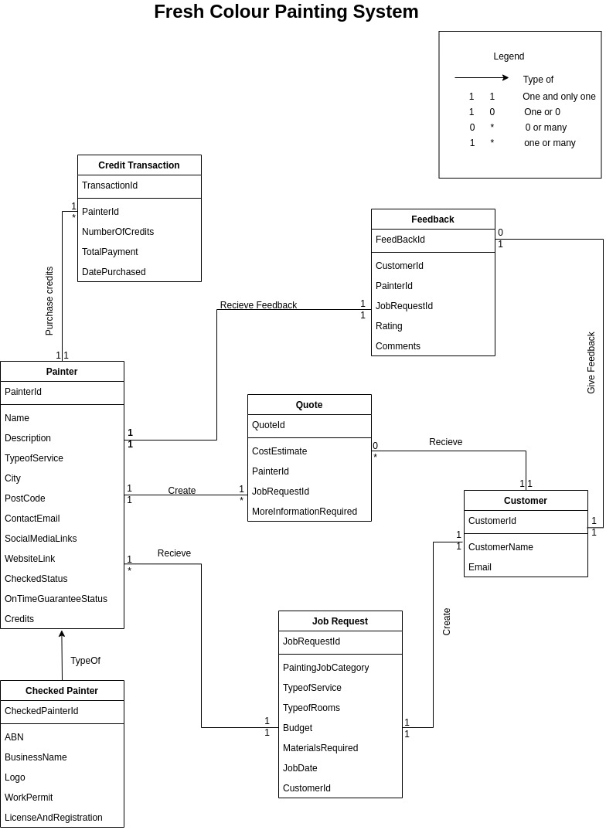

Q5. Crud Matrix
Domain Class  Use Case | Customer | Painter | JobRequest | Quote | Feedback | Credit  Transaction | SummaryReport
Submit Online form | C |  | C
Edit Quote |  |  |  | U
Purchase Credits |  | C |  |  |  | CU
View Credits |  |  |  |  |  | R
Send quote |  |  | R | C
Cancel Transaction |  |  |  |  |  | D
View quote |  |  |  | R
View Painter Profile | R
Register Painter |  | C
Print Credit Payment Reports |  | R
Give feedback | C | R |  |  | C
View feedback |  |  |  |  | R
Manage Feedback |  |  |  |  | UD
Manage account | UD | UD
Accept quote | R |  | U | UD
View summary reports |  |  |  |  |  |  | R
Notify painter of a customer Job | U
Verify Painter information |  | U
Generate monthly summary reports |  |  |  |  |  |  | CU
Notify Painters of quote status
Delete Summary reports |  |  |  |  |  |  | D
Close the request |  |  | D
Create Customer Account | C

Q6 Fully Developed Use Case Description
Use Case Name: | Submit Online Form
Scenario: | Customer is looking for a painter for a paint job.
Triggering Event: | Customer accesses the website and fills up and submits the form
Brief Description | The Customer will fill up details about the job in the job request form in the website, and once the form is submitted, the system will find the 2 most suitable painters and notify them.
Actors | Customer, FCP System, Painter
Stakeholders | Customer, Painter, Artie
Preconditions | The customer needs a paint job.  The customer can access the FCP System’s website.
Postconditions | A job request is created.  The system will find suitable painters and will be notified.  A customer account will be created if it does not already exists in the system.
Flow of Activities: | Actor | System
Flow of Activities: | 1. Customer fills up the necesssary information in the form  2. Customer submits the form | 1.1 System will check if values entered are valid.  2.1 Customer account will be create if doesnt exist yet.  2.2 Job request will be created and will find painters most suitable for the job.  2.3 The best two painters will be notified to send in a quote for the customer
Exception/ conditions: | 1.1 The customer enters invalid values for speficic fields or left them blank.  2.1 The customer submits the form with invalid values

Q7. Activity Diagram

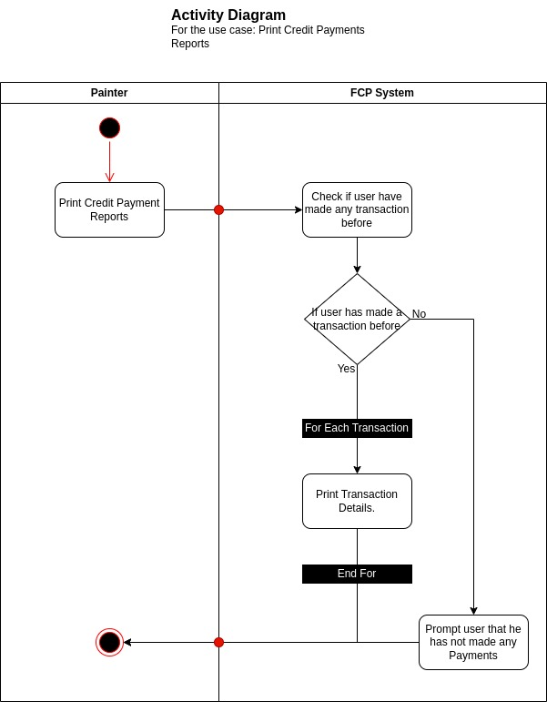

Q8. System Sequence Diagram
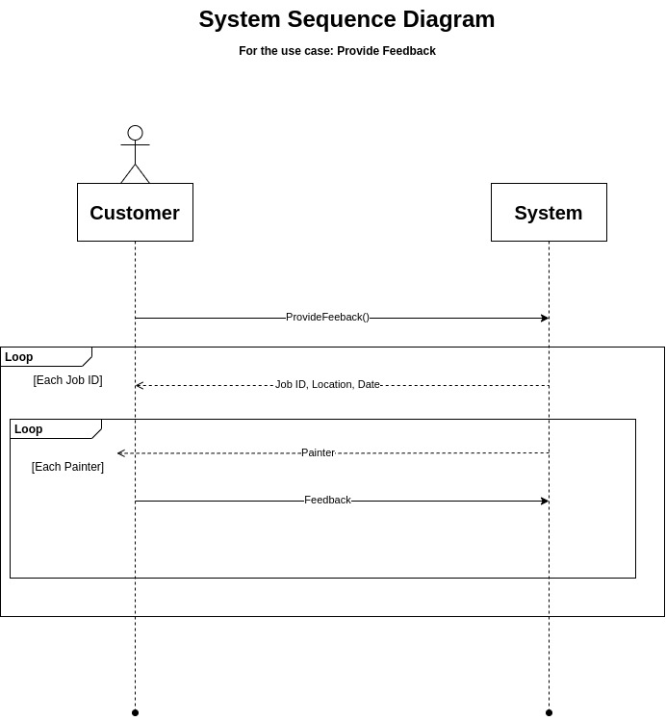

Q9. State Machine Diagram

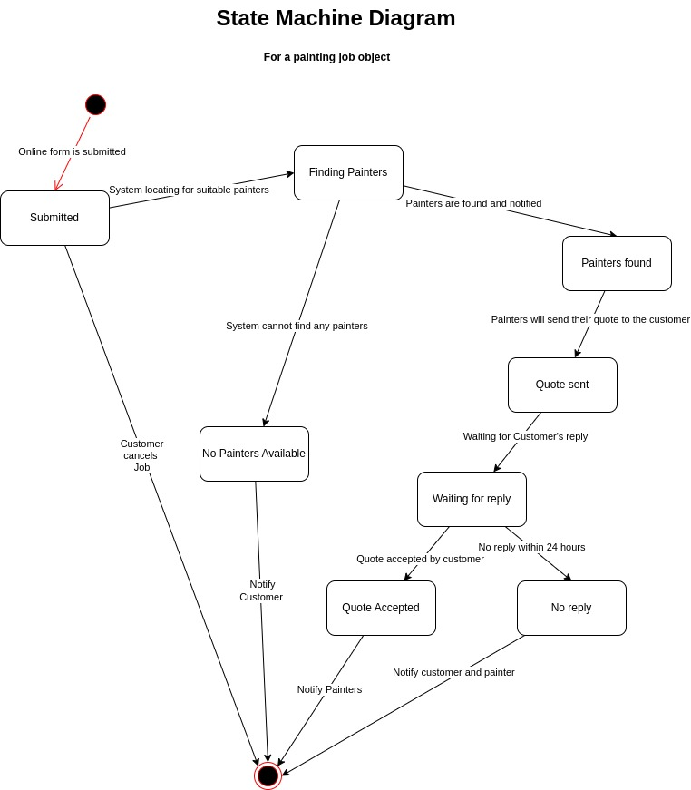

Q10. User Acceptance Plan
Use Case Name | Test Conditions | Expected Outcomes
Submit Online Form | Customer fully filled out all required fields, Submit Form | Job Request will be made, A new account will be created and inserted into the database if not yet exists,
View Quote | Customer recieve Quote from painter. Customer view Quote from painter | Quotes should properly display cost estimates, comments, and any other necessary information.
Give Feedback | Customer can access previous completed Jobs, Customer selects, and give comment, rating to that painter from that job. | Feedback should appear at painter’s profile.
Manage Feedback | Customer can update, delete any feedbacks of existing feedback. | Feedback is updated or deleted successfully,
Close the Request | Customer decides to cancel a job request. | Job request is successfully deleted.
Close the Request | Customer does not reply to a quote within 24 hours | Job request is successfully deleted.
View Painter | Customer can view a painter’s profile. | Accurate data from the painter’s profile should be shown.
Manage Account | Customer can update personal information | Account is updated
Manage Account | Customer can delete account | Account is deleted
Accept Quote | Customer can view and accept a quote from painters. | Job Request is updated and painters should be notified.

