(a.) Question 1 requires us to use javascript and HTML to make a web page to collect various information on a user. The data must be validated in order to be submitted.

(b.) The two key component I used to come up with a solution is HTML Form and Javascript Validation. The HTML Form is the frontend while the Javascript runs in the background, doing all the necessary checks.

Testing:
Idle
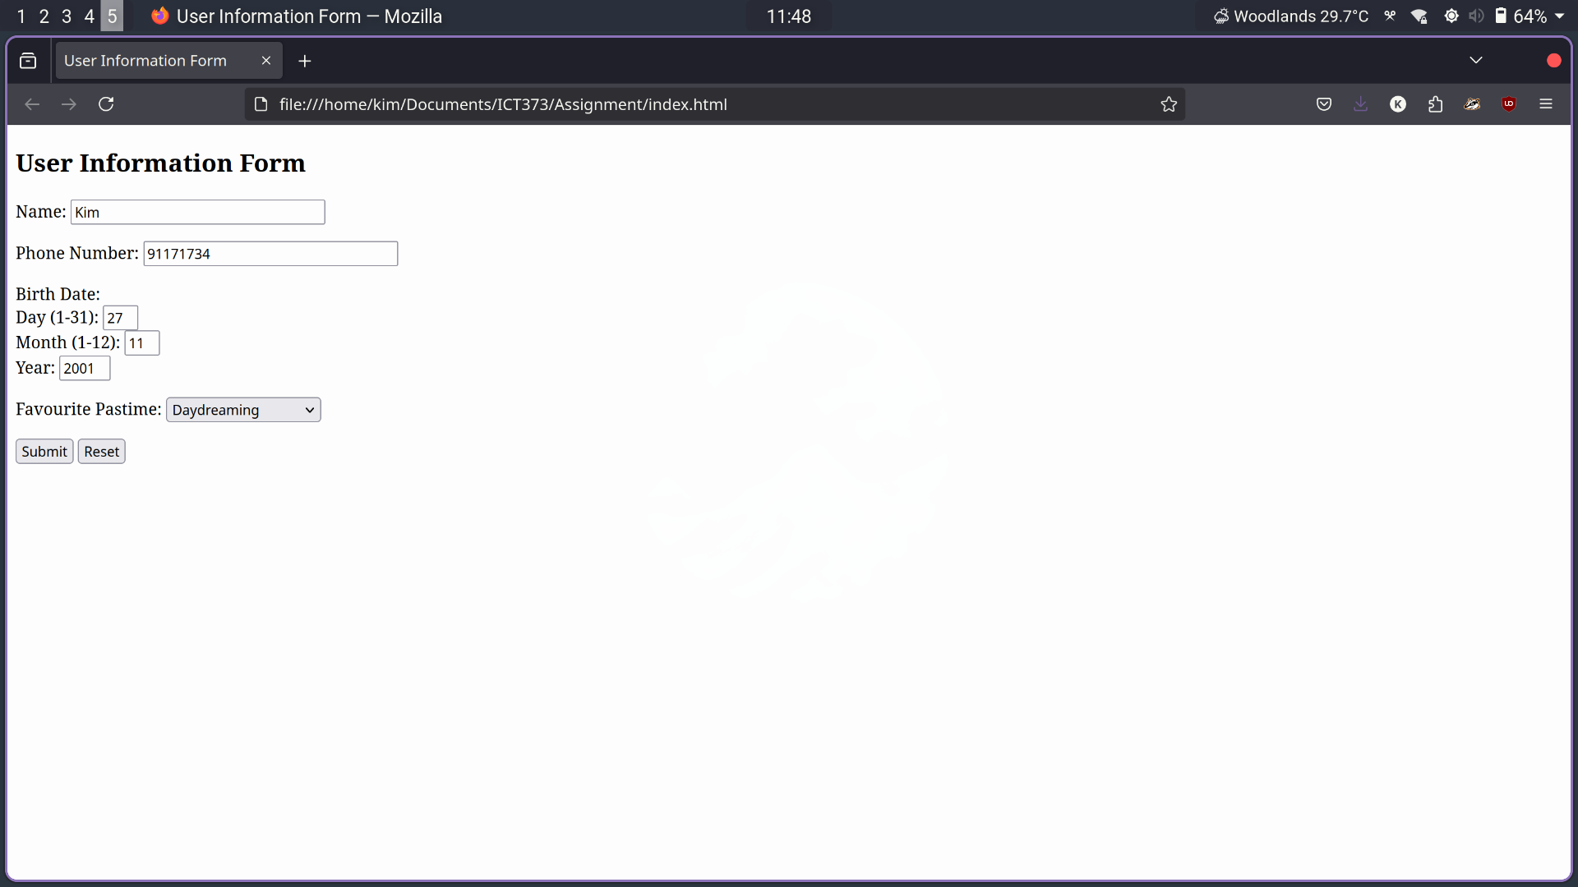

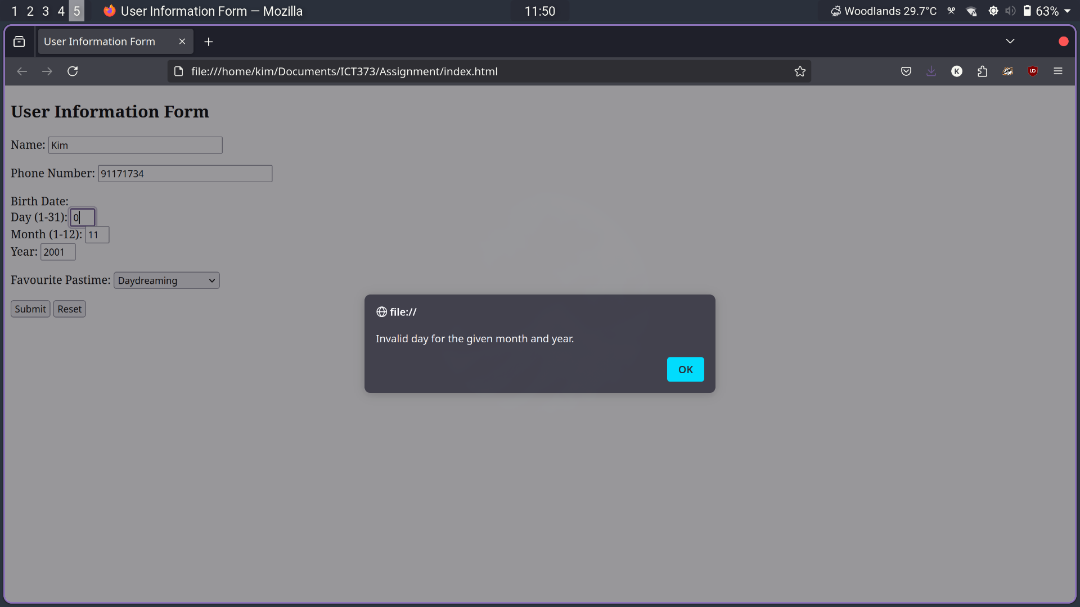
Out of bound day validation:

Form Submitted:


