Assignment 1 – Weekly Magazine Management System. A java program made by Kim Andrew Dela Cruz that aims to efficiently manage customer and magazine issues/supplements information. The program consists of 6 java source codes; Customer.java, Paying.java, Associate.java, Magazine.java, Supplement.java, Client.java. This program and documentation is developed and submitted before October 6, 2024.

Requirements/Specification
The java program stores Customer information such as email addresses, list of supplements that they are interested in, total cost of all the magazine issue and supplements that they have acquired, payment method, and associated customers which they pay for. The program also stores information about each weekly magazine issue and supplements like the name and cost. All the information is stored within the program in ArrayList data structures. The program allows the creation of new customers and magazine supplements by the user and removal of existing customers. The program can also print out all customer emails and print out the end of month invoices for all paying customers.

User Guide
To compile the program you must first have a java development kit installed; I have openJDK 17 installed in my machine. After checking or installing, you can compile the program by navigating or opening the project folder directory in your terminal.
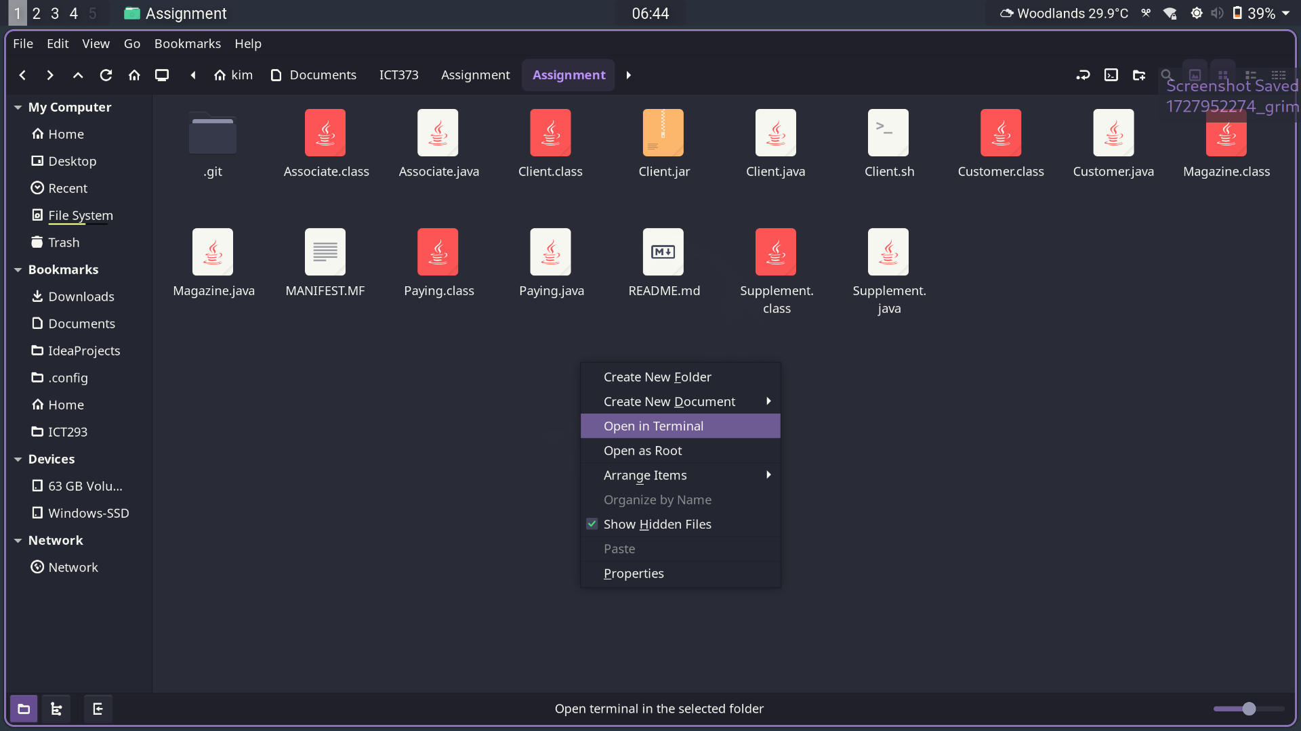

Once you are in the directory, you can compile by using the command “javac *.java”. After compiling you can run the program with the command “java Client”.
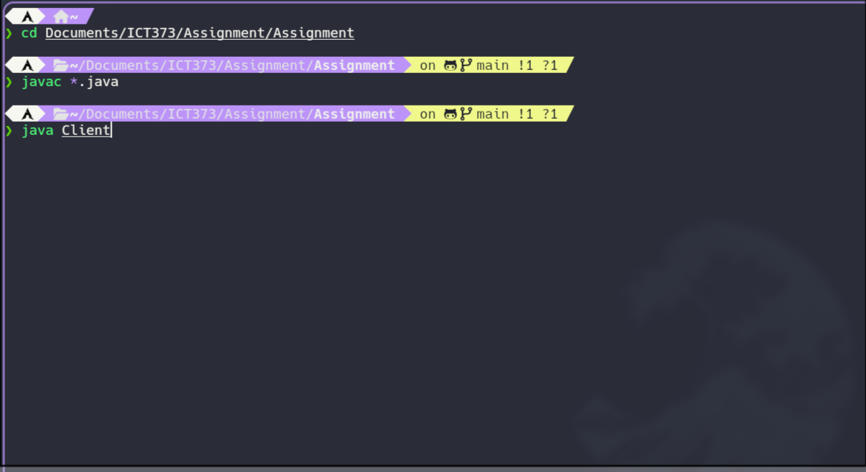

Once you run the program you can follow the on-screen instructions to use the program. Please check the names loaded customers and supplements by using selecting option 9 in the main menu. One more thing to note is that all names are not case sensitve in this program.

Structure/Design – the approach I used is an object oriented approach. The reason being is, by using object oriented approach I can modularize and reuse many parts of my program. Modularity, and encapsulation also helps with the maintainability and readability of the program.

UML Class Diagram
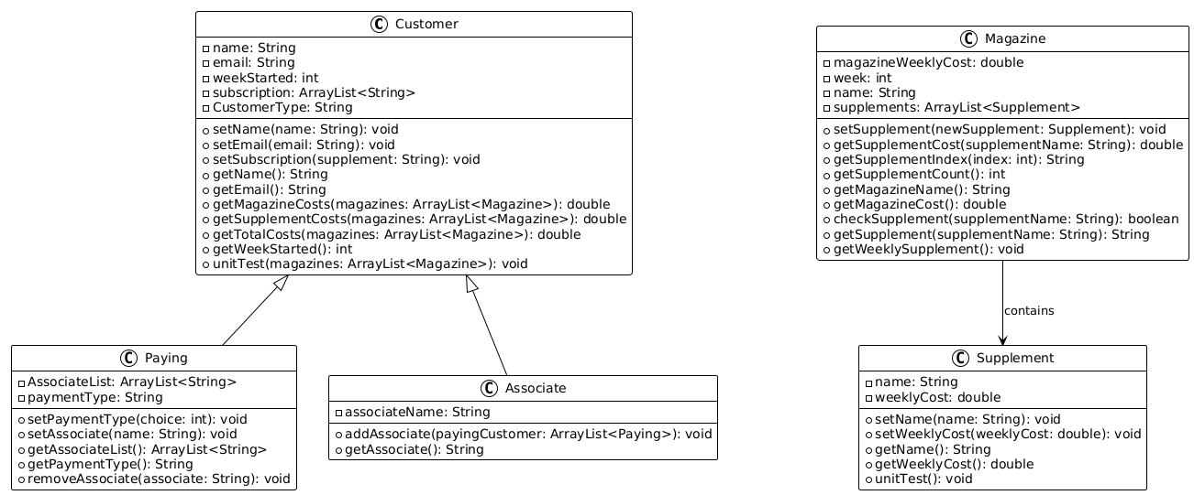
Psuedocode

Client Class:
function createSupplement(tempSupplements, userInput)
name = get input for supplement name
weeklyCost = get input for weekly cost
print "Enter Supplement Name:"
name = read input
print "Enter Weekly Cost:"
weeklyCost = read input
create new Supplement object with name and weeklyCost
add Supplement object to tempSupplements list
print "Supplement Created"
read input to consume newline

function createCustomer(payingCustomer, associateCustomer, currentWeek, userInput)
name = get input for customer name
email = get input for customer email
choice = get input for customer type (1 for paying, 2 for associate)
print "Enter Customer Name:"
name = read input
print "Enter Email:"
email = read input
print "Type 1 for paying, 2 for associate (1|2):"
choice = read input
switch choice
case "1"
print "Enter payment type, type 1 for Credit Card, 2 for Debit Card (1|2):"
choice = read input
if choice is "1"
print "Paying Customer added"
add new Paying customer to payingCustomer list with name, email, currentWeek, and "Credit Card" payment type
else if choice is "2"
print "Paying Customer added"
add new Paying customer to payingCustomer list with name, email, currentWeek, and "Debit Card" payment type
else
print "Invalid Response. Try Again."
case "2"
print "Enter paying customer:"
payingCustomerName = read input
for each payingCustomer in payingCustomer
if payingCustomerName equals payingCustomer.getName()
add new Associate customer to associateCustomer list with name, email, currentWeek, payingCustomerName, and payingCustomer
userExist = true
print "Associate Customer Added."
break

if not userExist
print "Paying User does not exist. Try Again."

function addSupplement(tempSupplements, magazines, currentWeek, userInput)
if tempSupplements is empty
print "There is no available supplements to add"
else
print "Available Supplements to add to magazine:"
for each supplement in tempSupplements
print index + ". " + supplement.getName() + " - " + supplement.getWeeklyCost()
print "Select which supplement to add (Type the number)"
choice = read input
choice = choice - 1
if choice is out of bounds
print "Choice out of bounds. Try Again"
else
tempName = tempSupplements.get(choice).getName()
tempCost = tempSupplements.get(choice).getWeeklyCost()
remove tempSupplements.get(choice) from tempSupplements
magazines.get(currentWeek).setSupplement(new Supplement(tempName, tempCost))
read input to consume newline
print "Successfully Added"

function addCustomer(payingCustomer, associateCustomer, magazines, currentWeek, userInput)
userExist = false
paying = false
index = 0
print "Enter Customer Name:"
name = read input
for each payingCustomer in payingCustomer
if payingCustomer.getName() equals name
userExist = true
paying = true
index = current index
break
for each associateCustomer in associateCustomer
if associateCustomer.getName() equals name
userExist = true
index = current index
break
if userExist
print "Select which supplement to subscribe to(Type the index): "
choice = read input
choice = choice - 1
if choice is out of bounds
print "Choice out of bounds. Try Again."
else
supplementName = magazines.get(currentWeek).getSupplementIndex(choice)
if paying
payingCustomer.get(index).setSubscription(supplementName)
else
associateCustomer.get(index).setSubscription(supplementName)
print "Successfully added customer"
else
print "User does not Exist. Try Again."
read input to consume newline

function printAllEmails(payingCustomer, associateCustomer)
print "Paying Customer:"
for each payingCustomer in payingCustomer
print payingCustomer.getEmail()
print "Associate Customer:"
for each associateCustomer in associateCustomer
print associateCustomer.getEmail()

function printInvoice(payingCustomer, associateCustomer, magazines)
print "End of Month Invoice:"
for each payingCustomer in payingCustomer
totalCost = 0
associateList = payingCustomer.getAssociateList()
print "Name:", payingCustomer.getName()
print "Email:", payingCustomer.getEmail()
print "Subscribed since Week:", payingCustomer.getWeekStarted()
print "Payment Type:", payingCustomer.getPaymentType()
print "Payment Breakdown:"
print "\tBase Magazine subscription -", payingCustomer.getMagazineCosts(magazines), "$"
totalCost = totalCost + payingCustomer.getMagazineCosts(magazines)
print "\tSupplement subscription -", payingCustomer.getSupplementCosts(magazines), "$"
totalCost = totalCost + payingCustomer.getSupplementCosts(magazines)
print "\tAssociate Cost Breakdown:"
for each associateName in associateList
for each associateCustomer in associateCustomer
if associateCustomer.getName() equals associateName
print "\t\tAssociate's Email Address:", associateCustomer.getEmail()
print "\t\tAssociate's Total cost:", associateCustomer.getTotalCosts(magazines), "$"
totalCost = totalCost + associateCustomer.getTotalCosts(magazines)
print "Total:", totalCost, "$"

function removeCustomer(payingCustomer, associateCustomer, userInput)
userExist = false
paying = false
index = 0
print "Enter Customer Name:"
name = read input
for each payingCustomer in payingCustomer
if payingCustomer.getName() equals name
userExist = true
paying = true
index = current index
break
for each associateCustomer in associateCustomer
if associateCustomer.getName() equals name
userExist = true
index = current index
break
if userExist
if paying
remove payingCustomer.get(index) from payingCustomer
print "Customer Successfully removed"
else
for each payingCustomer in payingCustomer
if associateCustomer.get(index).getAssociate() equals payingCustomer.getName()
payingCustomer.get(i).removeAssociate(associateCustomer.get(index).getAssociate())
print "Customer Successfully removed"
remove associateCustomer.get(index) from associateCustomer
else
print "Customer not found. Try Again."

Customer Class:
function getTotalCosts(magazines)
totalCost = 0
for each magazine in magazines
totalCost = totalCost + magazine.getMagazineCost()

for each magazine in magazines
for each subscription in subscription
if magazine.checkSupplement(subscription)
totalCost = totalCost + magazine.getSupplementCost(subscription)
return totalCost

Magazine Class:
function getSupplementCost(supplementName)
weeklyCosts = 0
for each supplement in supplements
if supplement.getName() equals supplementName
weeklyCosts = weeklyCosts + supplement.getWeeklyCost()
return weeklyCosts

function checkSupplement(supplementName)
for each supplement in supplements
if supplement.getName() equals supplementName
return true
return false

function getWeeklySupplement()
print "Available Supplements:"
for each supplement in supplements
print index + ". " + supplement.getName() + " - " + supplement.getWeeklyCost(), "$"

Associate Class (Sub-Class of Customer):
function addAssociate(payingCustomer)
for each payingCustomer in payingCustomer
if payingCustomer.getName() equals associateName
payingCustomer.setAssociate(this.getName())

Paying Class (Sub-Class of Customer):
function removeAssociate(associate)
for each associateName in AssociateList
if associateName equals associate
remove associateName from AssociateList

Limitation – the program is not able to :
- automatically change the current week
- give a more detailed payment breakdown
- add magazine issues in the program
- remove magazine issues and supplements
- edit name, cost, email, and more from existing customers and supplements

Testing:
TestID | Test Description | Input | Expected Result | Actual Result | Pass/Fail
T01 | Test option 1. Create a new supplement | Supplement Name: test_1  Supplement Cost: 7.99 | In option 9 (Unit Test). The created supplement should be shown. | Refer to figure. T01 Actual Result | Pass
T02 | Test option 2. Create a new paying customer | Customer Name: paying_customer  Email: customer@example.com  Type: 1  Payment Type: 1 | In option 9 (Unit Test). The created customer should be shown. | Refer to figure. T02 Actual Result | Pass
T03 | Test option 2.  Create a new associate customer | Customer Name: associate_customer  Email: associate@example.com  Type: 2  Paying Customer: Emma Walker | In option 9 (Unit Test). The created customer should be shown. | Refer to figure. T03 Actual Result | Pass
T04 | Test option 3. Add new supplement. | Assumption: test_01 (cost: 7.99) is already created.  Enter: 1 | After entering . The program should clear screen and Prompt “Successfully Added” | Refer to figure. T04 Actual Result | Pass
T05 | Test option 4.  Add new customer. | Enter Customer Name: Emma Walker.  Available supplement – 1. Culinary delights | After entering . The program should clear screen and Prompt “Successfully Added Customer” | Refer to figure. T05 Actual Result | Pass
T06 | Test option 5. Print all exsiting customer’s email. | Enter option 5 from main menu. | Screen Prints all existing customer’s email | Refer to figure. T06 Actual Result | Pass
T07 | Test option 6. Print end of month invoice for paying customer. | Enter option 6 from main menu. | Screen Prints the end of month invoice for paying customer. | Refer to figure. T07 Actual Result | Pass
T08 | Test option 7.  Remove existing customer. | Customer Name: Emma Walker | Screen Prompt’s “Successfully Removed Customer” | Refer to figure. T08 Actual Result | Pass
T09 | Test option 8. Exit program. | Enter option 8 from main menu. | Screen Promp’s “Program Exited” and exits the program. | Refer to figure. T09 Actual Result | Pass

T01 Actual Result:
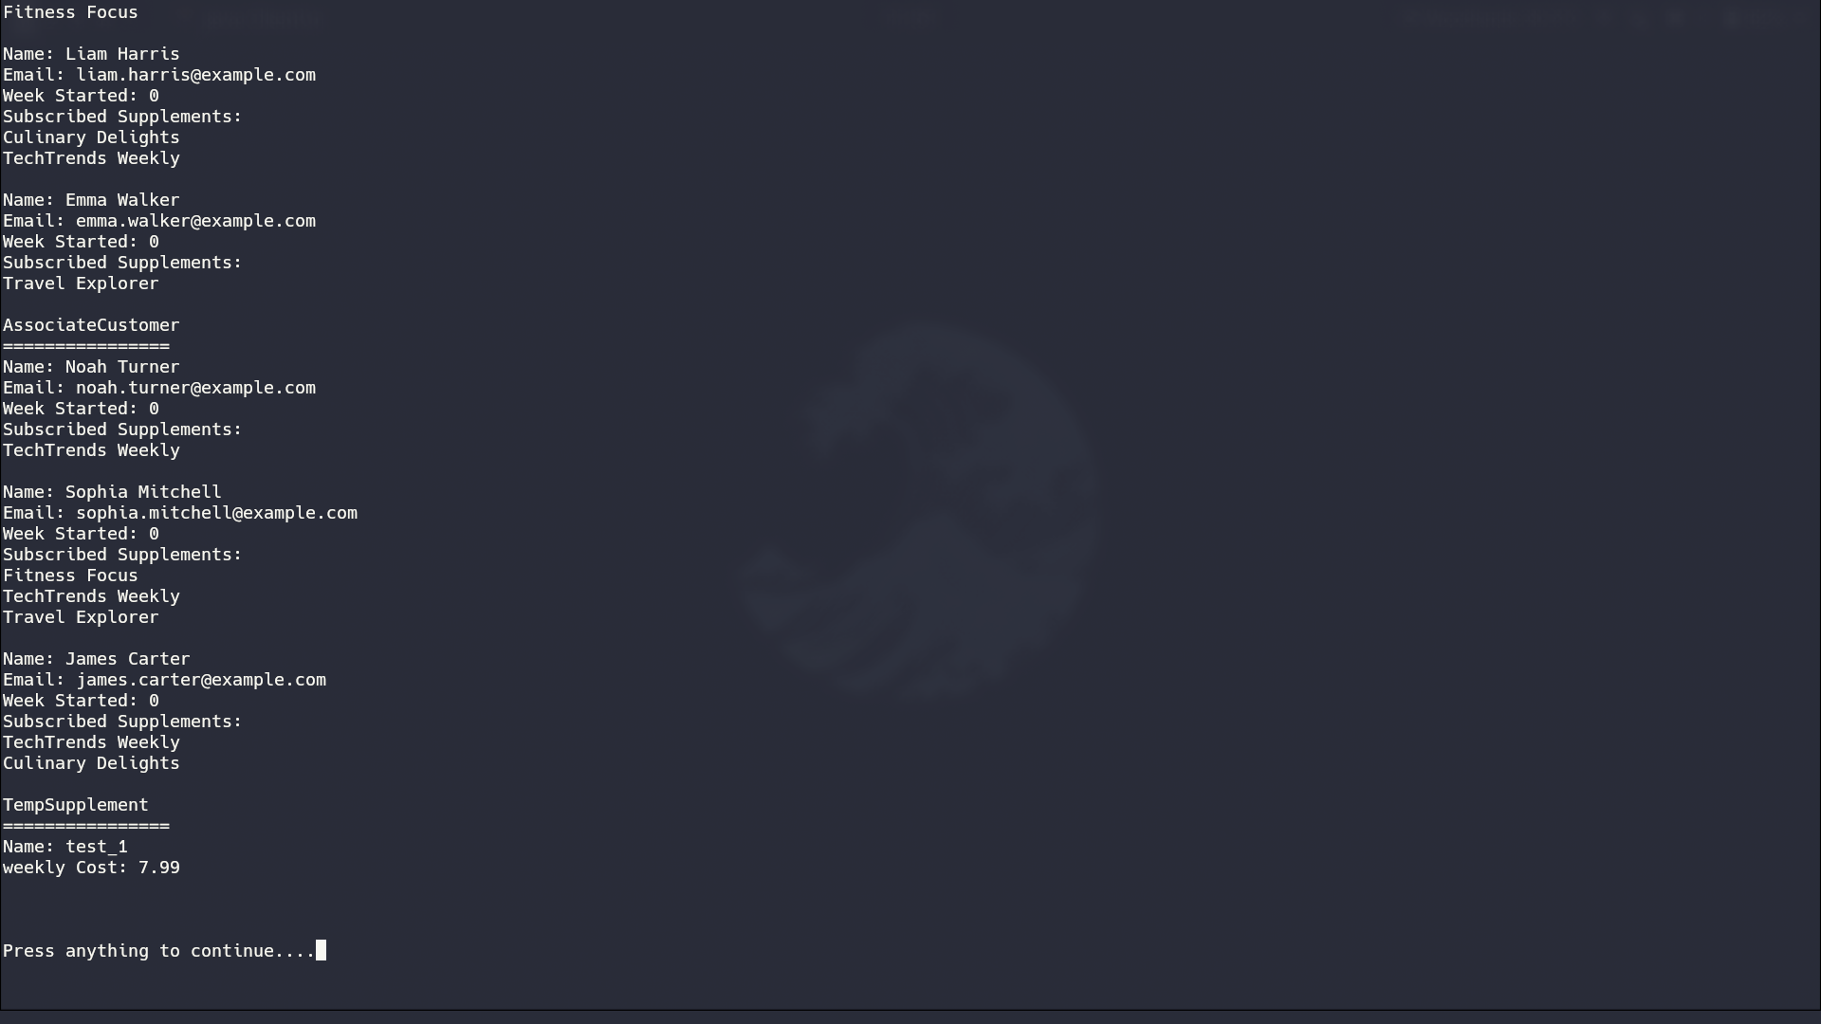

T02 Actual Result:
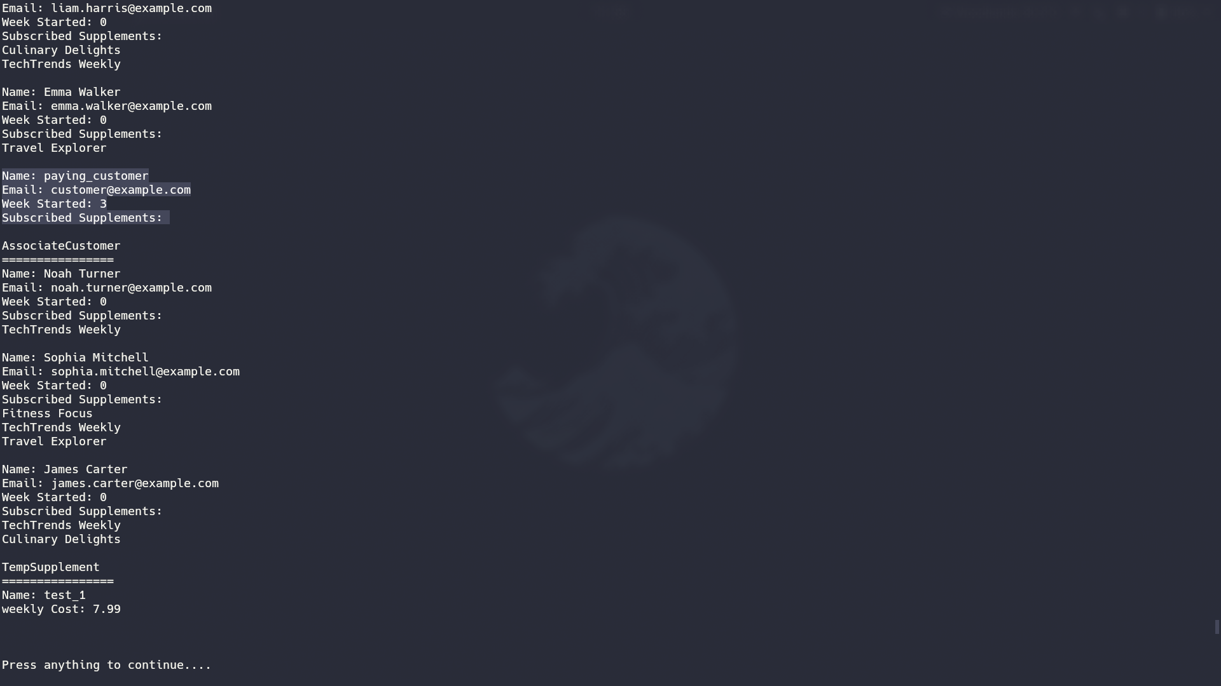

T03 Actual Result:
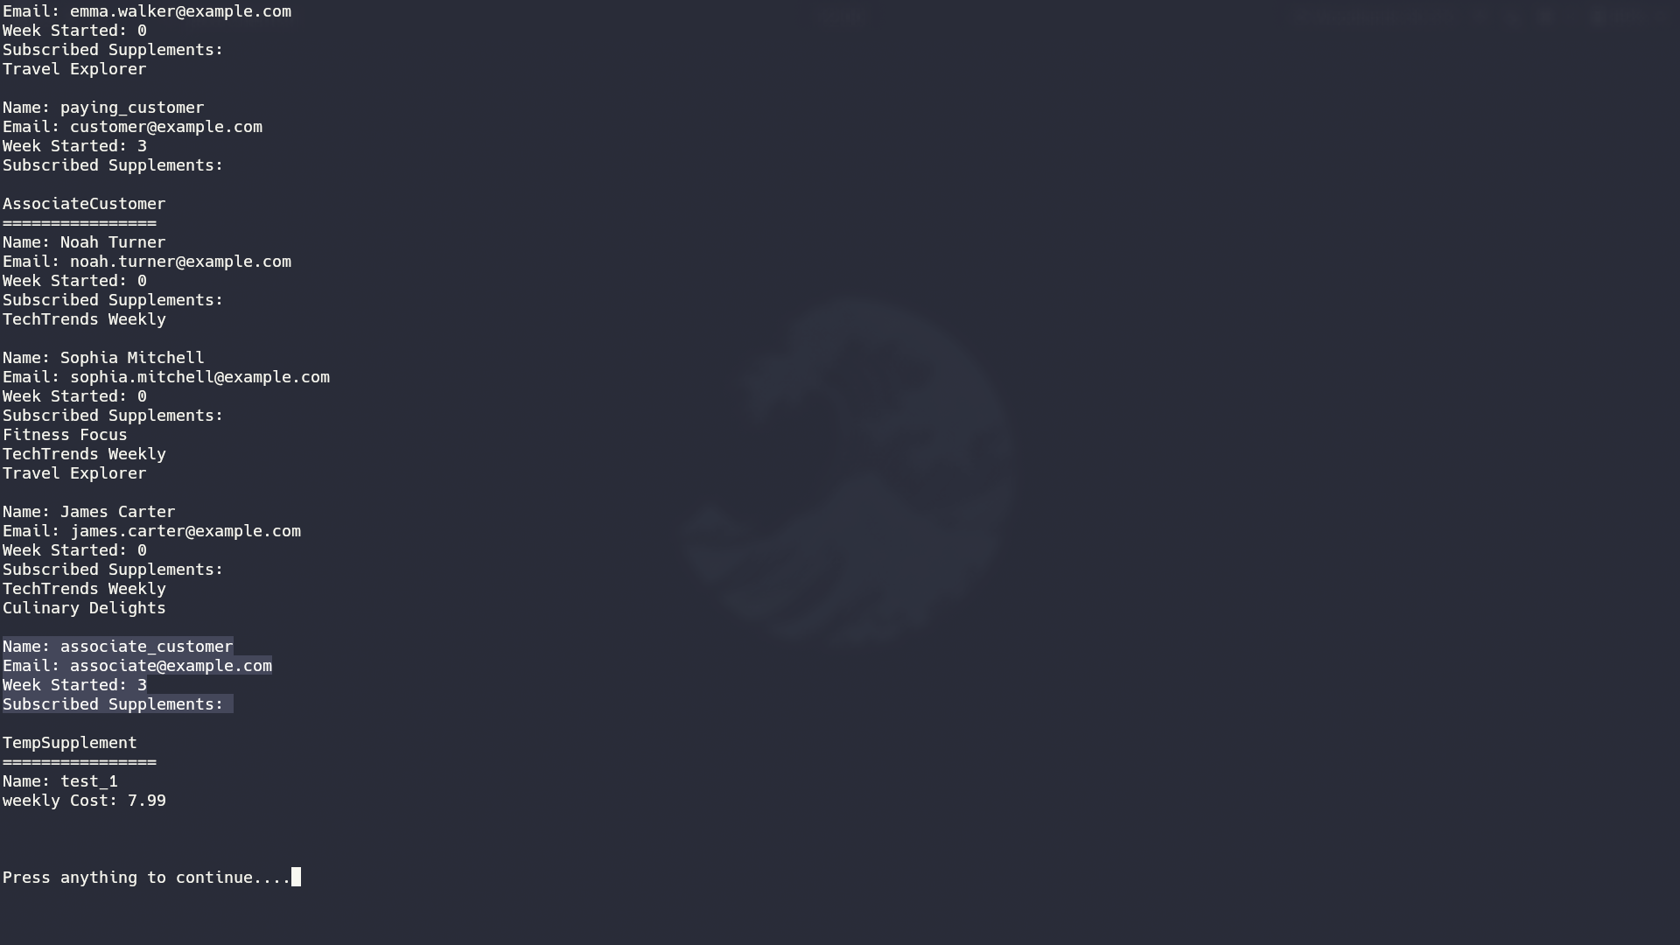

T04 Actual Result:
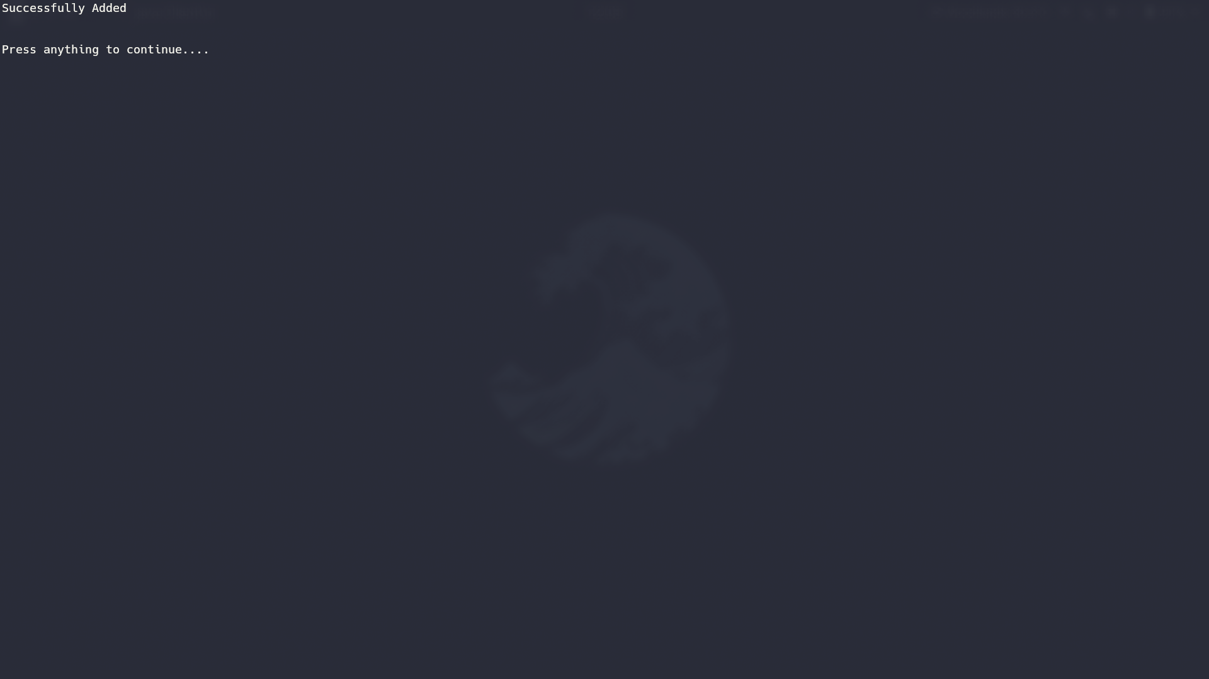

T05 Actual Result
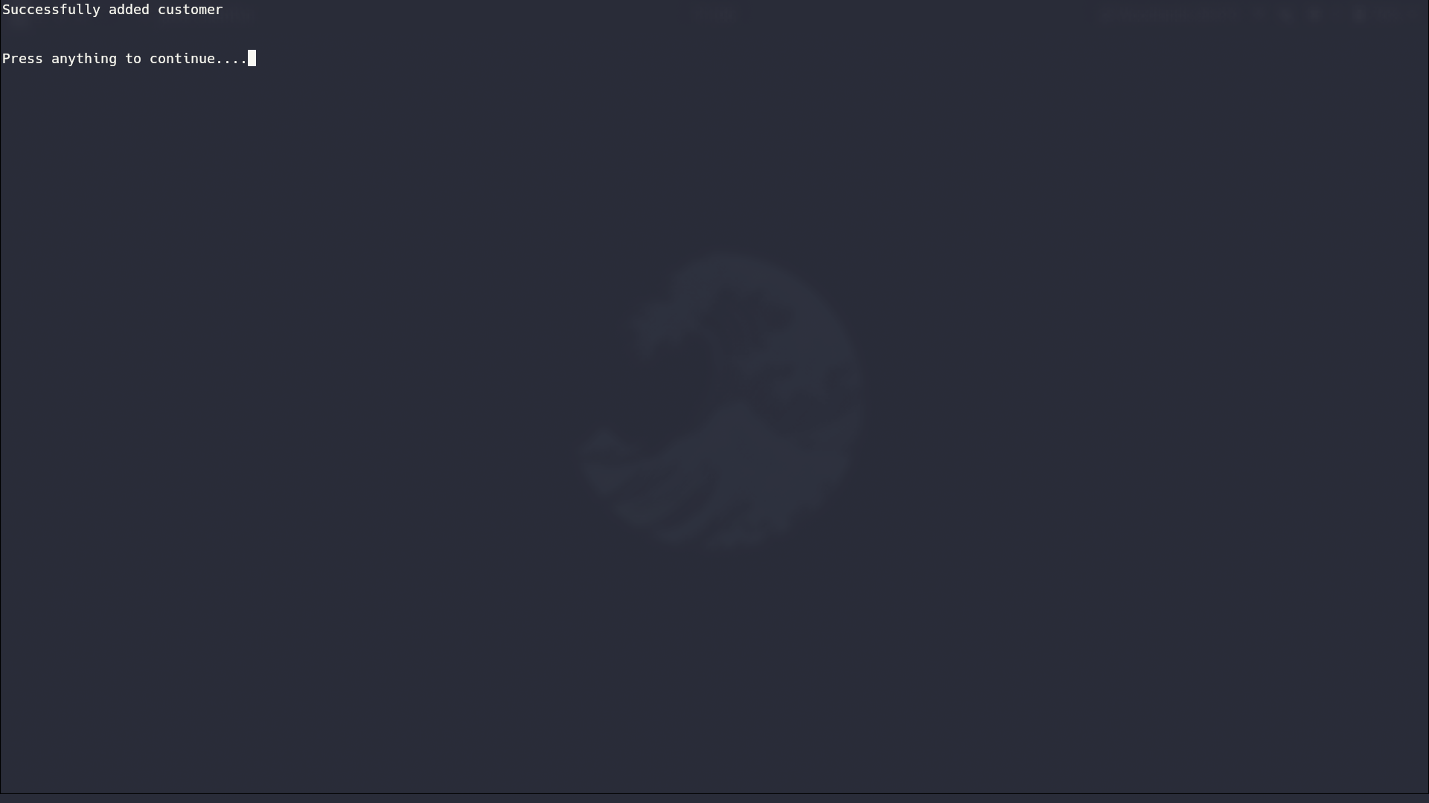

T06 Actual Result

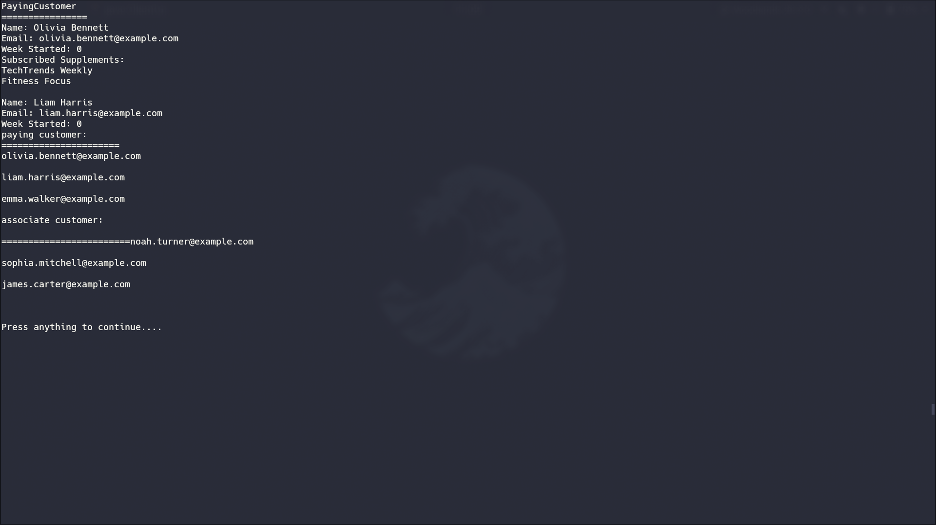

T07 Actual Result
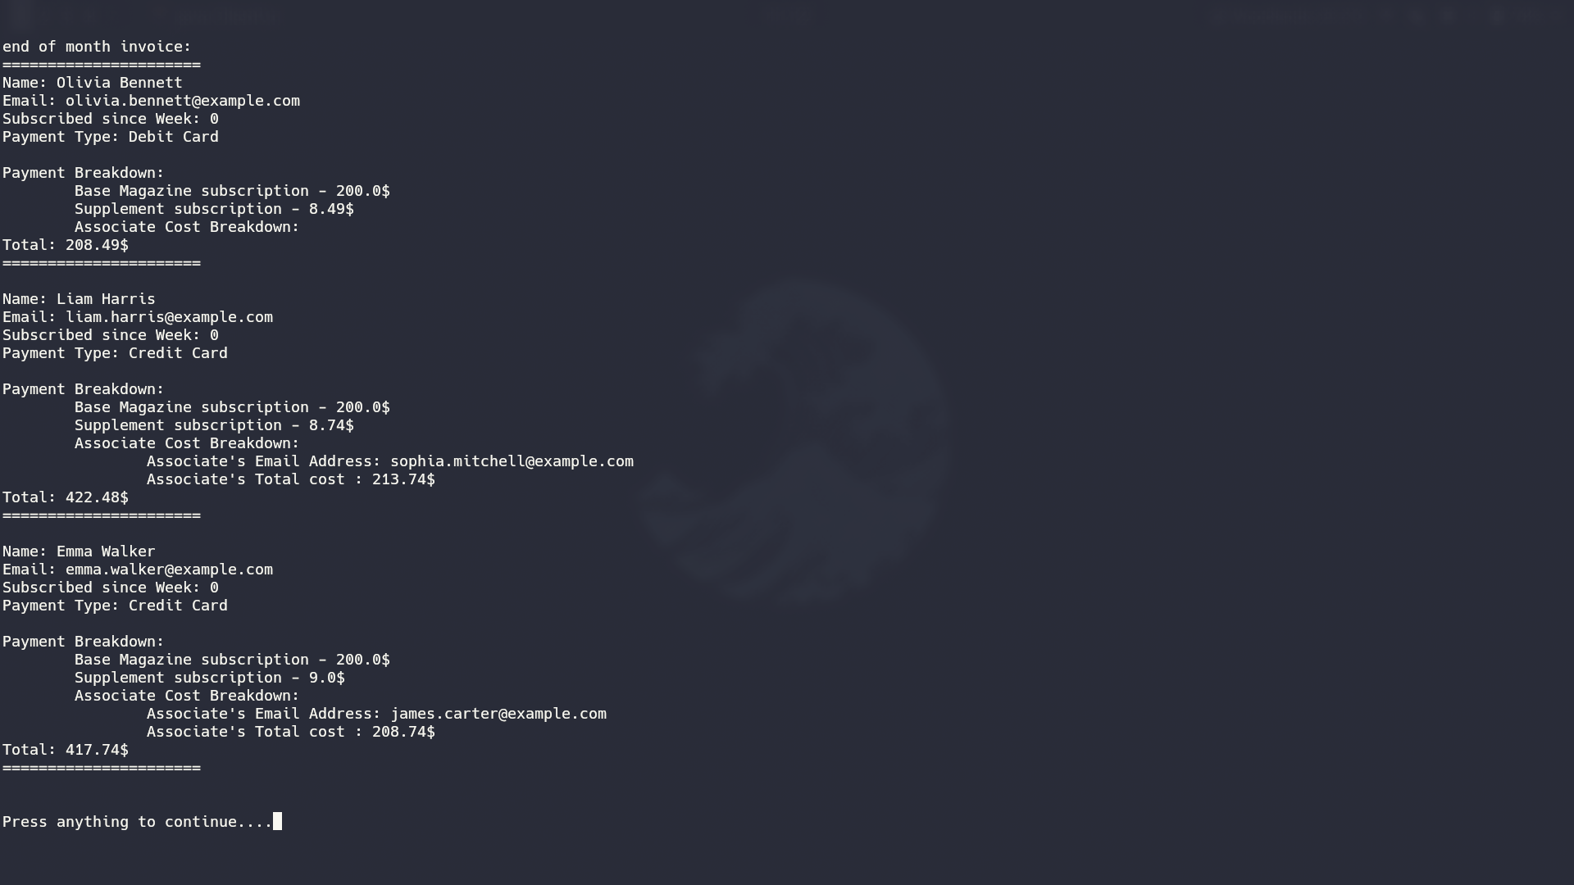

T08 Actual Result
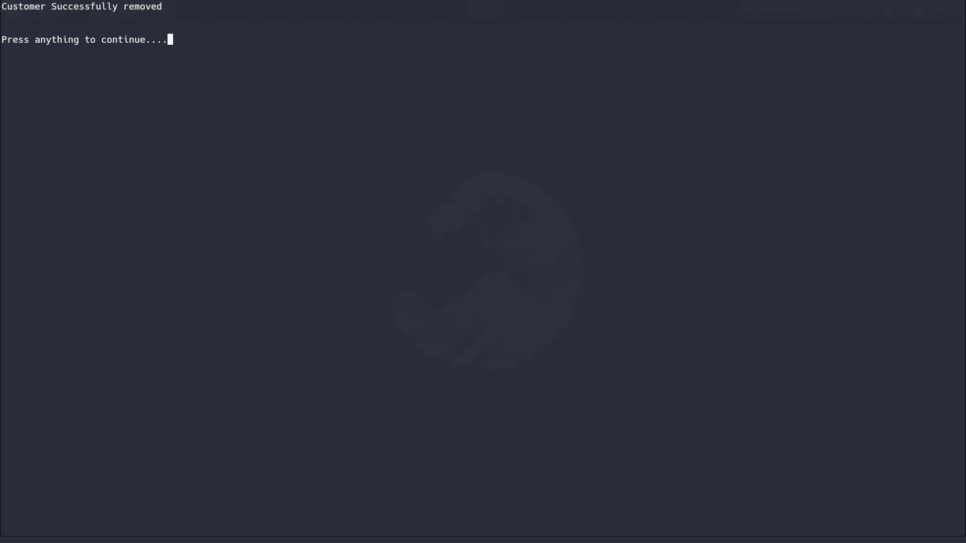

T09 Actual Result


