# Bootloader Instructions:

## General:

* A new RA6E1 bootloader has been added to the Samwise workspace and must be compiled before any application that uses it.
* The NXP_K24 and RA6E1 bootloaders have been changed to use source files in the form filename_BL.c/h to allow changes to the application to have minimal effect on the bootloader image.
* bootloader_K24 compiles without error but is UNTESTED
* bootloader_RA6E1 compiles without error and is being tested
* A batch script has been create to aid in determining when changes to the filename_BL.c/h files have been made from the base file, filename.c/h
  + Requires WinMerge (or change script to support your diffing tool)
  + Looks for files with filename_BL.c/h pattern and copies to the Bootloader/compare/bl folder as filename.c/h
  + Looks for a base file, filename.c/h, in the same folder as the filename_BL.c/h file and, if found, copies that file to Bootloader/compare/base
  + Opens WinMerge on the compare/bl and compare/base folders to identify changes
  + The user is then required to manually modify the filename_BL.c/h as needed.
  + Run the MTU\Bootloader\check_BL_files.bat to make the comparison
* The RA6E1 bootloader now creates a bootloader_RA6E1.bin file that is included in the linker step of the application build. Add this file with the Linker 🡪 Input instructions below.
* The Debugger 🡪 Images extra image file, bootloader_RA6E1.hex, no longer needs to be added. Remove this from your debugger configuration if previously included.

## IAR-EWARM Configuration:

To configure the IDE for J-Link, follow the steps below:

1. Open the Options for I210+c_RA6_Dev project
2. Set the Debugger 🡪 Setup options:  
   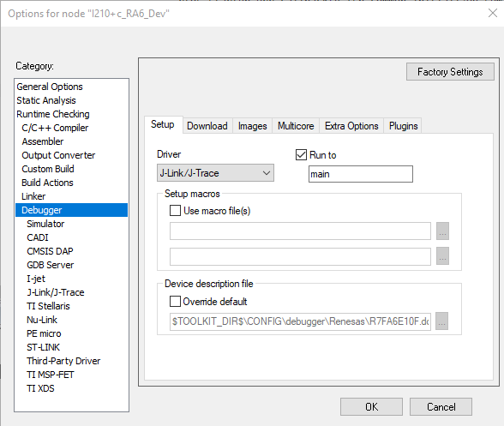
3. Set the Debugger 🡪 Download options:  
   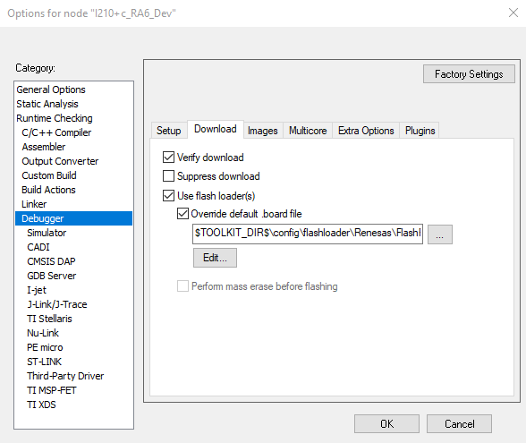
4. Set the Linker 🡪 Input to the settings below:  
   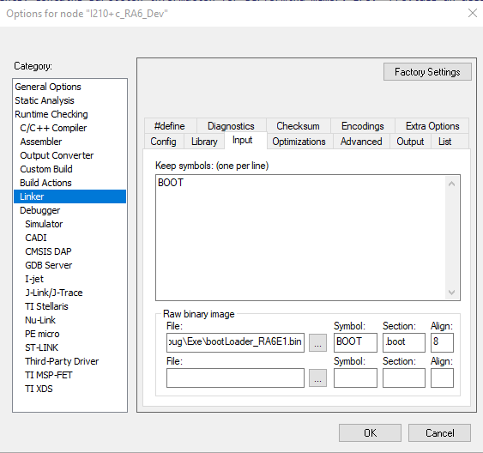  
   File text: **$PROJ_DIR$\..\Bootloader\R7FA6E1\IAR\Debug\Exe\bootLoader_RA6E1.bin**
5. Set the Debugger 🡪 Image options:  
   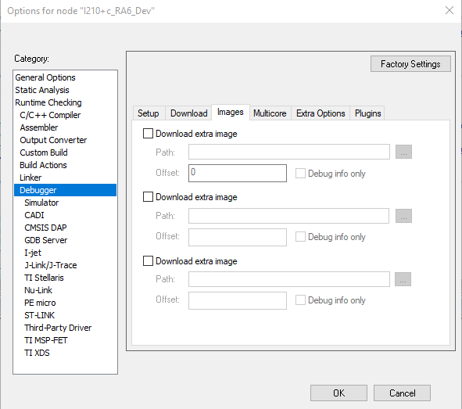
6. Set the Debugger 🡪 Extra options:  
   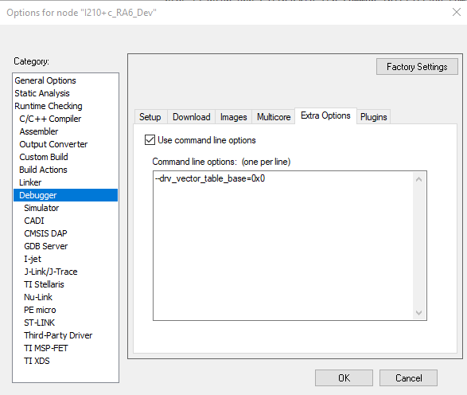  
   text: **--drv_vector_table_base=0x0**
7. Set the Debugger 🡪 Plugins options – no change: FreeRTOS (with task local context), FreeRTOS and OpenRTOS)

### J-Link Debugger:

For J-Link debugger, follow the steps below:

1. Set J-Link 🡪 Setup  
   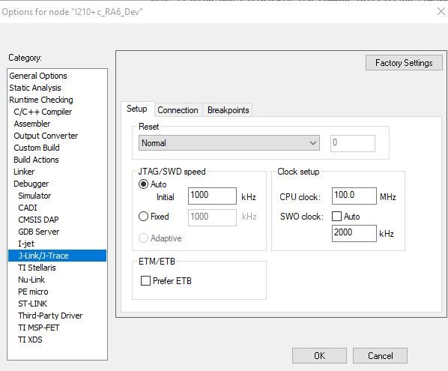
2. Set J-Link 🡪 Connection  
   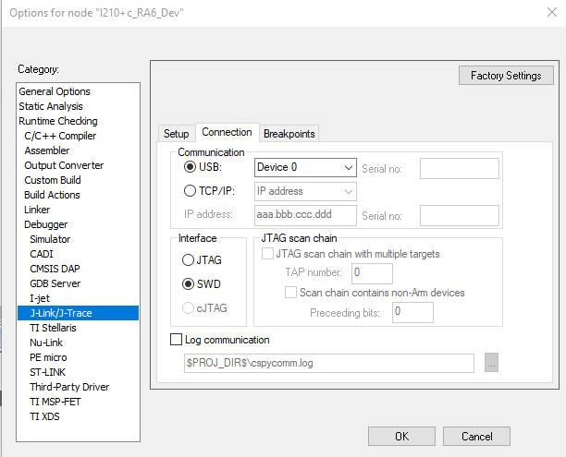  
   Note: SWD is required (JTAG causes an unknown error when downloading)
3. Set J-Link 🡪 Breakpoints (use default):  
   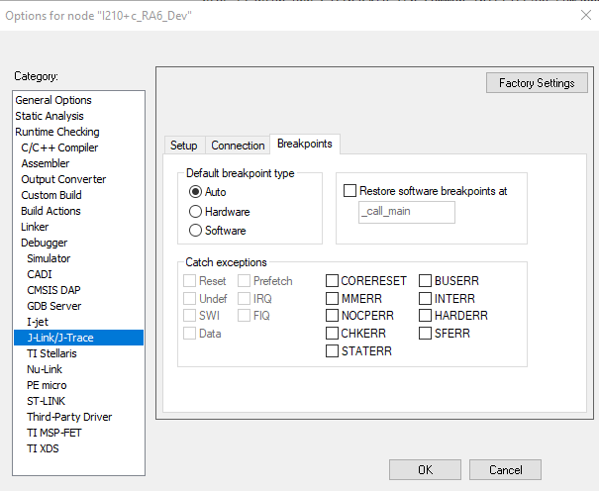

### I-Jet Debugger:

For I-Jet debugger, follow the steps below:

1. TBD
2. Set J-Link 🡪 Setup  
   