**Software**

**Requirements**

**Specification**

**For**

**Job Portal System**

**Version1.0**

**Prepared by Vishnu**

**Aitrich**

**10 September 2025**

**Table of Contents**

1. **Introduction 2**

**1.1 Purpose 2**

**1.2 Scope 3**

**1.3 Objectives 4**

**2. Functional Requirements 5**

**2.1 Primary actors of the system 5**

**2.2 Use Case Diagram 5**

**2.2.1 Job Seeker 5**

**2.2.2 Job Provider 5**

**2.2.3 Platform Admin 5**

**2.3 User Stories 6**

**2.2.1 Job Seeker 6**

**2.2.2 Job Provider 6**

**2.2.3 Platform Admin 6**

**2.4 Business Process Diagram 7**

**3. Non-Functional Requirements 8**

**4. Technical Requirements 8**

**5. Conclusion 9**

**JOB PORTAL**

Software Requirements Specification (SRS)

**1. INTRODUCTION**

A job portal system is an online platform designed to facilitate the connection between job seekers and employers. Its primary purpose is to streamline the job search process by providing a centralized platform where job seekers can search for job openings and submit their resumes, and employers can post job vacancies and review applications.

job portal systems play a crucial role in simplifying the recruitment process for both job seekers and employers, making it easier to match qualified candidates with suitable job opportunities.

In summary, clearly defining system requirements is crucial for the successful development and implementation of a job portal system. It ensures alignment of expectations, prioritizes essential functionalities, addresses scalability and flexibility needs, enhances user experience, ensures security and privacy, and enables accurate cost and timeline estimation.

**1.1 PURPOSE**

The purpose of the Software Requirements Specification (SRS) document for the job portal system is to provide a comprehensive and detailed description of the system's functional and non-functional requirements. This document serves as a blueprint or roadmap for the development team, stakeholders, and other relevant parties involved in the project.

The purpose of the Software Requirements Specification (SRS) document for the job portal system is to provide a comprehensive and detailed description of the system's functional and non-functional requirements. This document serves as a blueprint or roadmap for the development team, and other relevant parties involved in the project.

**1.2 SCOPE**

It includes designing separate login panels for users, administrators, and employees. The website front end will feature panel for new jobs, search options by sector, country, and keywords, and the ability for users to upload resumes, apply for jobs, and find premium or instant posts.

The main functionalities and features of a job portal system are designed to serve the needs of both job seekers and employers. Here are the key functionalities and features typically included in such a system:

* Search and Filter Tools
* Application Management
* User Profiles and Accounts
* Messaging and Notifications
* Alerts and Recommendations

In a job portal system, there are typically several distinct user roles or types of users, each with specific privileges and responsibilities. The primary user roles include:

**Job Seekers**: Job seekers are individuals who are actively seeking employment opportunities. They use the job portal system to search for job openings, submit applications, and manage their job-seeking activities. Job seekers may have the following capabilities:

Create and manage a profile with personal and professional information.

Search for job listings based on various criteria such as job title, location, and experience level.

Apply for job openings by submitting resumes, cover letters, and other required documents.

Receive notifications about new job postings, application status updates, and messages from employers

**Job provider**: Employers or recruiters are organizations or individuals responsible for hiring new employees. They use the job portal system to post job openings, manage applications, and communicate with job seekers. Employers may have the following capabilities:

Create and manage an employer account with company information and job postings.

Post job openings with detailed descriptions, requirements, and application instructions.

Review and manage applications from job seekers, including screening resumes and communicating with applicants.

**Platform Admin**: Administrators are responsible for managing and maintaining the job portal system. They have overall control and authority over the system's configuration, user management, and content moderation. Administrators may have the following capabilities:

Manage user accounts and permissions, including creating, editing, and disabling accounts.

Monitor and moderate user-generated content, such as job listings, resumes, and messages, to ensure compliance with platform policies and regulations.

**1.3 Objectives**

Overall, the high-level objectives of a job portal system aim to create a comprehensive and user-centric platform that effectively connects job seekers with employers, streamlines the recruitment process, enhances access to opportunities, and facilitates informed decision-making in the job market. Overall, the job portal system aims to address various goals and problems in the recruitment process, ultimately improving efficiency, transparency, and satisfaction for both job seekers and employers.

The job portal system aims to address several goals and problems related to the recruitment process for both job seekers and employers. Here are the main objectives or goals of the system,

* Efficient Matching
* Time and Cost Savings
* Increased Access to Opportunities
* Transparency and Accessibility
* Improved Candidate Experience

Overall, the objectives of the job portal system revolve around improving the efficiency, transparency, and satisfaction of the recruitment process for both job seekers and employers. By addressing these goals, the system aims to facilitate better matches between candidates and job opportunities, ultimately benefiting all parties involved in the recruitment process.

**2. FUNCTIONAL REQUIREMENT**

The functional requirements specify the core actions each primary actor—job seeker, job provider, and platform admin—can perform in the job portal. Job seekers can manage profiles, search and apply for jobs, and communicate with providers. Job providers post jobs, select candidates, and schedule interviews. Platform admins oversee user management, system monitoring, and resource updates. These requirements enable all actors to securely and efficiently accomplish their goals using the portal’s features.

Functional requirements improve job portal performance by providing clear, precise features that streamline user workflows and system operations. They enable efficient job searching, accurate matching between seekers and providers, and prompt communication, reducing delays and errors. With dedicated admin tools for monitoring and resource management, issues are quickly detected and resolved, boosting reliability and speed. Overall, well-defined functional requirements deliver a more responsive, organized, and user-friendly platform that meets stakeholder needs.

**2.1 Primary actors of the system**

In the context of a job portal system, Primary Actors of the System refers to the main types of Users or entities that interact directly with the system and perform essential roles. These primary actors are typically:

Job Seeker: An individual looking for employment who registers on the portal, creates a profile, searches, filters, and applies for jobs, communicates with providers, and receives notifications.

Job Provider: Companies or recruiters who register, create job posts, review candidate applications, shortlist candidates, schedule interviews, communicate with seekers, and manage notifications.

Platform Admin: The system administrator responsible for monitoring the portal’s health, managing user accounts, updating resources, handling feedback and support, and ensuring smooth platform operations.

Identifying these actors helps define the system boundaries and clarifies who the key users are, guiding the design and development of features tailored to each role's needs.

**2.2 Use Case diagram**

**2.2.3 Platform Admin**

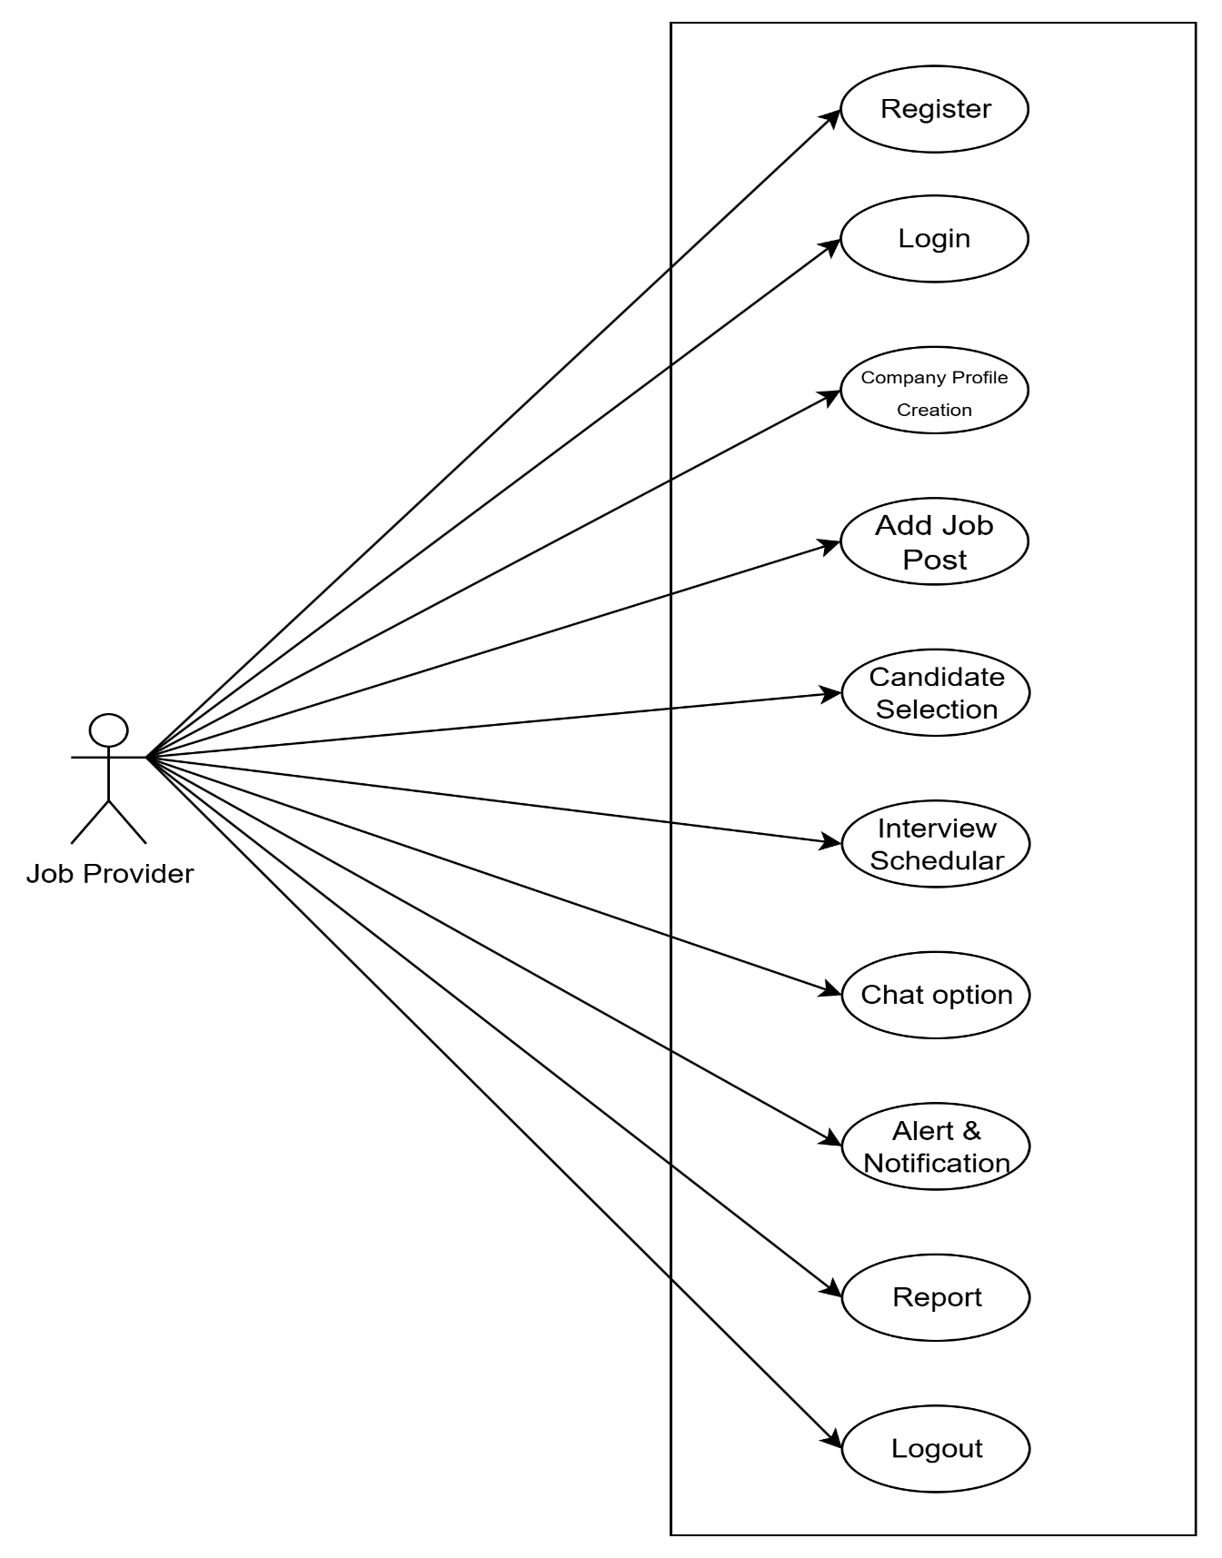

**2.2.3 Platform Admin**

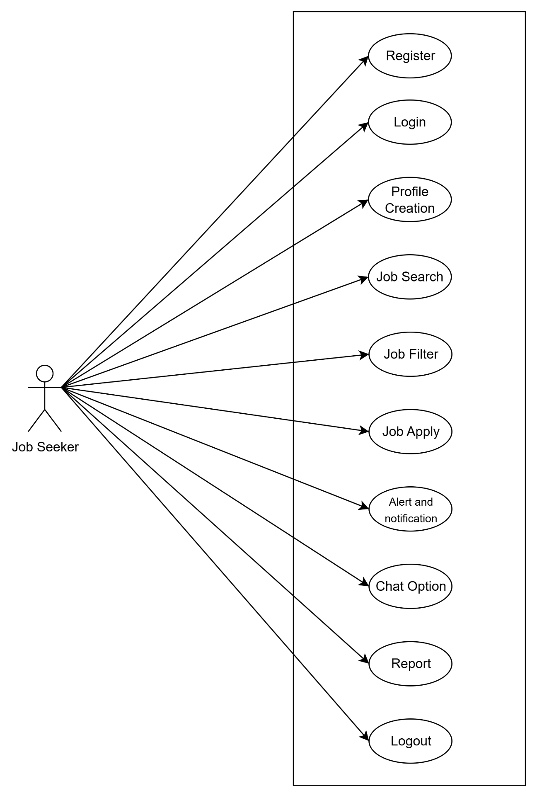

**2.2.3 Platform Admin**

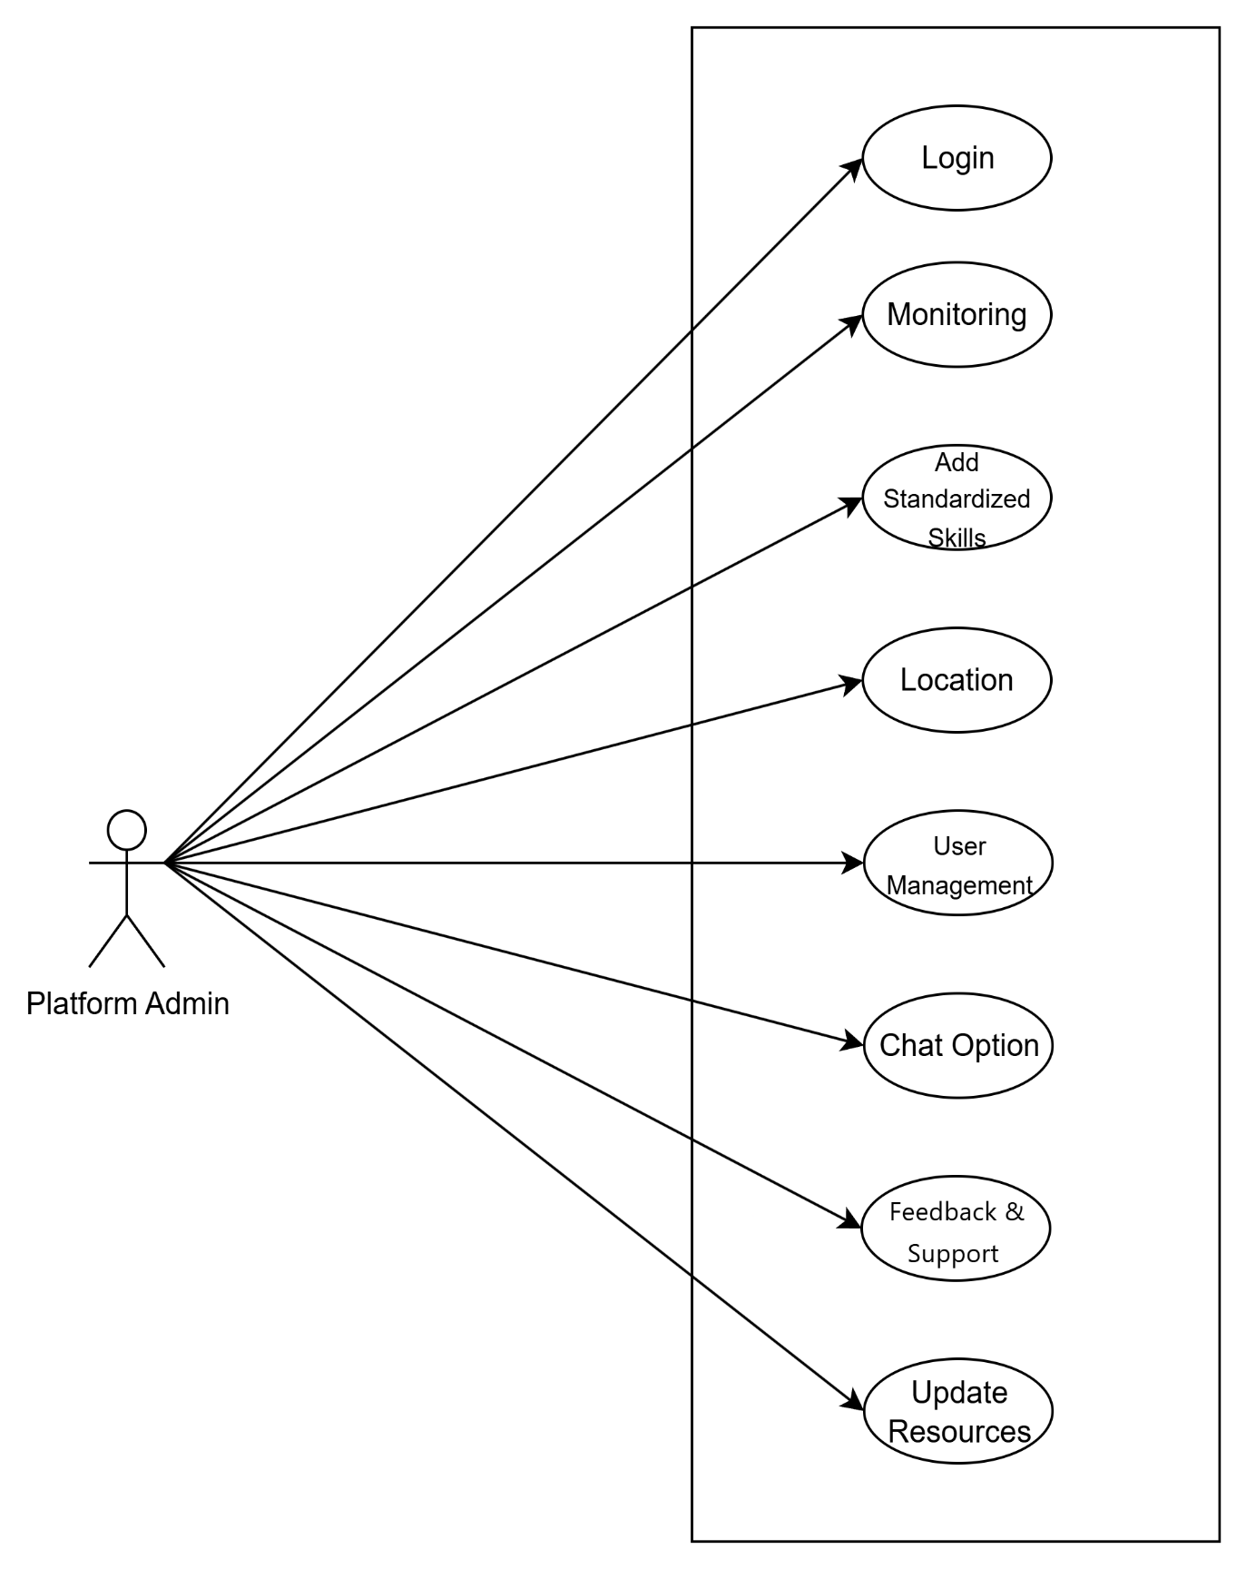

**2.3 User Story**

User stories are short, informal descriptions of a software feature written from the end user's perspective, focusing on what the user wants and why. They help teams understand user needs, prioritize development work, and deliver value in agile software development.

**2.3.1 Job Seeker**

* As a job seeker, I need to create my profile so that job providers can view my qualifications and experiences.
* As a job seeker, I want to search and filter jobs so that I can find positions relevant to my skills and interests.
* As a job seeker, I need to apply for jobs so that I can be considered for work opportunities matching my profile.

**2.3.2 Job Provider**

* As a job provider, I need to create a company profile so that job seekers can learn about my organization.
* As a job provider, I want to add job posts so that I can announce open positions and attract applicants.
* As a job provider, I want to communicate with job seekers using chat options so that I can clarify queries and finalize interviews.

**2.3.3 Platform Admin**

* As a platform amin I need to login to the application, so that I can provide my individual information for using the application as a platform admin.
* As a platform admin, I need to add standardized skills so that job listings and profiles remain consistent and searchable.
* As a platform admin, I need to handle feedback and support so that I can address user complaints and improve the system based on user input.

**2.4 BPMN**

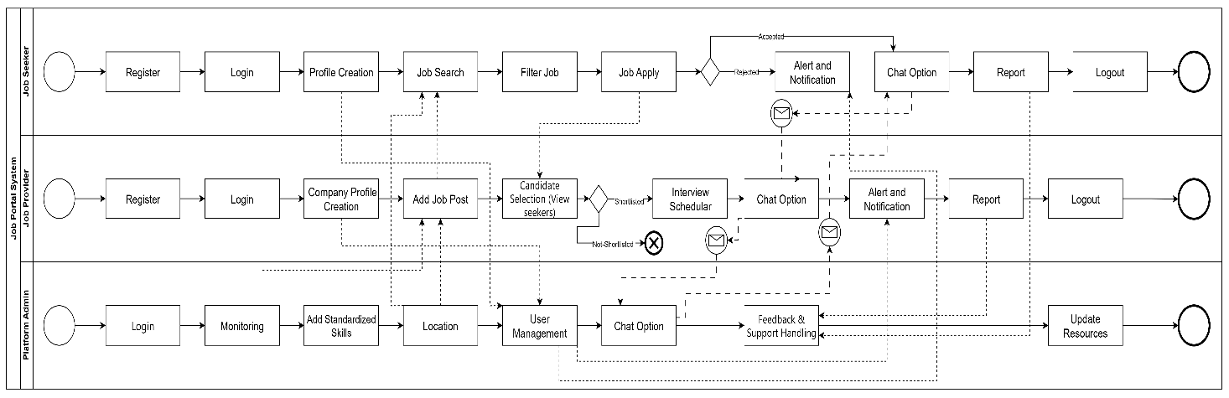

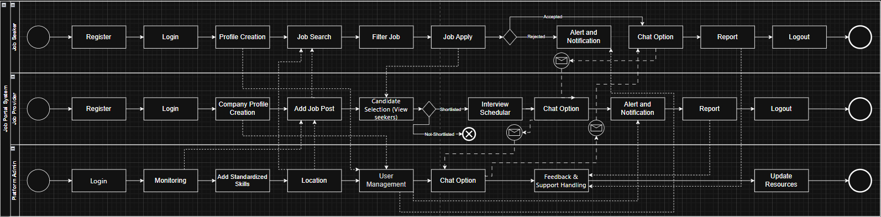

**3.NON FUCTIONAL REQUIREMENT**

Efficiency Requirement

When an “Online Job Portal and recruitment system” is implemented job

seekers and employers can view and upload job vacancies respectively from

their homes easily without any difficulty.

Usability Requirement

The “Online Job Portal and recruitment system” is designed for a user-friendly

environment and ease of use.

Reliability Requirement

The system should provide a reliable environment for both employers and job

seekers. All jobs should be reaching the admin without any errors and should

be shown to the viewers.

Database Security

An unauthorized person cannot access the panel and database, and do not

read and write the information.

**4. Technical Requirements**

The technical requirements of the job portal system define the hardware, software and development tools necessary to build and operate platform effectively.

These requirements ensure that the system is developed using modern, secure, and scalable technologies, while maintaining compatibility with current industry standards.

**Hardware Requirements**

Component Specification

Processor : Intel core i5

RAM : 16 GB

Storage : 512GB SSD

Internet : High Speed Connection (minimum 10 Mbps)

System Type : 64-bit operating system, x64-based processor

Operating System : Windows 10

**Software Requirements**

Component Specification

Operating System : Windows 10

Frontend : Html5, CSS3, JavaScript, Bootstrap

Backend : ASP.NET / .NET Core

Database : Microsoft SQL Server

**5. CONCLUSION**

In conclusion, this Software Requirements Specification (SRS) document has

comprehensively outlined the requirements and specifications for the development of the

Job Portal System. The objective of this document is to provide a clear understanding of the

project& scope, functionalities, and constraints to all stakeholders involved in its

development and implementation.

Throughout this document, we have outlined the following key points:

Project Scope: We have defined the boundaries and objectives of the Job Portal System,

including the features it will offer, user roles, and external interfaces.

Functional Requirements: A detailed breakdown of the system& functions, such as user

registration, job posting, search and filtering, and application submission, has been

provided.

Non-Functional Requirements: We have specified the performance, security, usability, and

scalability requirements that the system must adhere to.

In light of the outlined requirements, it is imperative that all client, including developers,

designers, testers, and project managers, refer to this SRS document as the authoritative

source of truth throughout the project& lifecycle. Regular reviews and updates to this

document will be necessary to accommodate changing project needs and evolving client

expectations.

The successful development and deployment of the Job Portal System will depend on strict

adherence to the specifications laid out in this SRS document. Therefore, it is

recommended that all parties involved in this project maintain open lines of communication,

engage in rigorous testing and validation processes, and actively manage risks to ensure

the system& success.

This SRS document represents the foundation upon which the Job Portal System will be

built. With diligent planning, execution, and ongoing refinement, we are confident that the

final product will meet the expectations of our client and provide a valuable platform for job.