**Software Requirements Specification**

**For**

**Job Portal System**

**Version 1.0**

**Prepared By Arshana Thasni**

**Aitrich**

**17-05-25**

**Table of Contents**

1. **Introduction 2**

**1.1 Purpose 2**

**1.2 Scope 3**

**1.3 Objectives 4**

**2. Functional Requirements 5**

**2.1 Primary actors of the system 5**

**2.2 Use Case Diagram 5**

**2.2.1 Job Seeker 5**

**2.2.2 Job Provider 5**

**2.2.3 Platform Admin 5**

**2.3 User Stories 6**

**2.2.1 Job Seeker 6**

**2.2.2 Job Provider 6**

**2.2.3 Platform Admin 6**

**2.4 Business Process Diagram 7**

**3. Non-Functional Requirements 8**

**4. Technical Requirements 8**

**5. Conclusion 9**

JOB PORTAL

Software Requirements Specification (SRS)

**1. INTRODUCTION**

The Job Portal System is a web-based platform designed to act as a bridge between job seekers and employers. It provides a centralized environment where job seekers can register, maintain profiles, upload résumés, search for relevant job openings, and submit applications. At the same time, employers can register, post job vacancies, review applications, and manage recruitment activities more efficiently. By automating these processes, the system reduces manual effort, saves time, and improves transparency in hiring.

This document specifies the software requirements for the Job Portal System. It defines the system’s objectives, scope, key features, and constraints to ensure a common understanding among stakeholders. Clearly describing the requirements at this stage helps align expectations, prioritize essential functionalities, address scalability and security needs, improve user experience, and support accurate estimation of cost and development timelines.

**1.1 PURPOSE**

The purpose of the Job Portal System is to provide a reliable, user-friendly, and centralized platform that enables job seekers and employers to interact efficiently. Job seekers can create and maintain profiles, upload résumés, search and filter job openings, and apply online, while employers can register, post vacancies, manage applications, and communicate directly with potential candidates. By digitizing these activities, the system eliminates traditional barriers, reduces manual processes, and accelerates the recruitment cycle.

This document defines the functional and non-functional requirements of the Job Portal System to ensure a clear understanding among all stakeholders, including developers, testers, project managers, and end users. The purpose of specifying these requirements is to align expectations, establish a baseline for design and development, enhance system scalability and security, and support accurate estimation of cost, resources, and timelines for successful implementation.

**1.2 SCOPE**

It includes designing separate login panels for users, administrators, and employees. The website front end will feature panel for new jobs, search options by sector, country, and keywords, and the ability for users to upload resumes, apply for jobs, and find premium or instant posts.

The main functionalities and features of a job portal system are designed to serve the needs of both job seekers and employers. Here are the key functionalities and features typically included in such a system:

* Search and Filter Tools
* Application Management
* User Profiles and Accounts
* Messaging and Notifications
* Alerts and Recommendations

In a job portal system, there are typically several distinct user roles or types of users, each with specific privileges and responsibilities. The primary user roles include:

**Job Seekers**: Job seekers are individuals who are actively seeking employment opportunities. They use the job portal system to search for job openings, submit applications, and manage their job-seeking activities. Job seekers may have the following capabilities:

Create and manage a profile with personal and professional information.

Search for job listings based on various criteria such as job title, location, and experience level.

Apply for job openings by submitting resumes, cover letters, and other required documents.

Receive notifications about new job postings, application status updates, and messages from employers

**Job provider**: Employers or recruiters are organizations or individuals responsible for hiring new employees. They use the job portal system to post job openings, manage applications, and communicate with job seekers. Employers may have the following capabilities:

Create and manage an employer account with company information and job postings.

Post job openings with detailed descriptions, requirements, and application instructions.

Review and manage applications from job seekers, including screening resumes and communicating with applicants.

**Platform Admin**: Administrators are responsible for managing and maintaining the job portal system. They have overall control and authority over the system's configuration, user management, and content moderation. Administrators may have the following capabilities:

Manage user accounts and permissions, including creating, editing, and disabling accounts.

Monitor and moderate user-generated content, such as job listings, resumes, and messages, to ensure compliance with platform policies and regulations.

**1.3 Objectives**

Overall, the high-level objectives of a job portal system aim to create a comprehensive and user-centric platform that effectively connects job seekers with employers, streamlines the recruitment process, enhances access to opportunities, and facilitates informed decision-making in the job market. Overall, the job portal system aims to address various goals and problems in the recruitment process, ultimately improving efficiency, transparency, and satisfaction for both job seekers and employers.

The job portal system aims to address several goals and problems related to the recruitment process for both job seekers and employers. Here are the main objectives or goals of the system,

* Efficient Matching
* Time and Cost Savings
* Increased Access to Opportunities
* Transparency and Accessibility
* Improved Candidate Experience

Overall, the objectives of the job portal system revolve around improving the efficiency, transparency, and satisfaction of the recruitment process for both job seekers and employers. By addressing these goals, the system aims to facilitate better matches between candidates and job opportunities, ultimately benefiting all parties involved in the recruitment process.

**2. FUNCTIONAL REQUIREMENT**

The Job Portal System shall allow job seekers to register, create and update personal profiles, upload résumés and supporting documents, search and filter job listings by various criteria such as title, sector, location, and experience level, and submit applications directly through the platform. Job seekers shall also receive automated notifications regarding new job postings, application status updates, and messages from employers. The system shall support secure authentication, profile management, and activity tracking for each job seeker account.

Employers (job providers) shall be able to register and manage company profiles, post detailed job openings with descriptions and requirements, review and manage received applications, and communicate with applicants through an integrated messaging system. Administrators shall have full control over system configuration, user management, and content moderation, including the ability to create, edit, or deactivate accounts and monitor job postings, résumés, and messages to ensure compliance with policies. The system shall also support premium or featured postings, role-based access control, and generate alerts or reports as required by each user role.

**2.1 Primary actors of the system**

In the context of a job portal system, Primary Actors of the System refers to the main types of Users or entities that interact directly with the system and perform essential roles. These primary actors are typically:

Job Seeker : An individual looking for employment who registers on the portal, creates a profile, searches, filters, and applies for jobs, communicates with providers, and receives notifications.

Job Provider : Companies or recruiters who register, create job posts, review candidate applications, shortlist candidates, schedule interviews, communicate with seekers, and manage notifications.

Platform Admin : The system administrator responsible for monitoring the portal’s health, managing user accounts, updating resources, handling feedback and support, and ensuring smooth platform operations.

Identifying these actors helps define the system boundaries and clarifies who the key users are, guiding the design and development of features tailored to each role's needs.

**2.2 Use Case diagram**

**2.2.1 Job Provider**

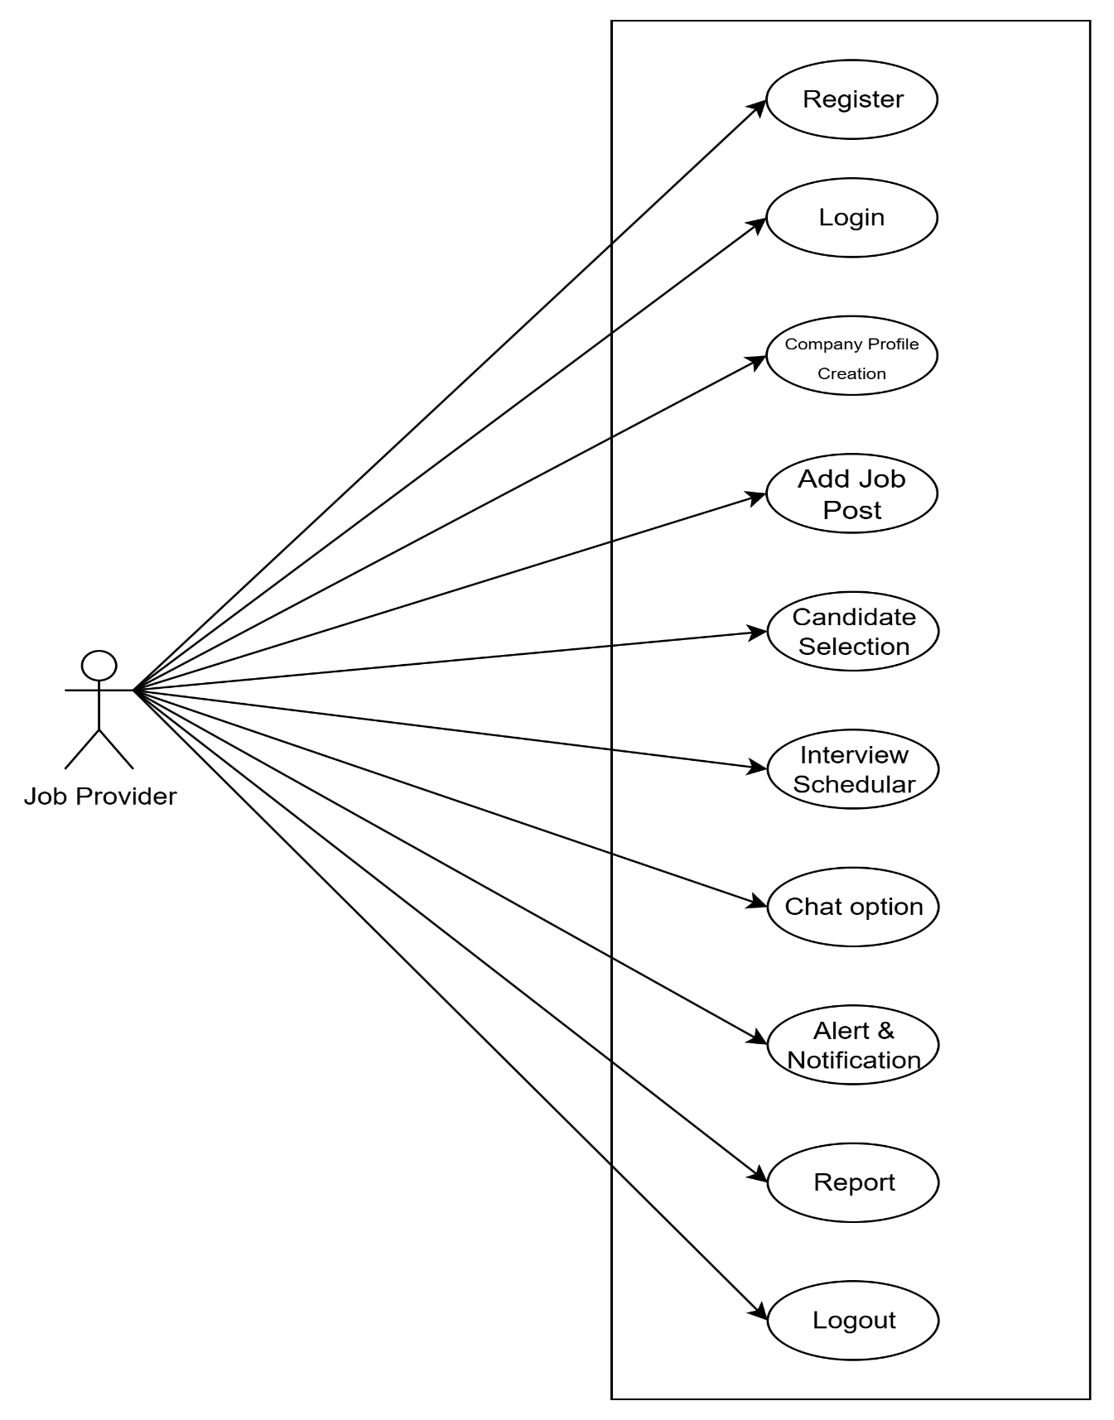

**2.2.2 Job Seeker**

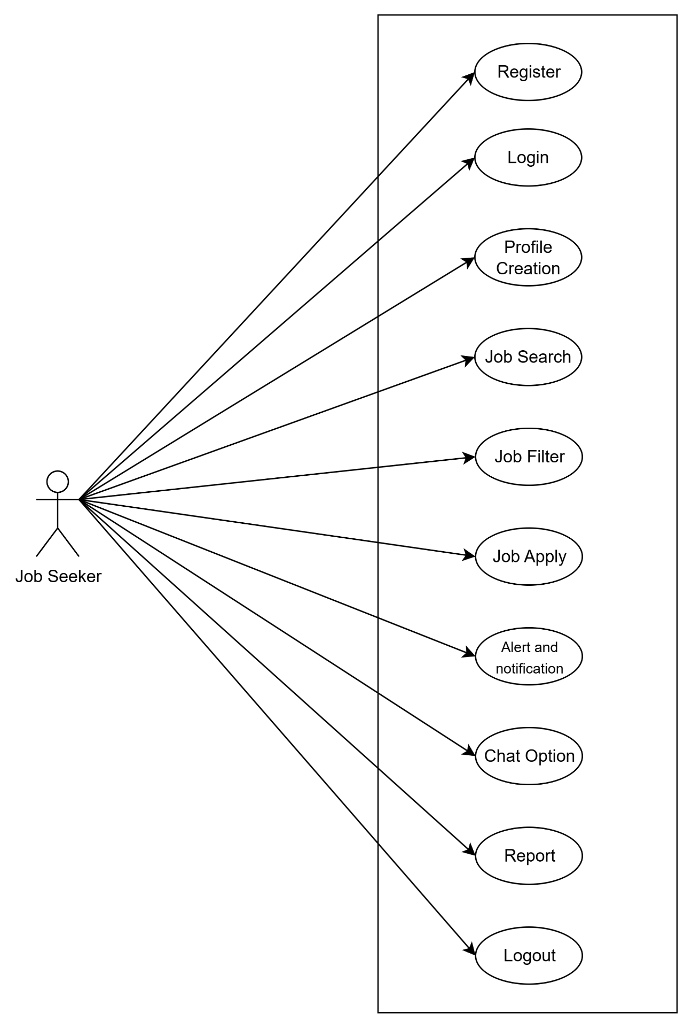

**2.2.3 Platform Admin**

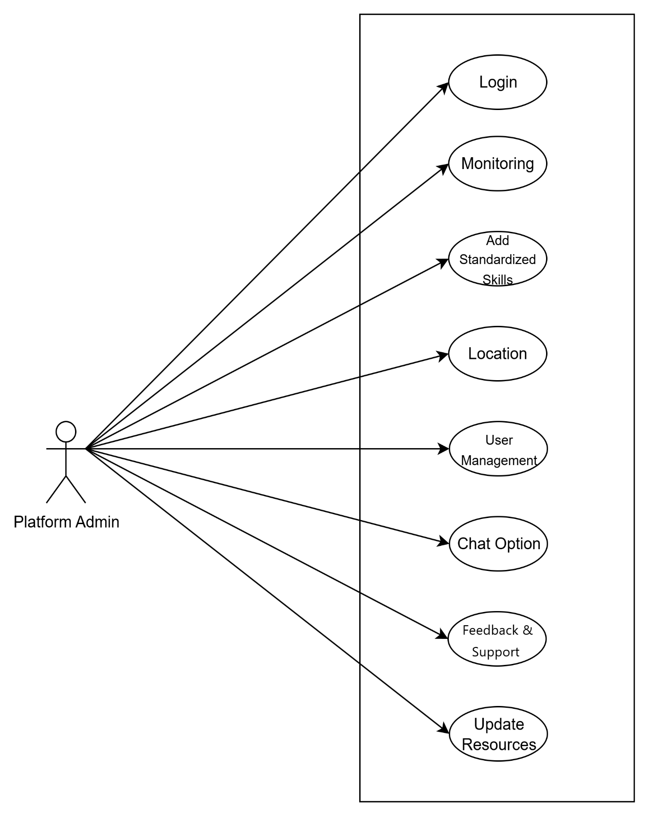

**2.3 User Story**

User stories are concise, easy-to-understand descriptions of a feature told from the perspective of the end user. They capture who the user is, what they want to achieve, and why it matters. By framing requirements this way, development teams can better understand user needs, prioritize features, and ensure the software delivers meaningful value throughout the agile development process

**2.3.1 Job Seeker**

* As a job seeker, I need to create my profile so that job providers can view my qualifications and experiences.
* As a job seeker, I want to search and filter jobs so that I can find positions relevant to my skills and interests.
* As a job seeker, I need to apply for jobs so that I can be considered for work opportunities matching my profile.

**2.3.2 Job Provider**

* As a job provider, I need to create a company profile so that job seekers can learn about my organization.
* As a job provider, I want to add job posts so that I can announce open positions and attract applicants.
* As a job provider, I want to communicate with job seekers using chat options so that I can clarify queries and finalize interviews.

**2.3.3 Platform Admin**

* As a platform amin I need to login to the application, so that I can provide my individual information for using the application as a platform admin.
* As a platform admin, I need to add standardized skills so that job listings and profiles remain consistent and searchable.
* As a platform admin, I need to handle feedback and support so that I can address user complaints and improve the system based on user input.

**2.4 BPMN**

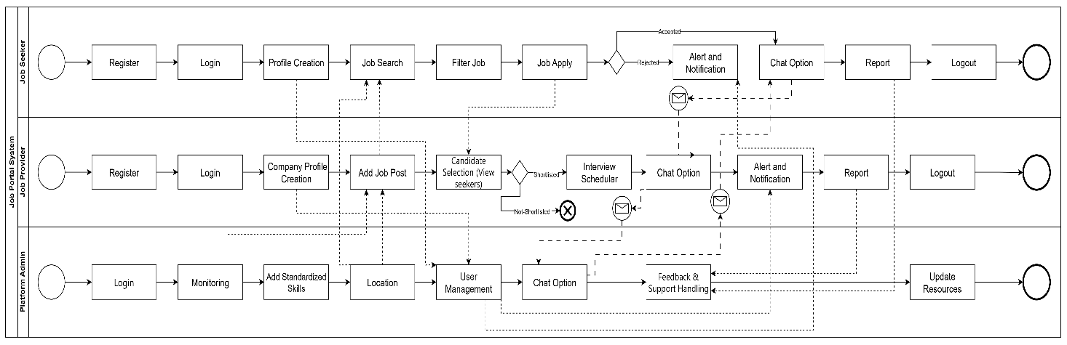

**3.NON FUCTIONAL REQUIREMENT**

Efficiency Requirement

When an “Online Job Portal and recruitment system” is implemented job

seekers and employers can view and upload job vacancies respectively from

their homes easily without any difficulty.

Usability Requirement

The “Online Job Portal and recruitment system” is designed for a user-friendly

environment and ease of use.

Reliability Requirement

The system should provide a reliable environment for both employers and job

seekers. All jobs should be reaching the admin without any errors and should

be shown to the viewers.

Database Security

An unauthorized person cannot access the panel and database, and do not

read and write the information.

**4. Technical Requirements**

The technical requirements of the job portal system define the hardware, software and development tools necessary to build and operate platform effectively.

These requirements ensure that the system is developed using modern, secure, and scalable technologies, while maintaining compatibility with current industry standards.

**Hardware Requirements**

Component Specification

Processor : Intel core i5

RAM : 16 GB

Storage : 512GB SSD

Internet : High Speed Connection (minimum 10 Mbps)

System Type : 64-bit operating system, x64-based processor

Operating System : Windows 10

**Software Requirements**

Component Specification

Operating System : Windows 10

Frontend : Html5, CSS3, JavaScript, Bootstrap

Backend : ASP.NET / .NET Core

Database : Microsoft SQL Server

**5. CONCLUSION**

The Job Portal System outlined in this Software Requirements Specification is designed to provide a robust, scalable, and user-friendly platform that bridges the gap between job seekers and employers. By consolidating job postings, applications, and communications into a single, streamlined environment, the system aims to simplify the recruitment process and enhance the overall experience for all stakeholders. Clearly defined roles and functionalities for job seekers, employers, and administrators ensure that each group can perform its tasks efficiently and securely.

Through features such as advanced job search and filtering, application management, messaging, and notifications, the system empowers job seekers to explore a wide range of opportunities and apply quickly and effectively. At the same time, employers benefit from the ability to post jobs, review applications, and directly engage with qualified candidates, thus reducing time-to-hire and improving recruitment outcomes. Administrators maintain oversight of platform activity, ensuring compliance with policies and safeguarding data integrity and privacy.

The specification of functional and non-functional requirements, along with user stories and defined scopes, provides a solid foundation for the system’s design and development. It ensures alignment among stakeholders, helps prioritize essential features, and reduces the risk of scope creep or misunderstanding during implementation. This clarity also enables more accurate cost estimation, scheduling, and resource allocation for successful project delivery.

In conclusion, the Job Portal System will serve as a comprehensive and reliable solution for modern recruitment needs. By adhering to the requirements specified in this document, the development team can build a platform that not only meets the expectations of its users but is also secure, scalable, and adaptable to future enhancements. This will ultimately create a sustainable and efficient ecosystem where job seekers and employers can connect with ease and confidence.