FOOD MANAGEMENT SYSTEM

# Abstract

Customer satisfaction is the key to success for any business. In a

restaurant, the traditional hand-waving method for calling services is

inefficient often leading to many complaints. The Restaurant Management

System increases operational efficiency through use of an internal wired

communications system. The communications system increases customer

satisfaction by leaving a system at each table which the customer can use to

request for a server. This system allows managers and owners to easily monitor

restaurant functions and employee progress.

In many popular restaurants, waiters/waitresses tend to miss out

on tables or customers’ calls during busy hours potentially decreasing ones

clientele. While this is an ongoing issue, there is still no product that

drastically improves the communication between the servers and the

customers in the current market. Hence, the goal is to design a system in

which the customers can call their servers easily and help the restaurant

increase overall efficiency.

Customer satisfaction is the key to success for any business. In a

restaurant, the traditional hand-waving method for calling services is

inefficient often leading to many complaints. The Restaurant Management

System increases operational efficiency through use of an internal wired

communications system. The communications system increases customer

satisfaction by leaving a system at each table which the customer can use to

request for a server. This system allows managers and owners to easily monitor

restaurant functions and employee progress.

In many popular restaurants, waiters/waitresses tend to miss out

on tables or customers’ calls during busy hours potentially decreasing ones

clientele. While this is an ongoing issue, there is still no product that

drastically improves the communication between the servers and the

customers in the current market. Hence, the goal is to design a system in

which the customers can call their servers easily and help the restaurant

increase overall efficiency.

The Online Restaurant Management System provides convenience for the customers. It overcomes the disadvantages of the traditional queuing system. This system increases the takeaway of foods than visitors. Therefore, this system enhances the speed and standardization of taking the order from the customer. It provides a better communication platform. The user’s details are noted electronically. This System set up menu online and the customers easily places the order with a simple mouse click. By using the food menu online anyone can easily track the orders, maintain customer's database and improve food delivery service. This system allows the user to select the desired food items from the displayed menu. The user orders the food items. The payment can be made online or pay-on-delivery system. The user’s details are maintained confidential because it maintains a separate account for each user.

An Online Food Ordering System is proposed here which simplifies the food ordering process. The proposed system shows an user interface and update the menu with all available options so that it eases the customer work. Customer can choose more than one item to make an order and can view order details before logging off. The order confirmation is sent to the customer. The order is placed in the queue and updated in the database and returned in real time. This system assists the staff to go through the orders in real time and process it efficiently with minimal errors.

Customer satisfaction is the key to success for any business. In a

restaurant, the traditional hand-waving method for calling services is

inefficient often leading to many complaints. The Restaurant Management

System increases operational efficiency through use of an internal wired

communications system. The communications system increases customer

satisfaction by leaving a system at each table which the customer can use to

request for a server. This system allows managers and owners to easily monitor

restaurant functions and employee progress.

In many popular restaurants, waiters/waitresses tend to miss out

on tables or customers’ calls during busy hours potentially decreasing ones

clientele. While this is an ongoing issue, there is still no product that

drastically improves the communication between the servers and the

customers in the current market. Hence, the goal is to design a system in

which the customers can call their servers easily and help the restaurant

increase overall efficiency.

Customer satisfaction is the key to success for any business. In a

restaurant, the traditional hand-waving method for calling services is

inefficient often leading to many complaints. The Restaurant Management

System increases operational efficiency through use of an internal wired

communications system. The communications system increases customer

satisfaction by leaving a system at each table which the customer can use to

request for a server. This system allows managers and owners to easily monitor

restaurant functions and employee progress

The Online Restaurant Management System provides convenience for the customers. It overcomes the disadvantages of the traditional queuing system. This system increases the takeaway of foods than visitors. Therefore, this system enhances the speed and standardization of taking the order from the customer. It provides a better communication platform. The user’s details are noted electronically. This System set up menu online and the customers easily places the order with a simple mouse click. By using the food menu online anyone can easily track the orders, maintain customer's database and improve food delivery service. This system allows the user to select the desired food items from the displayed menu. The user orders the food items. The payment can be made online or pay-on-delivery system. The user’s details are maintained confidential because it maintains a separate account for each user. The Online Restaurant Management System provides convenience for the customers. It overcomes the disadvantages of the traditional queuing system. This system increases the takeaway of foods than visitors. Therefore, this system enhances the speed and standardization of taking the order from the customer. It provides a better communication platform. The user’s details are noted electronically. This System set up menu online and the customers easily places the order with a simple mouse click. By using the food menu online anyone can easily track the orders, maintain customer's database and improve food delivery service. This system allows the user to select the desired food items from the displayed menu. The user orders the food items. The payment can be made online or pay-on-delivery system. The user’s details are maintained confidential because it maintains a separate account for each user. The Online Restaurant Management System provides convenience for the customers. It overcomes the disadvantages of the traditional queuing system. This system increases the takeaway of foods than visitors. Therefore, this system enhances the speed and standardization of taking the order from the customer. It provides a better communication platform. The user’s details are noted electronically. This System set up menu online and the customers easily places the order with a simple mouse click. By using the food menu online anyone can easily track the orders, maintain customer's database and improve food delivery service. This system allows the user to select the desired food items from the displayed menu. The user orders the food items. The payment can be made online or pay-on-delivery system. The user’s details are maintained confidential because it maintains a separate account for each user. The Online Restaurant Management System provides convenience for the customers. It overcomes the disadvantages of the traditional queuing system. This system increases the takeaway of foods than visitors. Therefore, this system enhances the speed and standardization of taking the order from the customer. It provides a better communication platform. The user’s details are noted electronically. This System set up menu online and the customers easily places the order with a simple mouse click. By using the food menu online anyone can easily track the orders, maintain customer's database and improve food delivery service. This system allows the user to select the desired food items from the displayed menu. The user orders the food items. The payment can be made online or pay-on-delivery system. The user’s details are maintained confidential because it maintains a separate account for each user. The Online Restaurant Management System provides convenience for the customers. It overcomes the disadvantages of the traditional queuing system. This system increases the takeaway of foods than visitors. Therefore, this system enhances the speed and standardization of taking the order from the customer. It provides a better communication platform. The user’s details are noted electronically. This System set up menu online and the customers easily places the order with a simple mouse click. By using the food menu online anyone can easily track the orders, maintain customer's database and improve food delivery service. This system allows the user to select the desired food items from the displayed menu. The user orders the food items. The payment can be made online or pay-on-delivery system. The user’s details are maintained confidential because it maintains a separate account for each user.

Customer satisfaction is the key to success for any business. In a

restaurant, the traditional hand-waving method for calling services is

inefficient often leading to many complaints. The Restaurant Management

System increases operational efficiency through use of an internal wired

communications system. The communications system increases customer

satisfaction by leaving a system at each table which the customer can use to

request for a server. This system allows managers and owners to easily monitor

restaurant functions and employee progress.

In many popular restaurants, waiters/waitresses tend to miss out

on tables or customers’ calls during busy hours potentially decreasing ones

clientele. While this is an ongoing issue, there is still no product that

drastically improves the communication between the servers and the

customers in the current market. Hence, the goal is to design a system in

which the customers can call their servers easily and help the restaurant

increase overall efficiency.

# Introduction

Online Restaurant Management System is a project which is referred to as a set of detail methods that is being used in handling the ordering process. Food ordering can be computerized or done manually. Those helps the customer to order their food themselves which is known as the customer self-ordering system. The customer self-ordering system can be defined as a computerized system that is being used by customers to place their own orders in the restaurant and allow the orders to be tracked, in order to prepare and deliver the food to the computers. Admin is the most powerful user of the system.

Online restaurant is a process of ordering food from a local restaurant through a web page. Much like ordering consumer goods online, many of these allow customers to keep accounts with them in order to make frequent ordering convenient. A customer choose from available items, and choose delivery or pick-up.

This project Online restaurant aim to be developed and brought to the market for maximum use and to create an avenue through the web where users can log on to our server and make a selection of whatever food they like. The following are the objectives this would bring:

1. The home page of this web interfile provides an avenue where customers will be able to gather more and reliable information about what the fast food industry really does.

2. The products and services offered would provide the customers with all the different categories of available products that they can choose and select from.

3. This will provide a user friendly environment between the customer and admin thus increasing the efficiency of the food ordering system.

arises.

4. It will also help for easy retrieval of orders made by the customers

# System Model

The structure of the system can be divided into three main logical components. The first component is the web ordering system and provides the functionality for customers to place their order and supply all necessary details. The Second logical component is the order retrieval system, used by the restaurant to keep track of all orders which have been placed, this component takes care of retrieving and displaying order information, as well as updating orders which have already been processed. The third and final component is Management which is managed by Admin who can process the whole function.

**Customer Restaurant**

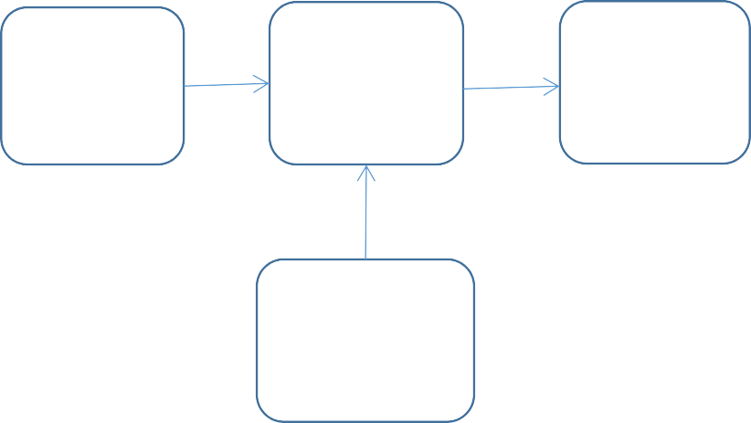

Web

Ordering System

**Database**

Order

Retrieval

Management

**Admin**

# General Use Case Diagram



Admin



User

Business Process Diagram



Start

Search

Splash

Screen

Restaurant

Details

Yes

Food Details

Login Home

No

Place Order/

cancel order

Registration

Exit

Payment

(C on D)

# Home Screen

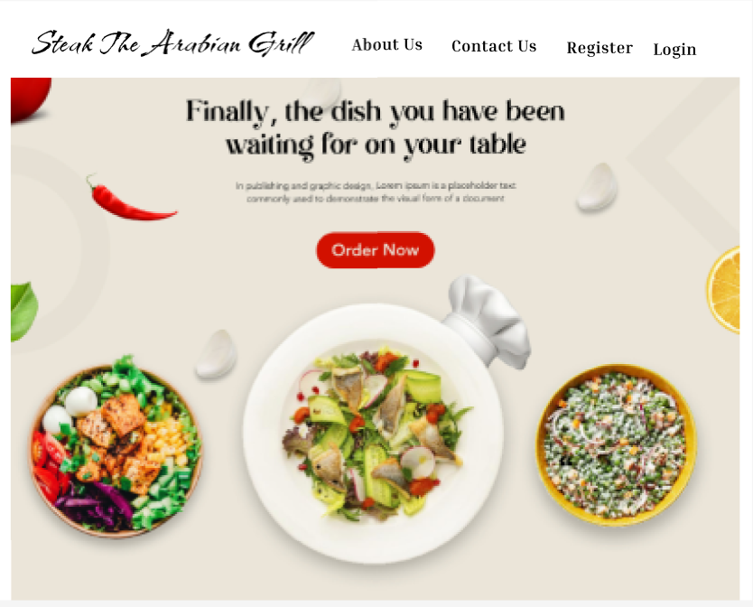

User Registration

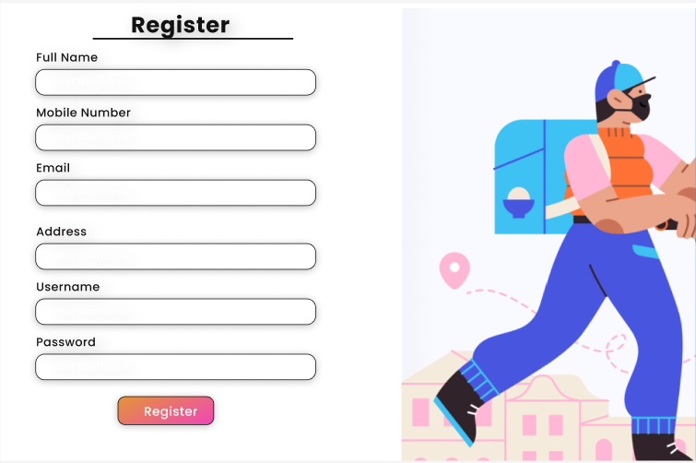

Login

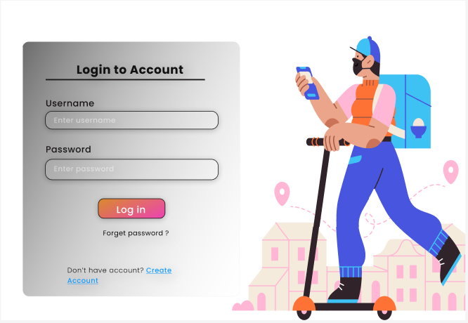

# Category

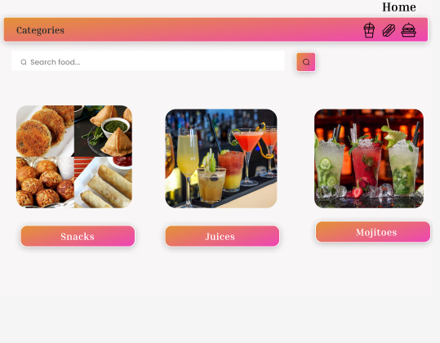

# Food Items

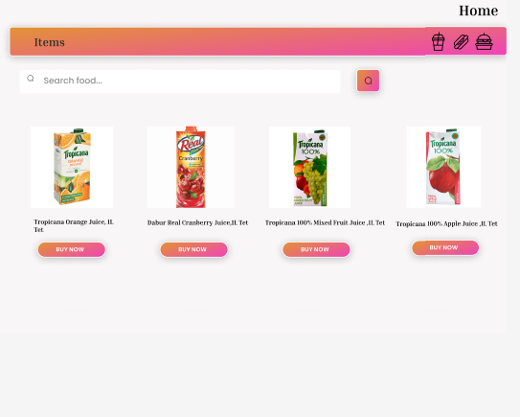

Order

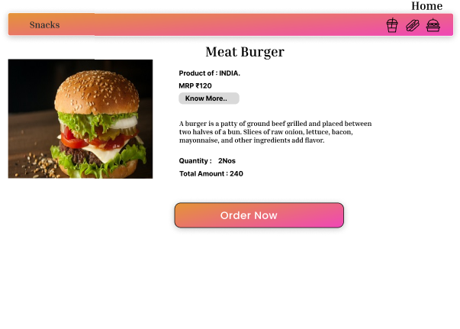

# Payment

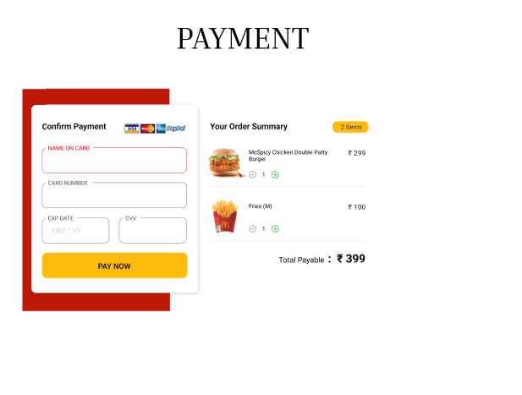

# ER Diagram

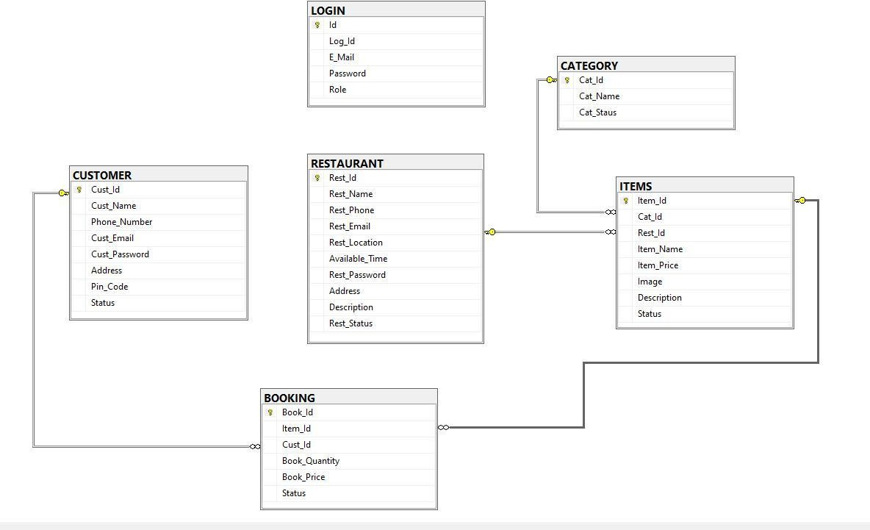

System Requirement

Our system can be used in window10, windows 7, and windows 8 with 32 bit, and 64 bit operating system.

• For Windows 7 and Windows 8 based computers, higher processor with 2 GB ram.

Software and Hardware Requirements

Software Requirements:

• Server side scripting tool: Asp.net

• Database tools: MYSQL

• Compatible operating system: Windows

.

Hardware Requirements:

• Hardware recommend by all the software needed.

• RAM: 256MB or more

• Hard Drive: 10 GB or more

• Communication hardware to serve client request

User Requirements

To deliver the best service to the users we tried to find out the users necessities which are below:

Administrator Aspect:

• Monitoring the whole system from admin panel.

• Taking back up of the database.

• Creating, deleting and modifying the records.

• Add customers

• Keeping the customer’s record like their details.

• Approve the notice to.

• Monitoring the transaction system.

Customer Aspect:

• Signing in and signing up to the system.

• Changing their password.

• Resetting forgot password.

Functional Requirements

This section provides requirement overview of the system. Various functional modules that can be implemented by the system will be

1. **Registration**

If customer wants to buy the product then he/she must be registered, unregistered user can’t go to the shopping cart.

1. **Login**

Customer logins to the system by entering valid user id and password for the shopping.

1. **Order Items**

the customer after login or registration can make order or cancel order of the food items.

1. **Payment**

In this system we are dealing the mode of payment by Cash. We will extend this to credit card,debit card etc in the future.

1. **Logout**

After ordering or surfing for the product customer has to logout.

# User Interface Specification

1. Login Page
2. Registration Form
3. There will be a screen displaying information about Food items and Restaurant
4. If the customers select the buy button then another screen of shopping cart will be opened.

# Non Functional Requirement

# In systems engineering and requirements engineering, a non-functional requirement is a requirement that specifies criteria that can be used to judge the operation of a system, rather than specific behaviours. They are contrasted with functional requirements that define specific behaviour or functions. The plan for implementing functional requirements is detailed in the system design. The plan for implementing non-functional requirements is detailed in the system architecture, because they are usually Architecturally Significant Requirements.

* Secure access to consumer’s confidential data and 24X7 availability.

# References

Other Food Delivery Apps Wikipedia