Exercise

Java Script

Aitrich Technologies Pvt. Ltd.
© All rights reserved.

Introduction

This document is a specification for the exercise problems for the topic, Java Script. It tests the student's level of knowledge and understanding of the topic.

This document consists of a set of problems that the student needs to solve and submit to the trainer, in the format specified in the Deliverable section of this document.

This exercise is to be performed only after the theory and workshop sessions of the topic, hence the student would have enough knowledge and confidence on the topic. Ideally, the student should be able to solve the problems himself/herself; however, he/she can seek the assistance of the trainer or lab assistant in case he/she is stuck with a specific problem.

Objectives

The objectives of this exercise are to test the student's understanding and knowledge on the topic, and to allow him to re-iterate his understanding by applying that knowledge in a software problem, so that he can use it in the further Programming endeavors.

Problem 1: Validate a form

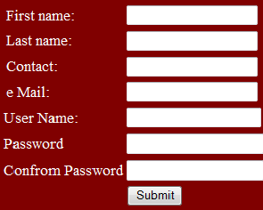

Features to be developed

The program should have the following features.

  - Check whether all the fields should be filled on submit
  - Numeric only validation for contact
  - Alphabets only for First name, last name
  - User name, password must have 8 character lengths
  - Check whether the password or Conform password are same

Problem 2: Make a calculator

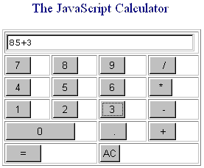

Features to be developed

The program should have the following features.

The calculator should perform all the function like
  - Addition
  - Subtraction
  - Multiplication
  - Division

Deliverable

- The entire program should be developed in a single Java Script and delivered as a zip archive.
- The zip archive should be accompanied by a summary document in Microsoft Word format, with the following sections
  - List each feature specified in this document, and explains how it is implemented,
  - How to execute the program(s).

Demo

The student should demonstrate the program to the instructor on a PC, by explaining the features one by one.

Conclusion

The completion of this exercise should re-iterate the student's confidence on Java Script. Please make sure you have gained enough confidence to move on.

