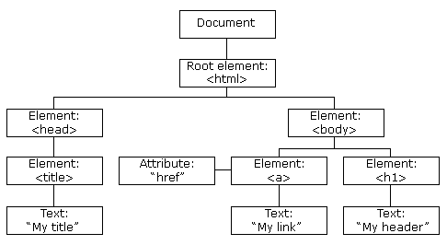

<!document>

<html>

<head>

<title>My title</title>

</head>

<body>

<a href=”Google.com”>My link</a>

<h1 id=”myhead”>my header</h1>

</body>

</html>

**Finding HTML Elements**

|  |  |
| --- | --- |
| **Method** | **Description** |
| document.getElementById(*id*) | Find an element by element id |
| document.getElementsByTagName(*name*) | Find elements by tag name |
| document.getElementsByClassName(*name*) | Find elements by class name |

**Changing HTML Elements**

|  |  |
| --- | --- |
| **Property** | **Description** |
| *element*.innerHTML =  *new html content* | Change the inner HTML of an element |
| *element*.*attribute = new value* | Change the attribute value of an HTML element |
| *element*.style.*property = new style* | Change the style of an HTML element |
| **Method** | **Description** |
| *element*.setAttribute*(attribute, value)* | Change the attribute value of an HTML element |

**Adding and Deleting Elements**

|  |  |
| --- | --- |
| **Method** | **Description** |
| document.createElement(*element*) | Create an HTML element |
| document.removeChild(*element*) | Remove an HTML element |
| document.appendChild(*element*) | Add an HTML element |
| document.replaceChild(*new, old*) | Replace an HTML element |
| document.write(*text*) | Write into the HTML output stream |

**Finding HTML Elements**

Often, with JavaScript, you want to manipulate HTML elements.

To do so, you have to find the elements first. There are several ways to do this:

* Finding HTML elements by id
* Finding HTML elements by tag name
* Finding HTML elements by class name
* Finding HTML elements by CSS selectors
* Finding HTML elements by HTML object collections