**Job Portal System**

**SRS**

**Table of contents**

**Introduction**

Purpose

Scope

Objectives

**Functional Requirements**

Primary actors of the system

Use Case Diagram

User stories

Business Process Diagram

**Non-Functional requirements**

**Technical Requirements**

**Conclusion**

**INTRODUCTION**

**Job Portal System** is an online platform designed to connect job seekers with job providers through the system admin.Each actors have their own role and permissions.Job seekers can search for the jobs and interact with the admin and job provider. Job seekers will get a list of jobs which are provided or posted by the job provider. Job providers can post the jobs and make updations. The **Job Portal System** has an admin that can manage both job seekers and job providers.

In this system job seekers,job providers and admin are playing important roles. Here job seekers can get an opportunity to search for the jobs which are posted by the job providers in distant places. So it is easy to search and apply for the jobs. They can search for their choices here. Job seekers profile will provide all the information about contact details.

**Purpose**

* It serves as a medium where job seekers can create profiles, upload resumes,and search for job openings across various industries and locations. Employers, on the other hand, can post job vacancies, review applicant profiles, and conduct the initial stages of the hiring process through the portal.

**Scope**

* The **Job Portal System** is providing more scopes into the job seekers career.They are getting more opportunities here, searching for jobs from their place.
* Based on his/her requirements, job seekers can search for the jobs.

**Objectives**

* This system will provide an open interaction between job seekers and job providers.
* In this job portal system job seekers can create a profile and enter the information also.
* Job providers can enter the jib vacancies and related information.

**FUNCTIONAL REQUIREMENTS**

**Primary actors of the system**

The primary actors of the job portal system are **job seekers, job providers** and **admin.** They will represent the main roles and interact with each other within the system to achieve specific goals. They were categorised based on their roles and responsibilities.

**1.Job Seeker**

Job seekers are persons who are looking for their career/job.They can interact with the system to create their profile,search for jobs, apply for jobs and manage their profile.Their primary actions are:

* Registering and creating a user profile.
* Search for jobs and filter them using keywords
* Save or apply for the jobs
* Track the status of your application.
* Logout from that system

**2.Job Provider**

Job Providers are also having a very important role in this job portal system. They can interact with the job seekers and admin. Job provider will post the job and go with edit/update. Their primary actions are:

* Registering and creating a user profile
* Post a job and edit/delete that job
* List out job seekers and view their profile
* Schedule an interview and edit/delete that interview
* Add member and provide chat with job seeker and admin
* Logout from that system

**3.Admin**

Admin has an important role here. That person can manage the profiles of the job seeker and job provider, block the profile of a job provider,pass the message to the job seeker and job provider ,etc. Their primary actions are:

* Login into the system by entering username and password.
* Block the profile if it is necessary.
* Enter skills for job post
* Logout from the system

**Use Case Diagrams**

**Admin Use Case Diagrams**

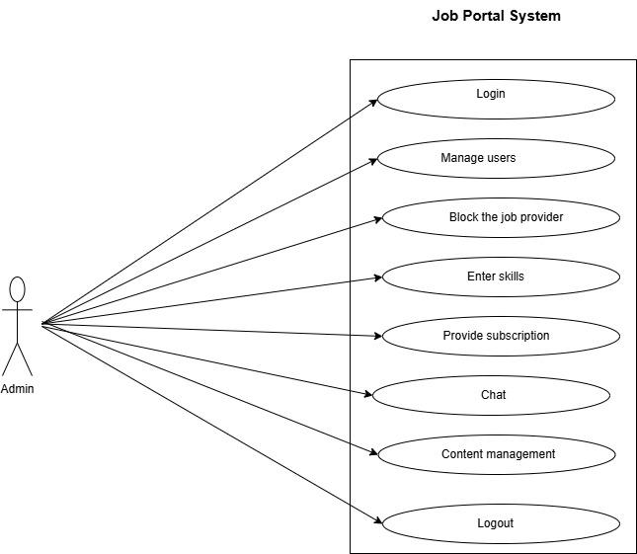

**Job Seeker Use Case Diagrams**

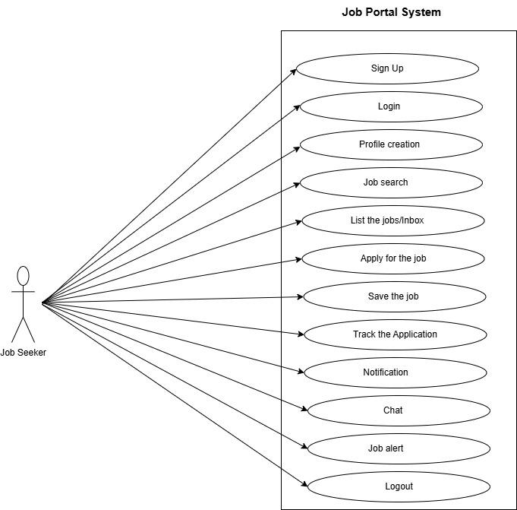

**Job Provider Use Case Diagrams**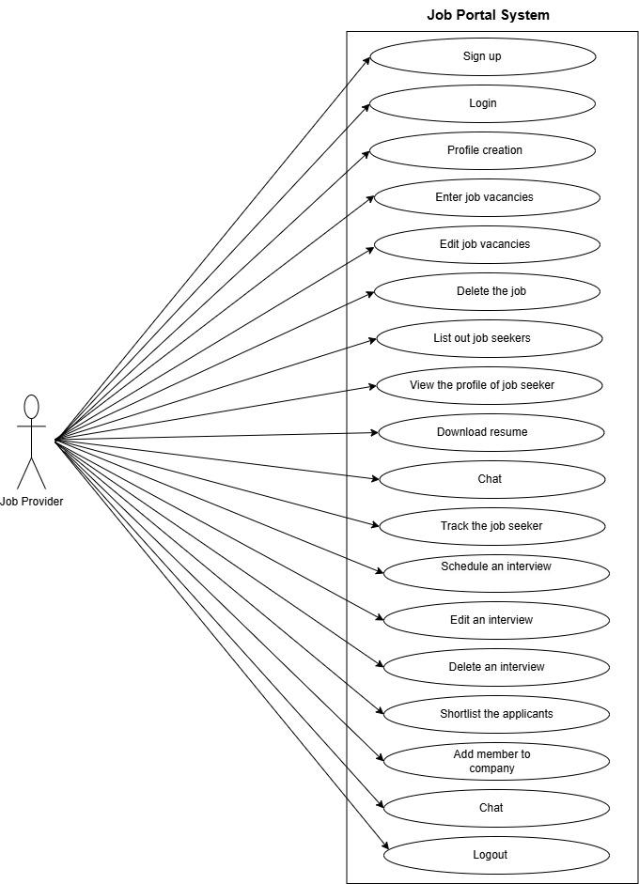

**User Stories**

**Admin User Stories**

| AS A [type of user] | I NEED TO [do some task] | SO THAT I CAN [get some result] |
| --- | --- | --- |
| Job Admin | Login into the job portal by entering username and password | Give permission to control the users in that jb portal |
| Job Admin | Load the dashboard page where is the admin features listed out | Select the features and allow some users to get into the job portal |
| Job Admin | Block the profile of job provider whose are sign up into that job portal | Block the job provider if he is doing illegal activities |
| Job Admin | Enter skills into the job vacancies | Control the job provider activities when they are entering vacancy details into the job portal. |
| Job Admin | Confirm the payment of the job seeker and job provider to give subscription into that job portal | Provide more features to them which are included in the subscription package of the job portal |
| Job Admin | Logout from the job portal | Unauthorised access will be prevented when the job admin is entering into the job portal by using username and password. |

**Job Seeker User Stories**

| AS A [type of user] | I NEED TO [do some task] | SO THAT I CAN [get some result] |
| --- | --- | --- |
| Job Seeker | Sign up into the portal if he is a new user | Get permission to enter in to the job portal for searching jobs |
| Job Seeker | Login into the job portal by entering username and password | Use the job portal facilities to search and find out the jobs. |
| Job Seeker | Create the profile by entering your educational and qualification details | Show my strength to the job providers |
| Job Seeker | Search for jobs with some keywords which are showing my needs | Find out the suitable jobs for me which are satisfying my needs |
| Job Seeker | List the jobs which are matching with my specified needs | Go through that vacancy descriptions and apply for that jobs |
| Job Seeker | Apply for the jobs from the listed jobs | Move forward with that application |
| Job Seeker | Save the job if currently i don’t want apply | Save the jobs to apply later |
| Job Seeker | Track the application status | Know about the status of that applied job |
| Job Seeker | Get alert about the newly added jobs into the portal | Get information about the new job vacancies. |
| Job Seeker | Get informed when a job provider scheduled for an interview | Prepare myself for that interview when I got informed early |
| Job Seeker | Chat with the job provider when they want to communicate with me | Communicate with the job providers about interview schedules  and much more. |
| Job Seeker | Logout from the job portal when my work is done | Secure my profile properly from unauthorised access. |

**Job Provider User Stories**

| AS A [type of user] | I NEED TO [do some task] | SO THAT I CAN [get some result] |
| --- | --- | --- |
| Job Provider | Login into the portal | Get permission to access the resume and view profile of the job seeker |
| Job Provider | Sign up into the job portal | Register/sign up into the job portal if he is first time entering into the job portal. |
| Job Provider | Create profile | Display my details there for providing jobs and much more. |
| Job Provider | Enter the job vacancies to the job portal | Showcase the job vacancies to the job seekers whose are login into the job |
| Job Provider | Edit the job vacancies if it is having any correction in that content | Show the current updates to the job seekers happened in that job vacancy |
| Job Provider | Delete the job vacancies if it is not existing . | Update the data in that job portal,if a job vacancy gets over that one will be deleted from that job portal. |
| Job Provider | List out the job seekers whose are applied into that job vacancy | Reach into the needful job seekers whose are having that qualification |
| Job Provider | View the profile of the job seekers to check the information about them | Take their resumes and contact information for further procedures |
| Job Provider | Download the resumes of the job seekers whose profile is matching with the requirements | Take out the information of the job seekers and communicate with them for forwarding their resumes for further procedures |
| Job Provider | Provide the chat option with job seekers and admin of that job portal also | Communicate with the job seekers about scheduling their interviews and communicate with the admin for getting help or information |
| Job Provider | Search for the job seekers within the job portal, whose profiles are matching with the keywords | Filter and list out the job seekers whose profile is matching with the search keywords |
| Job Provider | Track the application which is sent to the job seeker | Understand that it is delivered to the job seeker or it is remaining. |
| Job Provider | Schedule an interview with a job seeker when his profile matched with our requirements | Start communication with that job seeker and if he/she is ready to that job, we will schedule the date and time for that interview |
| Job Provider | Edit an interview which is already scheduled | Make changes in that interview schedule if it is having any correction. |
| Job Provider | Delete the interview if it having any reason | Delete the interview if it is not going to happen. |
| Job Provider | Add member if that person qualified in that interview | Add that member into the shortlisted ones. |
| Job Provider | Sort the job seekers whose are qualified in that interview | Sort them for further procedures. |
| Job Provider | Chat with the job seekers for communication | Communicate with them in future. |
| Job Provider | Logout from the job portal when the work is done. | Prevent the access of the job provider from that job portal. |

**BPMN Diagram**

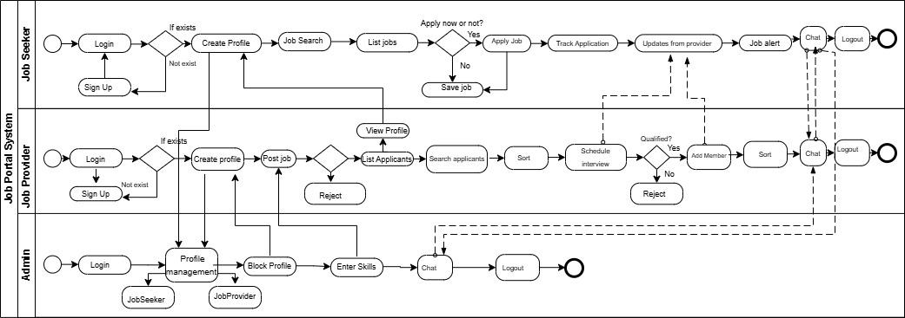

**NON-FUNCTIONAL REQUIREMENTS**

The non-functional requirements of the job portal system define the quality attributes and operational standards that the system must meet to deliver a seamless and efficient user experience.These requirements are critical to ensuring the system’s reliability,security and performance.

* Performance: The system must be able to manage many users at once, including both job providers and job seekers, without experiencing appreciable slowness or responsiveness issues.
* Reliability:The capacity of a software system to carry out its intended functions without failure, under specific conditions, and for a set amount of time is known as reliability, and it is a crucial non-functional requirement of software.
* Security: The methods, strategies, and safeguards used to keep software systems safe against unwanted access, use, disclosure, disruption, alteration, or destruction are collectively referred to as software system security.
* Usability: Usability is a critical non-functional requirement of software that refers to how easily and efficiently users can interact with the software to achieve their goals.
* Maintainability: A crucial non-functional requirement (NFR) of software is maintainability, which is the simplicity with which a software system may be updated, changed, or fixed to guarantee that it keeps up with evolving user demands.

**TECHNICAL REQUIREMENTS**

**HARDWARE REQUIREMENTS**

**Processor : Intel(R) Core(™) i5-8th Generation 8th**

**Installed RAM : 12.0 GB**

**SSD : 256GB**

**System type : 64-bit Operating system,x64-based processor**

**Operating System : Windows 11**

**SOFTWARE REQUIREMENTS**

**Web development : HTML, CSS3, JAVA Script, Bootstrap**

**Back-end Development : ASP.Net, frameworks, visual studio IDE**

**Front End : Angular**

**Databases : MS SQL Server**

**CONCLUSION**

The Job Portal System has been successfully completed, meeting its objectives and delivering a high-quality software solution. Throughout this project, our team has demonstrated exceptional skills, dedication, and collaboration, ensuring the timely delivery of the software.

The software developed during this project has been thoroughly tested, validated, and verified to ensure it meets the required specifications, functionality, and performance standards. The project's success can be attributed to the effective application of software development methodologies, tools, and techniques.

In conclusion, the successful completion of this software development project demonstrates our team's capabilities in designing, developing, and delivering high-quality software solutions that meet the needs of users and stakeholders.