Exercise #4

HTML Basics, Navigation
And Visual Elements

Aitrich Academy.

© All rights reserved.

Introduction

This document is a specification for the exercise problems for the topic,
HTML Basics, Navigation, Lists, Images and Iframes. It tests the student's level of knowledge and understanding of the topic.

This document consists of a set of problems that the student needs to solve and
submit to the trainer, in the format specified in the Deliverable section of this document.

This exercise is to be performed only after the theory and workshop sessions of the topic, hence the student would have enough knowledge and confidence on the topic. Ideally, the student should be able to solve the problems himself/herself; however, he/she can seek the assistance of the trainer or lab assistant in case he/she is stuck with a specific problem.

Objectives

The objectives of this exercise are to test the student's understanding and knowledge on the topic, and to allow him to re-iterate his understanding by applying that knowledge in a software problem, so that he can use it in the further Programming endeavors.

Problem 1: Create HTML page

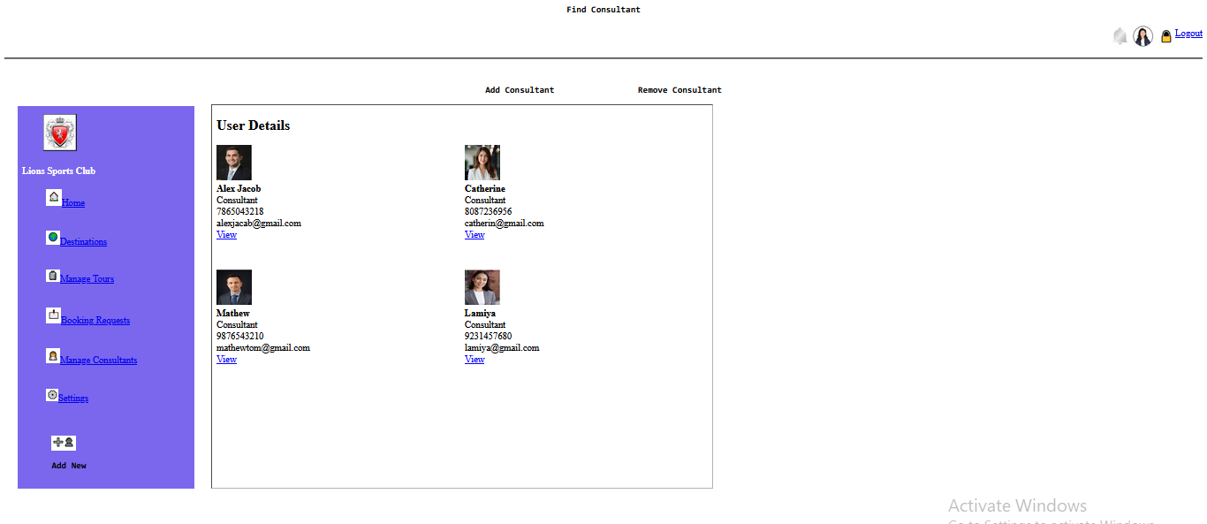

Features to be developed

The HTML page Which Contain
- Heading
- Paragraphs
- Other basic tags
- Image
- Use image
- Lists
- Hyperlinks
- Iframes

Deliverable
- The entire program should be developed in a single Basic HTML Tags, Navigation, Lists, Images and Iframes and delivered as a git hub link.

Demo

The student should demonstrate the program to the instructor on a PC, by explaining the features one by one.

Conclusion

The completion of this exercise should re-iterate the student's confidence on Basic HTML. Please make sure you have gained enough confidence to move on.

