Workshops

BOOTSTRAP

Aitrich Academy.
© All rights reserved.

Objectives
Students will enhance a basic Bootstrap travel page by implementing interactive and visual features found in the full version. This workshop focuses on layout refinement, component integration, and JavaScript interactivity using Bootstrap 5.

Workshop1:
Tasks for Students:
- Add “Sign Up and Sign in” button in navbar
- Add “Explore” Buttons to Destination Cards.
- Add Destination Cards

Output

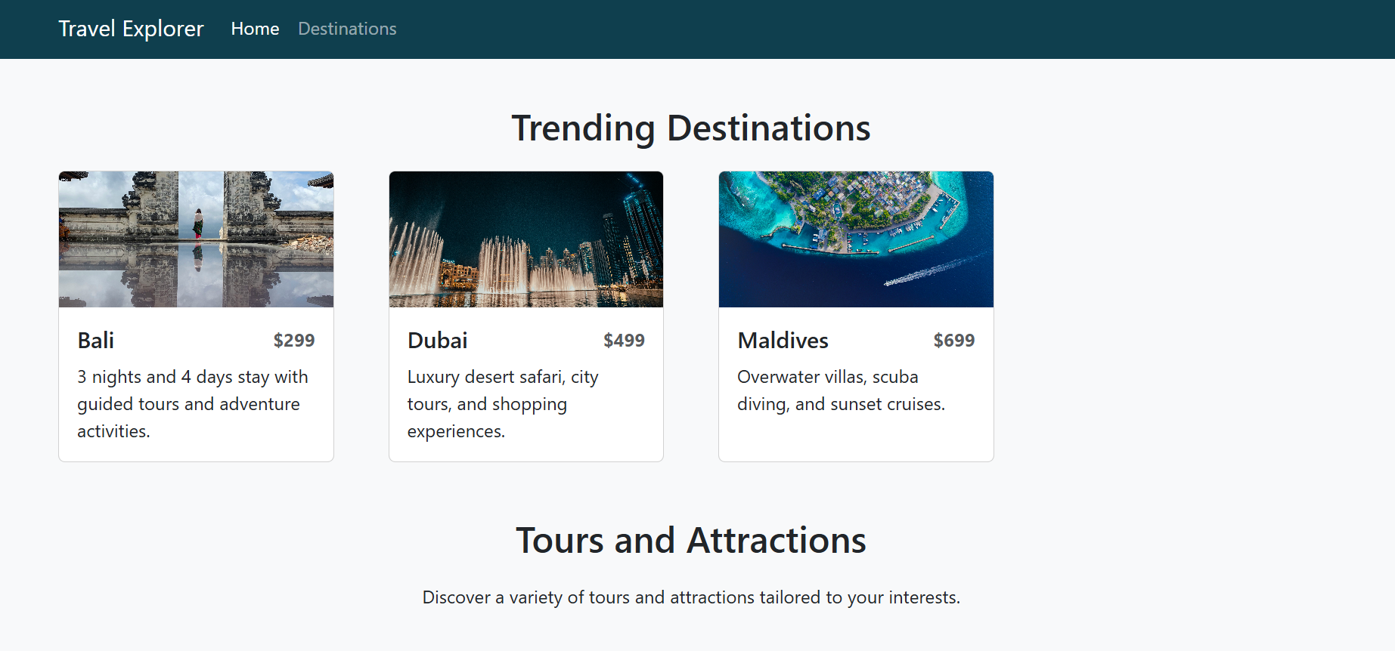

Expected output

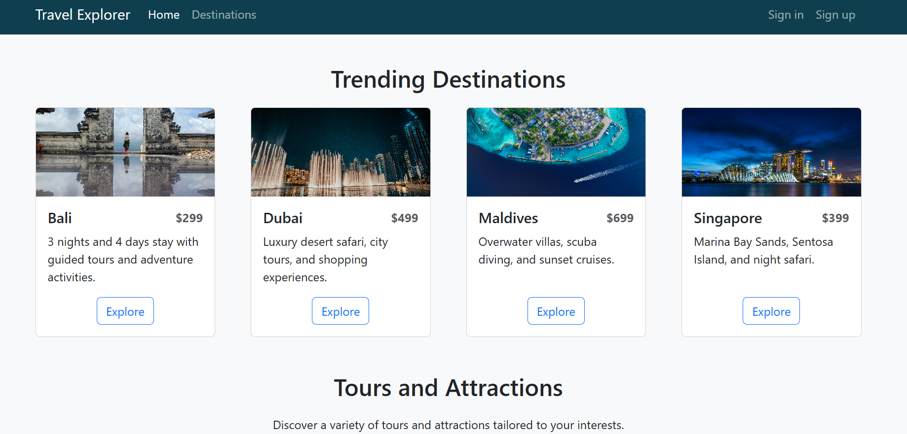

Testing Tasks
- Resize the browser to confirm navbar collapse/expand behavior.
- Check that all cards are responsive and evenly spaced.
- Verify that Explore buttons appear and are styled correctly.

Optional Features for advancement
- Add a search bar to filter destinations by name.
- Animate card images on hover.

Submission Guidelines
- Submit your updated HTML file.
- Highlight any bonus features you implemented.

Workshop2:

Tasks for Students:
- Replace Static side Image with Bootstrap Carousel of 3 or 4 images of your choice.
- Add “password and confirm password” in form.
- Add a “Sign In” button with primary color.

Output
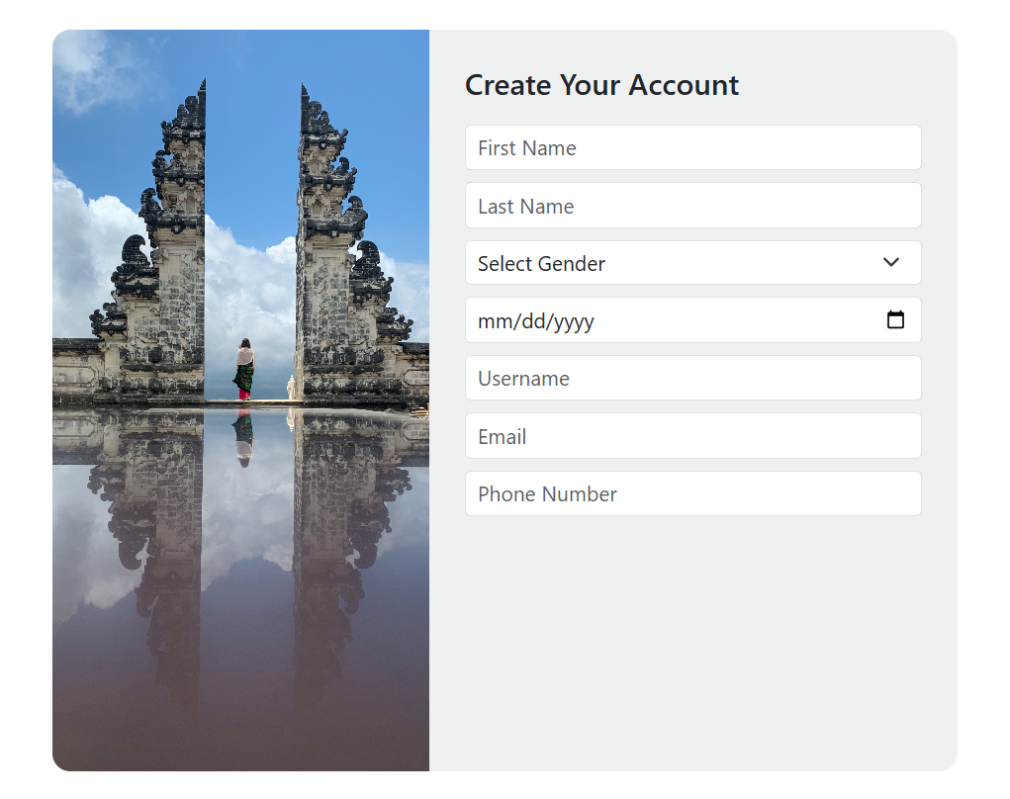

Expected output
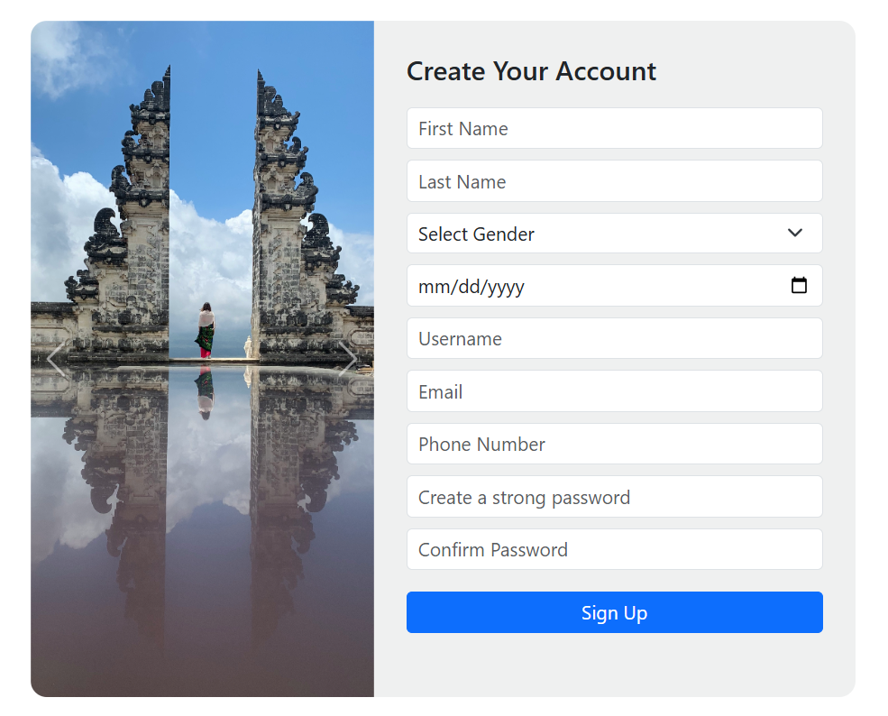

Testing Tasks

- Carousel with 3 to 4 images.
- Carousel navigation buttons.
- Form layout unchanged.
- Modal styling preserved.

Optional Features for advancement

- Add captions to each carousel image.
- Use data-bs-interval to control slide timing.

Submission Guidelines

- Submit your updated HTML file.
- Highlight any bonus features you implemented.

Workshop3:

Tasks for Students:

- Add a “Add New Tour” button.
- Add a new row in table list.
- Complete footer layout (provide quick links, support info, and newsletter subscription)

Output

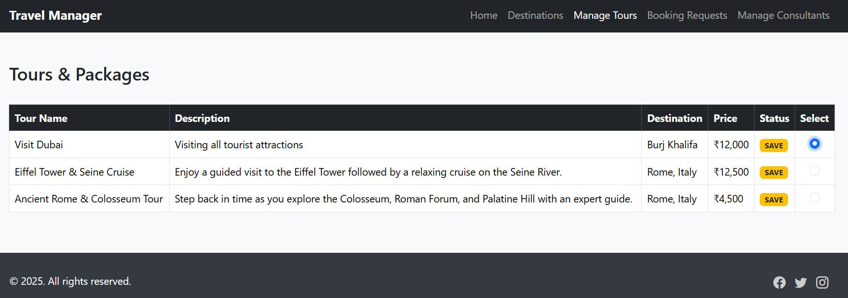

Expected output

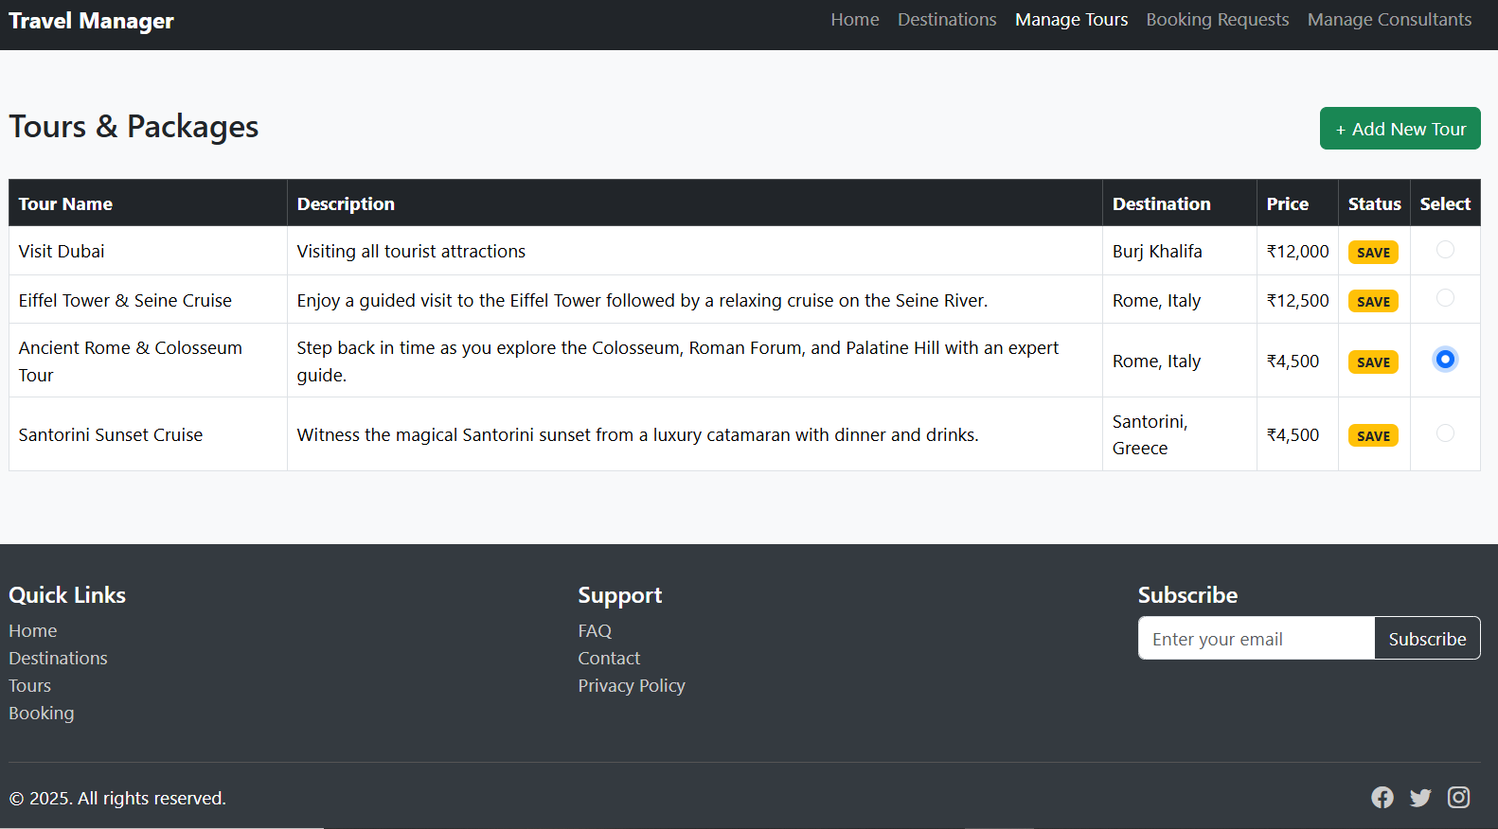

Testing Tasks

- “Add New Tour” button restored.
- Radio buttons added and centered.
- Footer includes links, support, and subscription.
- Code is clean and responsive

Optional Features for advancement

- Add a button below the table that says “Edit Selected Tour”, When clicked.

Submission Guidelines
- Submit your updated HTML file.
- Highlight any bonus features you implemented.

Workshop4:

Tasks for Students:

- Complete Navbar
- Add Price Summary.
- Add footer.

Output
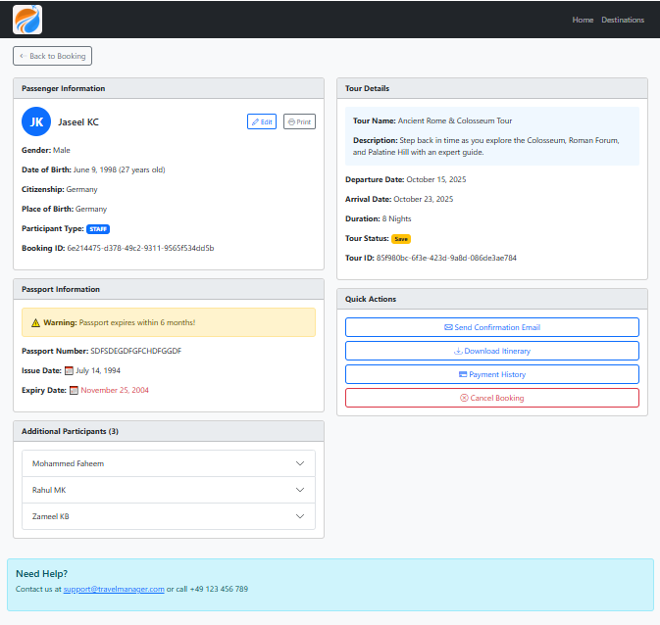
Expected output

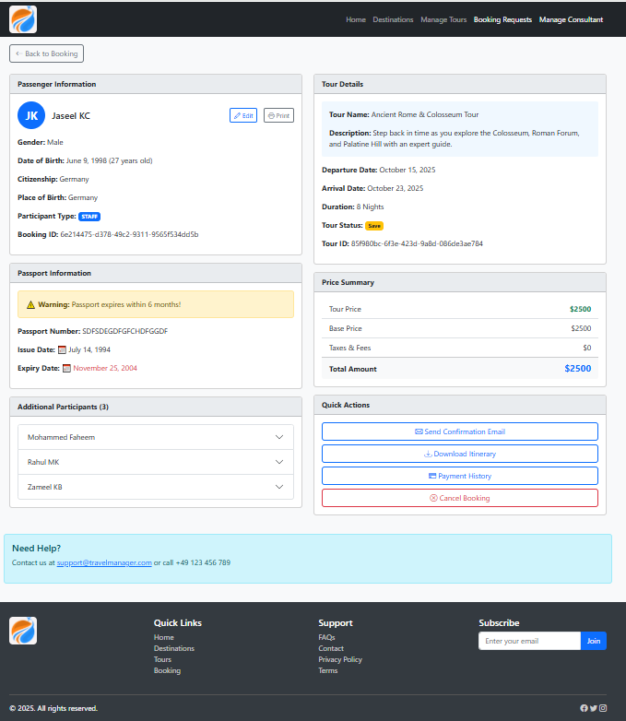

Testing Tasks

- Pricing Summary in correct position of layout.
- Footer layout unchanged.
- Modal styling preserved.

Optional Features for advancement

- Body color of each card can be modified.

Submission Guidelines

- Submit your updated HTML file.
- Highlight any bonus features you implemented.

