- What is LINQ in C#?
LINQ (Language-Integrated Query) is a query syntax in C# that allows developers to retrieve and manipulate data from different data sources like collections, databases, XML, and more in a consistent manner using C# syntax.
- What are the main advantages of LINQ?
- Consistent syntax for different data sources.
- Type safety and IntelliSense support in Visual Studio.
- Readability and maintainability of code.
- Reduces the need for complex SQL queries when used with databases.
- What are the different types of LINQ in C#?
LINQ includes the following types:
    - LINQ to Objects: Works with in-memory collections.
    - LINQ to SQL: Works with SQL Server databases.
    - LINQ to XML: Queries XML documents.
    - LINQ to Entities: Works with the Entity Framework.
    - LINQ to DataSets: Queries DataSets.
    - Parallel LINQ (PLINQ): Enables parallel processing of queries.
- What are the basic LINQ query operators?
Common LINQ query operators include:
    - Select, Where, OrderBy, GroupBy, Join, Take, Skip, First, Last, Any, All, and Aggregate.
- What is the difference between Select and SelectMany in LINQ?
  - Select: Projects each element of a sequence into a new form. It returns a collection of collections if applied to nested data structures.
  - SelectMany: Flattens the nested collections into a single collection.
- What does the OrderBy operator do in LINQ?
The OrderBy operator sorts the elements of a sequence in ascending order based on a key
- What is the difference between First and FirstOrDefault?

- First: Returns the first element of a sequence and throws an exception if the sequence is empty.
- FirstOrDefault: Returns the first element of a sequence or the default value (e.g., null for reference types, 0 for numeric types) if the sequence is empty.
- Explain deferred execution in LINQ.
Deferred execution means the query is not executed when it is defined but only when it is iterated (e.g., using a foreach loop or calling .ToList()).
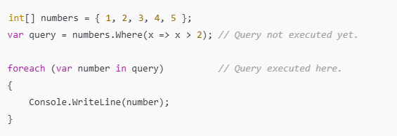
- What are lambda expressions in LINQ?

Lambda expressions are anonymous functions used in LINQ to create concise queries. They are written as input => expression.
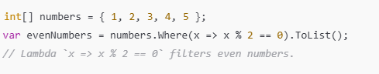

- What is the difference between First(), FirstOrDefault(), Single(), andSingleOrDefault()?

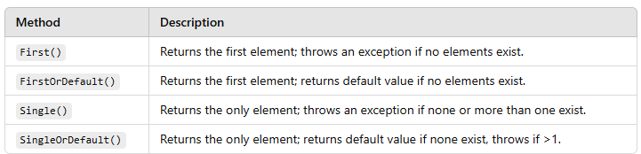

11. Explain the use of Join in LINQ.
The Join operator in LINQ is used to combine elements from two sequences based on a common key. It works like a SQL INNER JOIN. It matches elements from one collection with elements in another collection that share the same key and returns a new collection containing the matched results.

Parameters of Join
Outer Sequence: The first collection (e.g., students in the example).
Inner Sequence: The second collection (e.g., scores in the example).
Outer Key Selector: A function to select the key from the first collection.
Inner Key Selector: A function to select the key from the second collection.
Result Selector: A function to define the result for each matched pair.
var query = students.Join(
scores, // Inner sequence
student => student.StudentId, // Outer key selector
score => score.StudentId, // Inner key selector
(student, score) => new // Result selector
{
student.Name,
score.Score
});
12. Explaining LINQ Extension Methods
LINQ extension methods are a set of static methods in the System.Linq namespace that operate on collections implementing IEnumerable<T> or IQueryable<T>. These methods are called as though they are instance methods on the collection,
Common LINQ Extension Methods
- Where: Filters elements based on a condition.
- Select: Projects each element into a new form.
- OrderBy/ThenBy: Sorts elements in ascending order.
- GroupBy: Groups elements based on a key.
- Aggregate: Performs an accumulation operation.
13. What is the difference between skip() and skipwhile() extension methods?
The Skip method skips a specified number of elements from the beginning of the sequence.
• You specify the exact number of elements to skip.
• It does not depend on conditions; it simply skips the first n elements.
• The remaining elements (after the skipped ones) are returned.
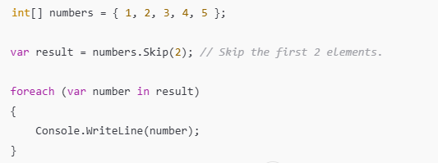
The SkipWhile method skips elements as long as a condition is true. Once the condition becomes false, it stops skipping and returns the rest of the elements.
• It uses a condition (predicate) to decide which elements to skip.
• As soon as the condition evaluates to false, it stops skipping and includes all remaining elements (even if they meet the condition later).
• Useful when you want to skip elements dynamically based on their values.
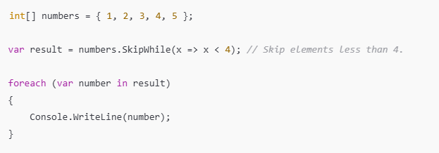
14. Explain how LINQ is useful than Stored Procedures?
- Debugging: It is difficult to debug a stored procedure but as LINQ is part of .NET, visual studios debugger can be used to debug the queries
- Deployment: For stored procedure, additional script should be provided but with LINQ everything gets compiled into single DLL hence deployment becomes easy
- Type Safety: LINQ is type safe, so queries errors are type checked at compile time
15. Explain how LINQ with databases can be used?
LINQ supports XML, SQL, Dataset and Objects. Through LINQ to objects or LINQ to Datasets one can use LINQ with other databases. The objects and datasets take care of database particular operations, and LINQ only needs to deal with those objects and not the database operations directly.
16. What is LET?
LET allows you to introduce a variable and assign a value calculated from the data values in a LINQ query. It allows storing the result of a query which can be used in a subsequent query.

