**Supplemental file 5**

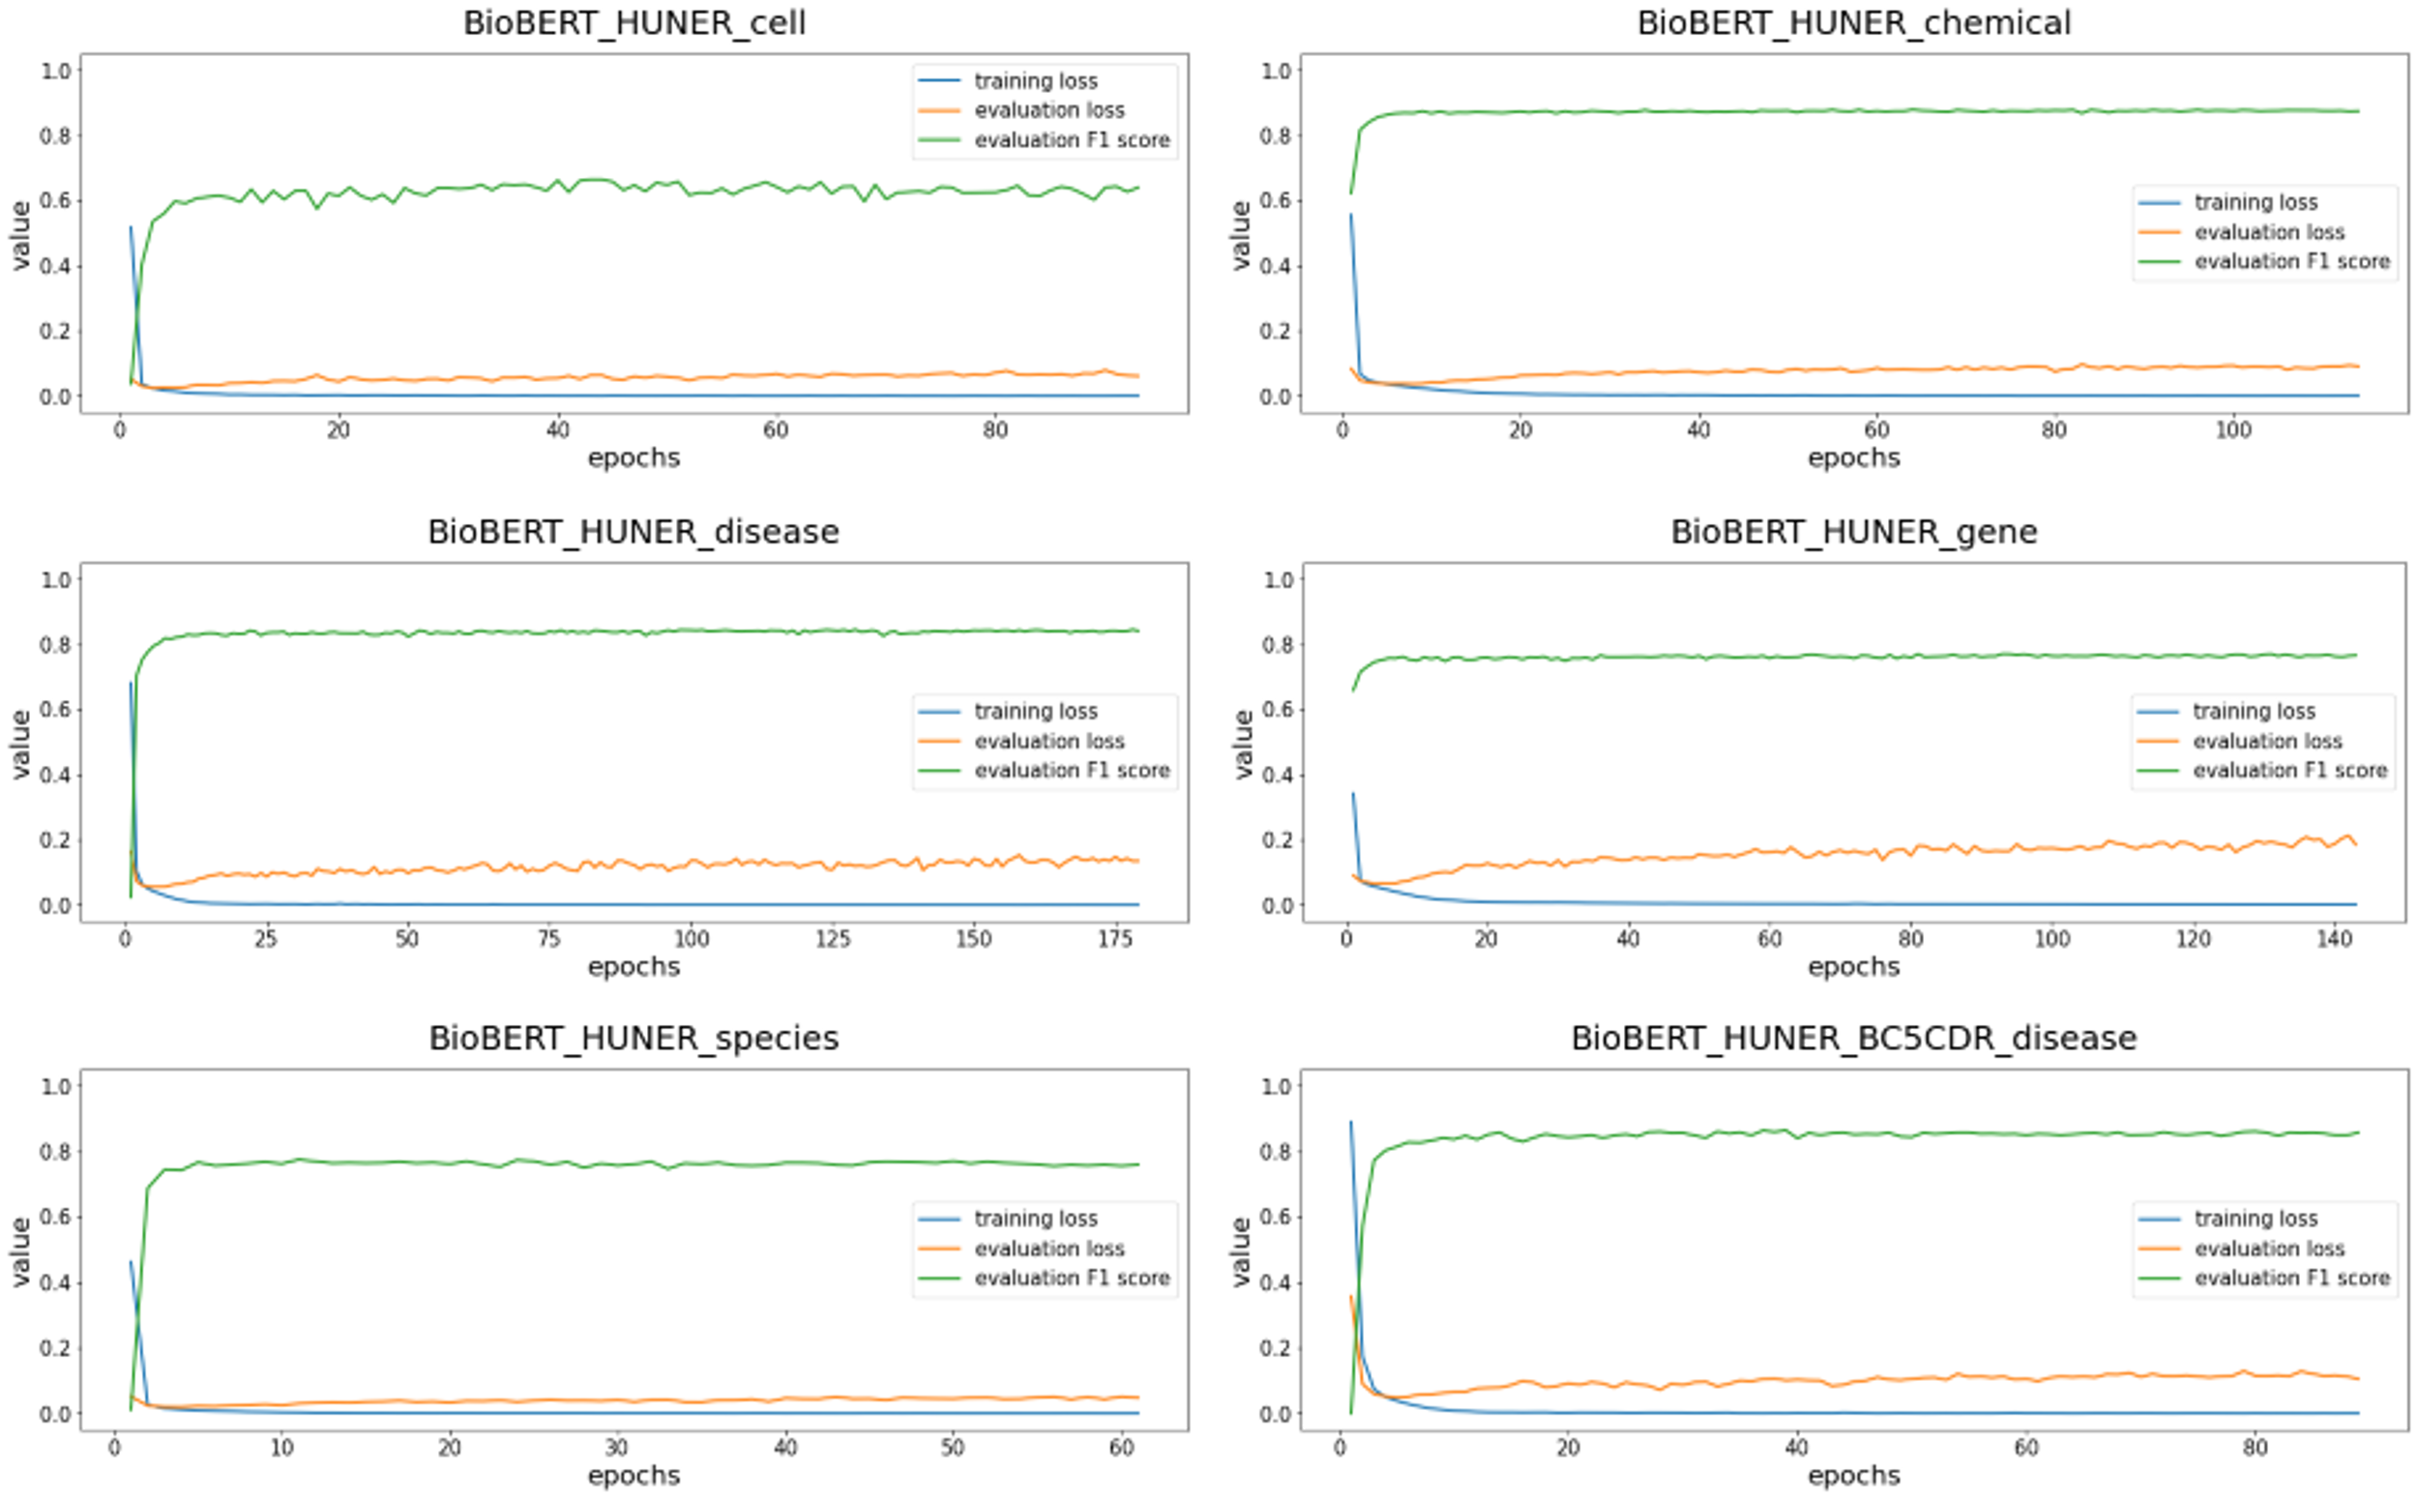

**Supplemental figure 1.** Loss curves for BioBERT_HUNER_v1 models and BioBERT_HUNER_BC5CDR_v1 model. “Training loss” curves show loss on the train_dev set, created by merging the HUNER training and development sets. “Evaluation” curves show loss and f1-score on the test set. The test sets of the corpora were used for evaluation. The models were trained under early stopping with a patience of 50, which are evaluated based on the F1 score of the test set

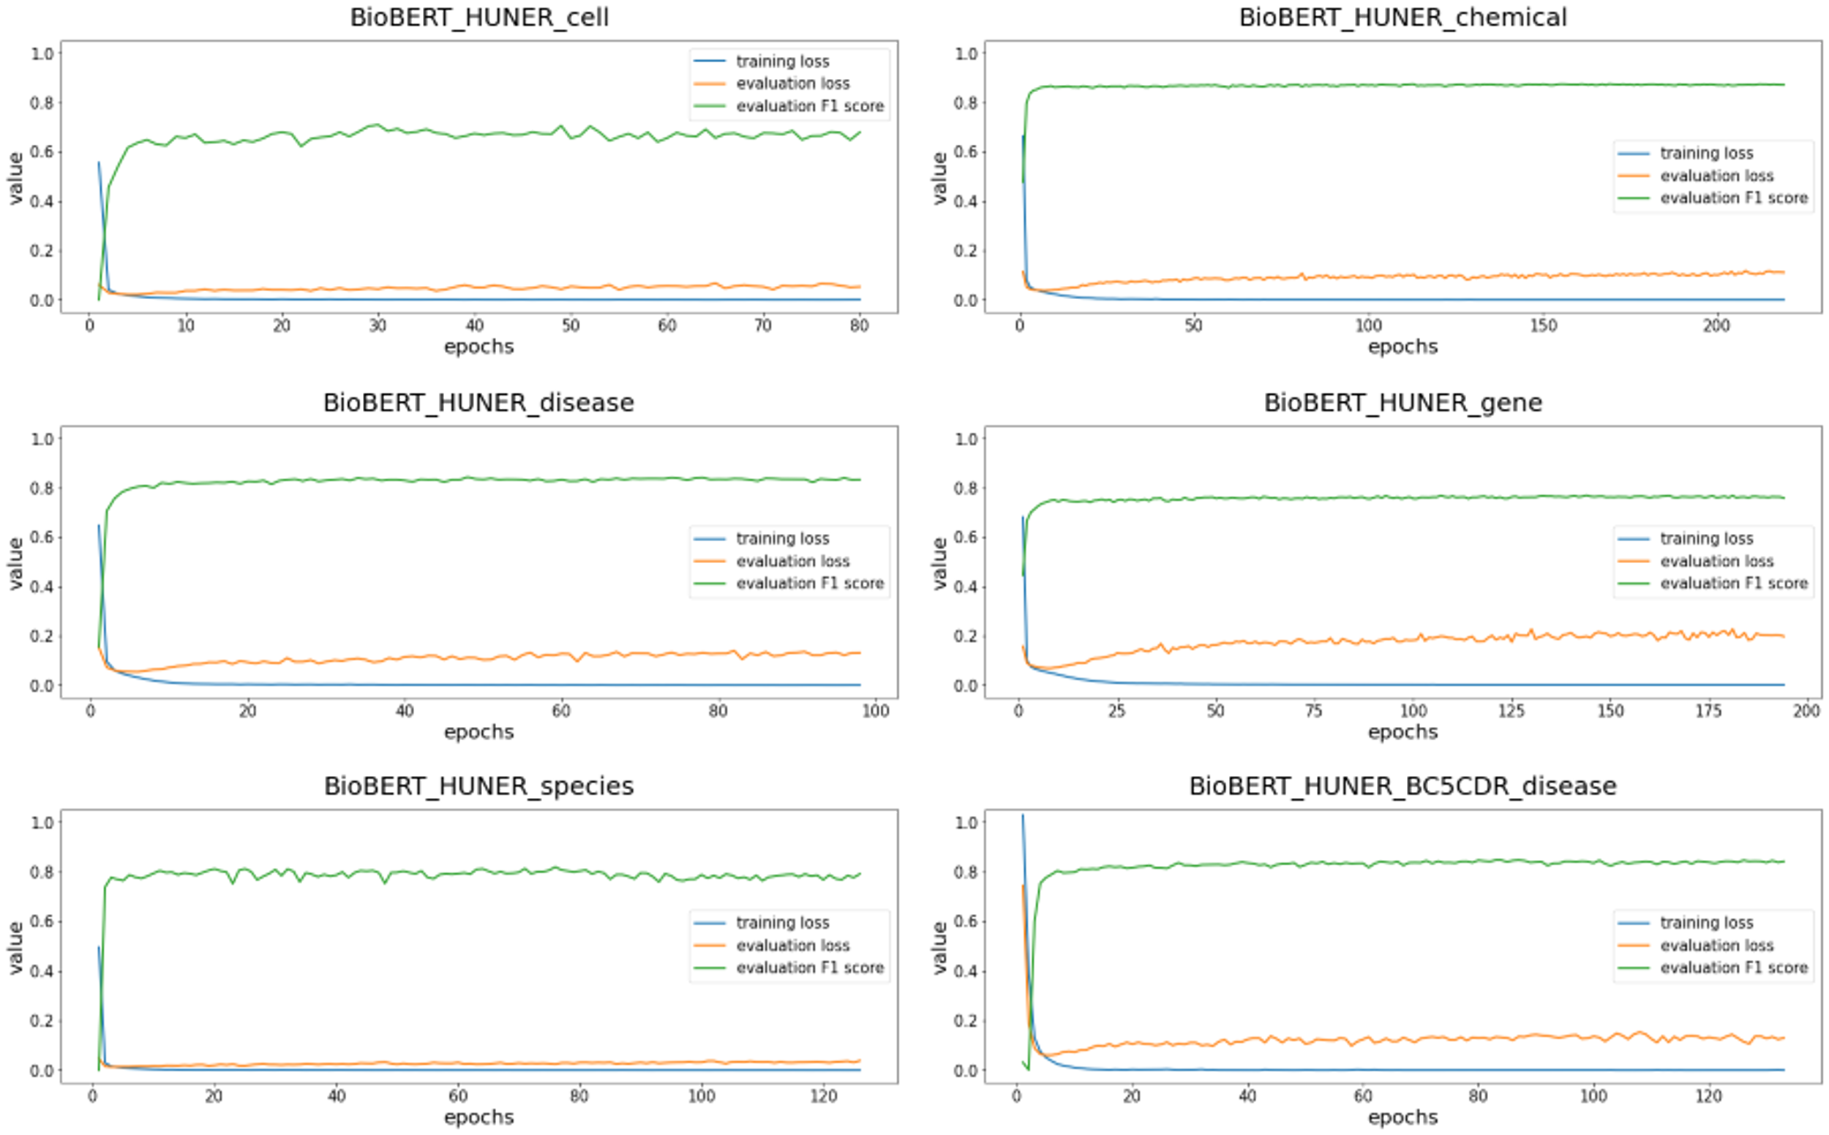

**Supplemental figure 2.** Loss curves for BioBERT_HUNER_v2 models and BioBERT_HUNER_BC5CDR_v2 model. “Training loss” curves show loss on the train set. “Evaluation” curves show loss and f1-score on the development set (based on the train-devel-test split of the HUNER corpora). The models were trained under early stopping with a patience of 50, which are evaluated based on the F1 score of the development set.