Date | Aim | Accomplishments | Continuation
V.14  mon 30/3 | (Work from home)  Setup work environment (documents, jupyter, github) and read benchmark collection article. | Jupyter tutorial, read article, started research on machine learning | Research machine learning CNN
tue  31/3 | (10-16)  Set up office, continue research on CNN | Office set up, read ch 2-3 in Géron– Hands-on machine learning with Scikit-Learn, Keras and Tensorflow | Continue read and exercise in Géron, chapter 10 and 14 (Introduction to Neural network, and CNN)
wed  1/ 4 | (10-17)  Reading and Exercises from Géron | Followed classification examples (MNIST) zoom meeting 14-15.30 | Continue CNN research, Follow fashion MNIST example with CNN, try to start the replication of benchmark annotation
thu  2/4 | (10-16)  Do the fashion MNIST example with CNN, start replication of carpenterlab github | Did a first training on the fashion MNIST, examples from ch 10 and 14 from Géron ,  Downloaded repository from carpenterlab (https://github.com/carpenterlab/unet4nuclei), recreated script 00 and 01 | Continue with understanding of fashion MNIST example, redo training with different settings, continue to modify/recreate scripts from carpenterlab repo.
fri  3 /4 | (10-17)  Zoom meeting, get aquinted to shared github, upload logbook, continue fashion MNIST example, and recreation of carpenterlab scripts. | Zoom meeting at 10. Tried with the recreation of carpenterlab, had som version issues that took a while to solve. Recreation failed due to lack of GPU. Will retrieve weight file from filip. Trained a neural network for the fashion MNIST for practice. Logbook not uploaded | Upload logbook to shared git, try to set up lunarc account, discuss with Filip about next steps.
V.15  mon  6/4 | (11.30-17)  Read Salmas thesis, upload logbook to github, get more understanding of the code from carpenterlab repo. Transform the imagecollection from C01 to tiff. | Uploaded logbook, read Salmas thesis, tried to convert C01 to tiff, but ran in to problems (Did not understand the subprocess.run command).  Set up a Snic account. | Continue with converting images, contact Filip for next steps
tue  7/4 | (10-17)  Convert images, start to orient a Word document and research how to write in Word for the thesis, add refererences,  Get started with LUNARC. | Made a script to convert C01 to tiff, one folder at a time using argparse for reusability. https://github.com/Malou-A/C01-to-tiff  Looked into mendeley for reference storage in Word. | Get to know LUNARC and continue with the benchmark reproduction.
wed  8/4 | (10-17)  Set up a meeting with Jon to discuss server usage. Find a way to continue with the benchmark reproduction (I can’t proceed because of lack of GPU).  Do some reading in Géron deep learning book. | I have done CNN training examples from Géron (lab for distance course), Signed up for a LUNARC account with help from Jon, I’ve tried to use the code for the benchmark reproduction with google colab to use their GPU but with no success since it does not work well with scripts within scripts, looked into the possibility of signing up for google GPU, to be able to work with jupyter and their GPU. (a lot of trouble shooting today) | Tomorrow continue with benchmark reproduction, try to manage to get google colab to work together with jupyter notebook for the GPU, more machine learning research while waiting for the lunarc account.
thu  9/4 | (10-14 – skärtorsdag, half day)  LUNARC account was created, so I will do the set up and learn how to use it.  When sorted, set up the benchmark reproduction, research U-net | Got LUNARC password, learned how to log on and orient in the server. Downloaded carpenter repo to LUNARC account for reproduction. Created conda environment | Continue with the environment set up for the reproduction (add correct versions of packages)
sun  12/4 | (20-23)  Install packages and run through scripts of carpenter repo | Ran in to problems, my LUNARC account keeps freezing up, and the conda environment set up requires more manually installed versions of packages. So only installation of a few packages (tensorflow 1.13.1, keras 2.2.4, cudas10, updated scikit-image package. | Continue with the conda environment to get the scripts of the carpenter repo to work.
mon  13/4 | (19.30-21.30)  Set up a google cloud account | Set up a google cloud account, did a tutorial for how to create a virtual machine.
Tue  14/4 | (Home with kids)  (Work hours 8-11)  zoom meeting at 10, set up notebook on google cloud with GPU | Zoom meeting, set up notebook on google cloud | Set up the carpenter repo at google cloud notebook.
Wed  15/4 | (Home with kids)  (working spread out through the day)  Set up versions in virtual environment in google cloud notebook, run the scripts, start training the model. | Virtual environment set up with versions tf – 1.13.1, keras 2.2.4. set up a new notebook with CUDAS 10.0, since 10.1 did not work with tf 1.13.1, started training the U-net model.  Got the whole repo to run! | Continue with reproduction, get a better understanding of the functions in the script, try the model on Aitslab-images.
Thu  16/4 | Deep learning lab
Fri  17/4 | Deep learning lab
Mon  20/4 | (10-17)  Look at the annotation tool “cvat”, do prediction on aitslab images. | Installed cvat, tried the tool, OpenVIVO needed to implement a model for auto annotation, downloaded it. | Get OpenVIVO correctly installed to get the model function to work in cvat.
Tue  21/4 | (10-17)  Get OpenVIVO to work, figure out how to use models with cvat, try to create a model to use. | Met with Lotta (studentadvisor),
Thu  23/4 | (10-17)  Recreate virtual environment on lunarc to use tensorflow 2.0, edit the script to make it compatible with tf 2.0. Get the script to work on lunarc (bbbc script) | Ran in to several errors today with the script. I probably need to reset the virtual environment and start from scratch to get it to work. It is version issue errors. Tried with several different versions. | Create a fresh virtual environment on lunarc from scratch, follow the same versions as Filip.
24/4 | (10-17)  Create new environment, with the most resent versions of all packages, change the script using tf_update_v2 for all commands that are outdated. | Finally, a environment that work is set up on lunarc. Managed to run the entire script. | Make a prediction with aitslab images, see if Cvat can be set up at lunarc.
27/4 | (10-17)  Start to create a README file for the masterthesis requirements, add what’s been done already. Get the aitslab-images to lunarc and convert to tiff using my script, do a prediction on the images with the bbbc model. | Created a README, managed to do the aitslab prediction on the bbbc model. | Get cvat and openvino in lunarc.
28/4 | (10-12) | Tried to install openvino in lunarc, but can’t load all required modules, and “docker” is not included as a module in lunarc | Crop aitslab images to the same size as bbbc (instead of just resize) and compare predictions with the other methods.
29/4 | (10-17)  Crop aitslab images to the same size as bbbc (instead of just resize) and compare predictions with the other methods.
29/4-22/6 | Logbook got accidentaly deleted, and no backup from these dates. | During this time, I have annotated 50 images in cvat, got the augmentation (affine transformation) to work, worked through the carpenter repo and learned what the script does and made it better suited for our images. Format of our annotations differ from the bbbc, so the script needed changes in some places. I’ve then trained the model with both the bbbc images, and aits images, and one model with only aits-images, a lot of debugging of code and changing of the code to also include micronuclei in the labelling.  Also ~2 weeks home with kids (illness/corona precausion) | Train 4 different models discussed with Sonja.  save 10 images for validation, and 10 for the very end to test the models  1. train with 30 images, without affine transformation  2. Model 1, with affine transformation  3. Model 2 with 100 bbbc images  4. Model 2 with all bbbc images.
23-24/6 | Create the 4 models, and start training on LUNARC. | Arranged the different scripts for the 4 models, created the textfiles with the different fractions of imagesets (training, validation,test). Did preprocessing on the images, changed so that all data will be created and used from the same folder instead of moving around/copying. Started training for all 4 models. | Evaluate models, recreate script for evaluation to be able to run it smoother from the backend and store the results in a better way.  Log results in a csvfile and upload to github
25/6 | Mistake made when set up the training, model files were not saved correctly, training needs to be redone.  - Train models (only 3 epochs first to be able to get results today)  - Set up the prediction and the evaluation scripts.  - redo the training with 15 epochs for final results tomorrow. | Trained the model, arranged prediction and evaluation scripts, started new training with 15 epochs | Get results from the models, upload to github
29/6 |  | Updated README, got results from models and uploaded results and README to github. Created table with F1-scores and Jaccard-index for github.
Mon 6/7 | Set up new models and document. | Set up Model 6 (same as model 1 but only 2 images in training set) , Model 7 (same but 5 images in training set) and Model 8 (same but 15 images in training set) and started training. Did some updates in the README file. | Set up Model 5, and Model 9, and do the affine transformation for the validation images and evaluate model 2 on them.
Tue  7/7 |  | Evaluated model 6-8, started model 5, Downloading the image sets were not as easy as expected, got help from Sonja, she found additional image sets at celltrackingchallenge.net, started with the preprocessing of the images. | Continue with model 5, set up and train Model 9, do affine transformation on validation set for model 2.
Wed  8/7 |  | Created script to extract grayscale images from bbbc038 set, and a script to merge annotations and create boundary labels.
Fri 10/7 |  | Preprocessing of BBBC007 and BBBC020.  BBBC007 annotations are done with black borders for all objects, which makes distinguishing between objects not possible.  BBBC020 don’t have annotations for objects at the imageborder, which make them not similar to ours. Cropping possible. | Continue with preprocessing of data, structurize and get Model 5 running. Train Model 9, affine transdormation on Model 2.
Mon  3/8 |  | Extract all grayscale images from bbc038 image set, some non-wanted grayscale images was included, so I manually went through all images to remove the bad ones. Updated README file.
4/8 |  | Structurized imagesets for model 5, put all scripts together to work with correct folderstructure, wrote down steps in README file | Set up model 5 and start training.
5/8 |  | Debugging, new images had more channels than original imageset, one set needed new preprocessing because of wrong fileformat. Got errors because of imagesize, changed in utils source code to fix the issue  Organized images so that model 5 is ready to be run, error when trying to submit the job, waiting for response from Salma
6/8 |  | Got model 5 up and running, evaluated model 2 with augmented validation set, changed utils script, corrected in README file, set up model 9 and started running it. | Evaluate models, put up results on github, continue structurize README file.
7/8 |  | Evaluation of models, Uploaded model results and updated result table. Edited in README file. Set up 2 new models, I handpicked 30 images from the additional images in Model5, and did one model (Model 10) with those images together with the aitsimages, no affine transformation. 1 model (Model 11) with only the 30 additional images, to see how well it runs against aits validation set.
10/8 |  | Did a Model 12, where I changed the size of the BBBC images (from Model 10-11) to be of the same size as the aitsimages. Evaluated model 10 and 11.
11/8
12/8 |  | Meeting discord, reevaluated all Models, because previous changes made in the prediction made the evaluation worse, started new model, where more images are included from the bbbc038 set. Updated result table
13/8 |  | Uploaded new evaluation notebooks to github, started new models, where model 3,5 and 10 trains for 15 more epochs, and one model where the weight is less on the border precision, to see if the borders gets smaller in the prediction. Did a script to enlarge the objects with 1 pixel, but the dilation function that is already implemented in the model works better. | Evaluate new models, create a histogram with the false negatives for different size categories in the models. Get the green stained images corresponding to the nuclei set I have.  Update README with new models.
14/8 | 14-31/8  Missed logging days | Have been creating several different new models, now 23 models in total. Found mistake in how the border is created, it is not 1 pixel as though, it varies, the BBBC has larger borders and exclude micronucleis of size 25.
1/9 | Write a script to retrieve area information from all nucleis found,  create a model with no micronucleis.  Meeting 14.15 | Tried to restore annotations on cvat (they have a funcion “upload annotations”) but I did not get it to work, seems as it doesn’t work on the “MASK” format as I have. Started to reannotate some images. | Continue reannotation, upload histogram notebooks, set up the new model (model 24) with no micronucleis
2/9 | TA 10-16
3/9 |  | Fixed histogram notebooks and created tables and uploaded them on github. Started with the script for FP size histogram. Started reannotate some images. | Continue with the FP histogram script, and reannotations.
4/9 | VAB-day | 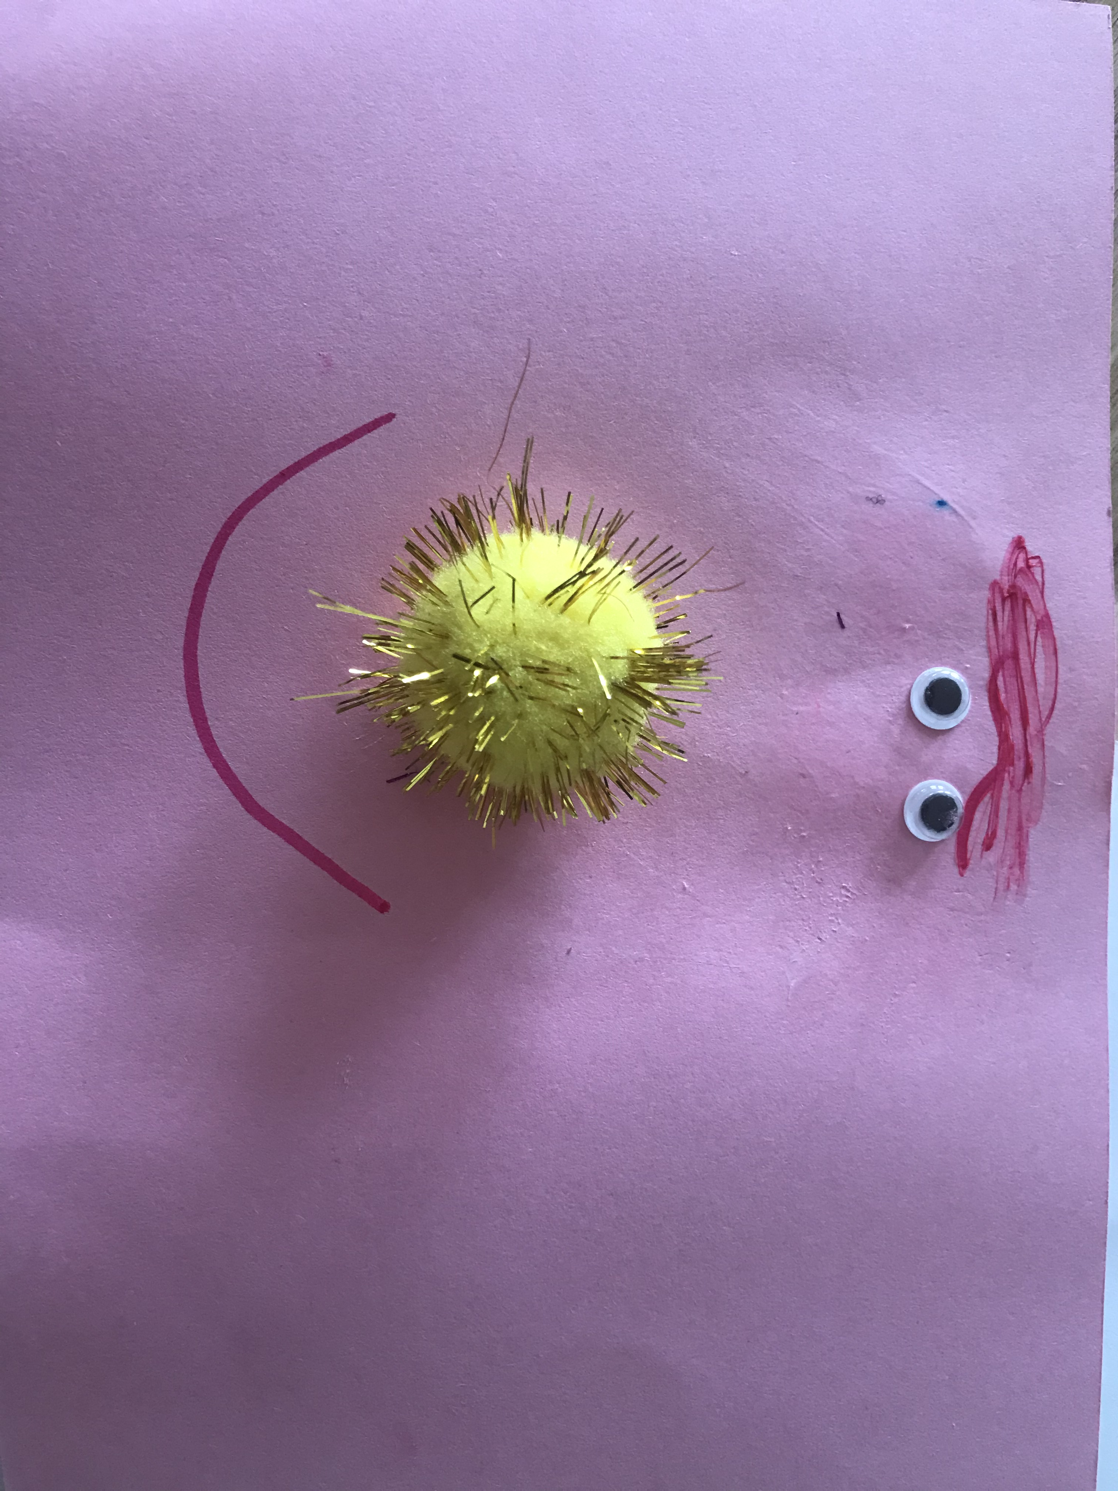  Made a script to change the annotations, created the new validation set.  I also assisted with this creation
7/9 |  | I changed a script to also retrieve false positives by area to be able to do an area specified false detection rate histogram.  I evaluated model 1,3, 12, 13, 14, 16 with validationset 2 and uploaded on github.  Started to rerun all evaluation notebooks to get the data for the histogram, also to change previous histogram where the ground_truth was wrong.
8/9 | TA-day, no project hours today
9/9 |  | Finished with the histogram for 70 % threshold and updated the F1 and jaccard – table with the corrected values. Did a imageset with images that have PLK1, KIF11, and LIPA, choosen randomly from all images in the imageset on LUNARC. Annotated a few of those images.
10/9 |  | Reannotated the images for the training set, started to train model 24, with imageset_1, nucleis > 40 pixels in images, boundary 2 pixels. Started to train model 25 with imageset_2, nucleis > 25.
14-18/9 |  | Wrote and rearranged in README. Gone through images, done some reannotation and trained new models. Annotated with focus on bright part, but model has trouble to segment dying cells with many bright spots in them. Retrieved image sets from control wells to annotate more dead/dying cells. Retrieved the green channel images to start annotate. Changed norm images to 16 bit and train a model with them. Read up on the functions for the preprocessing step to realize how the BBBC normalize their images with percentiles.
21/9 |  | Annotated more images and went trough all annotated images and corrected some from my point of view. Annotated 15 more images and started to train a model with the new set.
22/9 |  | Did the preprocessing on the green stain images, and started to annotate them.
23/9 |  | Tested different settings in the normalization script to get sharper edges on the cells in the green stain images. Logged in to kebnekeise and started to set up my folders there to continue with the models there. Tried to evaluate an image predicted with cellprofiler but had problems with the size, and pixelvalues that didn’t work with the script to create the labels.
24/9 |  | Changed annotations for all 64 annotated images, to set border on the “outer nuclei” even when bright parts included. Noticed mistake in previous model(32) that corrected and reran model. Started a model with the green stain images for the 6 annotated images. Created a new brighter set to be able to see the edges better for continuing of annotations.
25/9

