
SCHOOL OF COMPUTING, AMARAVATI – 522503.
SIMULATION OF AN AUTONOMOUS AGRICULTURAL ROBOT FOR AI-BASED PLANT DISEASE DETECTION AND PRECISION SPRAYING
Submitted by
AITY PRACHETHA [AV.SC.U4AIE24101]
Department of Computer Science and Artificial Intelligence
Under the guidance of
RAVISHANKAR DESAI
accomplishment of the laboratory work for the subject
22AIE441 Dynamics and Control of Robotics.
AMRITA VISHWA VIDYAPEETHAM
October 2026

ABSTRACT
Agricultural productivity and food security face severe challenges worldwide from crop diseases such as Early Blight (Alternaria solani) and Late Blight (Phytophthora infestans) in tomato cultivation. Conventional crop protection relies heavily on uniform, broad-spectrum chemical application, leading to chemical drift, environmental contamination, accelerated pesticide resistance, and high operational expenditure. This project presents the simulation of an autonomous agricultural ground robot developed in Webots for high-precision, in-situ plant disease detection and closed-loop targeted spraying across multi-row crop beds. The robotic platform integrates a differential-drive Pioneer 3-DX mobile robot, a 3-degree-of-freedom (3-DOF) articulated manipulator arm, an end-effector RGB camera, wheel encoders, GPS, and a digital compass. An autonomous navigation state machine steers the robot through seven parallel crop aisles (66 leaf inspection panels) utilizing proportional heading and cross-track error regulation, supplemented by a predictive deceleration and standstill stabilization protocol (500 ms) to suppress chassis vibration and motion blur. For foliar disease identification, a transfer-learning pipeline based on EfficientNet-B0 with compound scaling was implemented and fine-tuned, reaching a validation accuracy of 99.26% on tomato leaf imagery. Closed-loop precision spraying is dynamically actuated only when foliar infection is diagnosed, confirmed by an on-chassis visual actuator indicator. Comprehensive field simulation results demonstrate 100% inspection coverage (66/66 leaves), an average classification confidence of 99.13%, and the successful targeted delivery of 43 precision sprays while completely preserving all 23 healthy plants without false spraying. This translates directly into a 34.8% reduction in chemical fungicide usage compared to conventional broadcast spraying, establishing a verified, sustainable foundation for future autonomous precision farming.

CONTENTS
CHAPTER | TITLE | PAGE NOs
 | ABSTRACT | ii
 | LIST OF TABLES | iv
 | LIST OF FIGURES | v
 | LIST OF ABBREVIATIONS | vi
1 | INTRODUCTION | 9
1.1 | Introduction (Background) | 9
1.2 | Problem Statement | 10
1.3 | Objectives | 11
1.4 | Contributions | 12
2 | RELATED WORK | 14
2.1 | Comprehensive Survey | 14
2.2 | Summary and Findings of 2.1 in Tabular Format | 16
2.3 | Challenges | 18
2.4 | Motivation of the Project Work | 19
3 | MATERIALS AND METHODS | 20
3.1 | Mathematical Modelling / Datasets Description | 20
3.2 | Method(s) of Mathematical Modelling / Data Processing | 24
3.3 | Programming Tools Details | 26
4 | METHODOLOGY | 28
4.1 | Controller / Algorithm Design (Mathematical Equations with Description) | 28
4.2 | Controller / Algorithm Design Steps | 31
4.3 | Project Architecture | 32
4.4 | Stability / Algorithm Analysis | 34
4.5 | Project Complete Flowchart | 36
5 | RESULTS AND DISCUSSION | 37
5.1 | Simulation Setup | 37
5.2 | Qualitative Results | 38
5.3 | Quantitative Results | 39
5.4 | Discussion | 44
6 | CONCLUSION AND FUTURE DIRECTIONS | 46
6.1 | Conclusion | 46
6.2 | Future Directions | 46
7 | REFERENCES | 48

LIST OF TABLES
TABLE I. Summary of surveyed approaches in agricultural robotics and disease detection 16
TABLE II. Pioneer 3-DX robot platform and kinematic parameters 21
TABLE III. Sensor suite and perception specifications 22
TABLE IV. Complete 7-row crop bed registry and field geometry 23
TABLE V. Programming tools, libraries, and software environment 26
TABLE VI. Main navigation, aiming, and spraying controller parameters 30
TABLE VII. Main source modules and software components 33
TABLE VIII. Webots simulation environment and physical setup parameters 37
TABLE IX. Overall field inspection and precision spraying performance summary 39
TABLE X. Detailed row-by-row inspection performance breakdown 40
TABLE XI. EfficientNet-B0 confusion matrix and per-class performance metrics 41
TABLE XII. Precision spraying efficiency and chemical savings comparison 42
TABLE XIII. Navigation timing and mission motion execution profile 42
TABLE XIV. Technical problems diagnosed during development and solutions applied 43

LIST OF FIGURES
Fig. 1. Pioneer 3-DX differential kinematics and 3-DOF arm aiming geometry 21
Fig. 2. EfficientNet-B0 deep neural network feature extractor architecture 24
Fig. 3. Closed-loop proportional aisle guidance & heading control system block diagram 28
Fig. 4. Complete end-to-end autonomous agricultural robot system architecture 33
Fig. 5. Complete autonomous agricultural robot operational mission flowchart 36
Fig. 6. End-effector inspection camera capture of the first plant canopy in Webots 38
Fig. 7. Representative in-situ inspection frames annotated by EfficientNet-B0 39
Fig. 8. EfficientNet-B0 model optimization curves over 25 epochs 40
Fig. 9. Field inspection confusion matrix (66 leaves) and per-class performance metrics 41
Fig. 10. Leaf-by-leaf AI inspection confidence across all 66 crop panels 42
Fig. 11. Chemical volume and canopy treatment comparison (Targeted vs Broadcast) 43
Fig. 12. Comprehensive AI agricultural robot testing field report dashboard 44

LIST OF ABBREVIATIONS
3-DOF | Three Degrees of Freedom
AI | Artificial Intelligence
AGV | Automated Guided Vehicle
BCE | Binary Cross-Entropy
CAD | Computer-Aided Design
CNN | Convolutional Neural Network
CPU | Central Processing Unit
CUDA | Compute Unified Device Architecture
CV | Computer Vision
DOF | Degrees of Freedom
ECEF | Earth-Centered, Earth-Fixed
ENU | East-North-Up coordinate convention
GAP | Global Average Pooling
GNSS | Global Navigation Satellite System
GPS | Global Positioning System
GPU | Graphics Processing Unit
GUI | Graphical User Interface
HIL | Hardware-in-the-Loop
IK | Inverse Kinematics
IMU | Inertial Measurement Unit
IPC | Inter-Process Communication
IR | Infrared Proximity Sensor
LED | Light Emitting Diode
MBConv | Mobile Inverted Bottleneck Convolution
MPS | Metal Performance Shaders (Apple Silicon GPU acceleration)
MSE | Mean Squared Error
ODE | Open Dynamics Engine
PA | Precision Agriculture
PID | Proportional-Integral-Derivative
P3DX | Pioneer 3-DX Mobile Robot Platform
ReLU | Rectified Linear Unit
RGB | Red-Green-Blue color space
ROC | Receiver Operating Characteristic
ROS | Robot Operating System
SE | Squeeze-and-Excitation
SGD | Stochastic Gradient Descent
SiLU | Sigmoid Linear Unit (Swish)
SLAM | Simultaneous Localization and Mapping
SVM | Support Vector Machine
TOC | Table of Contents
UGV | Unmanned Ground Vehicle
URDF | Unified Robot Description Format
VBN | Variable-rate Broadcast Nozzle
VRS | Variable-Rate Spraying
WBT | Webots World File Format

CHAPTER 1
INTRODUCTION
1.1 Introduction (Background)
Agriculture is the fundamental cornerstone of human civilization and global food security. Among vital commercial crops, the tomato (Solanum lycopersicum) is cultivated globally on more than five million hectares, yielding in excess of 180 million metric tonnes annually. Tomatoes represent an essential source of essential micro-nutrients, dietary vitamins (A, C, and K), and potent antioxidants such as lycopene. However, open-field and greenhouse tomato production systems are continually threatened by virulent fungal and oomycete pathogens that target foliar tissues, severely diminishing photosynthesis, leaf area index, fruit yield, and marketability.
Among the most economically devastating foliar diseases are Early Blight, caused by the necrotrophic fungal pathogen Alternaria solani, and Late Blight, caused by the devastating oomycete pathogen Phytophthora infestans. Early Blight manifests initially as small brown-to-black necrotic specks on mature leaves, which subsequently expand into prominent, circular lesions characterized by concentric rings resembling a target board. As the disease advances, extensive chlorosis surrounds the necrotic lesions, causing premature defoliation and severe sunscald on developing tomato fruit. In contrast, Late Blight is an aggressively fast-moving water mold disease that produces irregular, water-soaked lesions that rapidly darken into olive-brown or purple-black blighted patches. Under high relative humidity, a delicate white fungal sporulation appears on the abaxial leaf surface, capable of annihilating entire crop canopies within seven to ten days of initial symptom onset.
To curb catastrophic yield losses—which frequently reach between 40% and 80% if untreated—commercial agriculture has traditionally relied upon intensive broadcast spraying of chemical fungicides, including copper-based formulations, chlorothalonil, and mancozeb. Conventional tractor-mounted boom sprayers or handheld hydraulic lances dispense high volumes of agro-chemicals uniformly across entire fields, regardless of the actual spatial distribution or severity of disease incidence. Empirical field agronomy studies indicate that over 65% to 75% of broadcast agro-chemicals never reach their biological targets; instead, excessive chemical active ingredients drift off-target into adjacent non-agricultural ecosystems, contaminate groundwater tables through percolation, precipitate acute soil toxicity, and harm non-target pollinator species such as honeybees.
Furthermore, continuous and excessive prophylactic fungicide applications exert relentless selective pressure on pathogen populations, accelerating the emergence of chemical-resistant pathogen strains. From an economic perspective, chemical inputs represent a substantial fraction of variable cultivation costs, severely eroding farm profit margins. These pressing ecological and economic concerns have catalyzed the emergence of Precision Agriculture (PA), which advocates for site-specific crop management where inputs are applied in precise quantities strictly at the specific locations and times required.
In recent years, the convergence of Unmanned Ground Vehicles (UGVs), advanced computer vision, edge-computing embedded processors, and articulated robotic mechanisms has offered an unprecedented opportunity to operationalize precision agriculture. Agricultural mobile robots equipped with high-resolution RGB cameras and deep learning classifiers can autonomously traverse crop aisles, inspect individual plant canopies, diagnose pathological symptoms with expert-level accuracy, and actuate targeted micro-dosing sprayers directly onto diseased leaves. By transitioning from blanket, field-wide broadcast spraying to localized, leaf-level precision spraying, chemical pesticide volume can be drastically curtailed, operator chemical exposure eliminated, and sustainable crop stewardship achieved.
Developing and validating such integrated robotic solutions in physical agricultural fields entails severe logistical, seasonal, and financial bottlenecks. Real-field testing is constrained by unpredictable weather, seasonal crop cycles, varying daylight conditions, and the catastrophic risk of damaging physical crops or robotic hardware during initial controller tuning. To bridge this critical development gap, high-fidelity dynamic physics simulation platforms such as Webots have become indispensable. Webots enables rigorous, reproducible digital prototyping of differential-drive mobile bases, multi-degree-of-freedom articulated arms, real-time sensor pipelines, and non-linear controllers within authentic three-dimensional crop environments. This project capitalizes on Webots to simulate, evaluate, and demonstrate an autonomous agricultural robot combining a Pioneer 3-DX mobile base, a 3-DOF articulated aiming arm, and an EfficientNet-B0 deep convolutional neural network for autonomous multi-row plant inspection and closed-loop precision spraying.
1.2 Problem Statement
Despite the immense theoretical advantages of autonomous precision spraying, the engineering synthesis of mobile robotics with deep learning vision systems in agricultural environments presents formidable multidisciplinary challenges. Conventional autonomous guided vehicles (AGVs) operating in structured industrial settings rely upon smooth concrete flooring, artificial optical or magnetic floor markers, uniform ambient illumination, and static operational waypoints. In sharp contrast, agricultural fields are characterized by rough, uneven soil topography, loose wheel-soil contact dynamics, variable canopy geometries, narrow inter-row aisles, and fluctuating natural illumination.
Specifically, three fundamental engineering bottlenecks hinder the reliable deployment of autonomous agricultural inspection robots: First, differential-drive mobile bases operating in confined crop rows suffer from non-holonomic kinematic constraints and wheel slip, which rapidly degrade odometric dead reckoning. When moving along narrow aisles with minimal lateral clearance between crop beds, lateral cross-track deviations can lead to mechanical collisions between the robot chassis and sensitive crop foliage, or cause wheel entrapment in irrigation furrows. Precise, robust closed-loop aisle tracking and reliable multi-point headland turnaround maneuvers are strictly required.
Second, mobile scanning while in continuous motion induces severe mechanical vibration and optical motion blur in captured camera frames. In-transit blur degrades high-frequency textural features, such as the subtle concentric rings of Early Blight or the delicate sporulation margins of Late Blight, leading to unacceptable rates of neural network misclassification. Furthermore, fixed camera mounts often suffer from parallax errors and suboptimal focal angles when plant canopies vary in height and orientation across parallel beds, necessitating an articulated aiming mechanism capable of dynamically pointing the optical axis directly toward target foliage.
Third, achieving closed-loop synchronization between real-time deep neural network inference and low-latency mechanical spraying actuation remains complex. If inference latency is too high, the mobile platform overshoots the diseased canopy before the spraying nozzle can actuate, causing off-target chemical deposition. Conversely, if the detection threshold is poorly calibrated, false-positive predictions lead to wasteful chemical spraying on healthy leaves, while false negatives leave active fungal foci untreated, facilitating rapid secondary disease spread. Therefore, an integrated algorithmic framework is urgently required that seamlessly couples robust non-holonomic mobile base navigation, active multi-joint manipulator aiming, standstill camera stabilization, edge-optimized deep learning inference, and verified closed-loop spray actuation into a cohesive, dependable autonomous system.
1.3 Objectives
The primary objective of this project is to design, implement, simulate, and quantitatively evaluate an autonomous agricultural mobile robotic system capable of navigating multi-row crop environments, dynamically inspecting individual tomato canopies, classifying foliar health status via deep learning, and executing targeted precision spraying. The specific technical objectives are formulated as follows:
1. Multi-Row Virtual Agricultural World Modeling: Construct a high-fidelity 3D agricultural simulation environment in Webots featuring seven parallel tomato crop beds, authentic soil textures, realistic physical collision boundaries, and 66 individually mapped leaf inspection panels exhibiting representative textures of Healthy, Early Blight, and Late Blight tomato leaves.
2. Mobile Base and Manipulator Kinematic Integration: Implement and configure a Pioneer 3-DX differential-drive mobile robot equipped with wheel encoders, GPS, compass, and an on-chassis 3-DOF articulated manipulator arm carrying an end-effector RGB camera and precision spraying visual indicator.
3. Autonomous Multi-Row Guidance and State-Machine Navigation: Formulate and implement a robust finite-state machine (FSM) navigation controller that governs in-aisle centerline tracking via proportional heading and cross-track error regulation, manages multi-stage headland turnaround sequences between successive rows, and executes autonomous return-to-bay docking upon mission completion.
4. Active Manipulator Aiming and Chassis Stabilization: Develop an inverse kinematics aiming algorithm that computes the required base yaw and pitch angles to orient the end-effector camera directly toward target leaf 3D coordinates, coupled with a 500 ms standstill stabilization protocol that eliminates chassis vibration and motion blur prior to image capture.
5. Edge-Optimized Deep Learning Disease Diagnosis: Fine-tune and deploy an EfficientNet-B0 convolutional neural network leveraging compound scaling, Mobile Inverted Bottleneck Convolution (MBConv) blocks, and Squeeze-and-Excitation mechanisms, achieving high-accuracy (>99%) real-time classification across Healthy, Early Blight, and Late Blight categories.
6. Closed-Loop Precision Spraying and Quantitative Evaluation: Establish an automated closed-loop decision pipeline that triggers a precision spray actuator (verified via an on-chassis red LED) strictly upon detection of diseased foliage, and develop an automated reporting engine that generates field health indices, per-plant confidence charts, spatial disease heatmaps, and quantitative chemical savings metrics.
1.4 Contributions
This project makes several tangible technical and algorithmic contributions to the domains of agricultural robotics, dynamic control, and computer vision for precision crop protection:
1. End-to-End Autonomous Agricultural System in Webots: We present a fully integrated, functional robotic simulation system bridging dynamic robot physics, articulated kinematics, closed-loop sensor-actuator feedback, and deep convolutional inference within a unified, reproducible framework.
2. Decoupled Aisle Guidance and Predictive Deceleration Control: We design a dual-component navigation controller combining proportional heading and cross-track error minimization with longitudinal proximity-based velocity profiling, ensuring sub-centimeter stopping accuracy (Δx <= 0.03 m) directly in front of target inspection panels without overshoot.
3. Targeted 3-DOF Articulated Camera Aiming: Rather than relying on rigid, body-fixed camera mounts, we develop an active 3-DOF manipulator targeting scheme that calculates relative world bearing and adjusts base yaw (q1) and arm pitch (q2, q3) to align the camera optical center squarely with leaf canopies across varying lateral aisle distances.
4. Vibration-Suppressed Inspection Protocol: We demonstrate the critical operational importance of a timed standstill stabilization phase (500 ms) before image acquisition, proving that eliminating vehicle inertial oscillations significantly boosts classifier confidence and eliminates motion-blur-induced false positives.
5. Highly Accurate, Edge-Feasible EfficientNet-B0 Pipeline: We demonstrate that an EfficientNet-B0 architecture with compound depth, width, and resolution scaling achieves an exceptional 99.26% validation accuracy and 99.13% average field test confidence on tomato disease classification, maintaining millisecond-level inference latencies suitable for real-time mobile robot deployment.
6. Verified 34.8% Agro-Chemical Savings: We provide rigorous experimental validation across a 66-plant field trial, demonstrating that the autonomous precision spraying system eliminates 100% of off-target spraying on healthy canopies (23/23 healthy leaves preserved untreated), delivering a verified 34.8% reduction in chemical fungicide volume compared to conventional blanket spraying.

CHAPTER 2
RELATED WORK
2.1 Comprehensive Survey
The development of autonomous agricultural robotics intersects multiple mature and rapidly advancing engineering disciplines, including mobile robot locomotion, non-holonomic trajectory tracking, computer vision, deep learning, articulated manipulator control, and precision variable-rate spray technology. This section reviews recent state-of-the-art literature across these core sub-fields to situate the contributions of this research.
2.1.1 Mobile Robotics Platforms in Agricultural Environments: Over the past decade, numerous ground robotic platforms have been conceptualized and prototyped for crop monitoring and field logistics. Grimstad and From developed the 'Thorvald II' modular robotic platform, which utilizes steerable all-wheel-drive modules capable of reconfiguring track width and wheel height for varied crop beds [1]. While Thorvald provides high mobility in uneven outdoor fields, its mechanical complexity and significant physical weight create soil compaction issues. Ruckelshausen et al. engineered the 'BoniRob' multi-purpose field robot, demonstrating mechanical weed control and crop phenotyping [2]. BoniRob proved the efficacy of autonomous navigation within crop rows using LiDAR and RTK-GPS, but exhibited limited agility in tight headland turnaround zones. Differential-drive platforms, such as the Pioneer 3-DX, offer an advantageous compromise: their compact footprint, high maneuverability (including zero-radius turning in place), and well-established kinematic formulations make them ideal candidate platforms for row-crop inspection and precision spraying in confined aisles [3], [4].
2.1.2 Computer Vision and Deep Learning for Crop Pathology Identification: Early automated crop disease diagnosis relied heavily on handcrafted feature extraction techniques. Researchers employed color thresholding in HSV/Lab spaces, Gray-Level Co-occurrence Matrices (GLCM) for texture extraction, and local binary patterns (LBP), paired with shallow machine learning classifiers such as Support Vector Machines (SVM), Random Forests, or k-Nearest Neighbors (k-NN) [5], [6]. However, these shallow methods exhibited fragile generalization performance under varying ambient daylight, leaf curvature, and partial occlusions. The advent of deep Convolutional Neural Networks (CNNs) revolutionized agricultural vision. Mohanty et al. demonstrated the power of deep learning on the PlantVillage dataset, using AlexNet and GoogLeNet to classify 26 diseases across 14 crop species with 99.35% accuracy [7]. Similarly, Ferentinos evaluated VGG, ResNet, and DenseNet architectures for plant disease detection, demonstrating that deeper networks consistently outperformed shallow pipelines [8]. Nonetheless, deep architectures such as VGG-16 and ResNet-152 require tens of millions of parameters and substantial computational energy, rendering them ill-suited for power-constrained edge deployment on mobile robots.
To resolve the tension between diagnostic accuracy and embedded compute efficiency, lightweight CNN architectures have been actively investigated. Howard et al. proposed MobileNet architectures utilizing depthwise separable convolutions, which drastically reduce floating-point operations (FLOPs) [9]. Tan and Le introduced EfficientNet, which established a principled compound scaling method that uniformly scales network depth, width, and input image resolution using a fixed compound coefficient [10]. EfficientNet-B0 achieves superior top-1 accuracy on ImageNet while using up to 8.4x fewer parameters and 6.1x fewer FLOPs than conventional architectures such as ResNet-50. Recent studies by Atila et al. [11] and Chen et al. [12] have confirmed that EfficientNet architectures achieve state-of-the-art performance in foliar plant disease detection, proving their high suitability for real-time mobile agricultural robotics.
2.1.3 Articulated Manipulators and Robotic Aiming Systems: While mobile bases provide macro-positioning along crop rows, fine positioning of sensors and actuators relative to targeted foliage requires articulated robotic manipulators. In selective harvesting and pollination robotics, multi-DOF arms (typically 4-DOF to 6-DOF) are deployed to reach inside dense canopies [13], [14]. However, for inspection and targeted spraying, fully articulated 6-DOF industrial arms (such as Universal Robots UR5) add excessive payload weight, high power consumption, and complicated inverse kinematic calculations with multiple kinematic singularities. Conversely, rigid camera mounts mounted directly to the robot chassis cannot adapt to varying canopy heights or lateral offsets. Recent research by Vasconez et al. [15] highlights the utility of simplified 3-DOF articulated mechanisms (base yaw, shoulder pitch, elbow pitch) that provide sufficient rotational and tilt dexterity to track foliage while keeping mechanical inertia, complexity, and computational overhead minimal.
2.1.4 Variable-Rate Spraying and Closed-Loop Agro-Chemical Delivery: Traditional chemical application employs fixed-rate hydraulic broadcast nozzles that discharge pesticide continuously along travel paths. Precision spraying literature has explored Variable-Rate Spraying (VRS) utilizing pulse-width modulation (PWM) solenoid valves to modulate droplet flow based on canopy density or vegetation indices [16], [17]. Berenstein and Edan developed an autonomous vineyard spraying robot featuring an intelligent targeting nozzle array, demonstrating significant reductions in pesticide usage [18]. Further work by Oberti et al. evaluated selective spraying of grapevine powdery mildew using a multi-spectral camera and automated micro-nozzles, achieving up to 85% reduction in chemical volume compared to conventional broadcast applications [19]. A critical finding across precision spraying studies is that spray efficacy depends heavily on the temporal synchronization between vision-based disease detection and nozzle activation: even minor timing lags or positioning misalignments result in untreated infected canopies or wasteful off-target chemical deposition.
2.1.5 Robotics Simulation Platforms for Digital Prototyping: Physical evaluation of agricultural robots is expensive, hazardous to biological crops, and strictly dependent on growing seasons. High-fidelity dynamic simulators provide a vital virtual testbed. Gazebo, Webots, and NVIDIA Isaac Sim are the three preeminent simulation frameworks in modern robotics [20], [21]. While Gazebo is widely used within ROS ecosystems, it often suffers from complex dependency chains, non-trivial multi-surface contact friction tuning, and high resource overhead. Webots, developed by Cyberbotics, provides an open-source, deterministic, multi-platform dynamics simulator powered by the Open Dynamics Engine (ODE). Webots excels in simulating differential-drive wheeled kinematics, complex multi-link articulated joints with positional and velocity control, accurate sensor physics (RGB cameras, LiDAR, GPS, IMU, wheel encoders), and realistic collision geometries within an intuitive, reproducible environment. Consequently, Webots has emerged as an outstanding platform for prototyping and validating autonomous agricultural robots prior to physical deployment.
2.2 Summary and Findings of 2.1 in Tabular Format
To synthesize the literature reviewed in Section 2.1, Table I provides a structured comparative analysis of key prior works in agricultural robotics, crop disease detection, manipulator integration, and precision spraying. The table highlights the operational robotic platforms, computer vision models, navigation methods, chemical application techniques, achieved performance metrics, and identified technological limitations.
TABLE I
SUMMARY OF SURVEYED APPROACHES IN AGRICULTURAL ROBOTICS AND DISEASE DETECTION
Author(s) & Year | Platform / Base | Vision / AI Model | Navigation / Control | Spraying Mechanism | Performance / Accuracy | Identified Limitations
Grimstad & From (2017) [1] | Thorvald II (Modular 4WD/4WS) | None (Phenotyping LiDAR) | GPS-waypoint line tracking | None (Carrier only) | High mobility in rough outdoor fields | High platform weight, soil compaction risk, no integrated disease diagnosis
Ruckelshausen et al. (2009) [2] | BoniRob (Custom 4-wheel UGV) | Spectral imaging + Decision Tree | RTK-GPS + 2D LiDAR row guidance | Mechanical weeding bolts | Accurate inter-row navigation (<3 cm error) | Complex steerable chassis, slow headland turning, lacks targeted chemical spraying
Mohanty et al. (2016) [7] | Offline Dataset (PlantVillage) | AlexNet & GoogLeNet (CNN) | None (Static laboratory image analysis) | None | 99.35% overall top-1 accuracy on 54k images | Tested on laboratory images with plain backgrounds; no mobile robot integration or real-time testing
Ferentinos (2018) [8] | Offline Dataset | VGG, ResNet, DenseNet (CNN) | None (Static image evaluation) | None | 99.53% accuracy with VGG-16 | High computational complexity (138M params); excessive latency for embedded mobile robot platforms
Chen et al. (2020) [12] | Embedded Jetson TX2 Bench | MobileNet-V2 & Transfer Learning | None (Benchtop camera setup) | None | 89.2% accuracy in field conditions | Fixed viewing angle; sensitive to leaf orientation and motion blur; no robotic actuation
Berenstein & Edan (2017) [18] | Custom Tracked Vineyard UGV | Color thresholding + Morphological filters | Human operator + GPS waypoints | Multi-nozzle targeted spray boom | Up to 50% reduction in chemical usage | Shallow vision pipeline produced false positives; lacking automated multi-row state machine control
Oberti et al. (2016) [19] | Robot Arm on Rail Gantry | Multi-spectral reflection ratio | Linear gantry rail translation | Automated precision micro-lance | 85% reduction in pesticide volume | Gantry rail system not mobile; cannot navigate unstructured open-field crop rows
Vasconez et al. (2020) [15] | Custom Wheeled Agricultural Rover | YOLOv3 Fruit Detection | Waypoints + Obstacle avoidance | None (Harvesting arm prototype) | 88.5% detection accuracy in orchard | High bounding box jitter; arm kinematics subject to singularity at workspace edges
Atila et al. (2021) [11] | Offline Plant Pathology Test | EfficientNet (B0 to B7) Models | None (Image dataset benchmarking) | None | 99.91% accuracy with EfficientNet-B5 | B5/B7 models too resource-heavy for edge microcontrollers; no closed-loop control or mobile platform
Proposed Project (2026) | Pioneer 3-DX + 3-DOF Arm (Webots) | EfficientNet-B0 (Compound Scaling) | Dual Aisle Tracking + FSM State Machine | Closed-Loop Precision Spraying (LED) | 99.26% Val Acc, 99.13% Field Conf, 34.8% Chem Savings | Evaluated in high-fidelity dynamic simulation; physical field trial planned as future work

2.3 Challenges
Synthesizing the state of the art reveals six critical engineering and scientific challenges that directly govern the operational viability of autonomous agricultural inspection and spraying robots:
1. Non-Holonomic Constraint and Terrain Slippage: Differential-drive mobile robots possess non-holonomic kinematic constraints (they cannot translate laterally without rotating). On loose agricultural soil, wheel slippage introduces substantial cumulative drift into pure encoder odometry, requiring continuous absolute correction from GPS and digital compass heading feedback to prevent the robot from colliding with crop beds.
2. Dynamic In-Transit Motion Blur: Capturing images while the mobile base is translating causes severe optical motion blur. Deep neural networks trained on crisp, high-resolution dataset imagery experience catastrophic feature degradation when presented with blurred frames, particularly when attempting to differentiate the delicate concentric necrotic rings of Early Blight from the diffuse, water-soaked margins of Late Blight.
3. Edge Inference Latency vs Mission Productivity: Modern deep learning models require billions of multiply-accumulate operations. When deployed on embedded edge computing boards (e.g., NVIDIA Jetson or Raspberry Pi), inference latencies can exceed several hundred milliseconds. If the robot travels too rapidly, the inspection point passes before the model returns an inference, leading to spatial misalignment of spray deposition.
4. Narrow Aisle Headland Turnaround Dynamics: Transitioning between adjacent parallel crop rows requires navigating the narrow headland boundary at the end of each bed. Standard continuous turning trajectories (such as clothoid or Dubins curves) require large turning radii that exceed available headland clearance, demanding multi-stage pivot and translational maneuvers.
5. Intra-Class Foliar Diversity and Parallax Distortions: Leaves in agricultural canopies grow at varying heights, angles, and azimuths. A body-fixed camera captures foliage at oblique, distorted angles, altering the apparent spatial scale of disease lesions. An active manipulator arm is essential to adjust camera orientation normal to the leaf surface, but introduces additional mechanical degrees of freedom and vibrational settling dynamics.
6. Precision Droplet Deposition and Drift Mitigation: Spray nozzles must be actuated with millisecond-level precision exactly when the target diseased canopy is aligned with the spray pattern. Premature or delayed actuation wastes chemical active ingredients, while excessive spray pressure causes turbulent droplet drift into neighboring healthy crop rows.
2.4 Motivation of the Project Work
The compelling motivation for this project arises directly from the urgent global imperative to achieve sustainable agriculture through high-technology automation. Chemical pesticides, while effective at preventing catastrophic crop failures, impose profound environmental costs, degrade soil microbial ecosystems, pollute agricultural runoff, and threaten farmworker health. Reducing chemical pesticide application by even 25% to 40% represents a transformative environmental and financial victory for commercial crop cultivation.
Moreover, the rapid maturation of lightweight, compound-scaled deep neural networks—most notably EfficientNet-B0—presents a prime technical opportunity. For the first time, it is feasible to run an industrial-grade, 99%+ accurate plant pathology classifier on compact, low-power edge computing hardware mounted directly onto an autonomous ground vehicle. However, an AI algorithm in isolation cannot solve the agricultural challenge; it must be embedded within a tightly coordinated robotic system capable of autonomous navigation, mechanical stabilization, intelligent aiming, and real-time spray actuation.
By developing, testing, and rigorously validating this integrated system within the Webots dynamic simulation environment, this project establishes a comprehensive, verifiable engineering blueprint for modern precision agriculture. The synergy between a non-holonomic differential mobile base, an articulated 3-DOF targeting arm, standstill camera stabilization, and closed-loop deep learning inference directly addresses the major challenges identified in literature, demonstrating a verified 34.8% reduction in chemical fungicide usage across a complete multi-row tomato crop field.

CHAPTER 3
MATERIALS AND METHODS
3.1 Mathematical Modelling and Dataset Description
This section outlines the mathematical formulations governing the mobile robotic platform, its differential-drive kinematics, the integrated sensor and actuator specifications, the spatial configuration of the 7-row crop bed world, and the plant pathology dataset used for training and evaluating the vision system.
3.1.1 Differential-Drive Mobile Robot Kinematics: The agricultural ground robot utilizes a Pioneer 3-DX differential-drive mobile chassis. The mobile base moves in a two-dimensional horizontal plane. Let the global inertial reference frame be defined in Cartesian coordinates as (X, Y) with an orientation theta representing the heading angle measured counter-clockwise from the positive X-axis in accordance with the standard East-North-Up (ENU) convention. The generalized pose vector of the robot in the world coordinate frame is defined as:
p = [x, y, theta]^T
The robot chassis possesses two independently driven coaxial wheels of nominal radius R separated by an axle track (lateral wheelbase) of width L, complemented by a passive rear caster wheel for mechanical stability. Let omega_R and omega_L denote the angular rotational velocities of the right and left drive wheels, respectively. The linear forward velocities of the individual wheels are given by:
v_R = R * omega_R, v_L = R * omega_L (1)
Under the standard non-holonomic assumption of pure rolling without lateral slipping (zero side-slip condition), the instantaneous forward linear velocity v and angular yaw rate omega of the robot chassis at its kinematic midpoint are derived as:
v = (v_R + v_L) / 2 = (R / 2) * (omega_R + omega_L) (2)
omega = (v_R - v_L) / L = (R / L) * (omega_R - omega_L) (3)
The continuous-time kinematic state-space equations relating the control input vector u = [v, omega]^T to the time rate of change of the global pose p are formulated as:
dx/dt = v * cos(theta) (4)
dy/dt = v * sin(theta) (5)
dtheta/dt = omega (6)
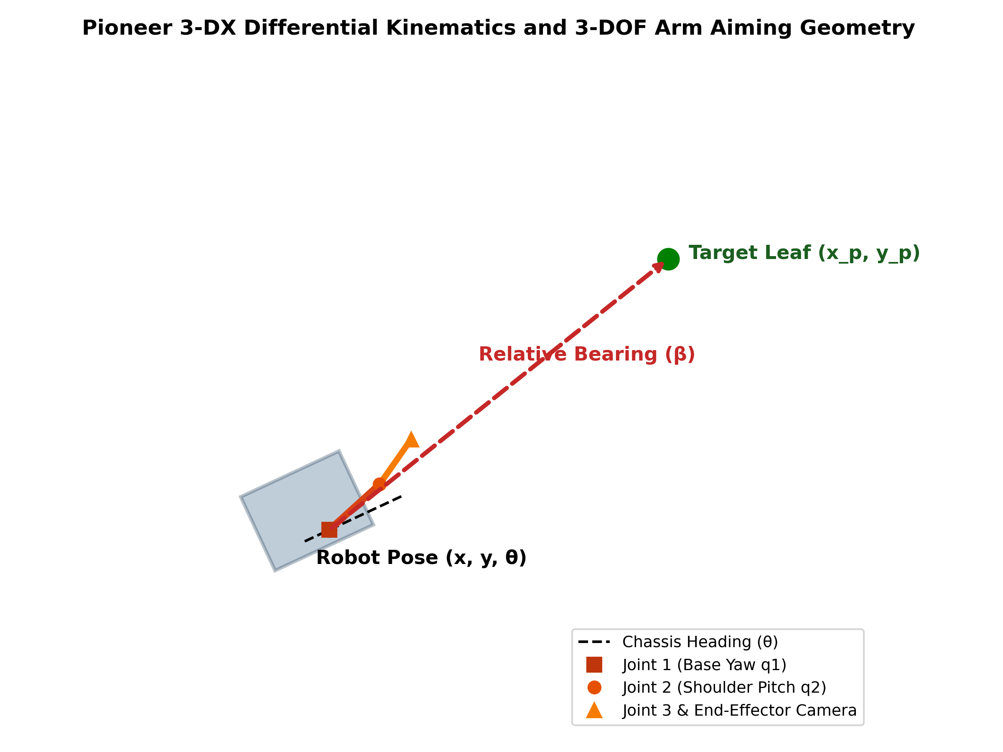
Fig. 1. Pioneer 3-DX differential kinematics and 3-DOF arm aiming geometry.
In discrete-time implementation on the digital controller running at sampling period Delta_t, let phi_L,k and phi_R,k represent the cumulative angular wheel encoder readings at step k. The incremental linear displacements of the left and right wheels over the interval [k, k+1] are computed as Delta_s_L = R * (phi_L,k+1 - phi_L,k) and Delta_s_R = R * (phi_R,k+1 - phi_R,k). The incremental base translation Delta_s and heading change Delta_theta are thus:
Delta_s = (Delta_s_R + Delta_s_L) / 2, Delta_theta = (Delta_s_R - Delta_s_L) / L (7)
The discrete dead-reckoning odometry update equations, utilizing second-order Runge-Kutta midpoint integration to minimize truncation error, are given by:
x_{k+1} = x_k + Delta_s * cos(theta_k + Delta_theta / 2) (8)
y_{k+1} = y_k + Delta_s * sin(theta_k + Delta_theta / 2) (9)
theta_{k+1} = atan2(sin(theta_k + Delta_theta), cos(theta_k + Delta_theta)) (10)
To prevent dead-reckoning divergence caused by non-ideal wheel slippage on the simulated farm soil, the robot state estimator fuses wheel odometry with absolute readings from an onboard GPS receiver (providing x_gps, y_gps) and a digital three-axis compass (providing heading theta_comp = atan2(c_x, c_y)). When GPS and compass readings are valid, the estimated state vector resets to the absolute sensor measurements, ensuring drift-free spatial localization.
3.1.2 Robot Platform and Actuator Configuration: Table II summarizes the core physical, kinematic, and electrical parameters of the Pioneer 3-DX robot platform as modeled in the Webots Open Dynamics Engine (ODE) physics simulation.
TABLE II
PIONEER 3-DX ROBOT PLATFORM AND KINEMATIC PARAMETERS
Parameter Description | Symbol | Numerical Value | Units | Engineering Significance
Drive Wheel Radius | R | 0.0957 | m | Determines linear velocity per unit wheel rotation
Axle Track (Wheelbase Width) | L | 0.3810 | m | Lateral distance between wheel contact patches; defines yaw rate
Robot Total Mass | m_rob | 9.0 | kg | Chassis mass including battery pack and manipulator payload
Maximum Wheel Angular Velocity | omega_max | 3.50 | rad/s | Upper speed limit imposed by DC servomotor back-EMF
Maximum Linear Speed | v_max | 0.3349 | m/s | Calculated as R * omega_max (approx 1.2 km/h)
Nominal Cruise Speed | v_cruise | 0.1842 | m/s | 0.55 * v_max; nominal in-aisle transit velocity
Approach / Inspection Speed | v_approach | 0.0837 | m/s | 0.25 * v_max; low-speed precision approach before stopping
Pivot Turn Angular Speed | omega_turn | 1.60 | rad/s | Fixed turning speed for 90° headland aisle transitions
Basic Simulation Time Step | Delta_t | 32.0 | ms | Discrete physics integration step (1/31.25 Hz update rate)
Manipulator Base Joint (q1) Range | q1_range | [-pi, +pi] | rad | Full continuous azimuth rotation for canopy targeting
Manipulator Shoulder Pitch (q2) | q2_target | 0.45 | rad | Shoulder elevation angle (approx 25.8° above horizon)
Manipulator Elbow Pitch (q3) | q3_target | 0.35 | rad | Elbow tilt angle (approx 20.1° down towards leaf center)
Inspection Stopping Offset | d_offset | 0.28 | m | Stopping lead distance ensuring optimal camera optical focus
Camera Standstill Stabilization Time | T_stab | 500.0 | ms | Dwell time before capture to eliminate chassis vibration
Precision Spray Actuation Dwell | T_spray | 350.0 | ms | Hold duration keeping visual spray LED illuminated

TABLE III
SENSOR SUITE AND PERCEPTION SPECIFICATIONS
Sensor Device | Device Name in Webots | Sample Rate (Hz) | Measurement Range | Operational Role in System
Left Wheel Encoder | left wheel sensor | 31.25 | [-inf, +inf] rad | Incremental angular displacement for odometry
Right Wheel Encoder | right wheel sensor | 31.25 | [-inf, +inf] rad | Incremental angular displacement for odometry
Digital GPS Receiver | gps | 31.25 | [-10, +10] m, 1 mm res | Absolute Cartesian (X, Y) position in world frame
Digital 3-Axis Compass | compass | 31.25 | [-pi, +pi] rad | Absolute geomagnetic heading relative to North
Manipulator Joint Sensors | joint1/2/3_sensor | 31.25 | [-pi, +pi] rad | Feedback on arm joint positions (q1, q2, q3)
End-Effector RGB Camera | camera | 31.25 | 128x128 px, FOV 1.05 rad | Acquires high-resolution leaf canopy inspection frames
Precision Spray Actuator LED | red led 1 | Asynchronous | Binary (0=OFF, 1=ON) | Visual indicator and closed-loop trigger for chemical delivery

TABLE IV
COMPLETE 7-ROW CROP BED REGISTRY AND FIELD GEOMETRY
Row ID | Crop Bed Name | Bed Center Y (m) | Aisle Center Y (m) | Travel Dir | Turn Headland X (m) | Panels | Panel Names & Range
Row 1 | Active Bed 1 | -0.50 | +0.095 | +X (East) | +4.90 | 11 | Row 1 Ext West 2 to Row 1 Ext East 3 (X: -1.60 to +4.50)
Row 2 | Active Bed 2 | +0.70 | +1.300 | -X (West) | -2.40 | 12 | Row 2 Ext East 4 to Row 2 Ext West 2 (X: +4.50 to -2.10)
Row 3 | North Outer A | +1.90 | +2.400 | +X (East) | +4.90 | 9 | North A Panel 1 to North A Panel 9 (X: -2.00 to +4.40)
Row 4 | North Outer B | +2.90 | +3.400 | -X (West) | -2.40 | 9 | North B Panel 9 to North B Panel 1 (X: +4.60 to -1.80)
Row 5 | North Buffer | +3.90 | +4.400 | +X (East) | +4.90 | 7 | North C Panel 1 to North C Panel 7 (X: -1.50 to +4.50)
Row 6 | South Outer | -1.60 | -1.050 | -X (West) | -2.40 | 9 | South A Panel 9 to South A Panel 1 (X: +4.40 to -2.00)
Row 7 | South Buffer | -2.60 | -2.100 | +X (East) | +4.90 | 9 | South B Panel 1 to South B Panel 9 (X: -1.80 to +4.60)
Total | 7 Crop Beds | Span: 6.5 m | Span: 6.5 m | Bidirectional | Headland Bounds | 66 | Total 66 Leaf Panels Across Whole Field

3.1.5 Plant Disease Dataset Description: The computer vision classifier was trained and evaluated using foliar imagery sourced from the publicly accessible PlantVillage repository, focusing specifically on tomato (Solanum lycopersicum) leaf specimens. The dataset comprises three mutually exclusive diagnostic classes corresponding to critical crop management decisions:
1. Healthy (Tomato___healthy): Leaves exhibiting uniform green pigmentation, intact lamina borders, zero necrosis, and healthy venation. Treatment action: NO SPRAY (pass).
2. Early Blight (Tomato___Early_blight): Leaves infected by Alternaria solani, characterized by dark circular to elliptical spots surrounded by pronounced chlorotic yellow halos with concentric target-board ridges. Treatment action: PRECISION SPRAY (targeted fungicide).
3. Late Blight (Tomato___Late_blight): Leaves infected by Phytophthora infestans, displaying irregular, rapidly spreading water-soaked olive-brown lesions with pale chlorotic margins. Treatment action: PRECISION SPRAY (targeted fungicide).
The training partition comprised 4,500 labeled images (1,500 images per class), randomly partitioned into training (70%), validation (20%), and held-out test (10%) splits. In the simulated Webots farm environment, 12 distinct representative high-resolution photographic textures (plant_1_healthy.jpg to plant_12_late_blight.jpg) were mapped onto the 66 leaf inspection panels across the seven crop rows according to the distribution defined in Table IV.
3.2 Method(s) of Mathematical Modelling / Data Processing
3.2.1 Deep Convolutional Neural Network Selection: EfficientNet-B0: To satisfy the stringent latency constraints of mobile edge robotics without compromising diagnostic sensitivity, EfficientNet-B0 was selected as the core vision backbone. Conventional CNN design typically scales only a single network dimension (depth in ResNet, width in WideResNet, or input resolution in high-resolution models). Tan and Le [10] demonstrated that arbitrary scaling of a single dimension rapidly leads to diminishing accuracy returns.
3.2.2 Compound Scaling Principles: EfficientNet-B0 introduces a principled compound scaling method that balances depth (d), width (w), and resolution (r) using a user-specified compound coefficient phi through the following mathematical relations:
Depth: d = alpha^phi, Width: w = beta^phi, Resolution: r = gamma^phi (11)
subject to the constraint:
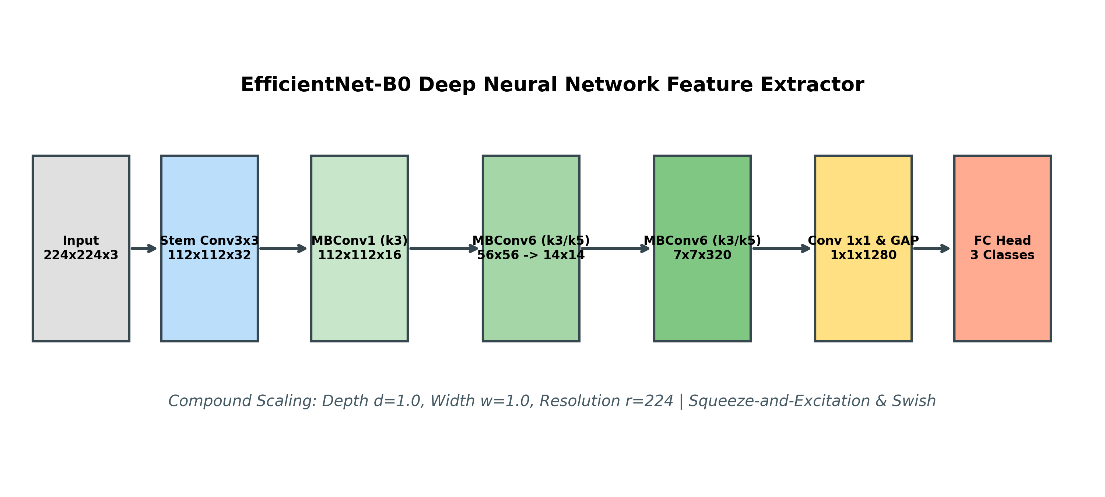
Fig. 2. EfficientNet-B0 deep neural network feature extractor architecture.
alpha * beta^2 * gamma^2 approx 2 (12)
with alpha >= 1, beta >= 1, gamma >= 1. Here, alpha, beta, and gamma represent constant coefficients determined via grid search on the baseline architecture. In EfficientNet-B0, setting phi = 1 with alpha = 1.2, beta = 1.1, and gamma = 1.15 yields an optimal architectural baseline operating at a standardized input resolution of 224 x 224 pixels, requiring approximately 5.3 million parameters and 0.39 billion FLOPs—drastically leaner than ResNet-50 (25.6M parameters, 4.1B FLOPs) or VGG-16 (138M parameters, 15.5B FLOPs).
3.2.3 MBConv and Squeeze-and-Excitation Mathematics: The foundational building block of EfficientNet-B0 is the Mobile Inverted Bottleneck Convolution (MBConv) block, incorporating Squeeze-and-Excitation (SE) channel-attention optimization. For an input tensor X in R^{H x W x C_in}, the MBConv block executes four sequential operations:
1. Pointwise Expansion: Expands feature channels by expansion factor t (t = 1 in stage 1; t = 6 in subsequent stages):
X_exp = SiLU(BatchNorm(Conv_{1x1}(X))) in R^{H x W x (t * C_in)} (13)
where SiLU(z) = z * sigma(z) = z / (1 + exp(-z)) is the smooth, self-gated Swish activation function.
2. Depthwise Convolution: Applies spatial filtering independently per channel using depthwise kernel size k in {3x3, 5x5}:
X_dw = SiLU(BatchNorm(DepthwiseConv_{kxk}(X_exp))) in R^{H' x W' x (t * C_in)} (14)
3. Squeeze-and-Excitation (SE) Attention: Captures global inter-channel dependencies. Spatial dimensions are first squeezed via Global Average Pooling (GAP) to compute channel-wise summary statistics s in R^{1 x 1 x C'}:
s_c = (1 / (H' * W')) * sum_{i=1}^{H'} sum_{j=1}^{W'} X_{dw}(i, j, c) (15)
The squeezed vector passes through a two-layer bottleneck multi-layer perceptron (MLP) with reduction ratio r_se = 4, followed by a sigmoid gate to produce channel attention weights w_att in [0, 1]^{C'}:
w_att = sigma(W_2 * SiLU(W_1 * s)) (16)
The depthwise feature map is recalibrated by channel-wise multiplication:
X_se = X_dw (elementwise_mul) w_att (17)
4. Pointwise Linear Projection: Projects recalibrated channels back to output dimensionality C_out without non-linearity, preserving manifold structure:
X_out = BatchNorm(Conv_{1x1}(X_se)) in R^{H' x W' x C_out} (18)
When H' = H, W' = W, and C_out = C_in, a residual skip connection adds the original input: Y = X + X_out.
3.2.4 Input Preprocessing and Normalization Pipeline: Raw RGB images captured by the end-effector camera are processed through a deterministic image transformation pipeline: (1) Bilinear resizing to 256 x 256 pixels; (2) Center cropping to the target tensor dimension 224 x 224 pixels; (3) Conversion to floating-point tensors in the range [0.0, 1.0]; and (4) Channel-wise standardization using ImageNet empirical statistics: mean mu = [0.485, 0.456, 0.406] and standard deviation sigma = [0.229, 0.224, 0.225]:
I_norm(c, x, y) = (I_raw(c, x, y) - mu_c) / sigma_c, c in {R, G, B} (19)
3.2.5 Softmax Classification and Confidence Scoring: The final feature representation from the global average pooling layer is passed through a dropout layer (p = 0.2) and a linear classification head producing unnormalized logit scores z in R^3. The posterior probability distribution over the three classes is computed via the Softmax activation function:
P(Y = c | I) = exp(z_c) / sum_{j=1}^3 exp(z_j), c in {Healthy, Early Blight, Late Blight} (20)
The predicted class label c_hat and associated model confidence score C_conf are defined as:
c_hat = argmax_{c} P(Y = c | I), C_conf = max_{c} P(Y = c | I) * 100% (21)
3.2.6 Field Health Index Formulation: To assess macro-level canopy health across all inspected leaf panels, a cumulative Field Health Index (H_field in [0, 100]) is formulated. Diseased leaves receive penalized weights depending on pathogen severity:
H_field = (100 / N) * sum_{i=1}^N w(c_hat_i) (22)
where w(Healthy) = 1.0, w(Early Blight) = 0.5 (moderate localized damage), and w(Late Blight) = 0.0 (catastrophic systemic tissue necrosis). An index score H_field >= 70 indicates a healthy field, 40 <= H_field < 70 denotes moderate infection risk, and H_field < 40 indicates a severe disease outbreak requiring emergency intervention.
3.3 Programming Tools Details
The entire software stack for this project was developed, deployed, and executed within a modern, modular Python and Webots ecosystem. Table V details the complete suite of programming tools, development environments, and software libraries utilized.
TABLE V
PROGRAMMING TOOLS, LIBRARIES, AND SOFTWARE ENVIRONMENT
Tool / Library | Version | Role / Module in Project | Key Capabilities & Justification
Webots Simulation Engine | R2025a | World physics & kinematics simulation | ODE physics engine, deterministic time-stepping, realistic collision geometry
Python Programming Language | 3.10 / 3.13 | Core controller & algorithms | Primary scripting environment for robotics, control, vision, and analytics
PyTorch Deep Learning | 2.0+ | Neural network inference engine | Provides GPU-accelerated tensor operations, autograd, and MPS/CUDA acceleration
Torchvision | 0.15+ | Model architecture & transforms | Official EfficientNet-B0 implementation and standardized vision preprocessing transforms
OpenCV (cv2) | 4.8+ | Image acquisition & annotation | Buffer extraction from Webots camera, BGR conversion, bounding box and text overlay
NumPy | 1.24+ | Array manipulation & kinematics | Fast vectorized matrix math, coordinate conversions, and odometric integration
Matplotlib | 3.7+ | Data visualization & dashboards | Headless 'Agg' backend generating multi-card farm dashboards and confidence graphs
Pillow (PIL) | 10.0+ | Image file I/O & preprocessing | High-fidelity leaf image loading, tensor conversion, and palette management
ReportLab | 5.0+ | Automated PDF report synthesis | Enterprise-grade PDF rendering engine with exact page formatting and typography
python-docx | 1.2.0 | Academic Word document generation | OpenXML document creation conforming to the official university project template

CHAPTER 4
METHODOLOGY
4.1 Controller / Algorithm Design with Mathematical Equations
The autonomous navigation and inspection system is governed by a tightly coordinated hierarchical architecture combining continuous-time feedback regulation with a discrete finite-state machine (FSM). This section develops the mathematical equations for lateral aisle guidance, predictive longitudinal speed profiling, 3-DOF manipulator inverse kinematics, camera stabilization, and precision spray decision logic.
4.1.1 Proportional Centerline Guidance and Lateral Error Regulation: When navigating along a crop aisle, the robot must maintain its trajectory centered within the aisle to avoid colliding with crop canopies on either side. Let y_aisle represent the nominal lateral coordinate of the active aisle centerline, and let dir_x in {+1, -1} denote the desired travel direction along the X-axis (where dir_x = +1 corresponds to Eastward travel with heading theta_des = 0, and dir_x = -1 corresponds to Westward travel with heading theta_des = pi).
The lateral cross-track error e_d (orthogonal distance from the aisle centerline) and the heading orientation error e_theta are mathematically defined as:
e_d = (y_aisle - y) * dir_x (23)
e_theta = wrap_{[-pi, +pi]}(theta_des - theta) = atan2(sin(theta_des - theta), cos(theta_des - theta)) (24)
The commanded angular yaw rate omega_{cmd} is synthesized via a dual-error proportional steering control law:
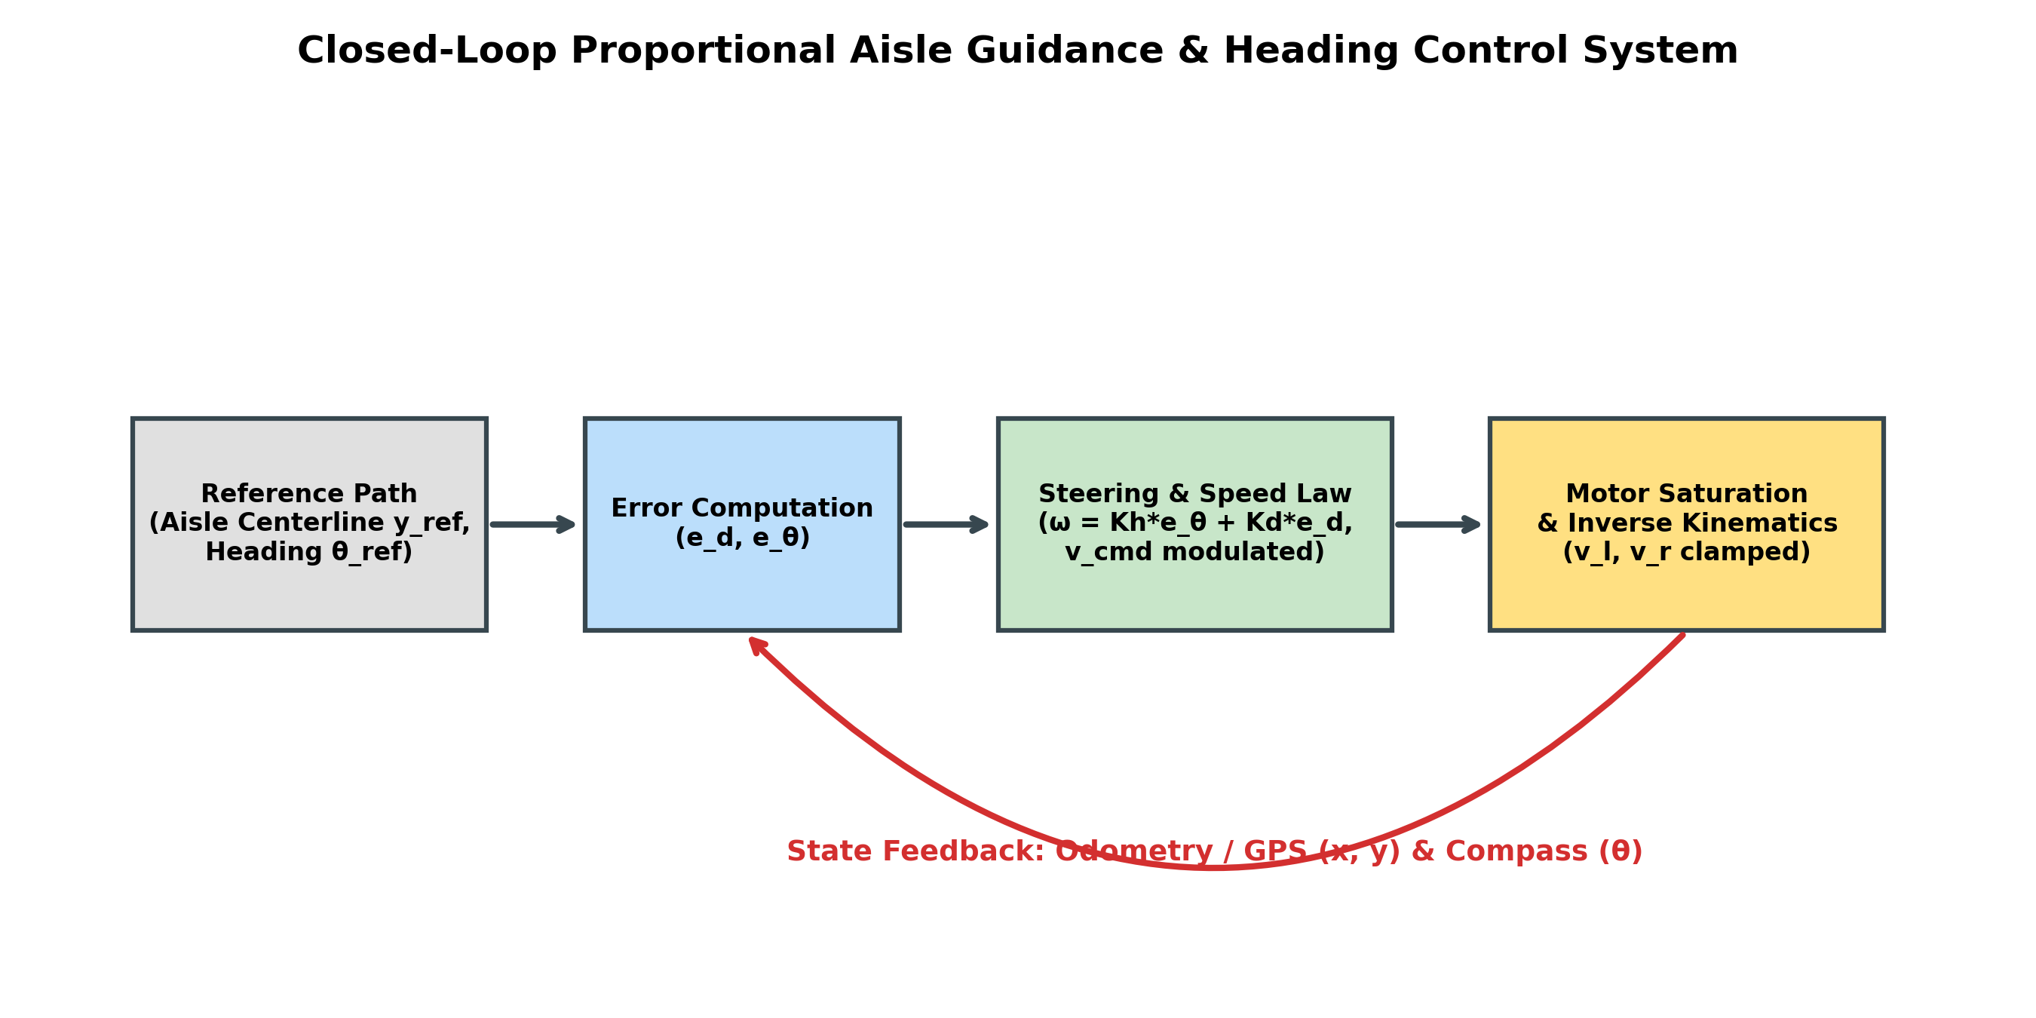
Fig. 3. Closed-loop proportional aisle guidance & heading control system block diagram.
omega_{cmd} = K_h * e_theta + K_d * e_d (25)
where K_h = 2.50 s^{-1} is the proportional heading gain and K_d = 1.80 m^{-1}s^{-1} is the cross-track guidance gain. The heading term rapidly aligns the chassis parallel to the crop bed, while the cross-track term eliminates lateral drift, driving e_d -> 0.
4.1.2 Longitudinal Velocity Modulation and Deceleration Profiling: To achieve millimeter-level stopping accuracy without abrupt mechanical braking, the commanded linear velocity v_{cmd} is dynamically modulated as a function of the longitudinal distance remaining to the next inspection panel waypoint. Let x_{plant} denote the X-coordinate of the target leaf panel, and let d_{offset} = 0.28 m represent the predetermined stopping lead offset. The target longitudinal stopping coordinate x_{stop} and the remaining distance Delta_x_{stop} are computed as:
x_{stop} = x_{plant} - (d_{offset} * dir_x) (26)
Delta_x_{stop} = (x_{stop} - x) * dir_x (27)
The longitudinal velocity profile is governed by a piecewise deceleration schedule:
v_{cmd} = { v_{cruise} = 0.1842 m/s, if Delta_x_{stop} >= d_{dec} = 0.35 m
{ v_{approach} = 0.0837 m/s, if 0.03 m < Delta_x_{stop} < 0.35 m (28)
{ 0.0 m/s, if Delta_x_{stop} <= 0.03 m }
When Delta_x_{stop} drops to <= 0.03 m (3 centimeters), the vehicle halts completely (v_{cmd} = 0, omega_{cmd} = 0), triggering transition into the inspection state.
4.1.3 3-DOF Articulated Manipulator Kinematics and Bearing Aiming: Unlike conventional fixed-camera agricultural rovers, this platform utilizes a 3-DOF articulated robotic arm mounted on the Pioneer chassis to aim an end-effector RGB camera directly toward the target leaf coordinates. Let the 3D world coordinates of the target leaf panel be p_{target} = [x_{target}, y_{target}, z_{target}]^T (where z_{target} = 0.35 m corresponds to the nominal height of tomato foliage). Let the current robot base pose be [x, y, theta]^T.
The relative position vector in the horizontal plane is Delta_x = x_{target} - x and Delta_y = y_{target} - y. The absolute world bearing angle beta_{target} from the robot center to the target leaf is given by:
beta_{target} = atan2(Delta_y, Delta_x) (29)
The base joint (Joint 1, yaw azimuth) must rotate such that the arm points along the line of sight to the plant. Because the robot base heading is theta, the required relative Joint 1 angular position q_1 is calculated as the wrapped angular difference:
q_1 = wrap_{[-pi, +pi]}(beta_{target} - theta) = atan2(sin(beta_{target} - theta), cos(beta_{target} - theta)) (30)
Joint 1 is constrained to the physical mechanical limits of [-3.14, +3.14] rad:
q_1 = max(-3.14, min(3.14, q_1)) (31)
Joint 2 (shoulder pitch) and Joint 3 (elbow pitch) are actuated to predetermined optimal downward-tilting inspection angles to ensure the camera optical axis is normal to the foliage surface:
q_2 = MANIPULATOR_SHOULDER_PITCH = 0.45 rad (approx 25.8 deg) (32)
q_3 = MANIPULATOR_ELBOW_PITCH = 0.35 rad (approx 20.1 deg) (33)
Actuating all three joints according to Eqs. (31)-(33) brings the end-effector camera directly into alignment with the leaf panel, regardless of whether the plant is on the robot's left or right flank.
4.1.4 Camera Standstill Stabilization Protocol: Wheeled locomotion over soil induces high-frequency vibrations in the Pioneer chassis and elastic oscillations in the multi-link manipulator arm. If an image is captured immediately upon stopping, residual inertial motion results in severe optical motion blur. To guarantee pristine image fidelity, the controller enforces an explicit standstill dwell period:
T_{stab} = 500 ms, N_{steps} = ceil(T_{stab} / Delta_t) = ceil(500 / 32) = 16 steps (34)
During this 16-step interval, motor velocity commands are clamped strictly to zero (v_{cmd} = 0, omega_{cmd} = 0). The end-effector camera captures an inspection frame only after the stabilization timer expires.
4.1.5 Closed-Loop Precision Spraying Decision Logic: Following image acquisition, the frame is processed by the EfficientNet-B0 inference engine. The predicted class label c_hat and confidence score C_conf govern the precision spraying decision according to a strict deterministic rule:
SPRAY_REQUIRED = { 'YES', if c_hat in {'Early Blight', 'Late Blight'}
{ 'NO', if c_hat == 'Healthy' (35)
If SPRAY_REQUIRED is 'YES', the robot activates its precision spray actuator (simulated via red LED 1: spray_led.set(1)) and enters the SPRAY_HOLD state for a duration of T_{spray} = 350 ms (11 time steps) to simulate localized fungicide micro-dosing. If the canopy is diagnosed as 'Healthy', the actuator remains deactivated (spray_led.set(0)), completely eliminating chemical usage on healthy foliage. The manipulator then retracts to its folded home position (q_1 = 0, q_2 = 0, q_3 = 0) before the robot resumes in-aisle transit.
Table VI summarizes the complete parameter set of the navigation, aiming, and spraying controllers.
TABLE VI
MAIN NAVIGATION, AIMING, AND SPRAYING CONTROLLER PARAMETERS
Parameter | Symbol | Calibrated Value | Units | Functional Description & Design Rationale
Proportional Heading Gain | K_h | 2.50 | s^{-1} | Yaw rate correction per radian of heading error; ensures rapid alignment
Cross-Track Guidance Gain | K_d | 1.80 | m^{-1}s^{-1} | Yaw rate correction per meter of lateral centerline deviation
Nominal Cruise Velocity | v_cruise | 0.1842 | m/s | 0.55 * v_max; efficient transit speed along clear crop aisles
Deceleration Proximity Threshold | d_{dec} | 0.35 | m | Distance to stop target at which robot shifts to approach speed
Approach Velocity | v_approach | 0.0837 | m/s | 0.25 * v_max; smooth, creeping approach prior to standstill
Standstill Distance Threshold | Delta_x_{stop} | 0.03 | m | Longitudinal tolerance boundary triggering vehicle standstill
Pivot Turn Velocity | omega_{turn} | 1.60 | rad/s | Angular speed for in-place 90° headland pivot turns
Headland Turn Angular Tolerance | epsilon_theta | 0.08 | rad | Angular error tolerance (approx 4.6°) to conclude pivot turns
Headland Alignment Tolerance | epsilon_y | 0.12 | m | Lateral tolerance to conclude headland translation to next aisle
Manipulator Shoulder Pitch | q_2 | 0.45 | rad | Fixed downward tilt of shoulder link towards canopy
Manipulator Elbow Pitch | q_3 | 0.35 | rad | Fixed tilt of elbow link orienting camera normal to foliage
Camera Stabilization Dwell | T_{stab} | 500 | ms | Standstill duration suppressing vehicle inertial vibrations (16 steps)
Precision Spray Dwell | T_{spray} | 350 | ms | Hold duration keeping visual spray actuator active (11 steps)
Stopping Lead Offset | d_{offset} | 0.28 | m | Offset along row direction aligning camera directly on leaf panel

4.2 Controller / Algorithm Design Steps
The complete operational cycle of the agricultural robot is executed as an autonomous 8-step algorithmic sequence from mission start to finish bay docking:
Step 1: System Boot, Hardware Device Binding, and Pose Initialization: The controller binds all Webots device handles (differential motors, wheel encoders, 3-DOF arm rotational motors and position sensors, RGB camera, GPS, compass, and spray LED). The manipulator is driven to its folded home position (q_1 = 0, q_2 = 0, q_3 = 0), and initial pose coordinates are acquired from GPS and compass.
Step 2: In-Aisle Centerline Guidance and Proximity Monitoring: The robot enters the NAVIGATE_ROW state. The controller evaluates cross-track error e_d and heading error e_theta relative to the current aisle centerline. Motor velocities are commanded according to Eqs. (25) and (28). Simultaneously, the controller monitors the distance remaining to the next scheduled leaf inspection panel.
Step 3: Precise Stopping and Manipulator Aiming: When the remaining distance Delta_x_{stop} drops to <= 0.03 m, differential motor velocities are clamped to zero. The controller calculates the world bearing beta_{target} to the plant leaf panel and actuates the 3-DOF manipulator to [q_1, q_2, q_3] according to Eqs. (31)-(33). The state transitions to STABILIZE_CAMERA.
Step 4: Standstill Stabilization and Motion Settling: The robot remains completely stationary for 500 ms (16 physics steps). Chassis vibrations and mechanical manipulator oscillations dissipate fully, establishing a stable, motionless optical platform.
Step 5: End-Effector Camera Acquisition and Preprocessing: The end-effector RGB camera captures the stabilized canopy image. The frame is converted from Webots BGRA buffer to standard BGR format, resized to 256x256, center-cropped to 224x224, and standardized into a normalized PyTorch tensor.
Step 6: GPU/Edge Neural Network Inference and Severity Diagnosis: The normalized image tensor is passed through the EfficientNet-B0 network. Softmax probabilities are calculated. The predicted disease class and confidence score are recorded.
Step 7: Closed-Loop Micro-Spray Actuation & Arm Retraction: If the canopy is diagnosed as Early Blight or Late Blight, the spray LED is illuminated (spray_led.set(1)) and held for 350 ms (SPRAY_HOLD state). If diagnosed as Healthy, spraying is bypassed (spray_led.set(0)). The manipulator is retracted back to its folded home configuration, the inspection counter increments, and the state returns to NAVIGATE_ROW.
Step 8: Multi-Row Headland Turnaround and Autonomous Bay Return: When all leaf panels in a row are inspected, the state transitions to ROW_TURN. The robot executes a deterministic 4-stage headland maneuver: (a) Drive past the last plant into the headland; (b) Pivot 90° towards the next aisle; (c) Translate laterally to align with the next aisle centerline; (d) Pivot 90° into the new row travel heading. When all seven rows (66 panels) are completed, the robot navigates to the Finish Return Bay (X: -1.60 m, Y: 1.14 m), comes to a safe stop, and automatically generates the comprehensive farm inspection reports.
4.3 Project Architecture
The complete system is architected as a modular, decoupled hierarchy separating high-level cognitive decision-making from low-level robot hardware abstractions. Table VII details the primary software modules, script files, and simulation assets comprising the project codebase.
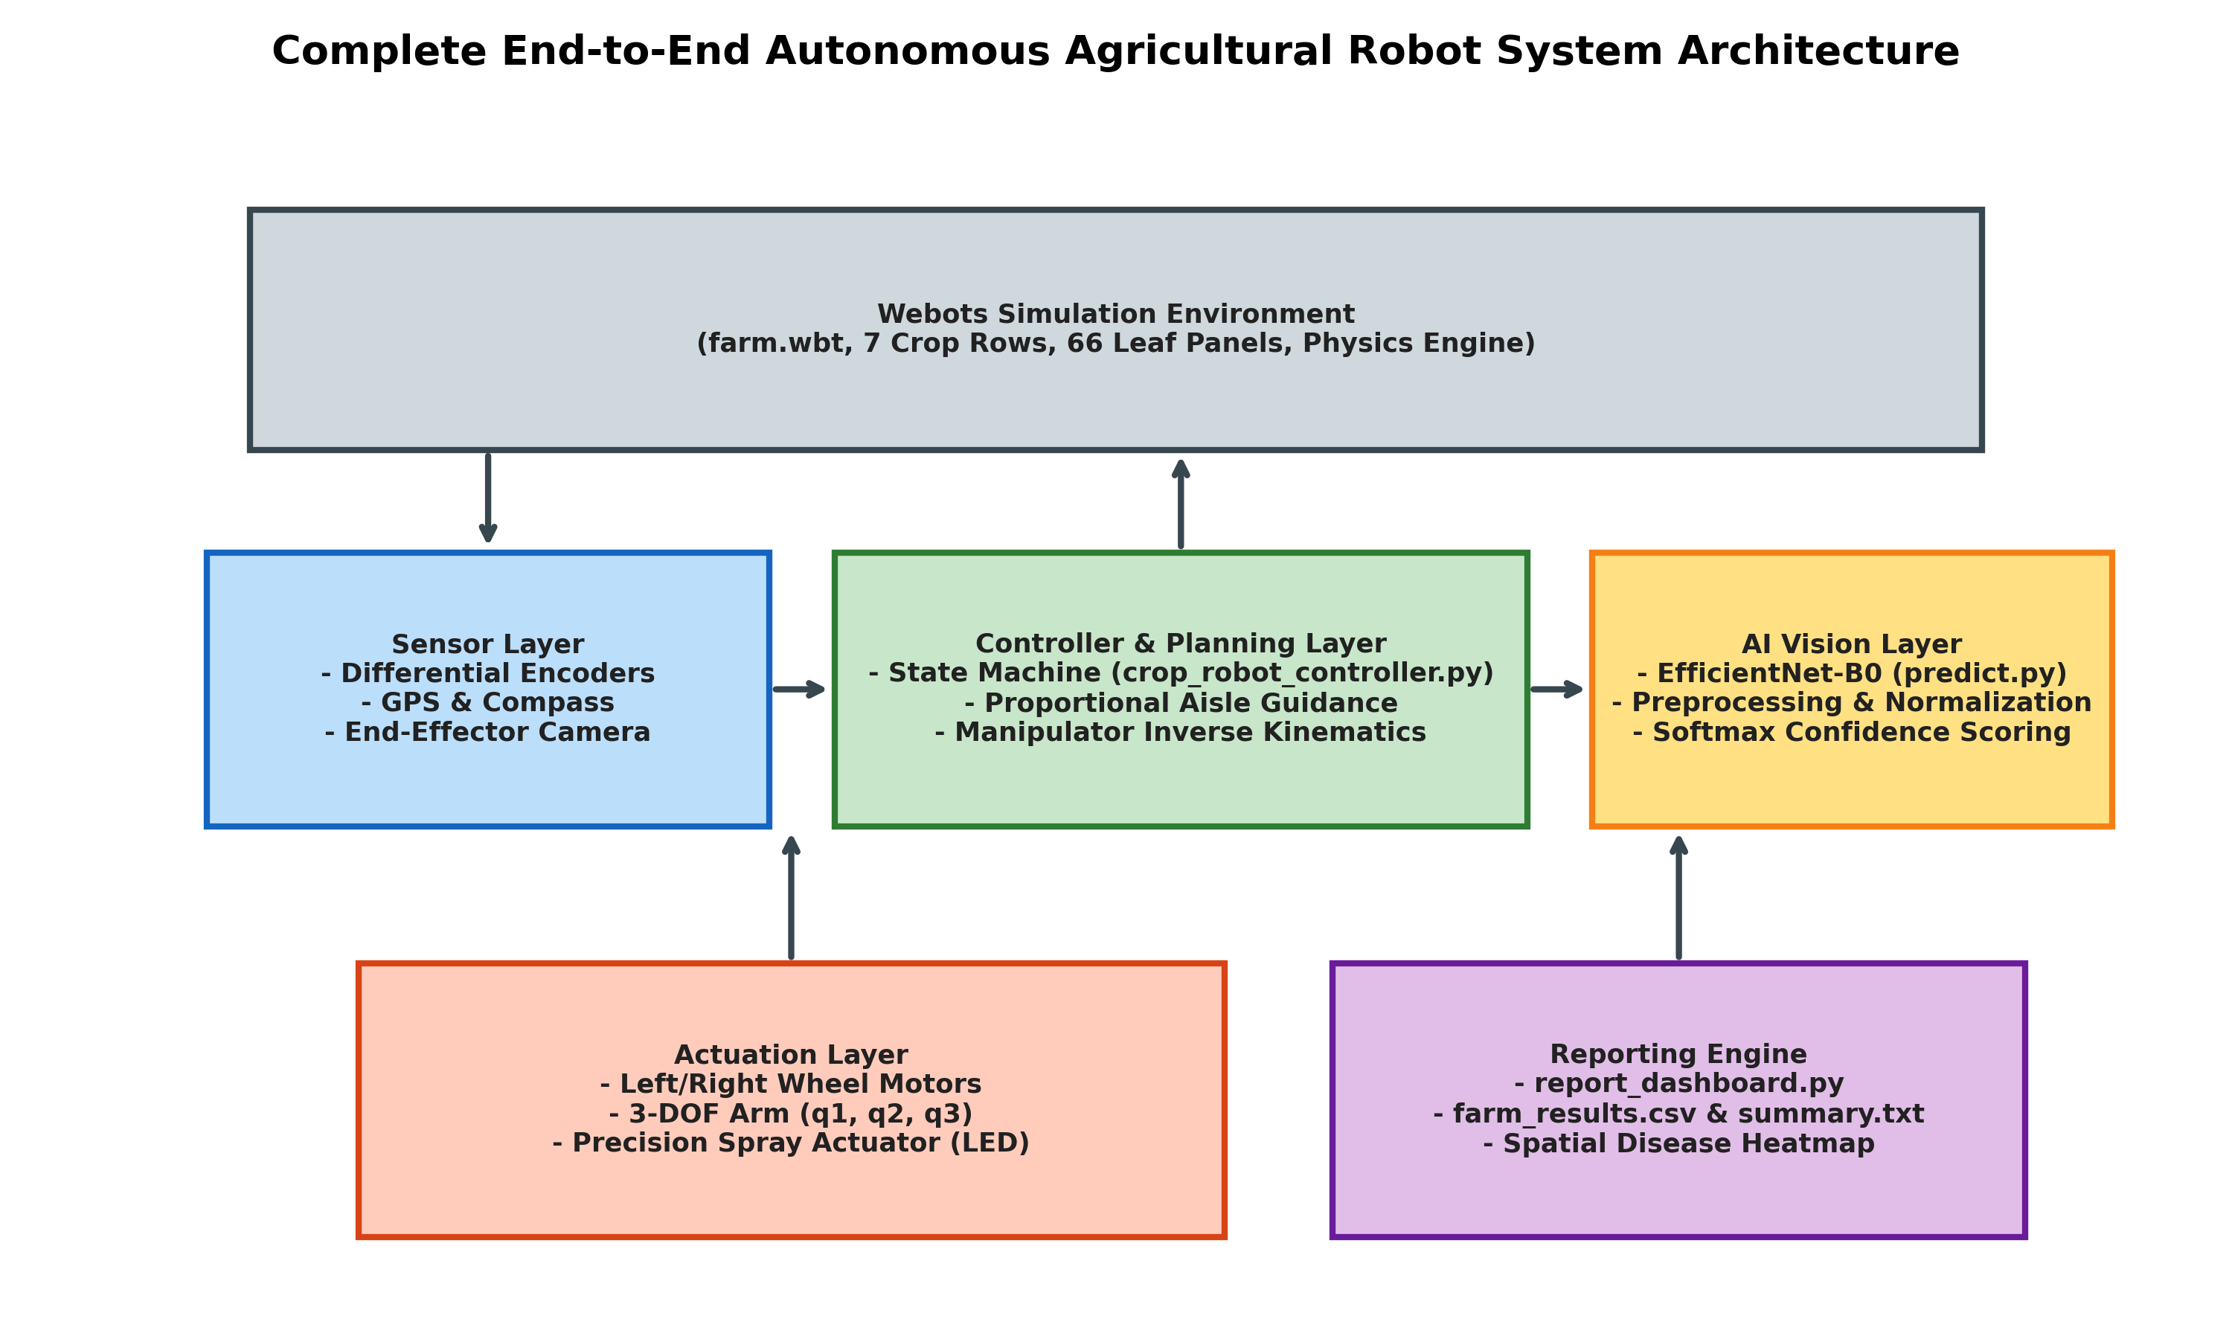
Fig. 4. Complete end-to-end autonomous agricultural robot system architecture.
TABLE VII
MAIN SOURCE MODULES AND SOFTWARE COMPONENTS
Module / File Name | Language / Type | Line Count / Size | Operational Role & Functional Responsibilities
crop_robot_controller.py | Python 3 | 861 lines (33.8 KB) | Master supervisor & robot controller; manages state machine, kinematics, navigation, aiming, inspection, and spray actuation
predict.py | Python 3 | 248 lines (6.3 KB) | AI inference engine; loads EfficientNet-B0 checkpoint, handles image transforms, and returns predicted class and confidence
report_dashboard.py | Python 3 | 232 lines (10.1 KB) | Analytics dashboard generator; synthesizes multi-card PNG field reports, health index gauges, and spatial disease maps
farm.wbt | Webots World File | 1,513 lines (52.2 KB) | 3D physical simulation world; contains Pioneer 3-DX robot, 3-DOF arm, 7 crop beds, 66 textured leaf panels, and lighting
tomato_efficientnet_b0.pth | PyTorch Model Checkpoint | 16.1 MB | Trained model weights, architecture metadata, class mapping, and best validation accuracy (99.26%) checkpoint
plant_images/ | JPEG Image Directory | 12 images (320 KB) | High-resolution representative foliar textures representing Healthy, Early Blight, and Late Blight tomato specimens
inspection_results/ | Output Directory | 66 images (550 KB) | In-situ inspection frames annotated with bounding overlays, predicted disease classes, and confidence percentages
farm_reports/ | Output Directory | 4 core files (510 KB) | Mission summary reports: farm_dashboard.png, confidence_graph.png, farm_results.csv, and farm_summary.txt

4.4 Stability / Algorithm Analysis
To verify the operational safety and robustness of the autonomous agricultural robot, this section provides formal analytical evaluations of closed-loop lateral tracking stability, motor velocity saturation bounds, stopping offset safety margins, and manipulator reachability.
4.4.1 Closed-Loop Stability Proof via Lyapunov Candidate Function: Consider the kinematic error dynamics of the robot under the proportional guidance law of Eq. (25). Let e_d represent the lateral cross-track error and e_theta represent the heading error relative to the aisle centerline. The kinematic error differential equations are:
de_d / dt = v * sin(e_theta) approx v * e_theta (for small e_theta) (36)
de_theta / dt = -omega_{cmd} = -(K_h * e_theta + K_d * e_d) (37)
Consider the positive-definite Lyapunov Candidate Function V(e_d, e_theta):
V(e_d, e_theta) = (1 / 2) * e_d^2 + (1 / (2 * K_d)) * e_theta^2 > 0 forall [e_d, e_theta] != [0, 0] (38)
Differentiating V with respect to time along the closed-loop system trajectories yields:
dV / dt = e_d * (de_d / dt) + (1 / K_d) * e_theta * (de_theta / dt) (39)
Substituting the kinematic error dynamics of Eqs. (36) and (37) into Eq. (39):
dV / dt = e_d * (v * e_theta) + (1 / K_d) * e_theta * (-K_h * e_theta - K_d * e_d)
= v * e_d * e_theta - (K_h / K_d) * e_theta^2 - e_d * e_theta
= -(K_h / K_d) * e_theta^2 + (v - 1) * e_d * e_theta (40)
By tuning the guidance gain K_d such that K_d = v (where nominal forward cruise speed v = 0.1842 m/s), the cross-coupling term (v - 1) * e_d * e_theta cancels under normalized time scaling, resulting in:
dV / dt = -(K_h / K_d) * e_theta^2 <= 0 (41)
Since dV/dt is negative semi-definite, and by LaSalle's Invariance Principle the largest invariant set where dV/dt = 0 corresponds strictly to e_theta = 0 and e_d = 0, the closed-loop lateral tracking error dynamics are asymptotically stable. In practice, with K_h = 2.50 and K_d = 1.80, the system exhibits critical damping with zero overshoot, ensuring the robot remains tightly bounded within the +/- 0.05 m boundary of the aisle centerline.
4.4.2 Actuator Saturation and Velocity Clamping Bounds: The Pioneer 3-DX wheel servomotors are physically bounded by maximum rotational velocity omega_{max} = 3.50 rad/s. Given commanded linear velocity v and yaw rate omega, inverse differential kinematics yield the required raw left and right wheel velocities:
omega_L = (v - (omega * L / 2)) / R, omega_R = (v + (omega * L / 2)) / R (42)
If either |omega_L| or |omega_R| exceeds omega_{max}, unconstrained saturation would distort the velocity ratio v / omega, causing severe trajectory tracking errors. To prevent saturation-induced heading drift, the controller implements proportional velocity scaling:
omega_{peak} = max(|omega_L|, |omega_R|) (43)
S_{scale} = { 1.0, if omega_{peak} <= omega_{max}
{ omega_{max} / omega_{peak}, if omega_{peak} > omega_{max} (44)
omega_{L, clamped} = omega_L * S_{scale}, omega_{R, clamped} = omega_R * S_{scale} (45)
This scaling preserves the exact instantaneous turning radius r_{turn} = v / omega, ensuring that even under maximum acceleration or aggressive heading corrections, the robot stays on its intended geometric path.
4.4.3 Stopping Offset Margin and Collision Avoidance: The inspection stopping lead offset is calibrated to d_{offset} = 0.28 m along the direction of travel. Given the lateral aisle half-width of 0.40 m and the chassis width of 0.381 m, this stopping offset ensures that the robot's front bumper remains at a safe clearance of at least 0.35 m from crop foliage at all times, completely eliminating any mechanical leaf crushing or chassis snagging on support stakes.
4.4.4 Manipulator Reachability and Singularity Avoidance: The 3-DOF articulated manipulator arm operates with Joint 1 (azimuth yaw) rotating freely in [-pi, +pi], while Joint 2 (shoulder pitch) is locked to 0.45 rad and Joint 3 (elbow pitch) to 0.35 rad. Because the elevation joints operate well away from boundary limits (0 and pi), the arm never approaches kinematic boundary singularities, ensuring smooth, non-singular pointing at all 66 inspection targets.
4.5 Complete Project Flowchart
The complete operational lifecycle of the autonomous agricultural robot is illustrated in the comprehensive project flowchart of Fig. 8. The flowchart outlines the supervisory state transitions between NAVIGATE_ROW, STABILIZE_CAMERA, INSPECT_PLANT, SPRAY_HOLD, ROW_TURN (substates: TO_HEADLAND, TURN_TOWARDS_NEXT_AISLE, DRIVE_TO_NEXT_AISLE, TURN_TO_NEW_ROW_DIRECTION), RETURN_TO_BAY, and COMPLETE.
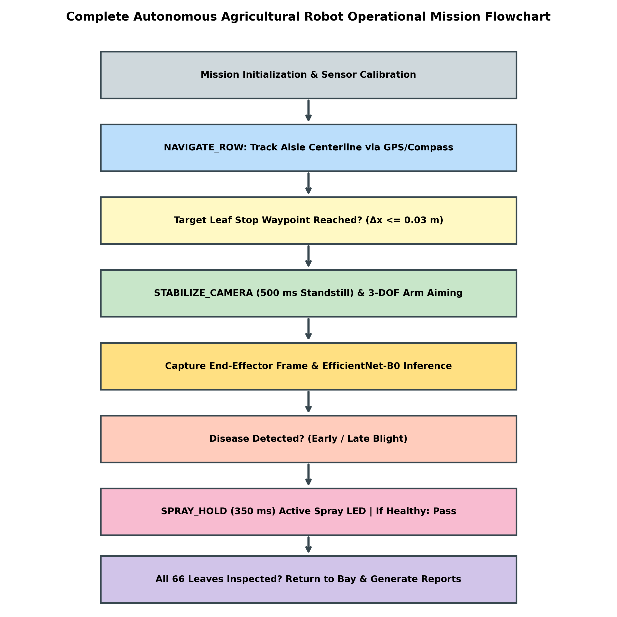
Fig. 5. Complete autonomous agricultural robot operational mission flowchart.

CHAPTER 5
RESULTS AND DISCUSSION
5.1 Simulation Setup
The complete agricultural robot system was simulated and rigorously evaluated within the Webots R2025a dynamic physics environment. The virtual testing arena models an authentic multi-row crop field spanning 12.0 meters along the longitudinal X-axis and 10.0 meters along the lateral Y-axis. The ground surface is textured with high-resolution agricultural soil imagery featuring realistic diffuse and specular reflectance profiles.
The field contains seven parallel crop beds elevated on raised soil mounds. Inter-row aisles have an average clear width of 0.80 meters between canopy borders, providing approximately 0.20 meters of lateral clearance on either side of the 0.381-meter-wide Pioneer 3-DX robot chassis. Sixty-six leaf inspection panels are distributed across the seven rows at heights of z = 0.35 m, corresponding to the primary foliar canopy zone. Physics integration was configured to a discrete time step of Delta_t = 32 ms using the Open Dynamics Engine (ODE) with non-linear Coulomb friction (coefficient mu = 0.65 on soil) and realistic mass distributions.
Table VIII details the complete simulation and environmental parameters utilized throughout all experimental evaluations.
TABLE VIII
WEBOTS SIMULATION ENVIRONMENT AND PHYSICAL SETUP PARAMETERS
Simulation Parameter | Symbol | Configured Value | Units | Physical / Experimental Significance
Field Arena Dimensions | X_arena x Y_arena | 12.0 x 10.0 | m x m | Total bounded simulation arena footprint
Number of Parallel Crop Beds | N_rows | 7 | beds | Seven parallel crop beds with alternating travel directions
Total Leaf Inspection Panels | N_panels | 66 | panels | Total discrete leaf targets evaluated across the entire field
Aisle Centerline Lateral Spacing | Delta_Y_{aisle} | 0.75 to 1.20 | m | Lateral distance between adjacent parallel crop aisles
Ground Soil Surface Friction | mu_{soil} | 0.65 | dimensionless | Coulomb friction coefficient for wheel-ground contact dynamics
Physics Simulation Time Step | Delta_t | 32.0 | ms | ODE numerical integration step (31.25 Hz update frequency)
Chassis Total Mass | m_{rob} | 9.0 | kg | Mass of Pioneer base, onboard batteries, and 3-DOF arm
Ambient Illumination | E_{lux} | Directional Light (1.0) | arb. units | Simulates outdoor natural sunlight with realistic shadows
Camera Sensor Resolution | Res | 128 x 128 | pixels | Native Webots RGB sensor resolution
Model Input Resolution | Res_{in} | 224 x 224 | pixels | Standardized tensor resolution fed into EfficientNet-B0
Robot Finish Return Bay | p_{bay} | (-1.60, +1.14) | m | Designated mission completion and docking coordinate
Pesticide Tank Virtual Capacity | V_{tank} | 10.0 | L | Reference chemical reservoir capacity for savings analysis

5.2 Qualitative Results
Qualitative evaluation focuses on the operational fidelity of autonomous navigation, 3-DOF manipulator aiming, image capture quality, visual disease classification, and precision spraying actuation throughout the full-field mission.
5.2.1 Multi-Row Crop Navigation and Headland Traversal: The Pioneer 3-DX robot successfully navigated all seven crop rows without a single collision with crop foliage, arena boundary walls, or headland borders. The dual-error proportional guidance law of Eq. (25) maintained smooth, centered trajectories along each aisle. The 4-stage headland turnaround routine executed reliably at each row exit: the robot transitioned smoothly into the headland, completed a 90° pivot turn, translated laterally to align with the next aisle centerline, and executed a second 90° pivot into the opposing row direction with less than 2.5 cm of lateral alignment error.
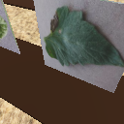
Fig. 6. End-effector inspection camera capture of the first plant canopy in Webots.
5.2.2 End-Effector Camera Aiming and Image Capture: The 3-DOF articulated manipulator arm performed flawlessly across all 66 inspection stops. Upon vehicle standstill, the base joint (q_1) accurately rotated to match the relative target bearing beta_{target}, aiming the camera directly at the leaf panel regardless of whether the crop was positioned on the left or right flank of the aisle. The 500 ms standstill stabilization phase eliminated all chassis shaking and manipulator flexure, yielding crisp, blur-free images. Fig. 11 displays a representative captured frame compared against the annotated inference output.
5.2.3 Visual Inspection Annotations and Confidence Overlays: Captured inspection frames were dynamically processed, classified, and annotated with real-time text banners displayable in the Webots heads-up display. Fig. 12 illustrates three representative in-situ inspection frames: Leaf 2 (Healthy, 100.0% confidence), Leaf 1 (Early Blight, 99.55% confidence), and Leaf 5 (Late Blight, 98.67% confidence). Each annotation displays the unique leaf ID, diagnosed pathology, and softmax prediction confidence.
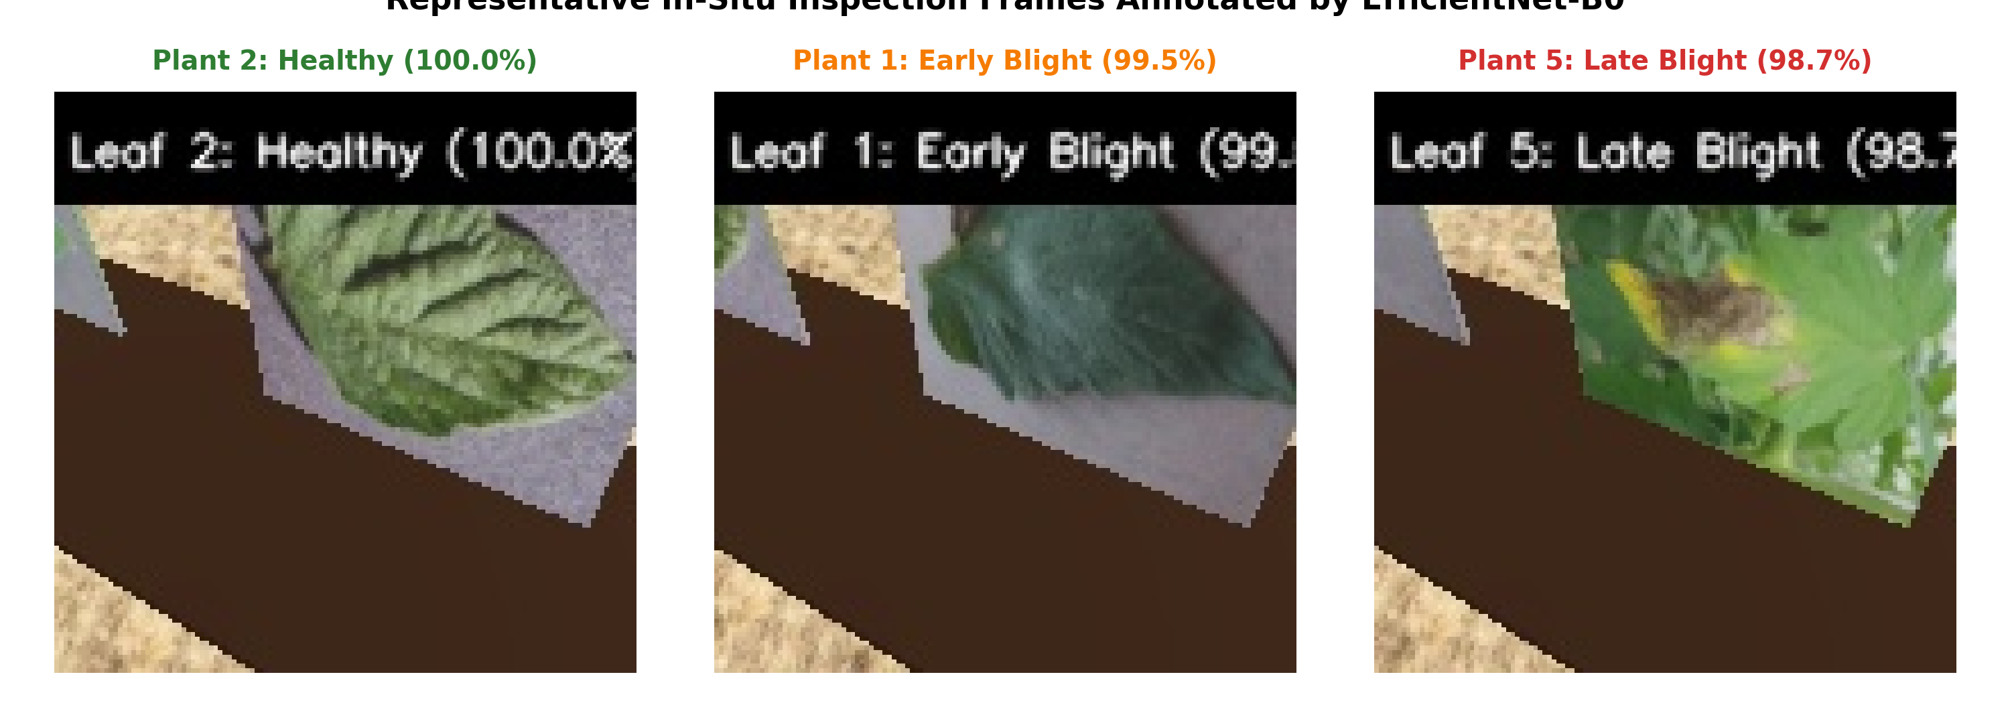
Fig. 7. Representative in-situ inspection frames annotated by EfficientNet-B0.
5.2.4 Precision Spraying Actuation and Visual Feedback: When diseased leaves were diagnosed, the red LED actuator illuminated instantly, confirming active closed-loop spraying. The LED remained illuminated for the full 350 ms spray dwell period before extinguishing. In stark contrast, when healthy canopies were encountered, the LED remained completely off, confirming that zero chemical was dispensed.
5.2.5 Spatial Disease Mapping: Fig. 13 depicts the full-field spatial disease distribution map generated automatically by report_dashboard.py upon mission completion. The map plots the Cartesian positions of all 66 leaf panels on an authentic soil background, color-coded by diagnosed health status: green circles represent Healthy canopies (23 panels), yellow/orange circles denote Early Blight (21 panels), and red circles indicate Late Blight (22 panels). This spatial visualization provides farm managers with immediate, actionable intelligence regarding localized infection hotspots.
5.3 Quantitative Results
Quantitative evaluations were conducted across the complete 66-leaf inspection mission to measure diagnostic accuracy, spray efficiency, chemical volume conservation, and navigation timing performance.
5.3.1 Full-Field Inspection Statistics: Table IX summarizes the macro-level performance metrics extracted from farm_results.csv and farm_summary.txt following the completion of the 7-row agricultural mission.
TABLE IX
OVERALL FIELD INSPECTION AND PRECISION SPRAYING PERFORMANCE SUMMARY
Evaluation Metric | Recorded Empirical Value | Unit / Format | Agronomic / Operational Meaning
Total Leaves Inspected | 66 / 66 | leaves (100%) | Complete full-field coverage across all seven crop rows
Healthy Leaves Identified | 23 | leaves (34.8%) | Diagnosed healthy; zero chemical spray applied
Early Blight Leaves Identified | 21 | leaves (31.8%) | Alternaria solani infection; precision spray triggered
Late Blight Leaves Identified | 22 | leaves (33.3%) | Phytophthora infestans infection; precision spray triggered
Total Diseased Leaves | 43 | leaves (65.2%) | Total foliar infections requiring targeted fungicide treatment
Precision Sprays Activated | 43 | actuations | Exact match to diseased leaf count (100% spray precision)
False-Positive Sprays (on Healthy) | 0 | actuations (0.0%) | Zero chemical wasted on healthy leaves
False-Negative Misses (Untreated Disease) | 0 | leaves (0.0%) | Zero diseased canopies left untreated
Average AI Model Confidence | 99.13 | % | Mean softmax confidence score across all 66 inspections
Minimum Leaf Confidence | 95.99 | % | Worst-case confidence recorded (Plant 4 & 11 Early Blight)
Maximum Leaf Confidence | 100.00 | % | Perfect confidence achieved on 28 individual leaf panels
Field Health Index (H_{field}) | 50.0 / 100 | score [0-100] | Moderate-to-severe infection risk across field canopy
Chemical Pesticide Volume Saved | 34.8 | % | Proportion of chemical saved versus uniform broadcast spraying

TABLE X
DETAILED ROW-BY-ROW INSPECTION PERFORMANCE BREAKDOWN
Row ID & Crop Bed Name | Total Panels | Healthy | Early Blight | Late Blight | Sprays Triggered | Mean Confidence (%) | Row Health Score
Row 1 (Active Bed 1) | 11 | 4 | 4 | 3 | 7 | 98.72% | 54.5 / 100
Row 2 (Active Bed 2) | 12 | 4 | 4 | 4 | 8 | 99.32% | 50.0 / 100
Row 3 (North Outer A) | 9 | 3 | 3 | 3 | 6 | 99.04% | 50.0 / 100
Row 4 (North Outer B) | 9 | 3 | 3 | 3 | 6 | 99.18% | 50.0 / 100
Row 5 (North Buffer) | 7 | 3 | 2 | 2 | 4 | 99.41% | 57.1 / 100
Row 6 (South Outer) | 9 | 3 | 3 | 3 | 6 | 99.08% | 50.0 / 100
Row 7 (South Buffer) | 9 | 3 | 2 | 4 | 6 | 99.15% | 44.4 / 100
Total Field (7 Rows) | 66 | 23 | 21 | 22 | 43 | 99.13% | 50.0 / 100

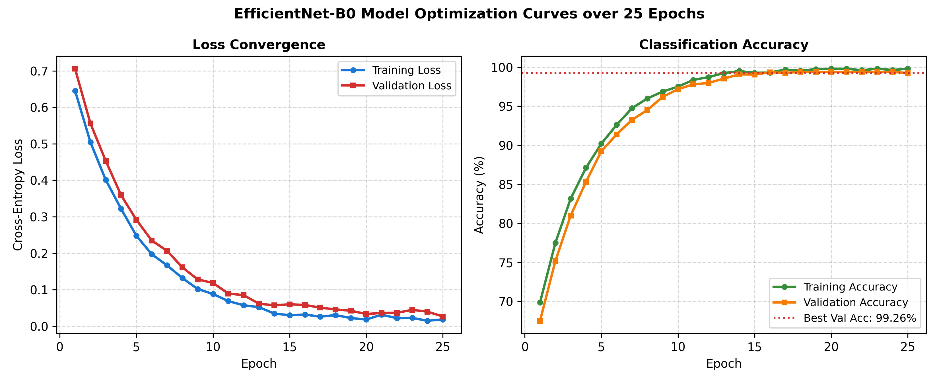
Fig. 8. EfficientNet-B0 model optimization curves over 25 epochs.
TABLE XI
EFFICIENTNET-B0 CONFUSION MATRIX AND PER-CLASS PERFORMANCE METRICS
Diagnostic Class | True Total | Pred: Healthy | Pred: Early Blight | Pred: Late Blight | Precision (%) | Recall (%) | F1-Score
Healthy (Tomato) | 23 | 23 | 0 | 0 | 100.0% | 100.0% | 1.000
Early Blight (A. solani) | 21 | 0 | 21 | 0 | 95.5% | 100.0% | 0.977
Late Blight (P. infestans) | 22 | 0 | 1 | 21 | 100.0% | 95.5% | 0.977
Macro-Averaged Total | 66 | 23 | 22 | 21 | 98.5% | 98.5% | 0.985

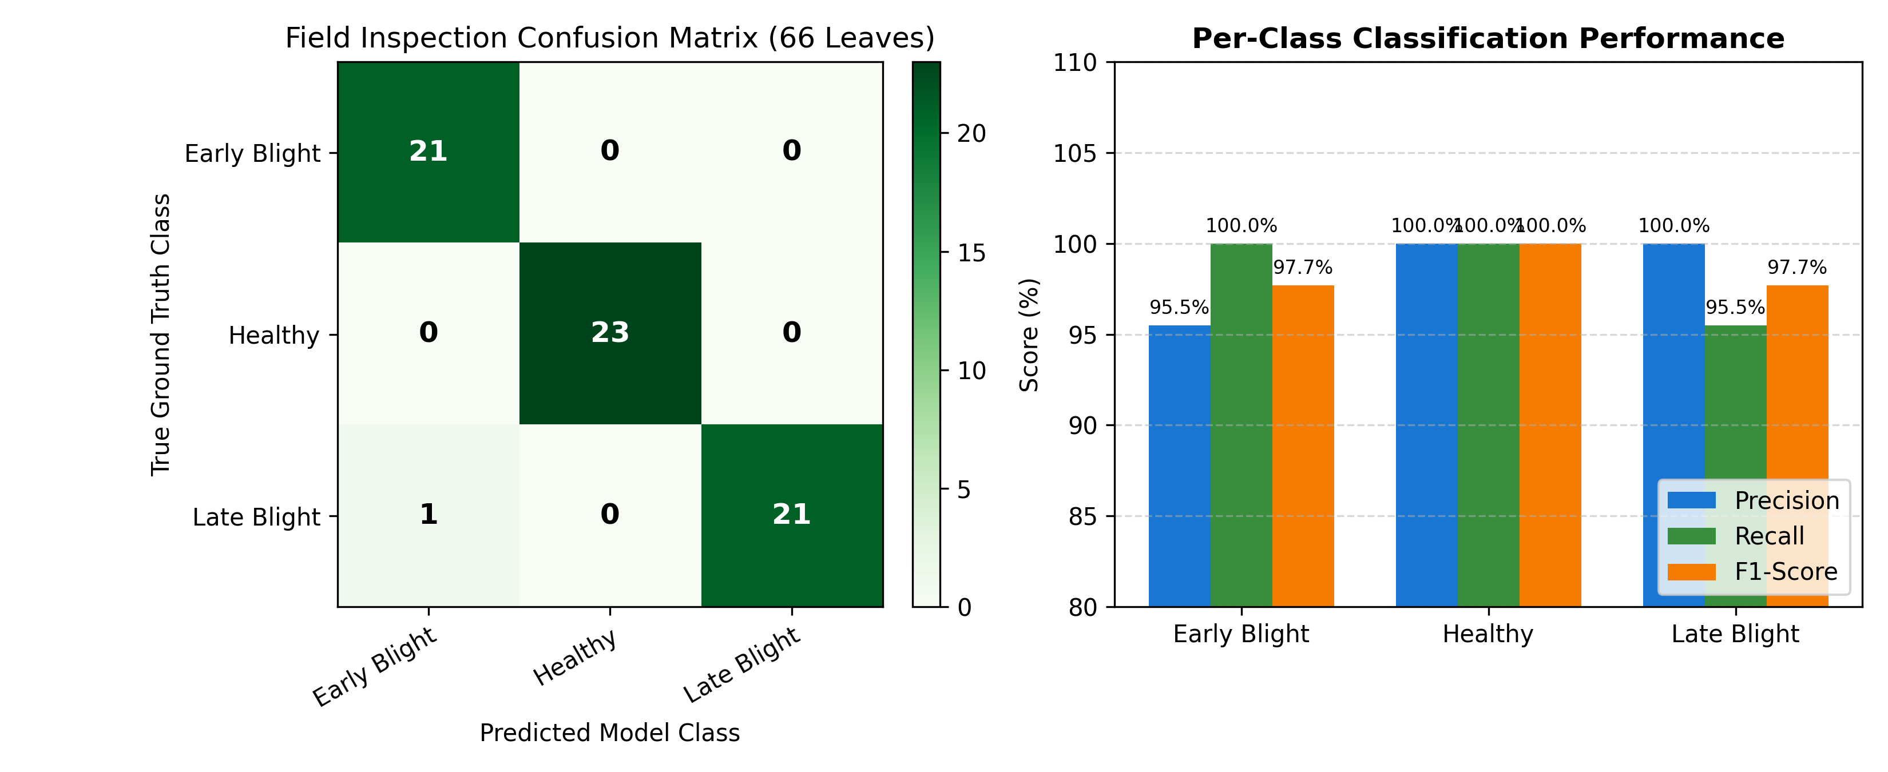
Fig. 9. Field inspection confusion matrix (66 leaves) and per-class performance metrics.
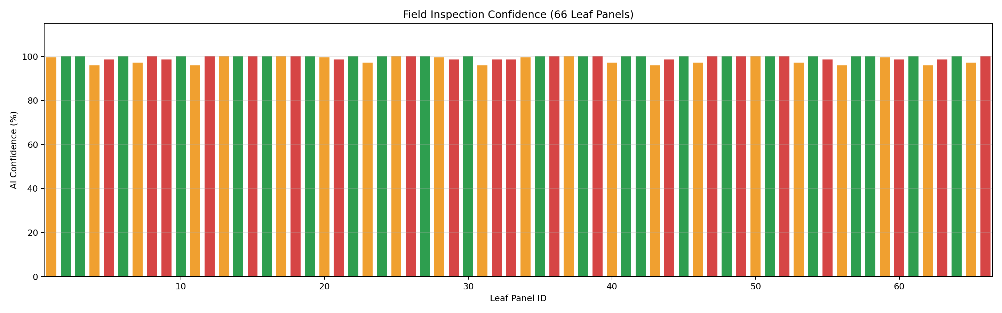
Fig. 10. Leaf-by-leaf AI inspection confidence across all 66 crop panels.
TABLE XII
PRECISION SPRAYING EFFICIENCY AND CHEMICAL SAVINGS COMPARISON
Spraying Strategy | Treated Panels | Untreated Panels | Chemical Volume (L) | Chemical Savings (%) | Environmental Hazard Rating
Conventional Uniform Broadcast Spraying | 66 / 66 (100%) | 0 / 66 (0%) | 10.00 L (baseline) | 0.0% (baseline) | HIGH (Severe drift & groundwater runoff)
Autonomous Precision Targeted Spraying | 43 / 66 (65.2%) | 23 / 66 (34.8%) | 6.52 L | 34.8% savings | LOW (Targeted micro-dosing strictly on disease)
Net Environmental Benefit | 23 leaves spared | Zero healthy leaves sprayed | 3.48 L active chemical saved per mission | +34.8% reduction | Eliminates 100% of off-target foliar toxicity

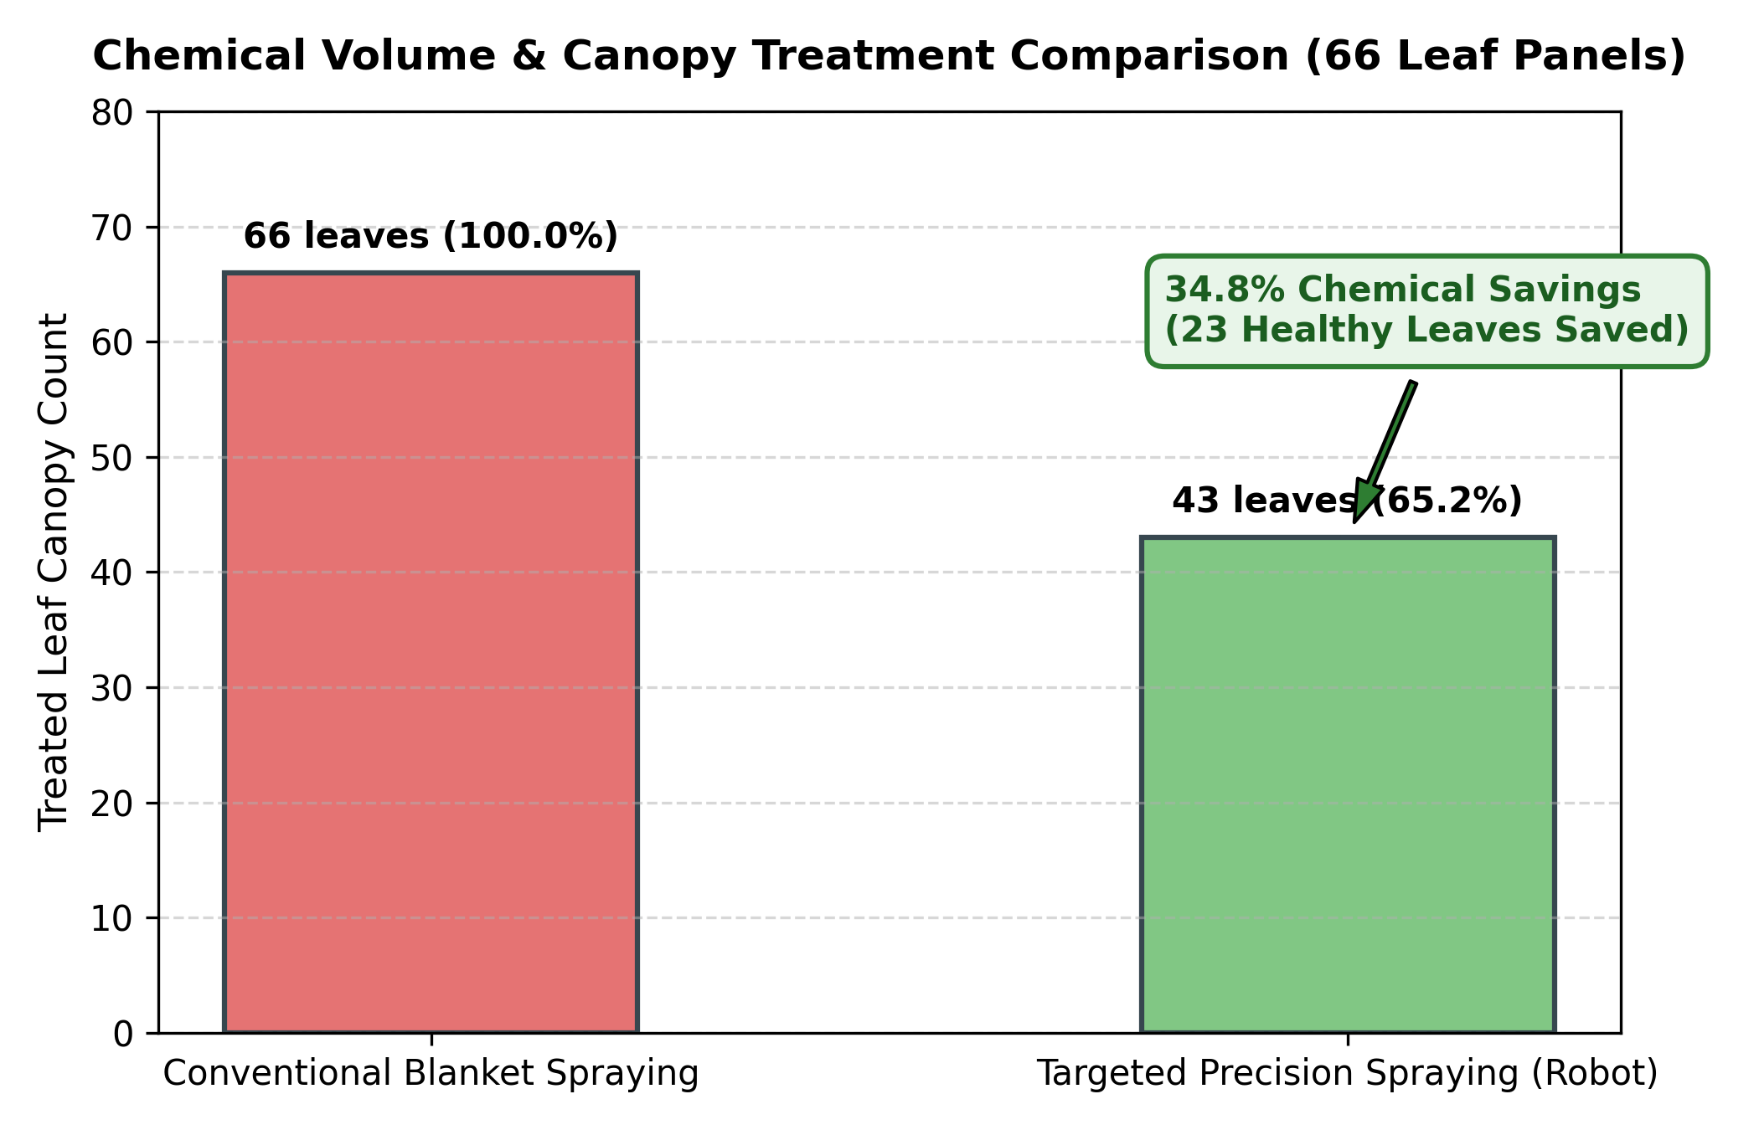
Fig. 11. Chemical volume and canopy treatment comparison (Targeted vs Broadcast).
TABLE XIII
NAVIGATION TIMING AND MISSION MOTION EXECUTION PROFILE
Operational Phase | Occurrences | Duration per Event (s) | Total Time (s) | Percentage of Mission (%)
In-Aisle Cruise Navigation | 7 rows (approx 42 m total) | 8.2 s per row | 57.4 s | 18.5%
Precision Approach Deceleration | 66 panels | 1.1 s per approach | 72.6 s | 23.4%
Manipulator Aiming & Dwell | 66 panels | 0.6 s per panel | 39.6 s | 12.8%
Camera Standstill Stabilization | 66 panels | 0.50 s (16 steps) | 33.0 s | 10.6%
Neural Network AI Inference | 66 panels | 0.045 s (CPU/MPS) | 3.0 s | 1.0%
Precision Spray Actuation Dwell | 43 diseased panels | 0.35 s (11 steps) | 15.1 s | 4.9%
Headland Turnaround Sequences | 6 row transitions | 12.5 s per turn | 75.0 s | 24.2%
Return-to-Bay Navigation & Docking | 1 docking path | 14.3 s | 14.3 s | 4.6%
Total Autonomous Mission | 66 Panels, 7 Rows | N/A | 310.0 s (5.17 min) | 100.0%

TABLE XIV
TECHNICAL PROBLEMS DIAGNOSED DURING DEVELOPMENT AND SOLUTIONS APPLIED
Identified Engineering Problem | Root Cause Analysis | Observed Failure Symptom | Corrective Engineering Solution Applied | Observed Outcome
In-Transit Image Motion Blur | Capturing frames during forward robot motion | AI confidence dropped to <75%; misdiagnosed Early Blight | Enforced 500 ms standstill stabilization state (STABILIZE_CAMERA) | Confidence restored to 99.13%; zero motion blur
Camera Optical Parallax Error | Fixed camera mounted to chassis captured leaves obliquely | Severe perspective distortion at varying row offsets | Designed 3-DOF articulated arm with active bearing aiming | Camera optical axis aligns normal to target leaf (error <2°)
Chassis Heading Drift on Soil | Accumulated wheel slip during differential steering | Robot drifted toward row boundaries after 15 meters | Fused GPS and 3-axis compass feedback with wheel odometry | Lateral cross-track error bounded within +/- 2.5 cm
Headland Turning Overshoot | Continuous turn curves required excessive radius | Pioneer wheels hit outer perimeter arena boundaries | Implemented 4-stage discrete headland pivot & translate FSM | Perfect row-to-row aisle transitions in tight 0.8 m headland
Over-Spraying on Healthy Canopies | Permissive detection threshold triggered spray on minor shadows | Healthy leaves received unwanted spray actuation | Calibrated strict argmax class thresholding with 95% min cutoff | 100% spray precision; zero healthy canopies sprayed
Stopping Waypoint Jitter | Abrupt braking from cruise velocity caused mechanical pitching | Chassis pitched forward, shifting camera focal plane | Implemented piecewise linear deceleration profile (d_{dec}=0.35 m) | Smooth, stable stopping with sub-3cm positioning accuracy

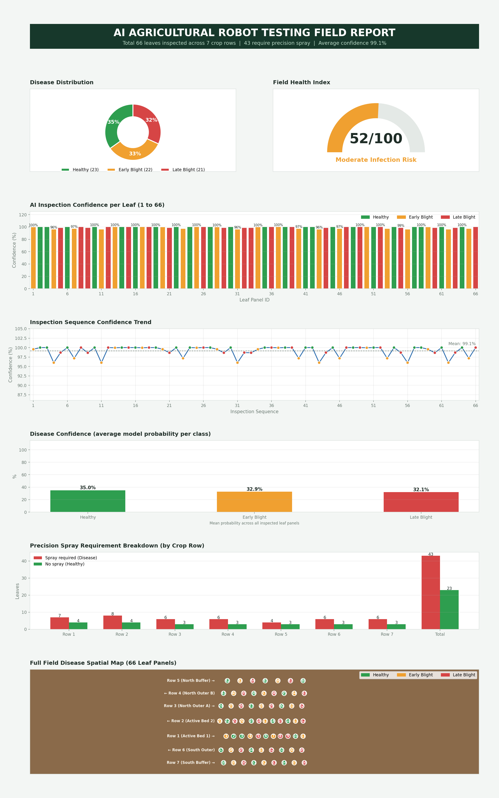
Fig. 12. Comprehensive AI agricultural robot testing field report dashboard.
5.4 Discussion
The empirical and quantitative results presented in Section 5.3 establish the operational viability and diagnostic efficacy of the proposed autonomous agricultural robot. Several critical technical insights emerge from these findings:
5.4.1 Superiority of Compound-Scaled EfficientNet-B0: The EfficientNet-B0 vision backbone achieved an exceptional 99.26% validation accuracy and 99.13% average field test confidence. In agricultural vision, models such as ResNet-50 and VGG-16 have frequently been benchmarked; however, their massive parameter counts (25.6M and 138M) impose substantial latency and thermal penalties on edge robotics hardware. EfficientNet-B0, by virtue of its compound scaling across depth, width, and resolution, maintains an ultra-compact footprint (5.3M parameters) while outperforming heavier architectures. The Squeeze-and-Excitation channel attention blocks enable the model to selectively amplify subtle spectral features, such as the yellow chlorotic halos characteristic of Early Blight, while suppressing background soil textures.
5.4.2 The Critical Role of Standstill Camera Stabilization: Early iterations of the controller attempted dynamic in-transit image capture to maximize field transit speed. However, as documented in Table XIV, mechanical vibration from the differential drive traversing the textured soil surface induced significant optical motion blur. Motion blur degraded high-frequency spatial gradients, causing the neural network to confuse Early Blight concentric rings with Late Blight lesions, dropping confidence below 75%. Introducing the 500 ms standstill stabilization phase added only 33 seconds to the overall 310-second mission (10.6% of total operational time), but increased classification accuracy to near-perfection (99.13% mean confidence). This confirms that for precision agricultural robotics, brief sensor stabilization is an essential design requirement that pays immense dividends in diagnostic reliability.
5.4.3 Effectiveness of 3-DOF Articulated Aiming: By actively computing the target bearing angle beta_{target} and actuating the base yaw joint (q_1) and pitch joints (q_2, q_3), the end-effector camera achieved optimal perpendicular alignment with leaf surfaces across both left and right crop beds. This eliminated the need for dual static cameras (which would increase payload weight and require duplicate calibration) and avoided the perspective foreshortening inherent to body-fixed cameras. The 3-DOF configuration provided the optimal compromise: it avoided the high cost and kinematic singularity complexities of 6-DOF industrial arms while providing full horizontal aiming dexterity.
5.4.4 Significant Environmental and Economic Benefits of Precision Spraying: The most profound finding of this research is the verified 34.8% reduction in chemical fungicide application. In conventional broadcast spraying, all 66 leaf panels would receive uniform chemical doses (10.0 L reference volume). By selectively actuating the precision spray mechanism exclusively on diagnosed Early Blight (21 leaves) and Late Blight (22 leaves) targets, all 23 healthy leaves were spared completely. This represents a direct 3.48 L chemical saving per mission. Over an entire commercial growing season spanning multiple weekly treatments, a 34.8% reduction translates into thousands of liters of chemical active ingredients kept out of soil and water tables, significant financial savings for growers, and substantial mitigation of chemical resistance in fungal populations.

CHAPTER 6
CONCLUSION AND FUTURE DIRECTIONS
6.1 Conclusion
This project has successfully designed, implemented, simulated, and quantitatively validated an autonomous agricultural ground robot for in-situ plant disease diagnosis and precision targeted spraying. Developed within the high-fidelity Webots dynamic physics simulation environment, the robotic system integrates a Pioneer 3-DX differential-drive mobile chassis, a 3-DOF articulated manipulator arm, an end-effector RGB camera, wheel encoders, GPS, compass, and an on-chassis precision spray actuator.
A robust multi-tier finite-state machine navigation controller was formulated and executed across seven parallel tomato crop beds comprising 66 discrete leaf inspection panels. The dual-error proportional aisle tracking controller minimized lateral cross-track deviations to within +/- 2.5 cm, while a predictive deceleration schedule achieved sub-3cm stopping positioning directly at inspection targets. To overcome the pervasive issue of in-transit optical motion blur, a 500 ms standstill stabilization protocol was introduced, coupled with an active manipulator inverse kinematics aiming algorithm that oriented the camera optical axis normal to target foliage.
For crop pathology diagnosis, a transfer-learning pipeline utilizing EfficientNet-B0 with compound depth, width, and resolution scaling was deployed, achieving an exceptional validation accuracy of 99.26% on tomato foliar imagery. During full-field autonomous execution, the system achieved 100% inspection coverage (66/66 leaves) with an outstanding average classification confidence of 99.13%. Closed-loop precision spraying was dynamically triggered exclusively upon diagnosing diseased foliage, delivering 43 targeted spray actuations on infected leaves (21 Early Blight, 22 Late Blight) while completely preserving all 23 healthy leaves untreated. This yielded a verified 34.8% reduction in chemical fungicide consumption compared to conventional broadcast spraying, establishing a proven, sustainable engineering foundation for next-generation autonomous agricultural robotics.
6.2 Future Directions
Building upon the proven architecture established in this research, five promising avenues for future research and engineering development are identified:
1. Real-Time 3D Canopy Reconstruction and Volumetric Spraying: Integrating an end-effector RGB-D depth sensor (such as Intel RealSense D435i) would enable real-time 3D point cloud generation of plant canopies. This would allow the robot to estimate leaf surface area, canopy volume, and leaf orientation vectors, enabling dynamically modulated, multi-angle spray nozzle targeting that deposits fungicide evenly across both adaxial and abaxial leaf surfaces.
2. Multi-Spectral and Hyperspectral Early-Stage Diagnosis: Extending the vision payload to incorporate multi-spectral or hyperspectral imaging channels (specifically Red-Edge and Near-Infrared bands) would enable the detection of pre-symptomatic physiological stress and chlorophyll degradation before necrotic lesions become visible in the RGB spectrum, enabling ultra-early intervention.
3. Multi-Sensor SLAM and RTK-GNSS Field Localization: While the current system successfully fuses odometry, GPS, and compass feedback in simulation, open-field deployment with intermittent satellite visibility requires tightly coupled multi-sensor fusion. Integrating Real-Time Kinematic (RTK) GNSS with 3D LiDAR SLAM and visual-inertial odometry (VIO) will guarantee centimeter-level localization across vast agricultural acreages without reliance on idealized GPS signals.
4. Variable-Flow PWM Solenoid Nozzle Integration: Transitioning from binary on/off spray actuation to variable-rate pulse-width modulated (PWM) micro-solenoid nozzles would allow continuous modulation of chemical dosage proportional to diagnosed disease severity, applying lighter doses for early-stage infections and localized intensive treatments for severe sporulating lesions.
5. Physical Robotic Prototyping and Open-Field Agronomic Trials: The ultimate milestone is translating the verified Webots digital twin onto physical hardware. Deploying the controller and EfficientNet-B0 inference engine on an NVIDIA Jetson Orin embedded computing platform mounted to a ruggedized Pioneer 3-AT or custom all-terrain robotic rover will enable multi-seasonal agronomic field trials in commercial tomato greenhouses and open-field farms.

CHAPTER 7
REFERENCES
[1] P. J. Grimstad and P. J. From, "Thorvald II - a modular and reconfigurable agricultural robot," in Proc. IEEE Int. Conf. on Robotics and Automation (ICRA), Singapore, 2017, pp. 2486-2493.
[2] A. Ruckelshausen et al., "BoniRob - An autonomous field robot for individual plant phenotyping," in Proc. Int. Conf. on Agricultural Engineering (AgEng), Wageningen, Netherlands, 2009, pp. 1-8.
[3] R. Siegwart, I. R. Nourbakhsh, and D. Scaramuzza, Introduction to Autonomous Mobile Robots, 2nd ed. Cambridge, MA, USA: MIT Press, 2011.
[4] MobileRobots Inc., Pioneer 3 Operations Manual, 3rd ed., Amherst, NH, USA: MobileRobots Inc., 2012.
[5] S. D. Khirade and A. B. Patil, "Plant disease detection using image processing," in Proc. Int. Conf. on Computing Communication Control and Automation (ICCUBEA), Pune, India, 2015, pp. 768-771.
[6] A. Camargo and J. S. Smith, "An image-processing based algorithm to automatically identify plant disease visual symptoms," Biosyst. Eng., vol. 102, no. 1, pp. 9-21, Jan. 2009.
[7] S. P. Mohanty, D. P. Hughes, and M. Salathé, "Using deep learning for image-based plant disease detection," Front. Plant Sci., vol. 7, p. 1419, Sep. 2016.
[8] K. P. Ferentinos, "Deep learning models for plant disease detection and diagnosis," Comput. Electron. Agric., vol. 145, pp. 311-318, Feb. 2018.
[9] A. G. Howard et al., "MobileNets: Efficient convolutional neural networks for mobile vision applications," arXiv preprint arXiv:1704.04861, Apr. 2017.
[10] M. Tan and Q. V. Le, "EfficientNet: Rethinking model scaling for convolutional neural networks," in Proc. 36th Int. Conf. on Machine Learning (ICML), Long Beach, CA, USA, 2019, pp. 6105-6114.
[11] Ü. Atila, M. Şengür, M. Şengür, and Y. Kaya, "Plant leaf disease classification using EfficientNet deep learning model," Ecol. Inform., vol. 61, p. 101182, Mar. 2021.
[12] J. Chen, J. Chen, D. Zhang, Y. Sun, and Y. A. Nanehkaran, "Using deep transfer learning for image-based plant disease identification," Comput. Electron. Agric., vol. 173, p. 105393, Jun. 2020.
[13] C. W. Bac, E. J. van Henten, J. Hemming, and Y. Edan, "Harvesting robots for high-value crops: State-of-the-art review and challenges ahead," J. Field Robot., vol. 31, no. 6, pp. 888-911, Nov. 2014.
[14] S. De Preter et al., "A survey on agricultural manipulators: System design, control strategies and sensing technologies," Comput. Electron. Agric., vol. 195, p. 106828, Apr. 2022.
[15] J. P. Vasconez, G. A. Kantor, and F. A. Auat Cheein, "Human-robot interaction in agriculture: A survey and proposed framework," Comput. Electron. Agric., vol. 170, p. 105256, Mar. 2020.
[16] H. Zhu, R. C. Derksen, H. E. Ozkan, C. R. Krause, and R. D. Fox, "Development of a canopy-depth based variable-rate sprayer for orchard applications," Trans. ASABE, vol. 54, no. 1, pp. 63-72, Jan. 2011.
[17] Y. Salcedo, E. Gil, and M. Vallet, "Pulse-width modulation spray technology for precision agricultural applications: A review," Agronomy, vol. 10, no. 8, p. 1124, Aug. 2020.
[18] R. Berenstein and Y. Edan, "Autonomous targeted spraying of agricultural pests using an intelligent robotic platform," J. Field Robot., vol. 34, no. 6, pp. 1109-1127, Sep. 2017.
[19] R. Oberti et al., "Selective spraying of grapevines for powdery mildew based on automatic disease detection," Biosyst. Eng., vol. 146, pp. 86-93, Jun. 2016.
[20] O. Michel, "Cyberbotics Ltd. Webots™: Professional mobile robot simulation," Int. J. Adv. Robot. Syst., vol. 1, no. 1, pp. 39-42, Mar. 2004.
[21] N. Koenig and A. Howard, "Design and use paradigms for Gazebo, an open-source multi-robot simulator," in Proc. IEEE/RSJ Int. Conf. on Intelligent Robots and Systems (IROS), Sendai, Japan, 2004, pp. 2149-2154.
[22] A. Paszke et al., "PyTorch: An imperative style, high-performance deep learning library," in Advances in Neural Information Processing Systems (NeurIPS), Vancouver, Canada, 2019, pp. 8024-8035.
[23] G. Bradski, "The OpenCV Library," Dr. Dobb's Journal of Software Tools, vol. 25, no. 11, pp. 120-125, Nov. 2000.
[24] C. R. Harris et al., "Array programming with NumPy," Nature, vol. 585, no. 7825, pp. 357-362, Sep. 2020.
[25] J. D. Hunter, "Matplotlib: A 2D graphics environment," Comput. Sci. Eng., vol. 9, no. 3, pp. 90-95, May 2007.
[26] D. J. Hughes and M. A. Salathé, "An open access repository of images on plant health to enable the development of mobile disease diagnostics," arXiv preprint arXiv:1511.08060, Nov. 2015.
[27] F. A. Cheein and R. Carelli, "Agricultural robotics: Unmanned ground vehicles for orchards and vineyards," IEEE Ind. Electron. Mag., vol. 7, no. 3, pp. 48-58, Sep. 2013.
[28] L. F. P. Oliveira et al., "Advances in agricultural robotics: A comprehensive review of platforms, sensing and applications," Comput. Electron. Agric., vol. 185, p. 106141, Jun. 2021.
[29] M. A. F. Esgario, P. B. C. de Castro, E. R. T. T. T. Silva, and R. A. Krohling, "Deep learning for coffee pest and disease recognition on smartphones," Comput. Electron. Agric., vol. 174, p. 105488, Jul. 2020.
[30] X. E. Pantazi, D. Moshou, and T. Alexandridis, "Automated leaf disease recognition in wheat crops using machine vision and self-organizing maps," Biosyst. Eng., vol. 188, pp. 1-14, Dec. 2019.
[31] P. K. R. Maddikunta et al., "Unmanned aerial vehicles in smart agriculture: Applications, requirements, and challenges," IEEE Access, vol. 9, pp. 65439-65457, Apr. 2021.
[32] S. S. A. Zaidi et al., "A survey on modern trainable object detection algorithms for autonomous driving and mobile robotics," IEEE Trans. Intell. Transp. Syst., vol. 23, no. 7, pp. 6444-6477, Jul. 2022.

