<https://www.c-sharpcorner.com/UploadFile/e4e3f7/dapper-king-of-micro-orm-C-Sharp-net/>

**ORM:**Object Relationship Mapper that maps your database directly with C# objects.   
  
There are many ORM tools available. One of them is Dapper. Dapper is known as the king of ORM.  
  
The following are the key features of Dapper:

* Speed and fast in performance.
* Fewer lines of code.
* Object Mapper.
* Static Object Binding.
* Dynamic Object Binding.
* Easy Handling of SQL Query.
* Easy Handling of Stored Procedure.
* Operating directly to IDBConnection class that provides smoothness and running query directly to the database instead of passing data using various objects as we do in EF and ADO.NET.
* Multiple Query Support.
* Support for Stored Procedure.
* Bulk Data insert functionality.
* Dapper also allows fetching multiple data based on multiple inputs.

**Why Dapper**

* Dapper is the second fastest ORM.  
    
  Image reference: [Dapper dotnet](https://github.com/StackExchange/dapper-dot-net).  
    
  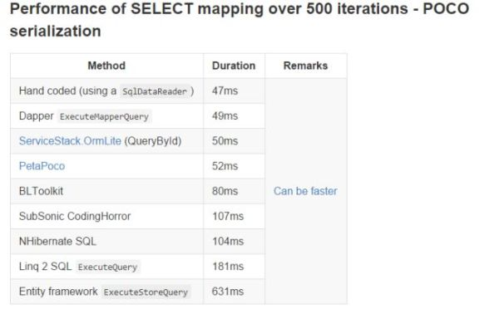
* Perform CRUD operations directly using IDBConnection object.
* Provide querying static and dynamic data over database.
* Get generic result for simple or complex data type.
* Dapper allow to store bulk data at once.

**How to Install Dapper**

There are two ways to install Dapper:

1. [**DapperMappingFileForC#4.5.cs**](https://github.com/StackExchange/dapper-dot-net/blob/master/Dapper%20NET45/SqlMapperAsync.cs)**.**  
     
   Add this SqlMapperAsync.cs file to your project and get started with Dapper functionality.   
     
   You can SqlMapperAsync.cs depending on the .Net framework you use.
2. **NuGet package Manager.**  
     
   In Visual Studio, create a new console project and in Solution Explorer right-click References and select Manage NuGet package Manager and search for Dapper and using the NuGet Package Manager Console command for the Nugget Package Manager “install-package dapper”, and this will install Dapper into your project.

**How Dapper Works**

“*Dapper Majorly Include Three Steps*”  
  
**Step 1**

Create an IDBConnection object with Connection String.  
  
**Step 2**

Write a query and store it in a normal string variable.  
  
**Step 3**

Call db.execute() and pass the query and it's done.