HOMEWORK: Defend One Architectural Decision
The architectural Description report will be based on the Waghi Vally Produce cooperative.

The decision
The decision is to store intake and payment records locally on the depot device using SQLite, with a confirmation copy stored on the manager’s computer. The field phone also keeps captured information in its local cache until it can synchronize.

What forces it
This decision was forced by the SRS requirement: “Intake and payment records will be stored in a local SQLite database on the depot device, with a confirmed copy on the manager's computer.” The requirement also states that this is necessary because “the system must continue working when offline and the cooperative needs protection against lost records.” The system has patchy mobile signals and no fixed internet, so the system cannot depend on a continuous network connection.

What rejected
The system was rejected using only a central database on the manager’s computer. This alternative would require the depot to connect to the manager’s computer whenever staff need to save intake or payment information. If the mobile signal is unavailable, work could stop and new records could not be stored. Local SQLite allows the system to continue recording information offline and synchronize it when a connection becomes available.

What it cost me
The main cost is synchronization complexity. The system must manage records created at different times and prevent duplicate records during repeated synchronization. Unique transaction IDs will be used so duplicate records can be rejected. The design also requires local storage on the phone and laptop and a consolidated database on the manager’s computer. I accept these costs because reliable offline operation and protection against lost records are more important for this cooperation than having a simpler centralized database.

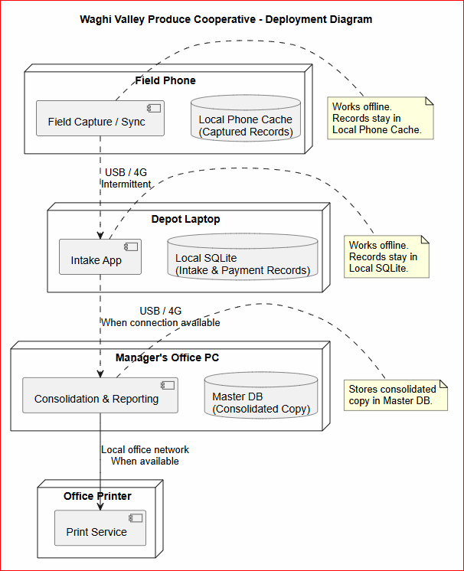

Figure 1.1 Deployment Diagram.
The diagram demonstrates how the data can be stored in the Waghi Vally Produce Cooperative system.

Reference
Mr. Himbiku. CMN224 Software Engineering, Week 5 lecture and Lab 4 (ULO2, ULO4)
AI assistant. I used an AI assistant to check whether my write-up matched the requirements of the task, draw diagram and improve grammar and organization. The entire report is based on my own understanding of the Waghi Valley Produce Cooperative, near Mt. Hagen

