问题1：ERROR 1292 (22007): Incorrect datetime value: '1967' for column 'SBIRTHDAY' at row 1

mysql> INSERT INTO STUDENT (SNO,SNAME,SSEX,SBIRTHDAY,CLASS) VALUES (108 ,'曾华' ,'男' ,1977-09-01,95033);

ERROR 1292 (22007): Incorrect datetime value: '1967' for column 'SBIRTHDAY' at row 1

mysql> INSERT INTO STUDENT (SNO,SNAME,SSEX,SBIRTHDAY,CLASS) VALUES (108 ,'曾华' ,'男' ,'1977-09-01',95033);

Query OK, 1 row affected (0.00 sec)

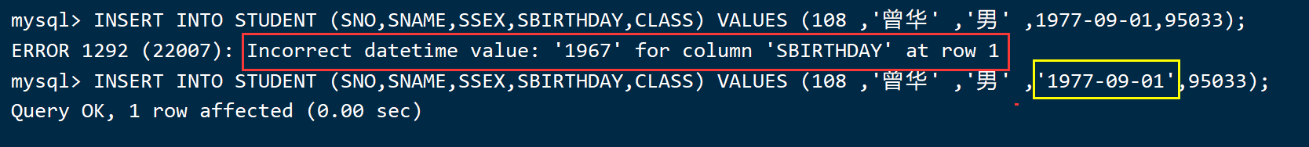

问题2：没有ip地址的问题

首先 systemctl restart NetworkManager

nmcli connection up ens33