1. List all information stored in the table course;

* SELECT * FROM course;

1. List the dept_name and buildings of all departments;

* SELECT dept_name, building FROM department;

1. List the instructor’s name appears in the table instructor;

* SELECT name FROM instructor;

1. List the instructor’s name whose salary is more than 90000 and dept_name is ‘Comp Sci’ ;

* SELECT name FROM instructor WHERE dept_name = 'Comp. Sci.' AND salary > 90000;

1. List the instructor’s all information after we gave a 10% raise to each instructor;

* SELECT *, salary*1.1 as raised_salary FROM instructor;

1. Show the different dept_name in the table instructor;

* SELECT DISTINCT dept_name FROM instructor;

1. List the course’s title ,dept_name,and credits which prerep_id is ‘CS-101’;

* SELECT title, dept_name, credits FROM course NATURAL JOIN prereq WHERE prereq_id='CS-101';

1. Find the titles of courses in the Comp Sci department the have 3 credits;

* SELECT title FROM course WHERE credits=3;

1. List the course_id which prereq_id is ‘CS-101’;

* SELECT course_id FROM course NATURAL JOIN prereq WHERE prereq_id='CS-101';

1. Find all courses that were offered at least twice in 2010(not unique);

SELECT course_id FROM (SELECT course_id, COUNT(course_id) AS c FROM section WHERE `year`=2010 GROUP BY course_id) AS T WHERE c > 1;

1. Find the instructor names and the courses they taught for all instructors in the Biology department who have taught some course;

* SELECT `name`, course_id FROM instructor NATURAL JOIN teaches WHERE dept_name='Biology';

1. List all courses taught in Fall 2009;

* SELECT * FROM course NATURAL JOIN section WHERE semester='Fall' AND `year`=2009;

1. Find the set of all courses taught either in Fall 2010 or in Spring 2009,or both we write.

* SELECT * FROM course NATURAL JOIN section WHERE (semester='Fall' AND `year`=2010) OR (semester='Spring' AND `year`=2009);

1. Find all courses taught in the Fall 2009 but not in the Spring 2010;

* SELECT * FROM section WHERE (semester='Fall' AND `year`=2009) AND course_id NOT IN (SELECT course_id FROM section WHERE (semester='Spring' AND `year`=2010));

1. Find the average salary of instructors in the Comp Sci department;

* SELECT avg(salary) FROM instructor WHERE dept_name='Comp. Sci.'

1. Find the total number of instructors who teach a course in the Spring 2010 semester;

* SELECT count(*) FROM instructor NATURAL JOIN teaches WHERE `year`=2010 AND semester='Spring';

1. Find the number of tuples in the course relation;

* SELECT count(*) FROM course;

1. Find the average salary in each department;

* SELECT dept_name, FORMAT(AVG(salary),2) AS avg_salary FROM instructor GROUP BY dept_name;

1. Find the average salary of instructors in those departments where the average salary is more than 42000;

* SELECT dept_name, AVG(salary) AS avg_salary FROM instructor GROUP BY dept_name HAVING AVG(salary) > 42000;

1. Find the names of all instructors whose salary is greater than at least one instructor in the Com Sic department.

* SELECT * FROM instructor WHERE salary> (SELECT min(salary) FROM instructor WHERE dept_name='Comp. Sci.');

**1.** **Modification of DB**

* Delete all the instroctors with a salary more than 90000;
* DELETE FROM instructor WHERE salary>90000;
* Adjust the budget of the Comp Sci to 120000;
* UPDATE department SET budget=120000 WHERE dept_name='Comp. Sci.';
* Salary are increased by 10 percent only the instructors with salary of less than 70000 (not including 70000),and others increased by 5 percent;
* UPDATE instructor SET salary=1.1salary WHERE salary<70000;  
  UPDATE instructor SET salary=1.05*salary WHERE salary>=70000;

**2.** **View Operation**

* Create a view named instructor_info with lists the ID,name,and building-name of each instructor.
* CREATE VIEW instructor_info AS (SELECT ID, `name`, building FROM instructor NATURAL JOIN department);
* Find all the instructors whose building name is ‘Taylor’ by the view you created above.
* SELECT name FROM instructor_info WHERE building='Taylor';
* Try to find the ‘View update policy’ in SQL Server:2
* SQLServer views are not cached, so everytime the user request a view the query is executed.
* 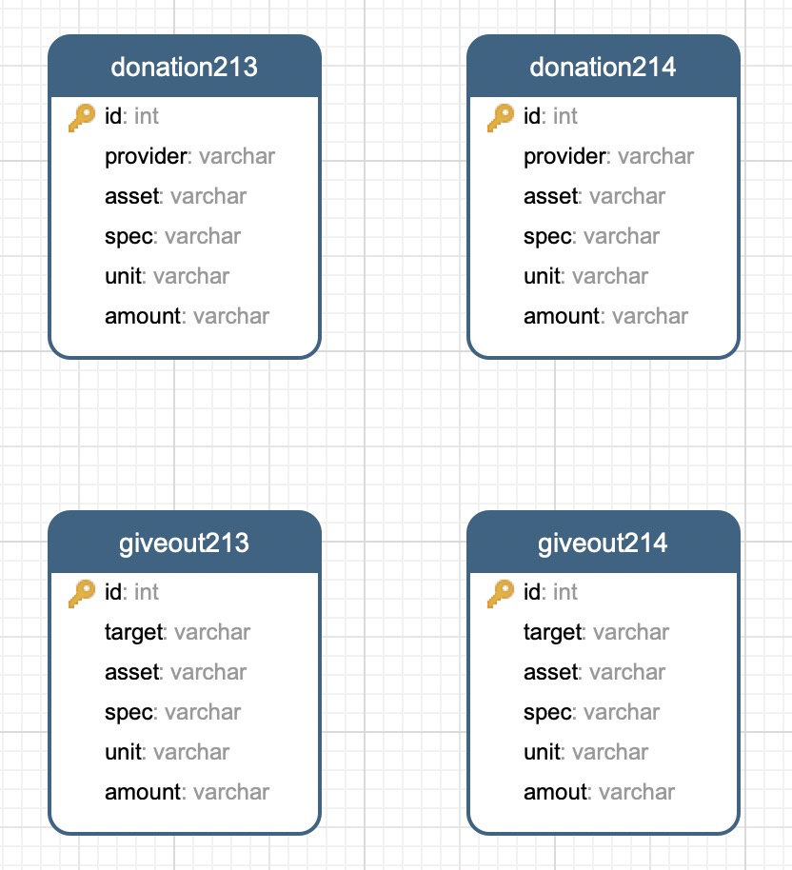

首先创建两个 View 整合数据：

CREATE view giveout AS (SELECT *, '2020-02-14' as date FROM giveout214 UNION SELECT *,'2020-02-13' as date FROM giveout213);  
CREATE view donation AS (SELECT *, '2020-02-14' as date FROM donation214 UNION SELECT *,'2020-02-13' as date FROM donation213);

1.查找蔡甸区卫生健康局接受的捐赠情况

SELECT * FROM (SELECT * FROM giveout214 UNION SELECT * FROM giveout213) AS T WHERE T.target='蔡甸区卫生健康局';

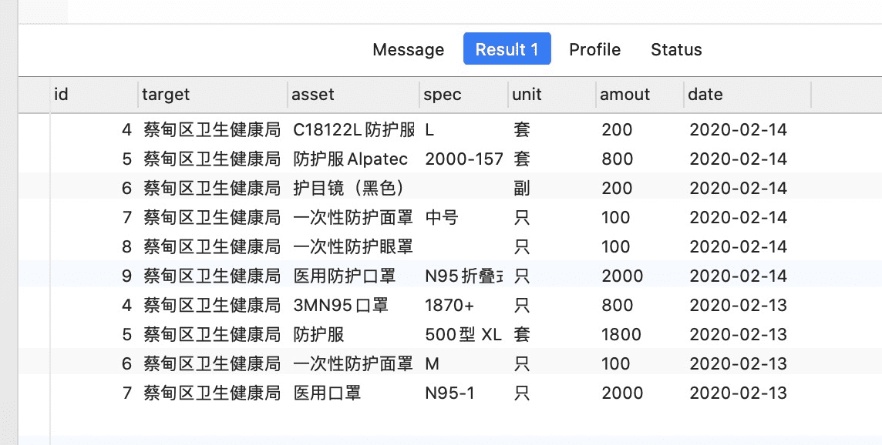

2.查找浏阳市华盛山庄的捐赠情况

SELECT * FROM donation WHERE provider='浏阳市华盛山庄';

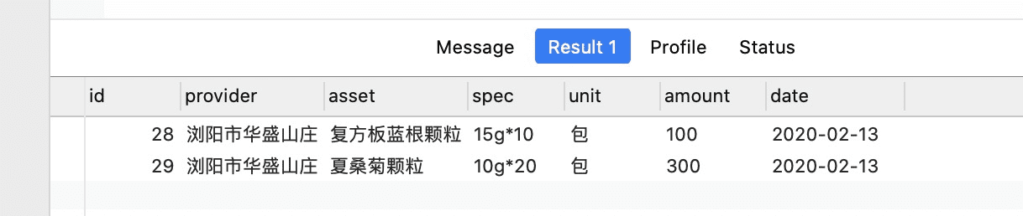

3.查找2.13到2.14医用口罩捐赠给了哪些单位

SELECT DISTINCT target FROM giveout;

（结果过长有省略）

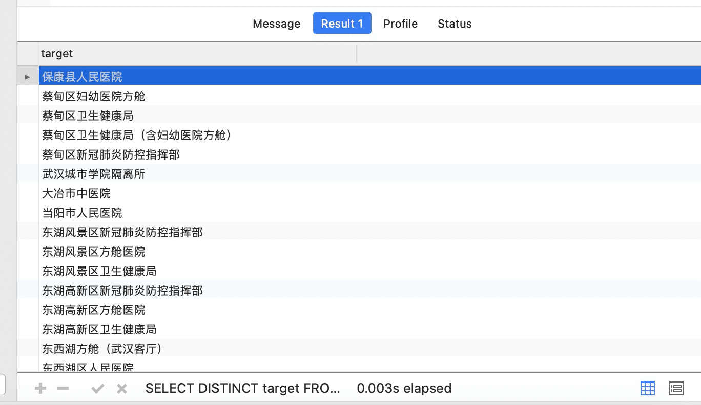

4.查询2.13到2.14社会捐赠的医用口罩的数目

SELECT count(*) FROM donation WHERE asset LIKE "%口罩%";

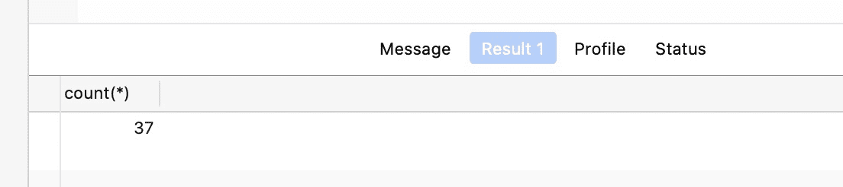

5.查询2.13到2.14发放的一次性手套大、中、小号各多少只

SELECT 'L' AS spec, count(*) FROM giveout WHERE asset LIKE "%手套%" AND (spec LIKE '%大号%' OR spec LIKE '%L%') UNION  
SELECT 'M' AS spec, count(*) FROM giveout WHERE asset LIKE "%手套%" AND (spec LIKE '%中号%' OR spec LIKE '%M%') UNION  
SELECT 'S' AS spec, count(*) FROM giveout WHERE asset LIKE "%手套%" AND (spec LIKE '%小号%' OR spec LIKE '%S%');SELECT 'L' AS spec, count(*) FROM giveout WHERE asset LIKE "%手套%" AND (spec LIKE '%大号%' OR spec LIKE '%L%') UNION  
SELECT 'M' AS spec, count(*) FROM giveout WHERE asset LIKE "%手套%" AND (spec LIKE '%中号%' OR spec LIKE '%M%') UNION  
SELECT 'S' AS spec, count(*) FROM giveout WHERE asset LIKE "%手套%" AND (spec LIKE '%小号%' OR spec LIKE '%S%');

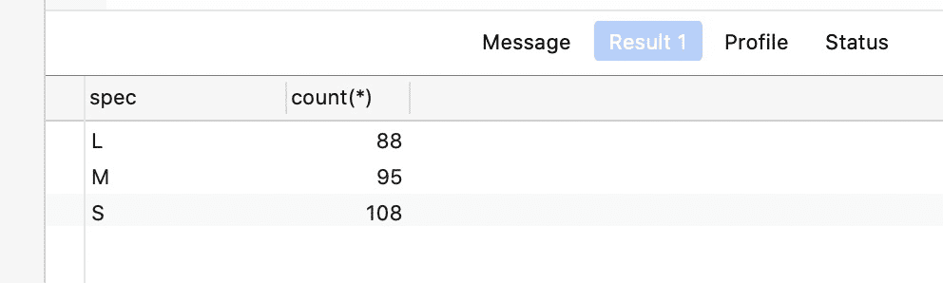

6.查询2.14接受了医用N95口罩捐赠的单位有哪几家，各获得多少只

SELECT target, sum(amount) FROM giveout214 WHERE asset LIKE '%N95%' GROUP BY target;

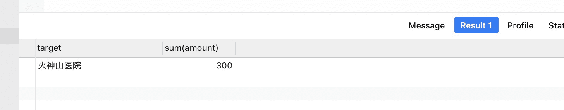

7.查找获得物资数量超过2000计量单位的单位有哪几家

SELECT target, sum(amount) FROM giveout GROUP BY target HAVING sum(amount) > 2000;

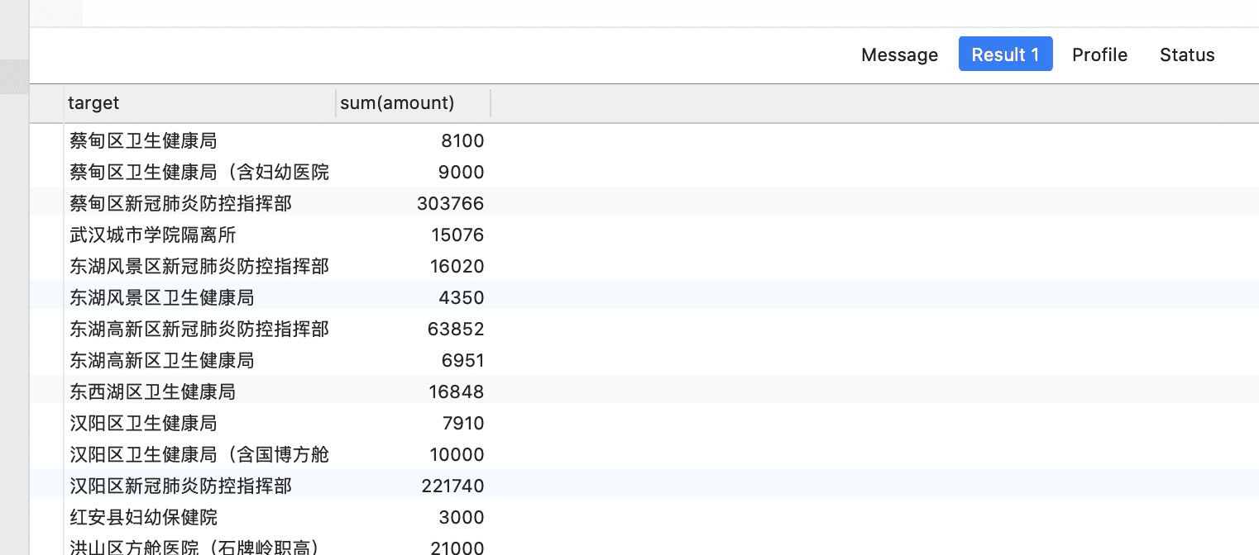

8.统计2.13到2.14两天平均每天发放了多少数量口罩

SELECT sum(amount) / 2 FROM giveout;

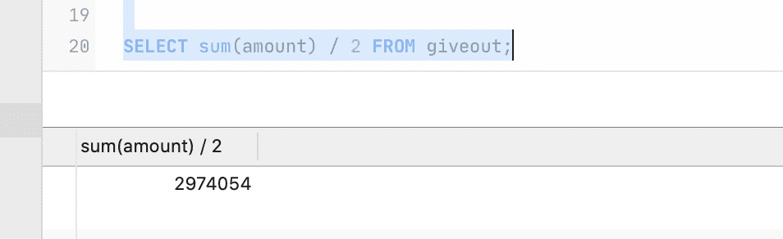

9.统计2.13到2.14一共发放的防护服的数量

SELECT sum(amount) FROM giveout WHERE asset LIKE '%防护服%';

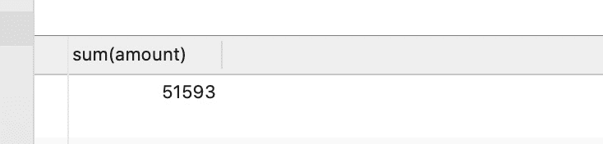

10.查询获得物资感冒清热颗粒的单位有哪几家，数量分别是多少

SELECT target, sum(amount) FROM giveout WHERE asset LIKE '%感冒清热颗粒%' GROUP BY target;

