Aiya Zhakupova SE-2439
Web Technologies 1(Frontend)
Assignment #7. jQuery (Selectors, Effects, Animations)
Link: Portfolio

Part 1. Getting Started with jQuery

Task 0. Setup
- Include jQuery from a CDN.
- Write a $(document.ready() function.
- Test by printing “jQuery is ready!” in the console.
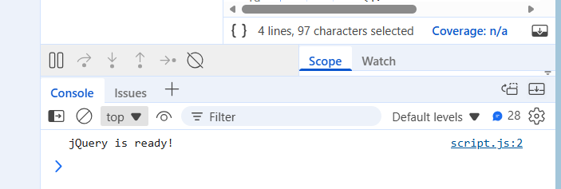

Task 1. Selectors & CSS
- Select elements by ID, class, and tag.
- Change their content with .text() and .html().
- Change styles dynamically with .css().
Added Change Theme button

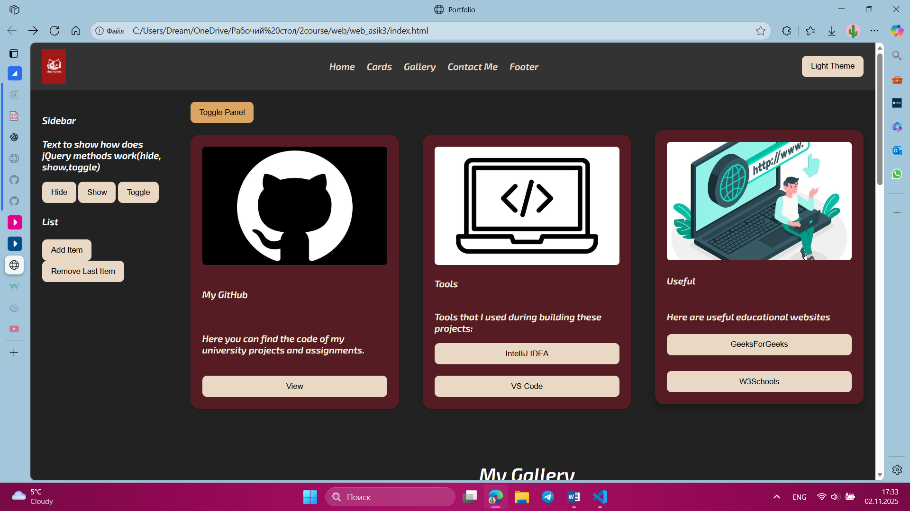

Part 2. jQuery Effects

Task 2. Visibility Methods
- Create a paragraph and two buttons: Hide and Show.
- Use .hide(), .show(), and .toggle().

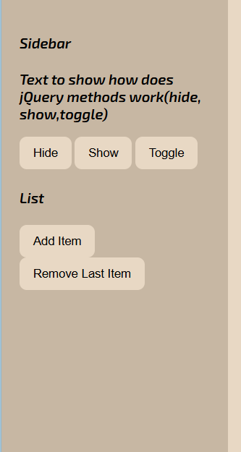

Task 3. Fade Methods
- Add an image and use .fadeIn(), .fadeOut(), .fadeToggle().
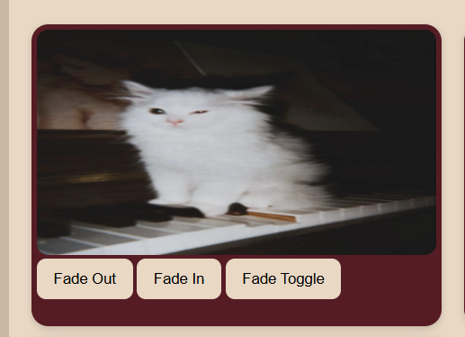

Task 4. Slide Methods
- Create a collapsible panel and control it with .slideUp(), .slideDown(), .slideToggle().
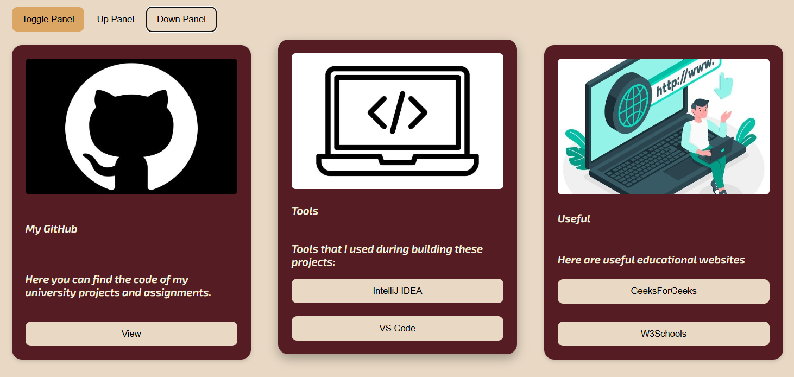

Part 3. DOM Manipulation with jQuery

Task 5. Add & Remove Elements
- Create a list with an “Add Item” and “Remove Item” button.
- Use .append(), .prepend(), .remove().
- 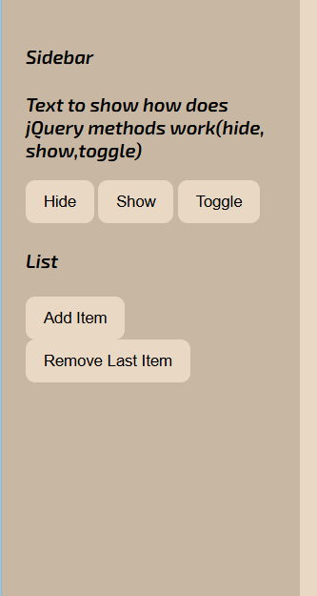

Task 6. Modifying Attributes
- Add a button that changes an image’s src attribute when clicked.
- Add another button that changes a link’s href dynamically.
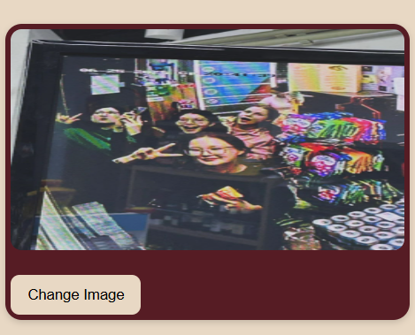

Task 7. Form Interaction
- Create a form with inputs for Name and Email.
- When the user types, display their input live below the form using .val() and .text().
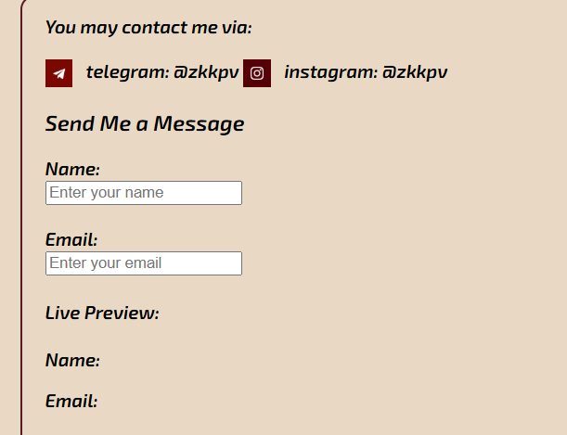

Part 4. Animations

Task 8. Basic Animation
- Animate a square <div>: increase its size and change position using .animate().

Task 9. Sequential Animations
- Animate the box step by step (move right → move down → shrink → return to original).

Task 10. Combined Animation
- Combine opacity, size, and movement into one .animate() call.
