**Aiya Zhakupova SE-2439**

**Web Technologies 1(Frontend)**

**Assignment 2: CSS Styling (Colors, Fonts, Layout)**

**Link:** [**https://asik2.netlify.app**](https://asik2.netlify.app)

Task 1. Simple Webpage Layout

**Description**

* Created the main page (index.html) and linked it with style.css.
* Used <div> elements for the entire structure of the page.
* The layout includes:
  + **Header** – website title.
  + **Navigation bar** – with 3 buttons/links to other pages(About Me, Emma Stones Tribute and Students Grades Tabel pages).
  + **Sidebar menu** – list with navigation items on the left(with link to parts of the current page).
  + **Aside content** – short description on the right.
  + **Footer** – with copyright information.

**CSS Styling**

* Added background colors for each section.
* Used border-radius, padding, margin for spacing and rounded corners.
* Styled buttons (button), links (a), and headings (h1, h3).

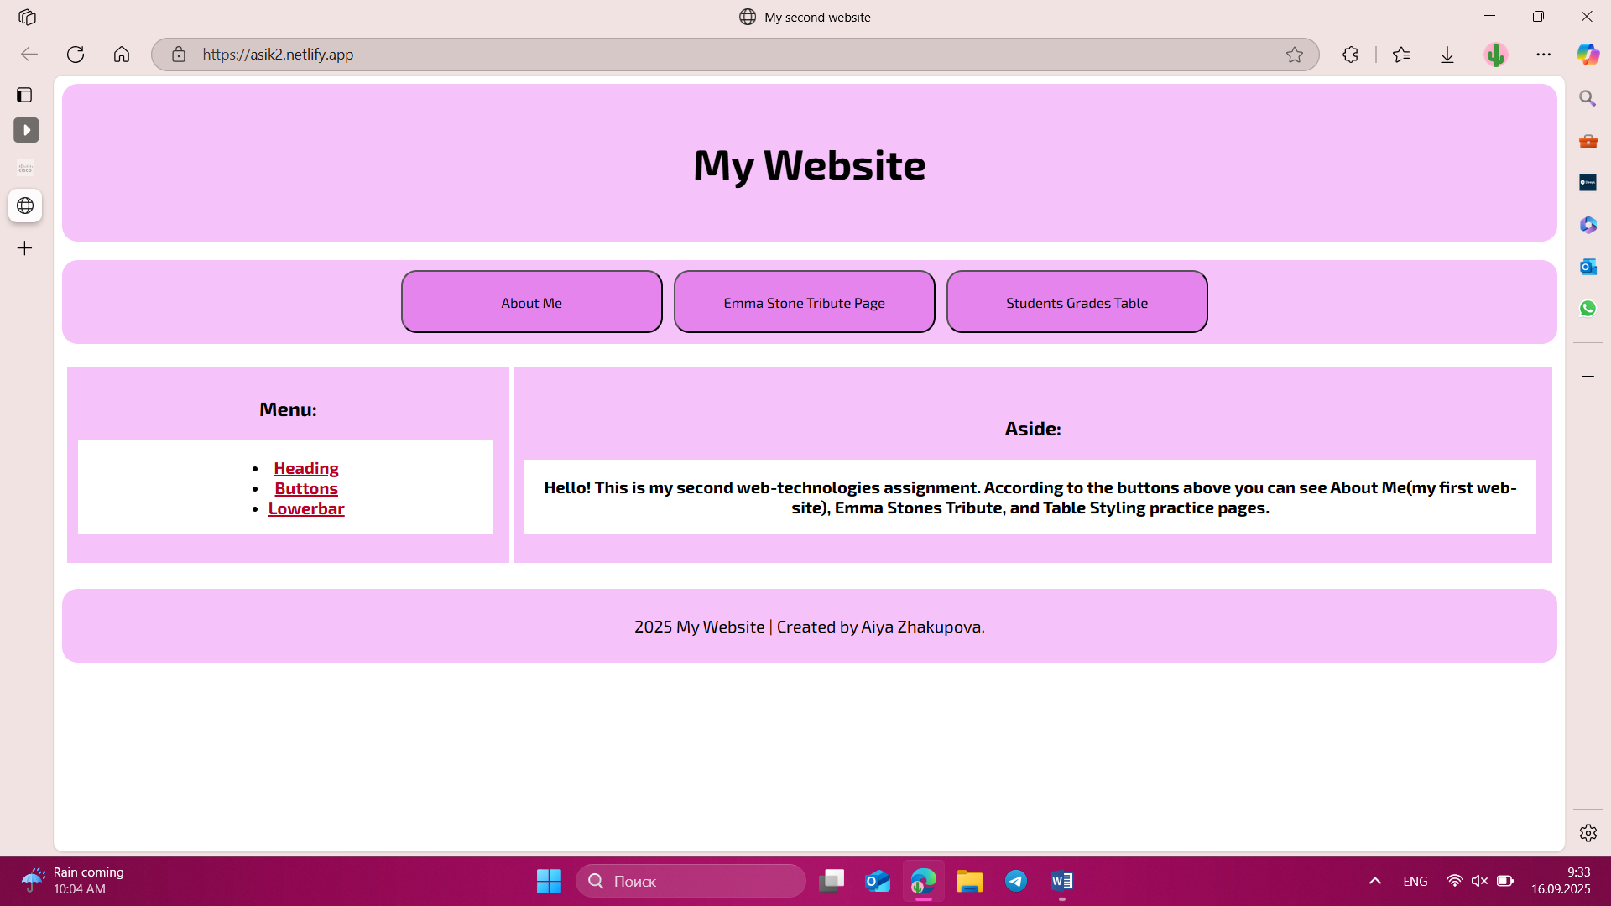

Task 2. Tribute Page (may see via the button on the main page)

### ****Description****

* Created tribute.html dedicated to actress **Emma Stone**.
* Page structure:
  + Main heading <h1> and subheadings <h2>.
  + Short biography in a <p> paragraph.
  + Lists: <ol> (important life events) and <ul> (achievements/contributions).
  + Portrait image (img) with alt attribute.
  + Two hyperlinks (a) and a “Learn More” button linking to Wikipedia.

### ****CSS Styling**** (tribute.css)

* Added background color to the page.
* Used **Google Fonts** for styling headings and paragraphs.
* Styled header with background and centered text.
* Image styled with border-radius and box-shadow.
* Lists styled with custom spacing and list markers.

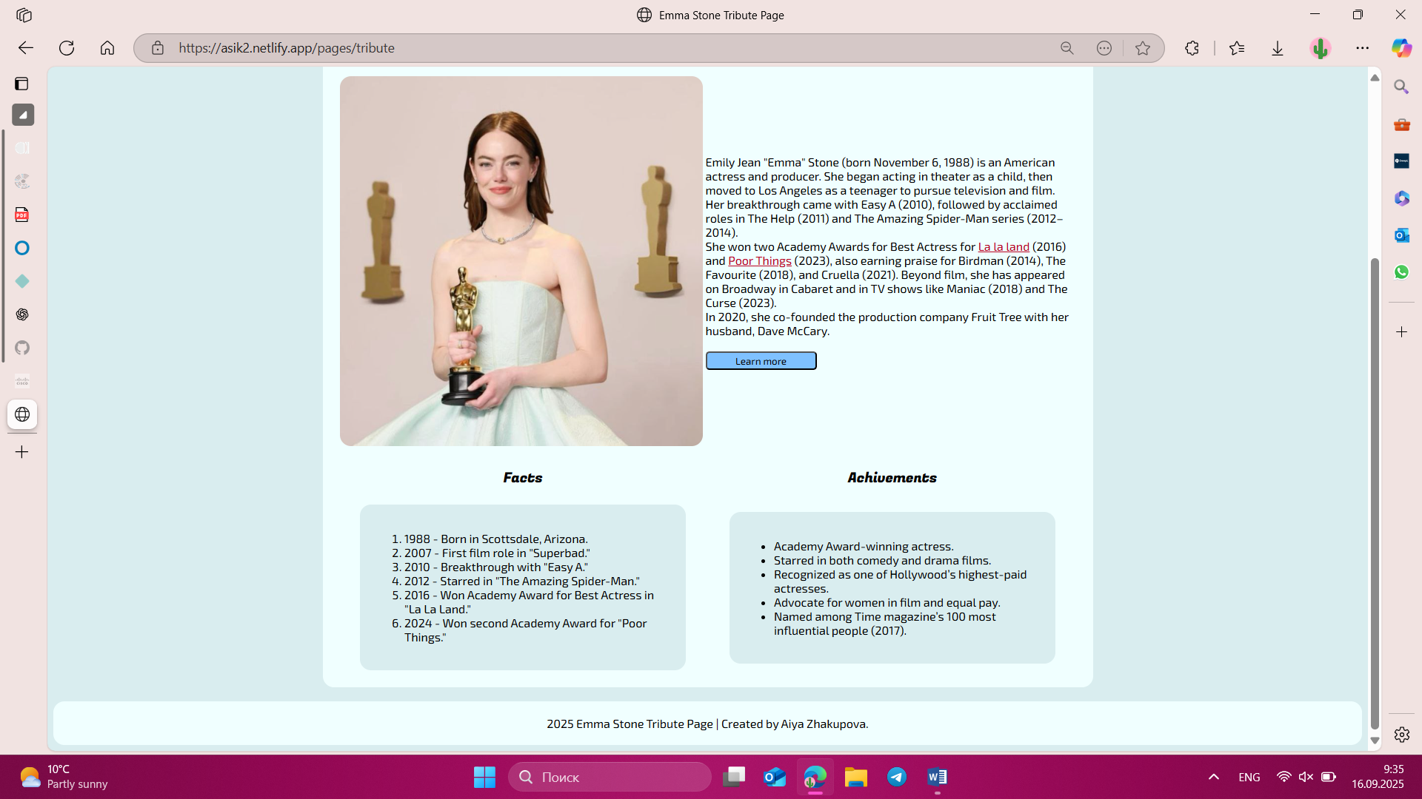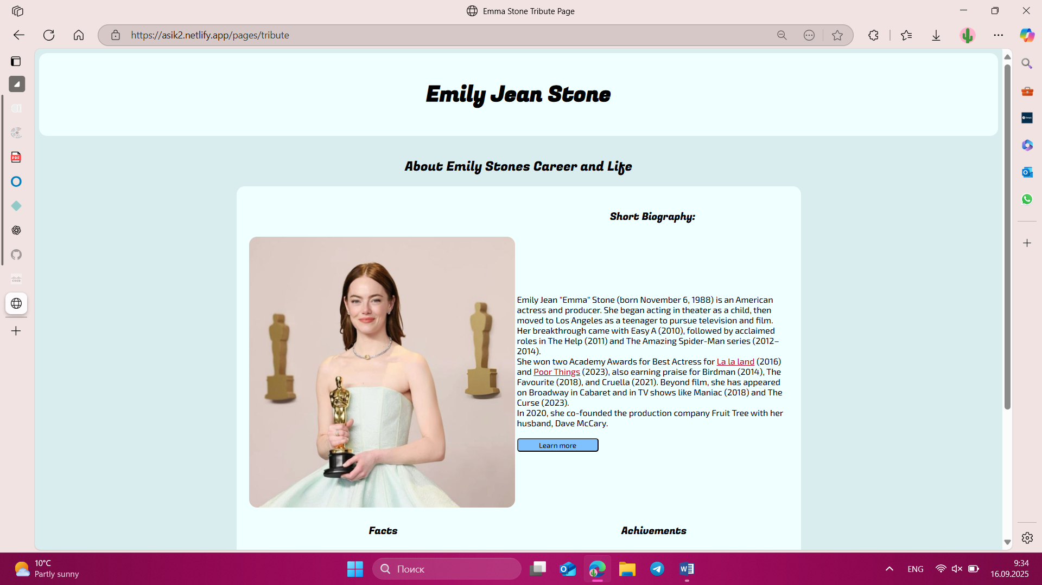

Task 3. CSS Table and Form (may see via the button on the main page)

### ****Description****

* Created table.html with:
  + A **table** displaying students’ names, subjects, and grades.
  + A **feedback form** with fields: name, email, role (dropdown), agreement (radio), comments (textarea), and submit button.

### ****CSS Styling**** (table.css)

* Table header styled with background color (.tableHeadings).
* Borders added to all table cells (td, th).
* Alternate row colors using nth-child(even).
* Highlighted one row with .unlucky class (red background).
* Center-aligned all table content.
* Form is centered and styled with padding and background.
* Labels are aligned and inputs styled for consistency.
* Submit button has custom color, rounded corners, and hover effect.
* Footer styled and centered at the bottom.

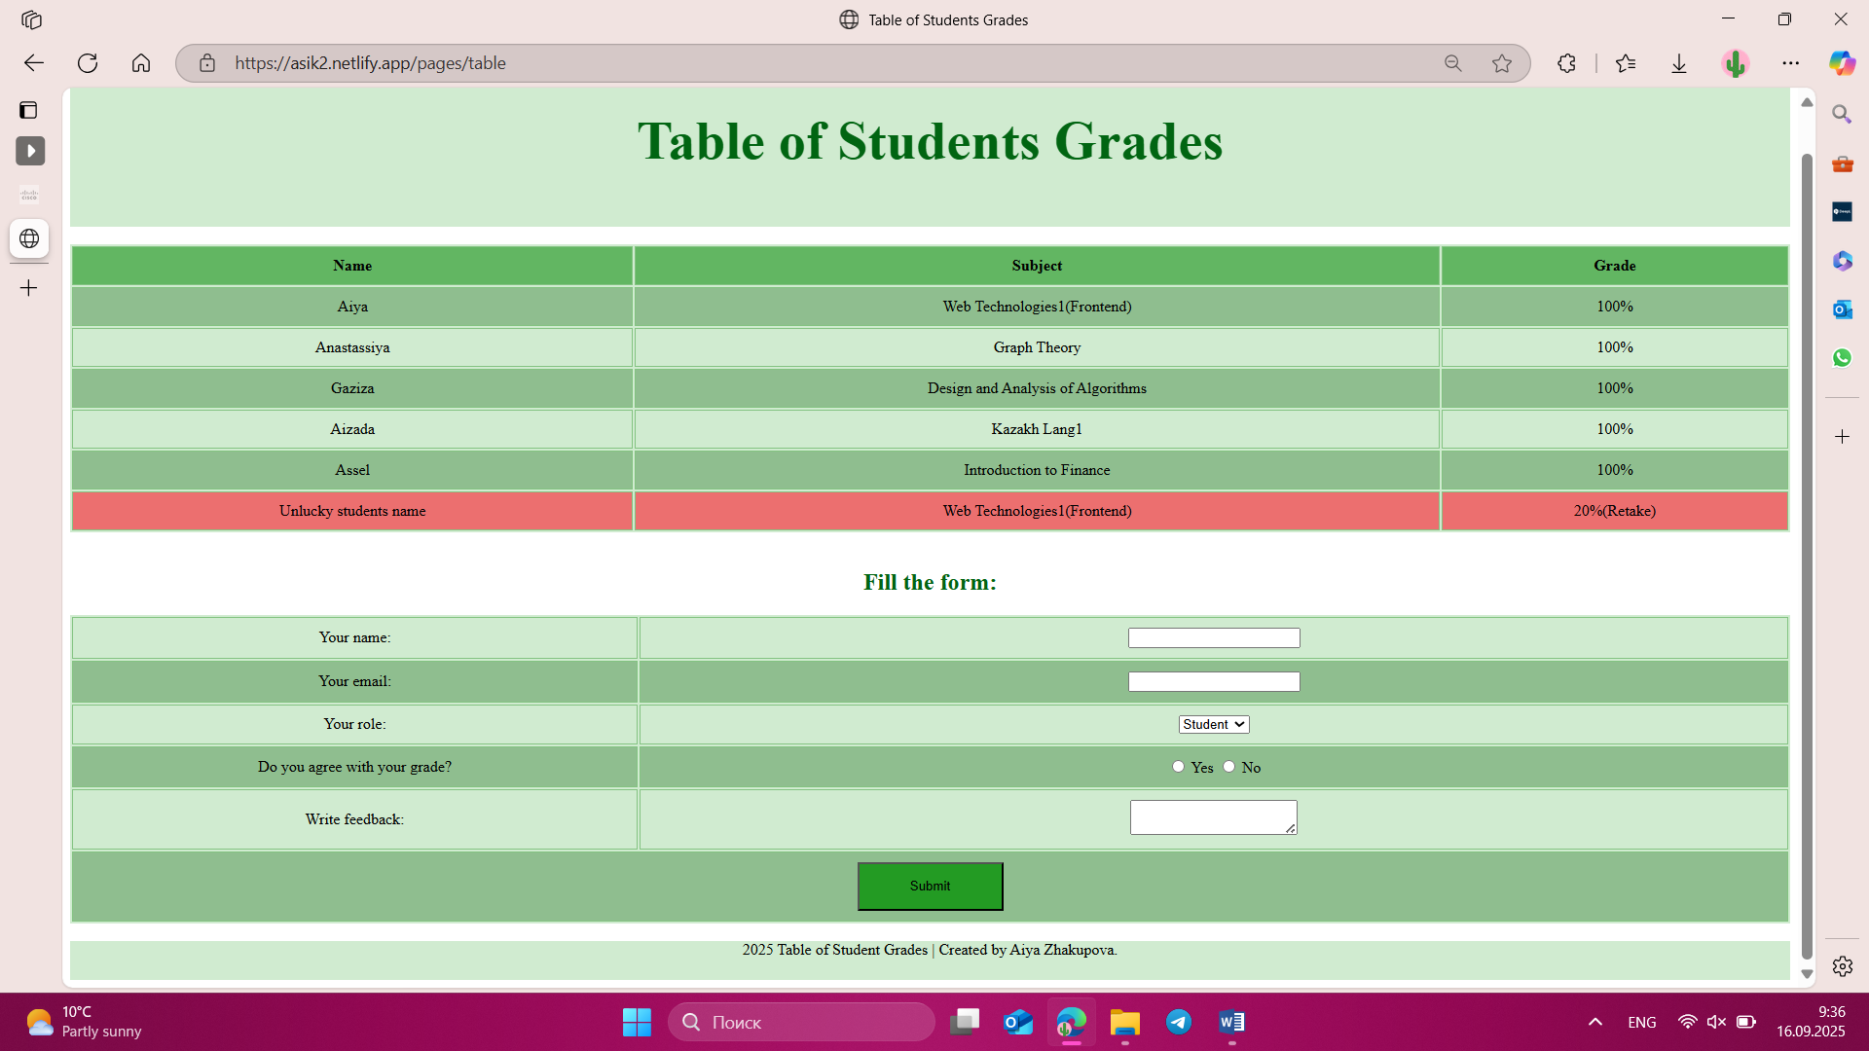

Task4. Midterm Project: Topic & Wireframe Design

Topic: Restaurant website

“Pasto” Italian restuarants website. The website targets local food enthusiasts and potential customers interested in premium dining experiences. The website aims to build excitement and anticipation for the restaurant's opening.

