Property Price Analysis/Visualization of London

# Business Problem

When someone looks to move from one neighborhood to another in a major city, it can be assumed that they will usually look for neighborhoods similar/dissimilar to the one they have stayed in earlier. This can be a factor when deciding which neighborhood to move to. So, after retrieving property prices and relevant neighborhood data, a system can be designed to cluster/classify neighborhoods and help the stakeholders decide on the best fit according to their preferences.

London being the largest/most populated city in the UK, this can be a very valid use case for people looking to move in London, from any other city or London itself.

# Data

To build this service, we make use of property prices data from propertydata.co.uk and Foursquare API for the other venue/amenity details. Combining both, we can make a dataset to compare the amenities/prices of individual neighborhoods and then cluster them based on similarity. The neighborhood/area codes are retrieved from Wikipedia.

1. Neighborhood codes/Area Data: <https://en.wikipedia.org/wiki/List_of_areas_of_London>
   1. Sample:

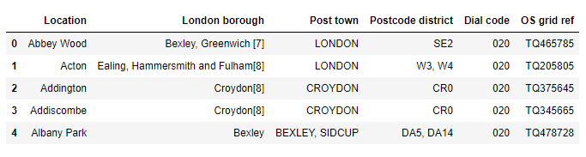

1. Property Data for London: <https://propertydata.co.uk/cities/london>
   1. Sample:

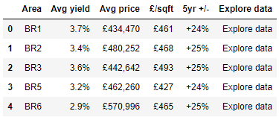

1. Neighborhood Information/Venues/Amenities: <https://api.foursquare.com>