Interfaces
CombatSystem:
Defines methods for combat actions:
- attack(CombatSystem opponent) – Attacks an opponent.
- receiveDamage(int damage) – Reduces health when damage is received.
- isAlive() – Checks if the entity is still alive.
InventorySystem:
Manages items:
- addItem(String item) – Adds an item to the inventory.
- useItem(String item) – Uses an item from the inventory.
LevelSystem:
Handles game levels:
- initiateLevel(CombatSystem player) – Starts a level.
- completeLevel(CombatSystem player) – Ends a level based on player status.
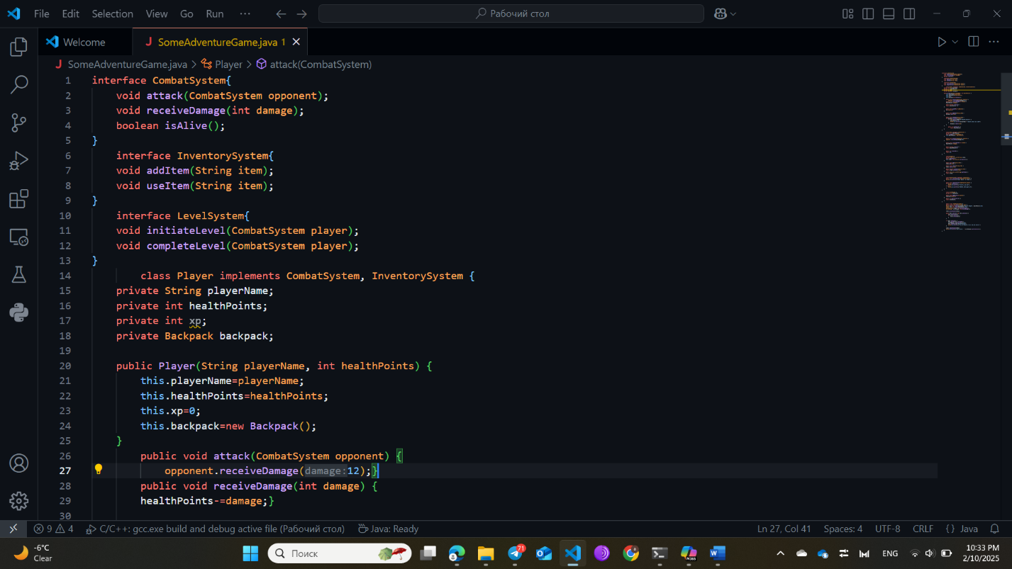

Classes:
- Player (implements CombatSystem, InventorySystem):
Represents the game’s main character:
  - Manages health, experience points (XP), and a backpack.
  - Can attack enemies, take damage, gain XP, and use items like health potions.
- Enemy (implements CombatSystem):
Represents opponents in the game:
  - Can attack players, take damage, and rewards XP when defeated.
- Backpack:
Manages the player's inventory:
  - Adds, removes, and checks for items.
- AdventureLevel (implements LevelSystem):
Controls the game’s level flow:
  - Starts and ends levels based on whether the player is alive.
- ScoreManager:
Keeps track of the player's total score:
  - Adds points for victories and displays total points.
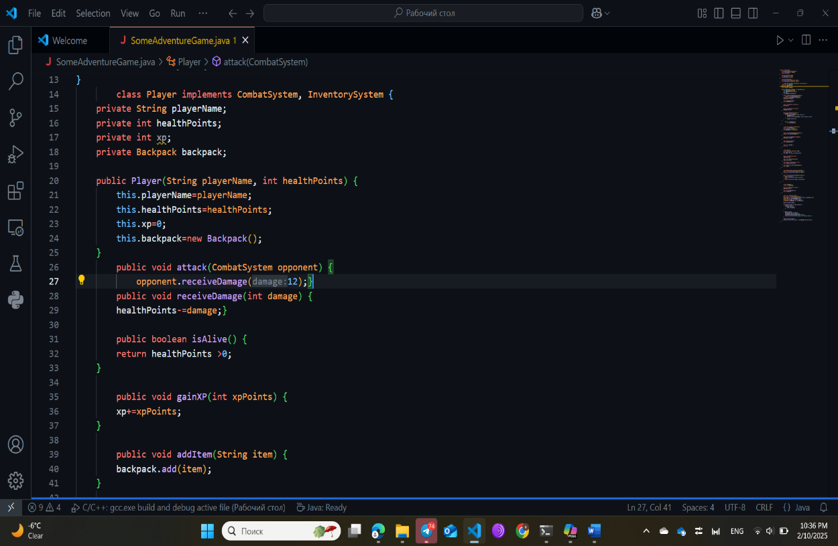
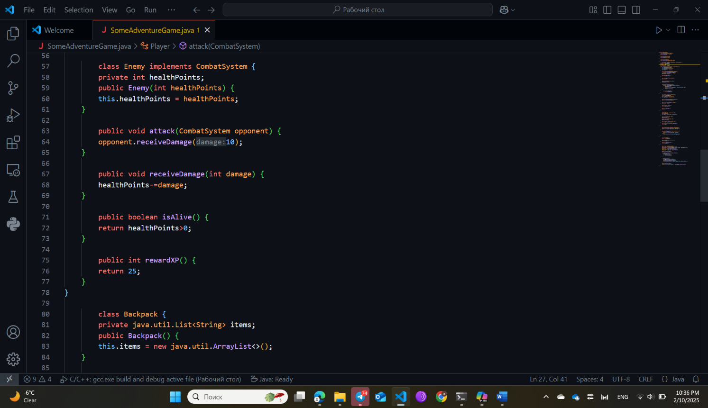
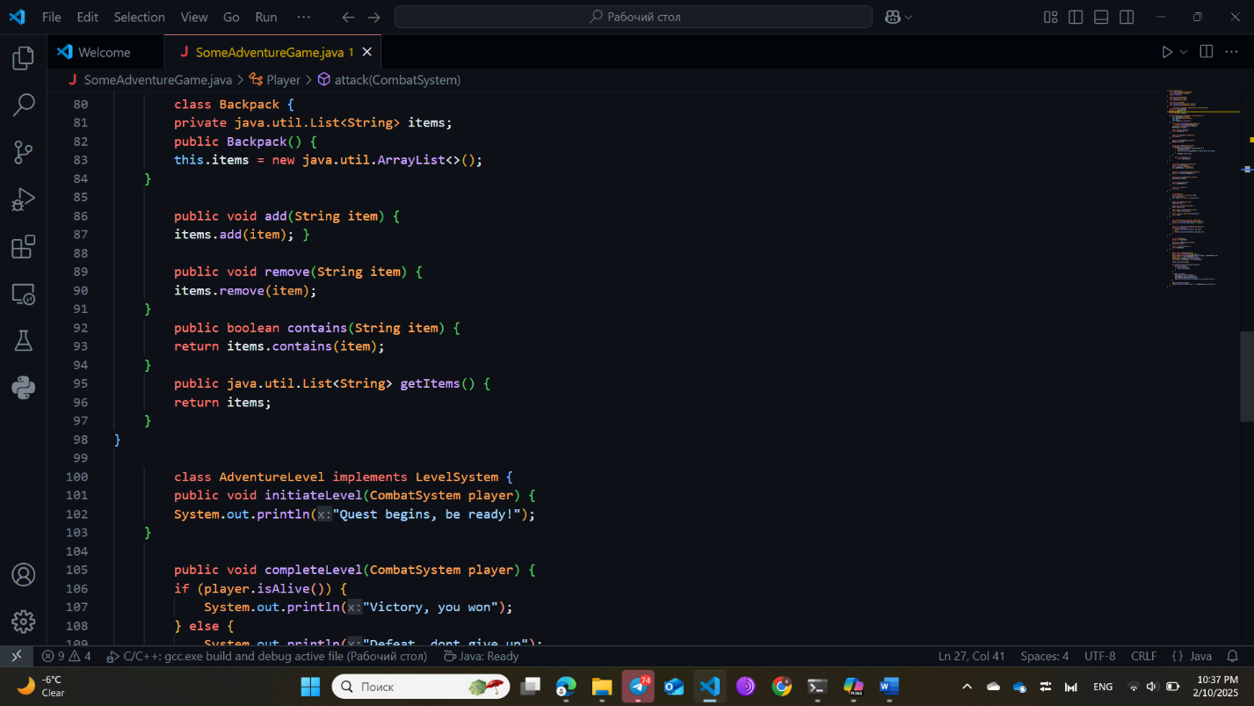
Main Class: SomeAdventureGame
- Gameplay Flow:
  - Creates a Player, an Enemy, and starts a level.
  - The player and enemy take turns attacking until one is defeated.
  - If the player wins, they gain XP, score points, and receive a health potion.
  - The level is completed, and the total score is displayed.
