# Coffee Shop and Payment Processing System Report

## 1. Coffee Shop Simulator

This system allows customers to order coffee with optional toppings using the Decorator Pattern. The CoffeeFactory class helps create different coffee types, and decorators allow adding toppings dynamically.

### Key Features:

- Uses the Factory Pattern to create coffee objects.

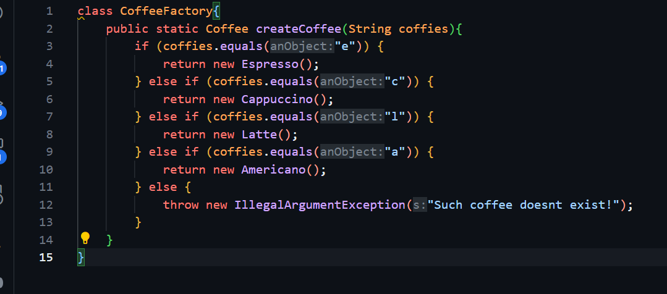

- Implements the Decorator Pattern for adding toppings.

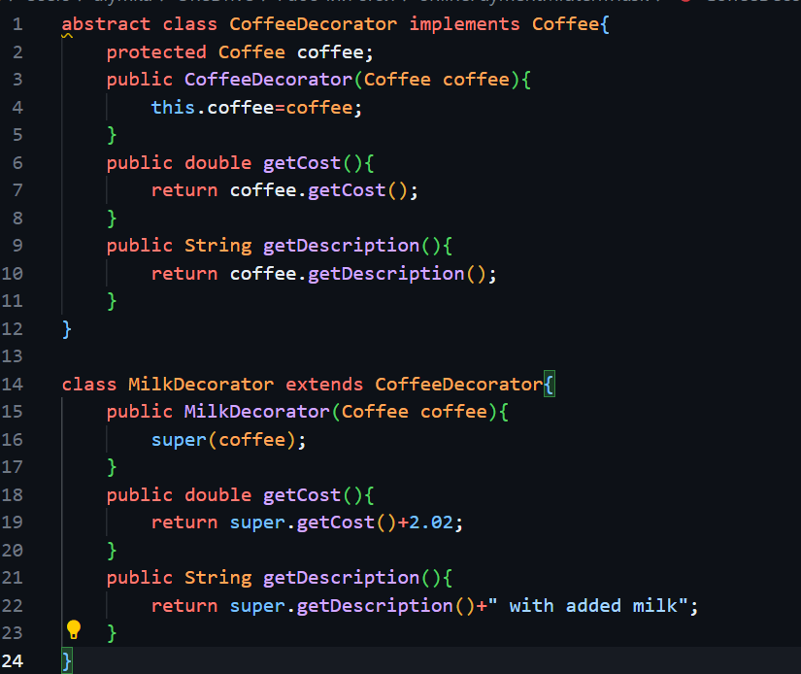

- Takes user input for coffee selection and toppings.

- Calculates the final cost dynamically based on the selected options.

## 2. Payment Processing System

This system handles different payment methods like Credit Card, PayPal, and Cryptocurrency using the Factory Pattern. It provides an easy way to extend payment methods without modifying existing code.

### Key Features:

- Uses the Factory Pattern to create payment method objects.

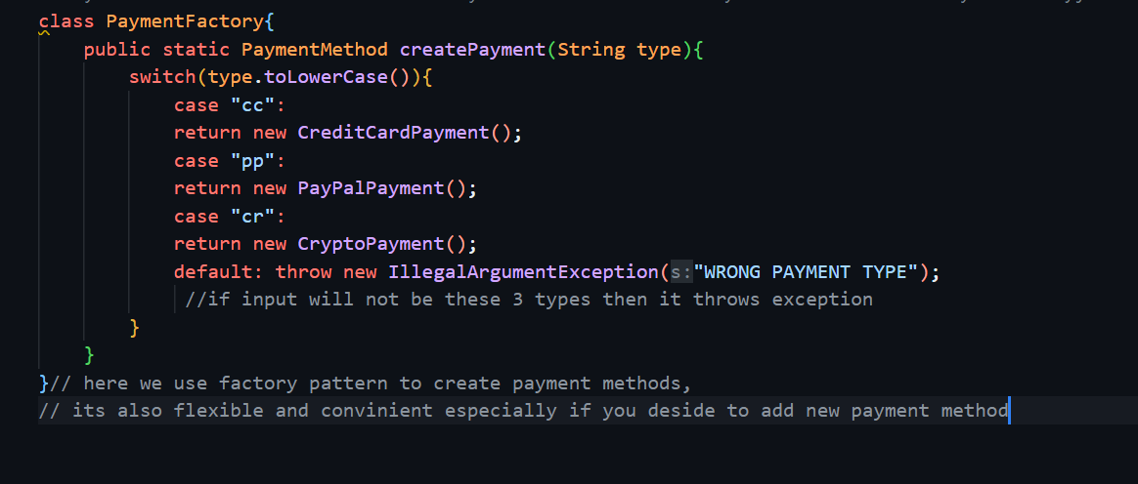

- Supports multiple payment options.

- Ensures code flexibility and scalability.