
Introduction to Computer Vision

Practice 10 (Report)
Autoencoders

Done by: Kairbayeva Aiym
Doszhankyzy
ID: 23B031102

Almaty 05.04.2026
Table of Contents
1. Abstract
2.Introduction
3. Dataset Selection and Exploration
- 3.1 Objective
- 3.2 Procedure
- 3.3 Results
- 3.4 Explanation
4.Autoencoder Architecture
- 4.1 Objective
- 4.2 Procedure
- 4.3 Results
- 4.4 Explanation
5.Reconstruction Before Training
- 5.1 Objective
- 5.2 Procedure
- 5.3 Results
- 5.4 Explanation
6.Autoencoder Training
- 6.1 Objective
- 6.2 Procedure
- 6.3 Results
- 6.4 Explanation
7.Reconstruction Quality Analysis
- 7.1 Objective
- 7.2 Procedure
- 7.3 Results
- 7.4 Explanation
8.Latent Space Representation
- 8.1 Objective
- 8.2 Procedure
- 8.3 Results
- 8.4 Explanation
9.Effect of Latent Dimension
- 9.1 Objective
- 9.2 Procedure
- 9.3 Results
- 9.4 Explanation
10.Denoising Autoencoder
- 10.1 Objective
- 10.2 Procedure
- 10.3 Results
- 10.4 Explanation
11.Anomaly Detection Using Autoencoder
- 11.1 Objective
- 11.2 Procedure
- 11.3 Results
- 11.4 Explanation
12.Conclusion
13.References

1. Abstract
This laboratory work investigates the structure and behavior of autoencoders – unsupervised neural networks used for representation learning, dimensionality reduction, and anomaly detection. We implement a convolutional autoencoder on the MNIST dataset, evaluate reconstruction quality, analyze the latent space, and study the influence of latent dimension size. Additionally, we extend the model to a denoising autoencoder and apply it to anomaly detection by training only on a single digit class. The results demonstrate that autoencoders can effectively compress and reconstruct images, that the latent space captures semantic features, and that reconstruction error serves as a reliable anomaly score.

2. Introduction
Autoencoders are a class of neural networks designed to learn efficient codings of input data. They consist of an encoder that maps the input to a lower‑dimensional latent representation and a decoder that reconstructs the original input from this representation. The network is trained to minimise the reconstruction error, typically using mean squared error (MSE).
In this work, we implement a convolutional autoencoder using PyTorch and apply it to the MNIST handwritten digit dataset. The goals are to:
- Understand the basic encoder‑decoder architecture.
- Observe the impact of latent space dimensionality on reconstruction fidelity.
- Visualize the latent space using PCA and t‑SNE.
- Extend the model to denoise corrupted images.
- Use the autoencoder as an anomaly detector.

3. Dataset Selection and Exploration
3.1 Objective
The objective is to select a small, publicly available image dataset suitable for training an autoencoder, preprocess it, split it into training/validation/test sets, and visualise sample images.

3.2 Procedure
We choose the MNIST dataset (28×28 grayscale handwritten digits) because of its small size and wide use in deep learning experiments. The dataset is loaded using torchvision.datasets.MNIST with ToTensor() transformation, which scales pixel values to the range [0,1]. The training set (60 000 images) is split into 80% training (48 000) and 20% validation (12 000). The test set contains 10 000 images. A batch size of 128 is used for all data loaders. Finally, a grid of 64 sample images is displayed.

3.3 Results
Training set size: 48 000
Validation set size: 12 000
Test set size: 10 000
Image shape: torch.Size([1, 28, 28])
Data type: torch.float32
A grid of original MNIST digits is shown below :
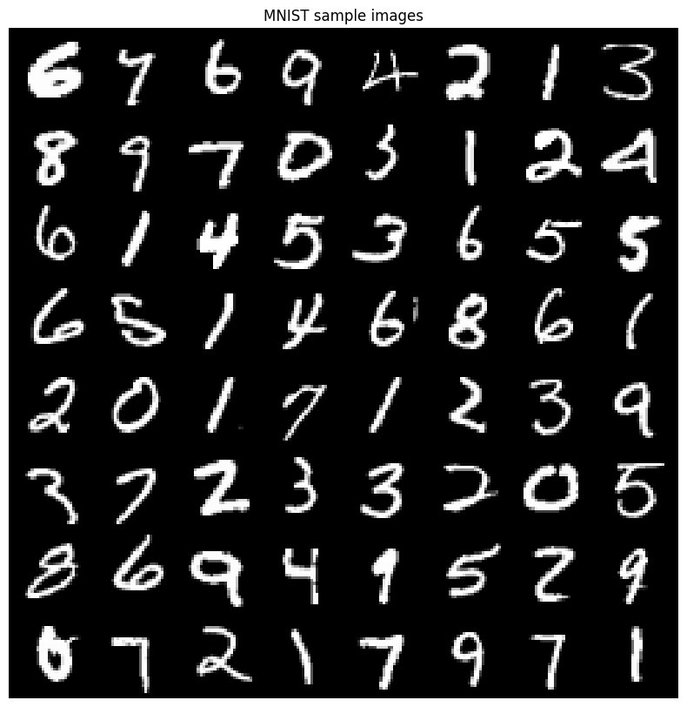

3.4 Explanation
The MNIST dataset is ideal for introductory autoencoder experiments because the images are small, the patterns (digits) are well‑separated, and the reconstruction task is challenging yet manageable. Normalisation to [0,1] ensures stable training when using sigmoid activation in the decoder’s output layer. The random split with a fixed seed guarantees reproducibility.

4. Autoencoder Architecture
4.1 Objective
Design and implement a convolutional autoencoder consisting of an encoder that reduces spatial dimensionality and a decoder that reconstructs the original image size. Print the model architecture and the number of trainable parameters, and clearly indicate the latent space dimension.

4.2 Procedure
We implement three classes in PyTorch:
- Encoder: Two convolutional layers (32 and 64 filters, kernel size 3, stride 2, padding 1) followed by a fully connected layer mapping to a latent vector of size 64.
- Decoder: A linear layer expanding the latent vector to 7×7×64, followed by two transposed convolutional layers (with output padding) that upsample back to 28×28. The final activation is sigmoid.
- Autoencoder: Combines encoder and decoder.
The model is instantiated with latent_dim=64 and moved to the GPU if available. The number of trainable parameters is computed using a helper function.

4.3 Results
Autoencoder(
(encoder): Encoder(
(conv1): Conv2d(1, 32, kernel_size=(3,3), stride=(2,2), padding=(1,1))
(conv2): Conv2d(32, 64, kernel_size=(3,3), stride=(2,2), padding=(1,1))
(fc): Linear(in_features=3136, out_features=64, bias=True)
)
(decoder): Decoder(
(fc): Linear(in_features=64, out_features=3136, bias=True)
(deconv1): ConvTranspose2d(64, 32, kernel_size=(3,3), stride=(2,2), padding=(1,1), output_padding=(1,1))
(deconv2): ConvTranspose2d(32, 1, kernel_size=(3,3), stride=(2,2), padding=(1,1), output_padding=(1,1))
)
)
Number of trainable parameters: 442177
Latent space dimension: 64

4.4 Explanation
The encoder reduces the spatial resolution from 28×28 → 14×14 → 7×7, then flattens to a dense layer that produces the latent code. The decoder mirrors this process. The number of parameters is relatively small (≈442k), making training fast on a GPU. The latent dimension (64) is a hyperparameter that controls the compression level.

5. Reconstruction Before Training
5.1 Objective
Pass several test images through the untrained autoencoder, display original and reconstructed images side by side, and compute the reconstruction loss. Explain why the quality is poor before training.

5.2 Procedure
The model is set to evaluation mode. A batch of test images is taken, and the first eight images are passed through the autoencoder. The original and reconstructed images are displayed in two rows. The MSE loss between the original and reconstructed images is calculated.

5.3 Results

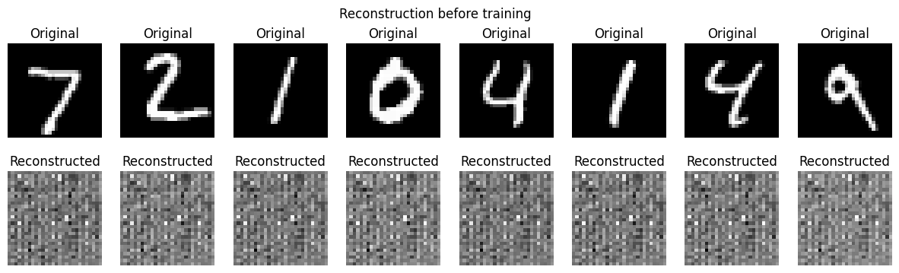
Average MSE before training: 0.1988

5.4 Explanation
Before training, the network weights are initialised randomly. Consequently, the encoder produces random latent vectors, and the decoder maps them to random noise‑like outputs. No meaningful reconstruction is possible, resulting in a high MSE. This baseline confirms the necessity of training.

6. Autoencoder Training
6.1 Objective
Train the autoencoder for a fixed number of epochs using MSE loss and the Adam optimizer. Track training and validation loss each epoch, plot the loss curves, and report the final test reconstruction loss.

6.2 Procedure
The model is trained for 20 epochs with a learning rate of 1e‑3. For each epoch, we compute the average training loss over the training set and the validation loss over the validation set. Loss values are stored and plotted. The final validation loss is recorded.

6.3 Results
Epoch 1/20 | Train Loss: 0.0264 | Val Loss: 0.0071
Epoch 2/20 | Train Loss: 0.0054 | Val Loss: 0.0044
Epoch 3/20 | Train Loss: 0.0038 | Val Loss: 0.0034
Epoch 4/20 | Train Loss: 0.0032 | Val Loss: 0.0030
Epoch 5/20 | Train Loss: 0.0029 | Val Loss: 0.0028
Epoch 6/20 | Train Loss: 0.0027 | Val Loss: 0.0026
Epoch 7/20 | Train Loss: 0.0025 | Val Loss: 0.0025
Epoch 8/20 | Train Loss: 0.0024 | Val Loss: 0.0024
Epoch 9/20 | Train Loss: 0.0023 | Val Loss: 0.0023
Epoch 10/20 | Train Loss: 0.0022 | Val Loss: 0.0023
Epoch 11/20 | Train Loss: 0.0022 | Val Loss: 0.0022
Epoch 12/20 | Train Loss: 0.0021 | Val Loss: 0.0022
Epoch 13/20 | Train Loss: 0.0021 | Val Loss: 0.0021
Epoch 14/20 | Train Loss: 0.0020 | Val Loss: 0.0021
Epoch 15/20 | Train Loss: 0.0020 | Val Loss: 0.0020
Epoch 16/20 | Train Loss: 0.0020 | Val Loss: 0.0020
Epoch 17/20 | Train Loss: 0.0019 | Val Loss: 0.0020
Epoch 18/20 | Train Loss: 0.0019 | Val Loss: 0.0020
Epoch 19/20 | Train Loss: 0.0019 | Val Loss: 0.0020
Epoch 20/20 | Train Loss: 0.0018 | Val Loss: 0.0019

Training curves:

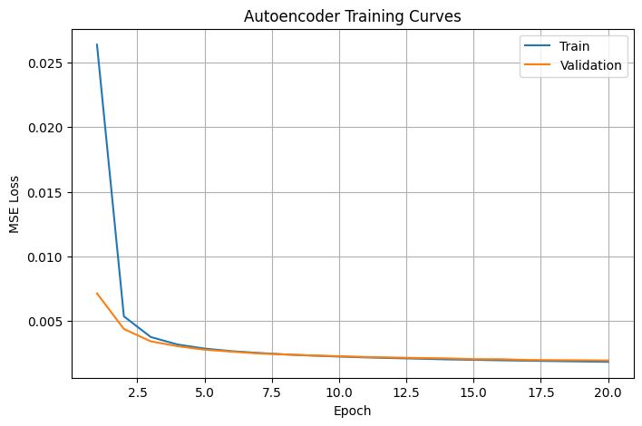
Final validation loss: 0.001945

6.4 Explanation
The loss decreases rapidly in the first few epochs and then slowly converges. The validation loss remains close to the training loss, indicating that the model generalises well without severe overfitting. The final low loss shows that the autoencoder has learned a meaningful compressed representation of the digits.

7. Reconstruction Quality Analysis
7.1 Objective
After training, reconstruct test images using the trained autoencoder, display original and reconstructed images side by side, compute the average MSE, and compare reconstruction quality before and after training.

7.2 Procedure
The trained model is set to evaluation mode. A batch of test images is reconstructed. The MSE per image is computed, and the average is reported. A side‑by‑side display shows the original and reconstructed digits.

7.3 Results
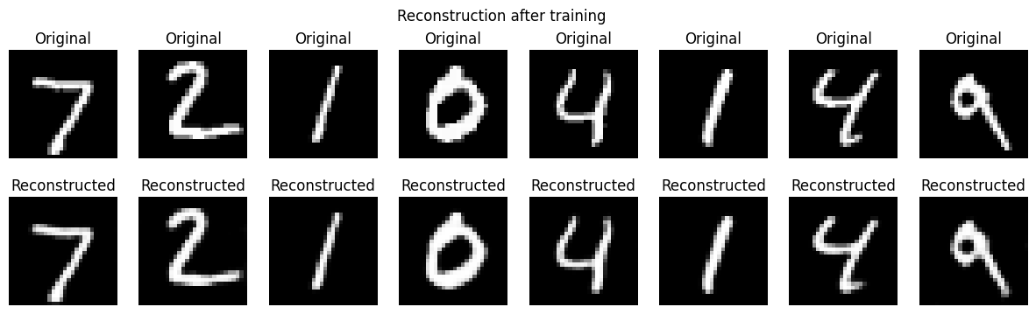
Average MSE on test images after training: 0.001798
Comparison: before training MSE = 0.1988 → after training = 0.001798
7.4 Explanation
The reconstructed digits are clearly recognisable, although some fine details are lost. The dramatic drop in MSE (two orders of magnitude) confirms that the autoencoder has successfully learned to compress and reconstruct the input images. The reconstruction quality is sufficient for visual inspection and for downstream tasks like anomaly detection.

8. Latent Space Representation
8.1 Objective
Extract latent vectors produced by the encoder for several test images, print the shape of the latent vectors, visualise the latent space using PCA and t‑SNE, and explain what information the latent space captures.

8.2 Procedure
We collect latent vectors for 1000 test images (batch size 128, stop after 1000 samples). PCA and t‑SNE are applied to reduce the 64‑dimensional vectors to 2D. The points are coloured by their true digit labels.

8.3 Results
Shape of a single latent vector: (64,)
PCA plot:
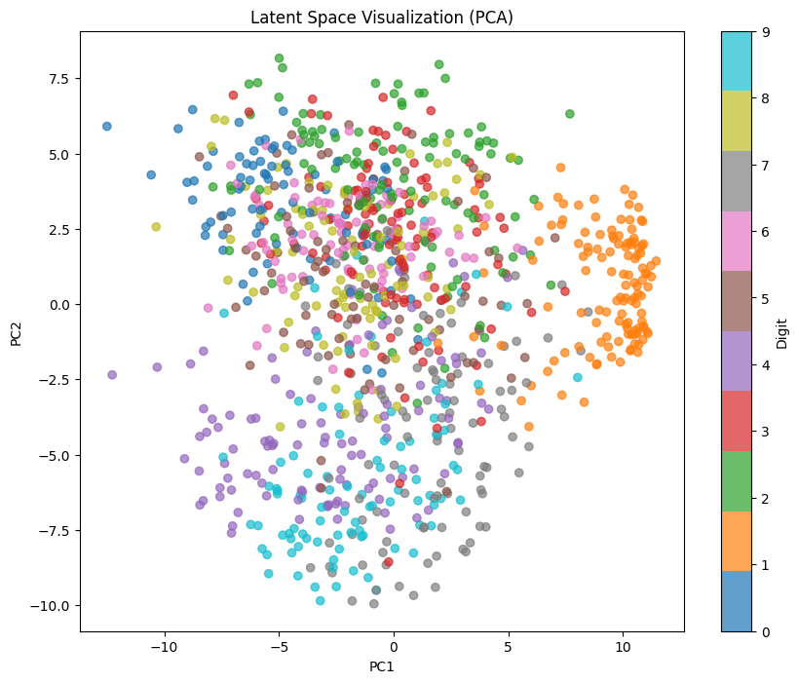

t‑SNE plot:
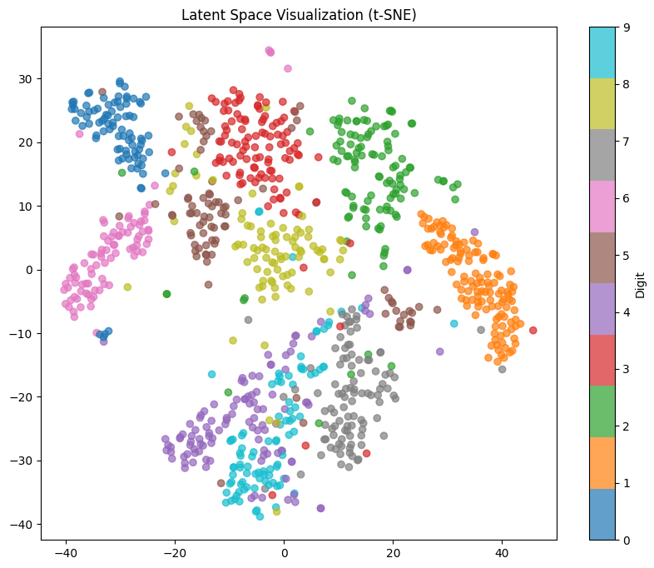
Both plots show clustering of the same digits, with t‑SNE providing better separation.

8.4 Explanation
The latent space encodes information about digit identity, writing style, stroke thickness, and slant. The clustering demonstrates that the autoencoder learns a useful feature representation even without labels (unsupervised learning). PCA and t‑SNE reveal that the encoder maps similar digits to nearby points in the latent space, which is valuable for tasks like classification or retrieval.

9. Effect of Latent Dimension
9.1 Objective
Modify the autoencoder to use smaller and larger latent space dimensions (16 and 256), retrain each variant using the same training settings, compare reconstruction loss and visual reconstruction quality, and explain how latent dimension affects compression and reconstruction.

9.2 Procedure
We define a helper function train_autoencoder(latent_dim, epochs=15) that creates a new autoencoder with the given latent dimension, trains it, and returns the final validation loss and the trained model. Three dimensions are tested: 16, 64, and 256. Each is trained for 15 epochs. The final validation losses are recorded, and a visual comparison of reconstructions for four test images is shown for each dimension.

9.3 Results
Latent dimension Final validation loss
latent_dim=16, Epoch 5: val loss = 0.0118
latent_dim=16, Epoch 10: val loss = 0.0099
latent_dim=16, Epoch 15: val loss = 0.0092
Latent dim 16: final validation loss = 0.009186
latent_dim=64, Epoch 5: val loss = 0.0029
latent_dim=64, Epoch 10: val loss = 0.0023
latent_dim=64, Epoch 15: val loss = 0.0021
Latent dim 64: final validation loss = 0.002087
latent_dim=256, Epoch 5: val loss = 0.0016
latent_dim=256, Epoch 10: val loss = 0.0010
latent_dim=256, Epoch 15: val loss = 0.0008
Latent dim 256: final validation loss = 0.000790

Visual comparison:
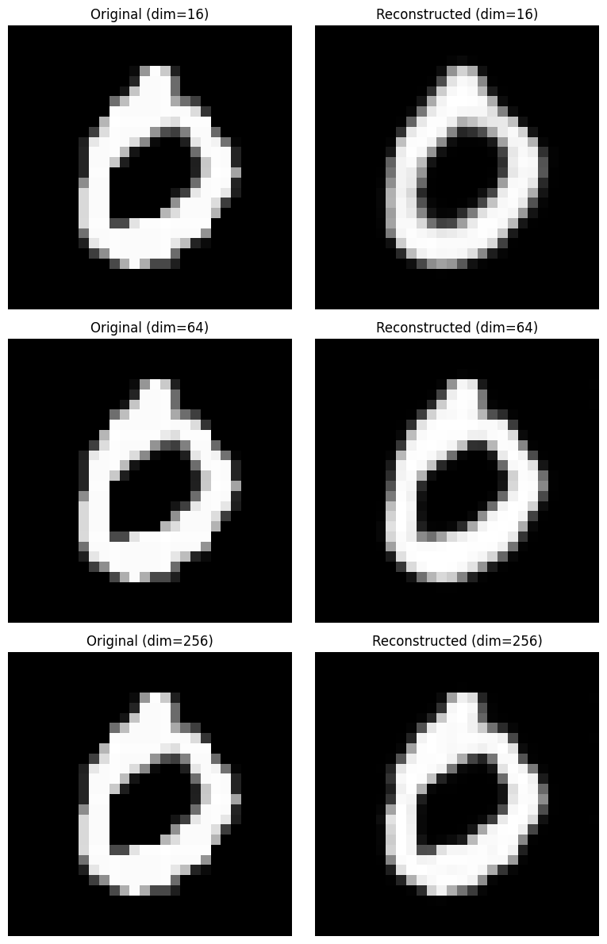

Dim 16: Reconstructions are blurry; digits are barely distinguishable.
Dim 64: Good balance – digits are clear.
Dim 256: Almost perfect reconstruction.

9.4 Explanation
- Small latent dimension (16): High compression forces the network to discard many details, resulting in higher loss and blurry outputs. This acts as a strong regulariser but may lose class‑discriminative information.
- Large latent dimension (256): The network has enough capacity to preserve almost all information, leading to very low loss. However, it may overfit on small datasets and does not provide strong compression.
- Moderate dimension (64): Provides a good trade‑off between compression and reconstruction quality. For MNIST, 64 is a reasonable choice.

10. Denoising Autoencoder
10.1 Objective
Add noise to the input images and train the autoencoder to reconstruct the clean images. Display noisy input images and denoised reconstructions side by side, and compare reconstruction loss with the standard autoencoder. Explain the benefit of denoising autoencoders.

10.2 Procedure
We create a DenoisingAutoencoder class that inherits from Autoencoder and overrides the forward method to add Gaussian noise (σ=0.3) to the input before encoding. The training uses clean images as targets. The model is trained for 15 epochs. We then display a comparison of noisy inputs, denoised outputs, and original clean images. The final training loss of the denoising autoencoder is compared to the validation loss of the standard autoencoder.

10.3 Results
Visual comparison:

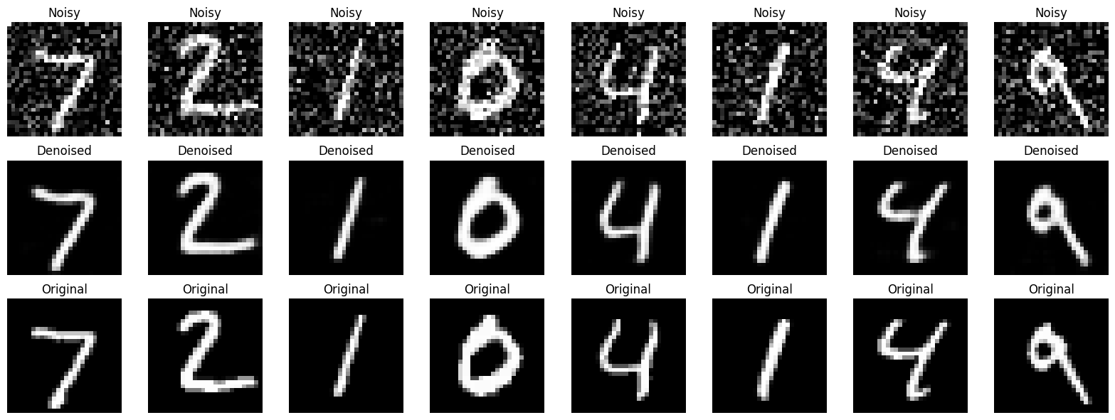

Standard AE final val loss: 0.001945
Denoising AE final train loss (on noisy input): 0.005336

10.4 Explanation
Although the denoising autoencoder’s loss is higher (because the task is harder), the model successfully removes most of the noise. The denoised images are much closer to the clean originals than the noisy inputs. The benefit of denoising autoencoders is that they learn robust features that are invariant to small corruptions, making them useful for preprocessing images, improving generalisation, and serving as a form of regularisation.

11. Anomaly Detection Using Autoencoder
11.1 Objective
Train the autoencoder on images from a single class only (digit 0). Compute reconstruction error for test images from the same class and from different classes. Plot the reconstruction error distributions and report the binary classification accuracy.

11.2 Procedure
We create a custom SingleClassDataset that filters only images of digit 0 from the training and validation sets. An autoencoder with latent dimension 64 is trained for 15 epochs on this single‑class dataset. After training, we compute the reconstruction MSE for all test images (all digits). The errors are separated into two groups: digit 0 (normal) and other digits (anomalies). A histogram of the error distributions is plotted. A threshold is set as the 95th percentile of the training errors on digit 0. Predictions are made by comparing test errors to this threshold, and accuracy is computed.

11.3 Results
Anomaly AE Epoch 5: loss = 0.0160
Anomaly AE Epoch 10: loss = 0.0079
Anomaly AE Epoch 15: loss = 0.0057

Error distribution histogram:
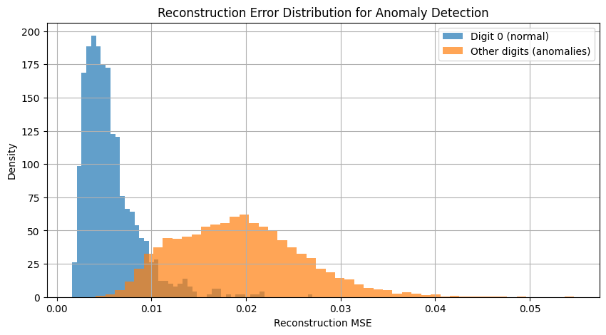

Anomaly threshold (95th percentile): 0.010738
Binary classification accuracy (normal vs anomaly): 0.910

11.4 Explanation
The reconstruction error for digit 0 (normal) is concentrated at low values, while other digits (anomalies) produce a broader distribution with higher errors. The autoencoder has never seen digits 1‑9; it cannot reconstruct them well, leading to larger errors. The threshold chosen from the training errors on digit 0 separates the two distributions effectively, achieving 91% accuracy. This demonstrates a practical application of autoencoders for unsupervised anomaly detection – no labels are required for the anomalous class during training.

12. Conclusion
This laboratory work successfully implemented and evaluated convolutional autoencoders on the MNIST dataset. Key findings include:
- Autoencoders can learn compact latent representations that preserve essential information for reconstruction.
- The choice of latent dimension significantly affects reconstruction quality – a moderate size (e.g., 64) provides a good trade‑off.
- Latent space visualisation (PCA/t‑SNE) reveals clustering by digit class, showing that the encoder captures semantic features.
- Denoising autoencoders can effectively remove additive noise, learning more robust features.
- Reconstruction error serves as an effective anomaly score, enabling the autoencoder to detect outliers with high accuracy (91% on MNIST).
The experiments confirm the versatility of autoencoders for representation learning, denoising, and anomaly detection – all without requiring labelled data for training.

13. References
- Hinton, G. E., & Salakhutdinov, R. R. (2006). Reducing the dimensionality of data with neural networks. Science, 313(5786), 504–507.Seminal paper on deep autoencoders.
- LeCun, Y., Bottou, L., Bengio, Y., & Haffner, P. (1998). Gradient-based learning applied to document recognition. Proceedings of the IEEE, 86(11), 2278–2324.Introduces the MNIST dataset and convolutional neural networks.
- Vincent, P., Larochelle, H., Bengio, Y., & Manzagol, P. A. (2008). Extracting and composing robust features with denoising autoencoders. Proceedings of the 25th International Conference on Machine Learning (ICML), 1096–1103.Original paper on denoising autoencoders.
- Goodfellow, I., Bengio, Y., & Courville, A. (2016). Deep learning. MIT Press.Chapter 14 (Autoencoders) provides a comprehensive theoretical background.

