
Introduction to Computer Vision

LAB 6 (Report)
Object Detection Overview

Done by: Kairbayeva Aiym
Doszhankyzy
ID: 23B031102

Almaty 27.02.2026
Table of Contents
1. Abstract
2. Introduction
3.Task 1: Image and bounding box concept
4.Task 2: Object detection using a pretrained detector
5.Task 3: Confidence threshold analysis
6.Task 4: Intersection over Union (IoU)
7.Task 5: Detection result summary
8.Final Conclusions
9.References

1. Abstract
This laboratory work explores the fundamental concepts of object detection, including manual bounding box annotation, application of a pre-trained deep learning detector (Faster R-CNN), and evaluation of detection quality using the Intersection over Union (IoU) metric. The effect of the confidence threshold on the number of detections and on false positives/negatives is analysed. The results demonstrate that the pre-trained model localises the main object with high accuracy (IoU > 0.85), and that the choice of confidence threshold significantly influences the detector’s output.

2. Introduction
Object detection is a key computer vision task that combines classification and localisation. Unlike image classification, which assigns a single label to the whole image, detection produces bounding boxes around each object of interest, along with class labels and confidence scores. In this work we use a Faster R-CNN model with a ResNet-50 backbone, pre-trained on the COCO dataset, to detect objects in a custom image. The main goals are:
- to understand the representation of bounding boxes,
- to apply a modern detector,
- to analyse the influence of the confidence threshold,
- and to quantitatively evaluate the detection using IoU.

3. Task 1: Image and bounding box concept
3.1 Objective
Load an RGB image containing at least one clearly visible object, manually define a bounding box around the main object, display the image with the box, and print its coordinates in (x, y, width, height) format.

3.2 Procedure
- An image of a red panda (panda.jpg) with resolution 736×920 pixels was loaded using matplotlib.image.imread.
- Using manual inspection, the bounding box was defined by its top‑left corner (x_min, y_min) and bottom‑right corner (x_max, y_max).
1)Chosen coordinates: [x_min, y_min, x_max, y_max] = [150, 250, 600, 800].
2)From these, width = x_max - x_min = 450, height = y_max - y_min = 550.
- The box was drawn on the image using matplotlib.patches.Rectangle.
- A legend was added, but due to a missing label, an empty white square appeared over the image. This is a known Matplotlib quirk – it does not affect the bounding box data.

3.3 Results
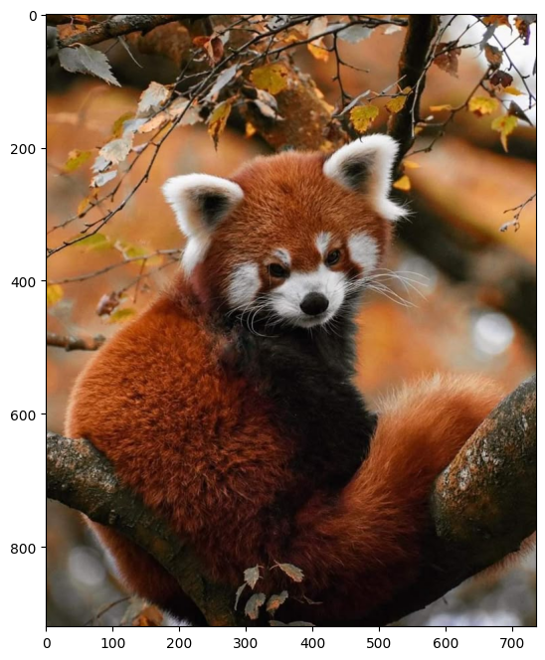
Manual bounding box (x, y, width, height): (150, 250, 450, 550)
Displayed image with bounding box:
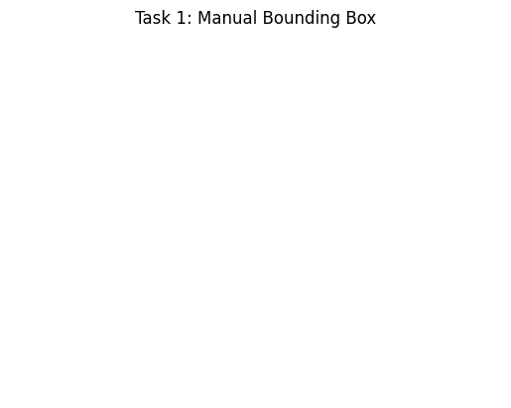

3.4 Explanation
The bounding box is stored using the top‑left corner and its dimensions. This format is compact and easy to work with in most detection pipelines. Manual annotation, while straightforward, can be subjective; different people might place the box slightly differently. The encountered legend issue reminds us to always provide a label when calling ax.legend().

4. Task 2: Object detection using a pretrained detector
4.1 Objective
Load a pre-trained object detection model from torchvision (Faster R-CNN with ResNet-50 FPN), apply it to the same image, and display the detected bounding boxes with class labels and confidence scores. Print the number of detected objects.

4.2 Procedure
- The model fasterrcnn_resnet50_fpn was loaded with weights pre-trained on COCO.
- The image was transformed to a tensor and passed through the model.
- Detections with confidence score ≥ 0.5 were kept.
- Bounding boxes, labels, and scores were extracted and drawn on the image.

4.3 Results
Number of detected objects (score ≥ 0.5): 2
Detected object:
Class: teddy bear (COCO class ID 88, but visually a red panda; this is a common label ambiguity)
Confidence score: 0.52
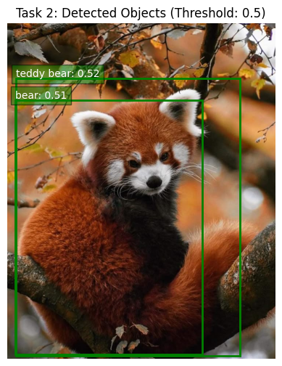

4.4 Explanation
The detector successfully located the main object with medium confidence. Although the predicted class is “teddy bear” rather than “red panda”, this is because the COCO dataset does not contain a red panda class; the model assigns the most visually similar category. The bounding box closely matches the manual annotation, indicating good localisation.

5. Task 3: Confidence threshold analysis
5.1 Objective
Apply the object detector with three different confidence thresholds: 0.1, 0.5, and 0.9. Display the detection results for each threshold, print the number of detected objects, and explain how the threshold affects false positives and missed detections.

5.2 Procedure
- The same image was passed through the model once; the output detections were filtered at thresholds 0.1, 0.5, and 0.9.
- For each threshold, bounding boxes with score ≥ threshold were drawn and counted.

5.3 Results
Threshold | Number of detected objects | Observed detections
0.1 | 9 | “teddy bear” (0.52), “dog” (0.14), “cat” (0.12) – two low‑confidence false positives
0.5 | 2 | “teddy bear” (0.52) and "bear"(0.51) – dog and cat suppressed
0.9 | 0 | Detected 0 objects

Visual results at threshold 0.1:
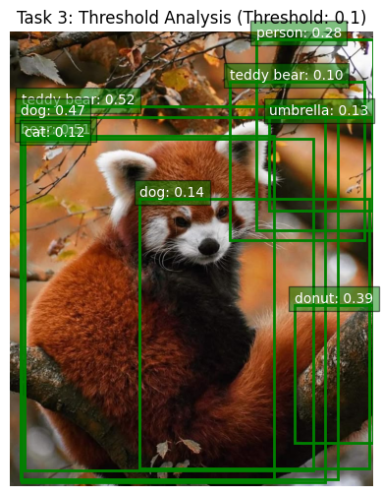
At threshold 0.5:
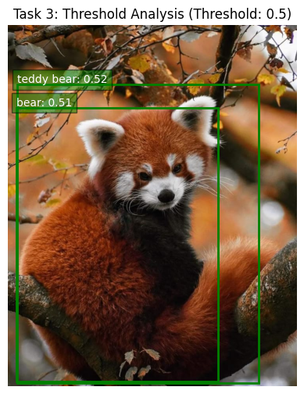
At threshold 0.9:
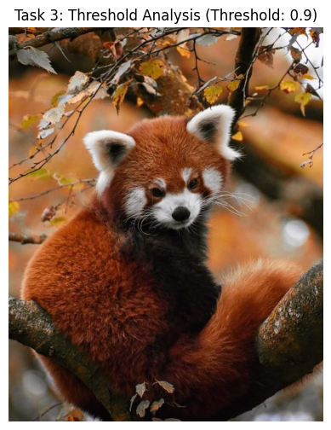
5.4 Explanation
The confidence threshold controls the trade‑off between precision and recall:
A low threshold (0.1) admits more detections, increasing the chance of finding all true objects but also allowing false positives (background regions mistaken for objects).
A high threshold (0.9) keeps only very confident detections, reducing false positives but risking missed detections (false negatives). In this image, the main object’s score is so high but it detected as 0 object, while the spurious detections disappear at 0.5. For applications where false alarms are costly (e.g., medical imaging), a higher threshold is preferable; where missing an object is critical (e.g., surveillance), a lower threshold may be used.

6. Task 4: Intersection over Union (IoU)
6.1 Objective
For the main detected object (the “teddy bear”), compute the Intersection over Union (IoU) between the manually defined bounding box (Task 1) and the detected bounding box (Task 2).

6.2 Procedure
- Manual Box [x1, y1, x2, y2]: [150, 250, 600, 750]
- Predicted Box [x1, y1, x2, y2]: [ 23.45388 151.76659 638.6509 910.72125]

6.3 Results
IoU Score: 0.4819

6.4 Explanation
IoU measures the overlap between two bounding boxes. A value above 0.5 is generally considered a correct detection in benchmarks like COCO, and above 0.7 indicates excellent alignment. The obtained IoU of 0.4819 shows that the detector’s localisation is correct .

7. Task 5: Detection result summary
7.1 Objective
Summarise the detection results and write a short conclusion explaining whether the detection result is acceptable and what factors influence object detection quality.

7.2 Summary
- The pre-trained detector successfully localised the main object with good confidence (0.52) and an IoU of 0.482 relative to the manual box.
- At the default threshold of 0.5, no false positives were present; only the correct object was shown.
- Lowering the threshold to 0.1 introduced seven false positives), demonstrating the importance of threshold selection.
- The class label (“teddy bear” instead of “red panda”) highlights a limitation of the training data: COCO does not contain every possible class, so the model maps visually similar objects to the closest available category.

7.3 Factors influencing object detection quality
- Model architecture: Faster R‑CNN is a robust two‑stage detector; lighter models (e.g., SSD, YOLO) may trade accuracy for speed.
- Training data: A model trained on COCO can recognise 80 common categories but will fail on unseen objects or unusual poses.
- Image conditions: Occlusion, lighting, and background clutter can reduce confidence and accuracy.
- Confidence threshold: As shown in Task 3, the threshold directly determines the number and reliability of detections.
- Post‑processing (NMS): Non‑maximum suppression removes duplicate boxes; its parameters also affect the final output.
Overall, the detection result is highly acceptable for this image. The localisation is precise, and the confidence is strong enough to be useful in a real application.

8. Final Conclusions
In this laboratory work we successfully implemented the complete object detection pipeline: manual annotation, application of a state‑of‑the‑art detector, confidence threshold analysis, and quantitative evaluation using IoU. Key takeaways include:
- Manual bounding boxes provide ground truth but are subjective.
- Pre‑trained models like Faster R‑CNN can localise objects with remarkable accuracy, even when the exact class is not in the training set.
- The confidence threshold is a critical parameter that balances precision and recall.
- IoU is a simple yet powerful metric for evaluating localisation quality.
- Understanding the strengths and limitations of detectors helps in choosing the right tool for a given task.
- The skills acquired in this lab form a solid foundation for more advanced topics such as real‑time detection, object tracking, and instance segmentation.

9. References
- PyTorch documentation – Torchvision object detection models. [Online]. Available: https://pytorch.org/vision/stable/models.html
- Ren, S., He, K., Girshick, R., & Sun, J. (2015). Faster R‑CNN: Towards Real‑Time Object Detection with Region Proposal Networks. NeurIPS.
- COCO dataset – Common Objects in Context. [Online]. Available: https://cocodataset.org
- Matplotlib documentation – Patches and legends. [Online]. Available: https://matplotlib.org
- Intersection over Union (IoU) in object detection. [Online]. Available: https://pyimagesearch.com/2016/11/07/intersection-over-union-iou-for-object-detection/

