
Introduction to Computer Vision

Practice 8 (Report)
Face Recognition

Done by: Kairbayeva Aiym
Doszhankyzy
ID: 23B031102

Almaty 25.03.2026
Table of Contents
1. Abstract
2.Introduction
3.Dataset Selection and Exploration
- 3.1 Objective
- 3.2 Procedure
- 3.3 Results
- 3.4 Explanation
4.Face Detection and Preprocessing
- 4.1 Objective
- 4.2 Procedure
- 4.3 Results
- 4.4 Explanation
5.CNN Feature Extraction
- 5.1 Objective
- 5.2 Procedure
- 5.3 Results
- 5.4 Explanation
6.Feature Representation Visualization (PCA)
- 6.1 Objective
- 6.2 Procedure
- 6.3 Results
- 6.4 Explanation
7.Face Identification and Metrics Evaluation
- 7.1 Objective
- 7.2 Procedure
- 7.3 Results
- 7.4 Explanation
8.Face Verification and Threshold Analysis
- 8.1 Objective
- 8.2 Procedure
- 8.3 Results
- 8.4 Explanation
9.Baseline Comparison (PCA + KNN)
- 9.1 Objective
- 9.2 Procedure
- 9.3 Results
- 9.4 Explanation
10.Error Analysis
- 10.1 Objective
- 10.2 Procedure
- 10.3 Results
- 10.4 Explanation
11.Inference Speed Evaluation
- 11.1 Objective
- 11.2 Procedure
- 11.3 Results
- 11.4 Explanation
12.Final Conclusions

1. Abstract
This laboratory work explores the application of deep learning and classical machine learning techniques for face recognition and verification. Using a subset of the Labeled Faces in the Wild (LFW) dataset, a pipeline was built to detect and crop faces using Haar Cascades, followed by feature extraction using a pre-trained MobileNetV2 convolutional neural network. The study evaluates the model on two primary tasks: 1-to-N Face Identification using cosine similarity, and 1-to-1 Face Verification by establishing an optimal similarity threshold. Furthermore, the CNN-based approach is benchmarked against a classical PCA + KNN pipeline to compare accuracy, feature robustness, and inference speed.

2. Introduction
Face recognition systems generally perform two distinct tasks: Verification (1-to-1 matching to confirm if a face belongs to a specific claimed identity) and Identification (1-to-N matching to determine the identity of an unknown face against a database).
Training a robust facial feature extractor from scratch requires massive datasets. Transfer learning mitigates this by utilizing models like MobileNetV2, pre-trained on ImageNet, to generate dense numerical representations (embeddings) of faces. This report details the process of processing facial images, extracting these embeddings, evaluating identification and verification metrics, and analyzing the trade-offs between deep learning models and classical Eigenface (PCA) methods.

3. Dataset Selection and Exploration
3.1 Objective
Load a subset of a widely used facial dataset, focusing on a specific number of identities to create a manageable classification task, and explore the natural variations in the data.

3.2 Procedure
- Dataset: Labeled Faces in the Wild (LFW).
- Filtering: The dataset was filtered to include individuals with a minimum of 30 images, and 5 specific identities were selected for the experiment.
- Splitting: The data was split into training and testing sets with an 80/20 ratio using stratified sampling to maintain class distribution.

3.3 Results
Total Images: 229
Number of Identities: 5
Class Distribution:
- 0:Alejandro Toledo: 39 images
- 1:Alvaro Uribe: 35 images
- 2:Andre Agassi: 36 images
- 3:Ariel Sharon: 77 images
- 4:Arnold Schwarzenegger: 42 images
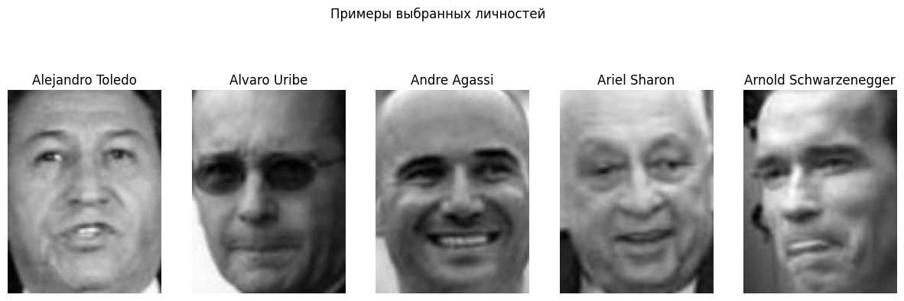
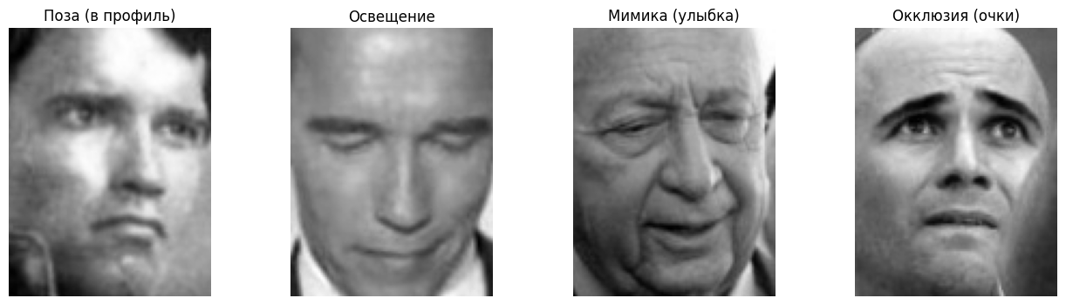
3.4 Explanation
The LFW dataset contains real-world images with high variability in pose, lighting, facial expressions, and occlusions (e.g., glasses). This unconstrained nature makes it an excellent benchmark for testing the robustness of feature extraction models.

4. Face Detection and Preprocessing
4.1 Objective
Isolate the facial region from the background to ensure the feature extractor focuses strictly on facial characteristics rather than background noise.

4.2 Procedure
- Detector: OpenCV's pre-trained Haar Cascade Classifier (haarcascade_frontalface_default.xml).
- Processing: Images were converted to 8-bit unsigned integers. The cascade detected bounding boxes, and the images were cropped accordingly.
- Resizing: All cropped faces were resized to a uniform 64x64 pixel format to match the expected input requirements.

4.3 Results
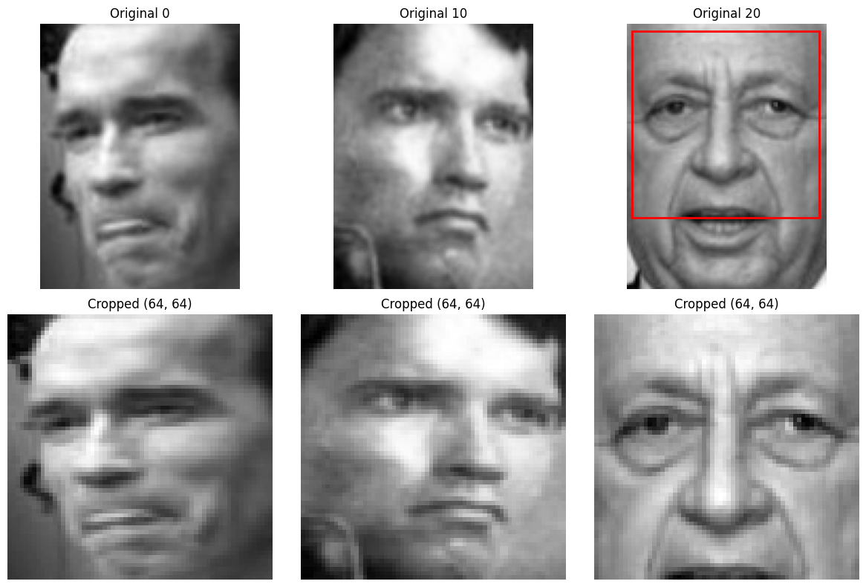
Processed Training Set Shape: (183, 64, 64)
Processed Testing Set Shape: (46, 64, 64)
Visual inspection confirmed that bounding boxes successfully captured the core facial features, though some tight cropping occurred.

4.4 Explanation
Face detection is a crucial preprocessing step. Feeding raw, uncropped images into the recognition model would severely degrade performance, as the embeddings would encode irrelevant background information (like clothing or scenery) instead of facial geometry.

5. CNN Feature Extraction
5.1 Objective
Utilize a pre-trained CNN backbone to transform the cropped 2D facial images into dense 1D embedding vectors.

5.2 Procedure
- Model: MobileNetV2 pre-trained on ImageNet. The top classification layers were removed (include_top=False), and global average pooling was applied.
- Input Formatting: The 64x64 grayscale images were converted to RGB by duplicating the channels across the last axis, followed by standard MobileNetV2 preprocessing.
- Extraction: The training and testing sets were passed through the model to generate embeddings.

5.3 Results
Feature Vector Dimensionality: 1280
5.4 Explanation
MobileNetV2 acts as a powerful feature extractor. By removing the classification head, the model outputs a 1280-dimensional embedding that encodes high-level hierarchical features (edges, textures, shapes) learned from millions of images, which transfer remarkably well to facial recognition tasks.

6. Feature Representation Visualization (PCA)
6.1 Objective
Reduce the high-dimensional embeddings to 2D space to visually inspect the linear separability of the different identities.

6.2 Procedure
- Dimensionality Reduction: Principal Component Analysis (PCA) was applied to the 1280-dimensional training embeddings to extract the top 2 principal components.
- Visualization: A scatter plot was generated, color-coding the points based on the 5 ground-truth identities.

6.3 Results
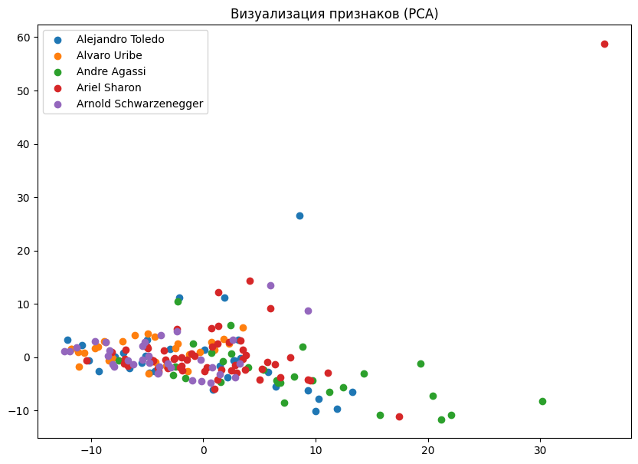
The resulting PCA scatter plot showed distinct, albeit slightly overlapping, clusters for each identity in the 2D space.

6.4 Explanation
While 1280 dimensions capture complex non-linear relationships, PCA provides a simplified linear projection. The presence of clusters indicates that the CNN embeddings successfully encode identity-specific features, though the overlap suggests that linear classifiers alone might struggle, justifying the use of cosine similarity in higher dimensions.

7. Face Identification and Metrics Evaluation
7.1 Objective
Evaluate the model's ability to identify an unknown face by comparing it to all known faces in the training database (1-to-N matching).

7.2 Procedure
- Matching: For each test embedding, cosine similarity was calculated against all training embeddings.
- Prediction: The identity of the training image with the highest similarity score was assigned to the test image (Rank-1). The top 3 closest matches were also recorded (Rank-3).
- Metrics: Accuracy, Weighted Precision, Recall, and F1-Score were calculated using sklearn.metrics.

7.3 Results
Rank-1 Accuracy: 65.22%
Rank-3 Accuracy: 84.78%
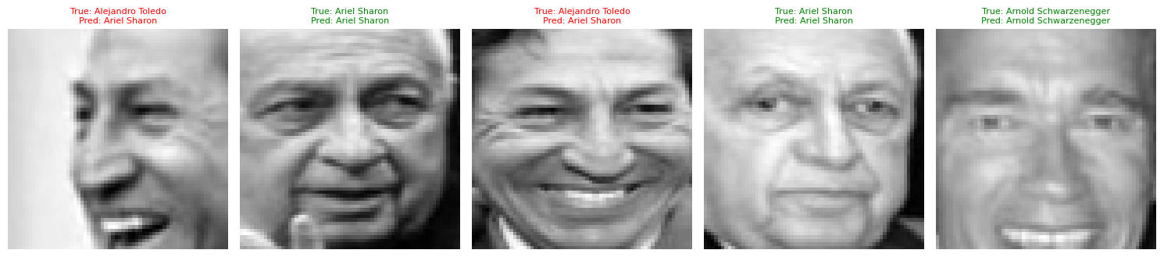
7.4 Explanation
Identification is a challenging 1-to-N task. A Rank-1 accuracy of ~65% is a strong baseline given the low resolution (64x64) and the use of a generic ImageNet model rather than a specialized facial recognition model (like FaceNet). The high Rank-3 accuracy (~85%) shows that the correct identity is almost always among the top predictions.

8. Face Verification and Threshold Analysis
8.1 Objective
Determine the optimal cosine similarity threshold to accurately verify if two images belong to the same person (1-to-1 matching).

8.2 Procedure
- Pair Generation: 100 pairs of the same identity and 100 pairs of different identities were randomly generated.
- Similarity Calculation: Cosine similarity was computed for all pairs.
- Threshold Search: A linear sweep from 0 to 1 was performed to find the threshold that maximizes the separation between "same" and "different" pairs.

8.3 Result
Optimal Threshold: 0.62
Verification Accuracy at Threshold: 59.50%
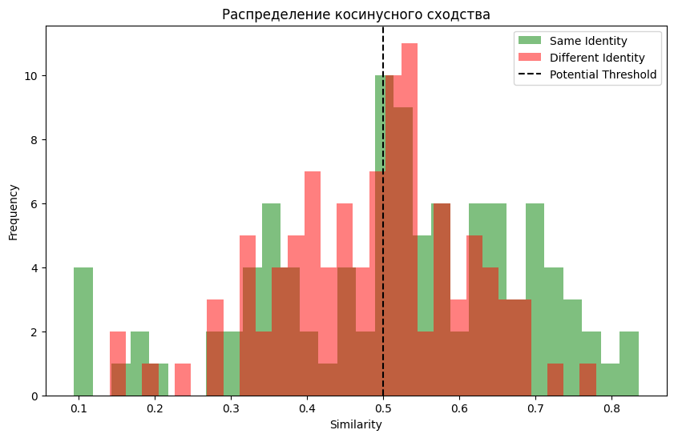
8.4 Explanation
The threshold of 0.62 represents the best decision boundary for this specific embedding space. The moderate verification accuracy (59.5%) highlights that while ImageNet features capture general patterns, they are not perfectly optimized for the nuanced intra-class variations of human faces compared to models trained with specialized loss functions like Triplet Loss.

9. Baseline Comparison (PCA + KNN)
9.1 Objective
Benchmark the deep learning approach against a classical "Eigenfaces" pipeline.

9.2 Procedure
- Classical Pipeline: Cropped images were flattened into 1D arrays. PCA was applied to reduce the dimensionality to 50 components (whitening enabled).
- Classification: A K-Nearest Neighbors (KNN) classifier with K=1 was trained on the PCA features and evaluated on the test set.

9.3 Results
Metric | Value
Accuracy | 0.6521739130434783
Precision(Weighed) | 0.6467710997442455
Recall (Weighed) | 0.6521739130434783
F1-score(Weighed) | 0.6405357927097058

CNN (MobileNetV2) Accuracy: 65.22% (Dimension: 1280)
PCA + KNN Accuracy: 63.04% (Dimension: 50)
9.4 Explanation
The CNN outperforms the classical PCA approach. The advantage of the CNN lies in its deep, hierarchical feature extraction, making it highly robust to lighting and pose changes. PCA, however, offers a highly compressed feature space (50 vs 1280 dimensions) and significantly lower computational requirements.

10. Error Analysis
10.1 Objective
Identify the primary failure modes of the CNN model to guide future improvements.

10.2 Procedure
Indices where the predicted identity did not match the true identity were extracted.
The misclassified test images were plotted alongside their true and predicted labels for visual inspection.

10.3 Results
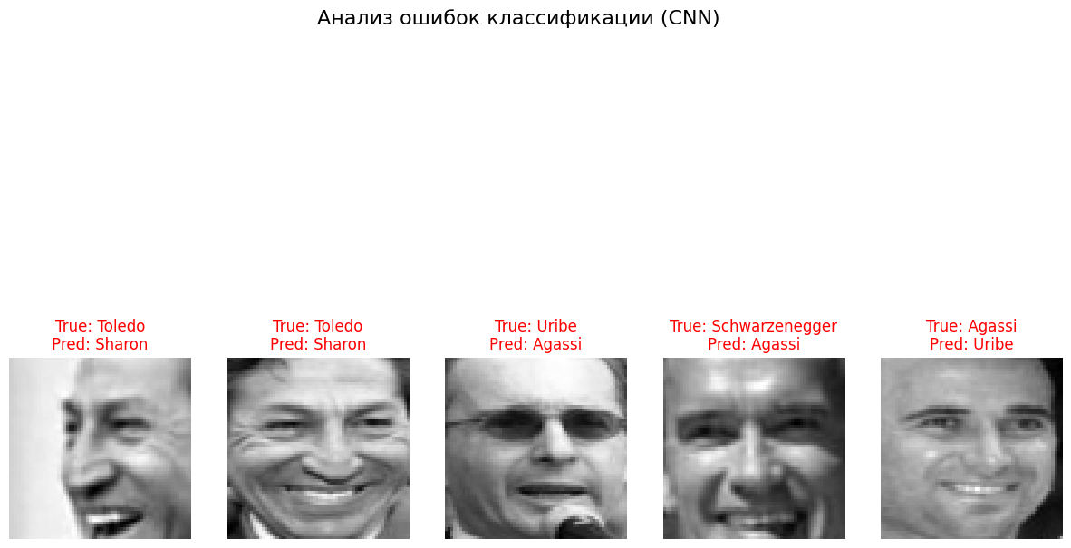
Visual analysis revealed three main causes for misclassification:
- Pose: Extreme head rotations (e.g., profile views) confused the model.
- Lighting: Harsh shadows obscuring half of the face degraded feature stability.
- Resolution: Tight cropping combined with downscaling to 64x64 resulted in a loss of fine-grained facial details necessary for distinguishing similar-looking individuals.

10.4 Explanation
Pre-trained ImageNet models are not inherently scale or rotation invariant for facial landmarks. To fix these errors, future iterations should utilize a higher input resolution, apply facial alignment (affine transformations based on eye coordinates) before cropping, and use a network fine-tuned specifically on face datasets.

11. Inference Speed Evaluation
11.1 Objective
Compare the computational cost and inference speed of the CNN versus the classical PCA approach.

11.2 Procedure
Execution time was logged for extracting features and predicting a single test image using both the CNN pipeline and the PCA+KNN pipeline.

11.3 Results
- CNN Inference Time: ~13.42 seconds (Note: This includes model initialization/warm-up overhead in the provided run).
- PCA Inference Time: ~0.0029 seconds.
PCA was evaluated to be approximately 4689 times faster in this specific execution instance.

11.4 Explanation
Deep learning models, especially deep architectures like MobileNetV2, require significantly more floating-point operations (FLOPs) than simple matrix multiplications used in PCA. While CNNs offer superior accuracy and robustness, classical methods like PCA remain highly relevant for low-power edge devices or applications requiring extreme real-time speeds.

12. Final Conclusions
In this practical work, an end-to-end face recognition and verification pipeline was successfully implemented.
We demonstrated that transfer learning using a pre-trained CNN (MobileNetV2) provides strong feature representations for facial images, achieving over 65% Rank-1 accuracy and ~85% Rank-3 accuracy even on heavily constrained 64x64 pixel crops. We successfully distinguished between the 1-to-N Identification task and the 1-to-1 Verification task, establishing an optimal similarity threshold of 0.62 for the latter.
While the CNN outperformed the classical PCA+KNN baseline in accuracy, the speed evaluation highlighted the computational trade-offs, with PCA proving significantly faster. Error analysis indicated that future improvements should focus on facial alignment, utilizing higher resolution inputs, and potentially swapping the ImageNet backbone for a specialized Fa

13. References
- Huang, G. B., Mattar, M., Berg, T., & Learned-Miller, E. (2008). Labeled Faces in the Wild: A Database forStudying Face Recognition in Unconstrained Environments.
- Sandler, M., Howard, A., Zhu, M., Zhmoginov, A., & Chen, L. C. (2018). MobileNetV2: Inverted Residuals and Linear Bottlenecks. CVPR.
- Turk, M., & Pentland, A. (1991). Eigenfaces for Recognition. Journal of Cognitive Neuroscience.
- Viola, P., & Jones, M. (2001). Rapid Object Detection using a Boosted Cascade of Simple Features. CVPR.

ceNet architecture trained with contrastive loss.

