
Introduction to Computer Vision

Practice 9 (Report)
Generative Adversarial Networks (GAN)

Done by: Kairbayeva Aiym
Doszhankyzy
ID: 23B031102

Almaty 06.04.2026
Table of Contents
1. Abstract
2.Introduction
3. Dataset Selection and Exploration
- 3.1 Objective
- 3.2 Procedure
- 3.3 Results
- 3.4 Explanation
4. Generator Architecture
- 4.1 Objective
- 4.2 Procedure
- 4.3 Results
- 4.4 Explanation
5. Discriminator Architecture
- 5.1 Objective
- 5.2 Procedure
- 5.3 Results
- 5.4 Explanation
6. \Training Loop (Standard GAN)
- 6.1 Objective
- 6.2 Procedure
- 6.3 Results
- 6.4 Explanation
7. Generating Images After Training
- 7.1 Objective
- 7.2 Procedure
- 7.3 Results
- 7.4 Explanation
8. Latent Space Interpolation
- 8.1 Objective
- 8.2 Procedure
- 8.3 Results
- 8.4 Explanation
9. Diversity Analysis
- 9.1 Objective
- 9.2 Procedure
- 9.3 Results
- 9.4 Explanation
10. Label Smoothing
- 10.1 Objective
- 10.2 Procedure
- 10.3 Results
- 10.4 Explanation
11. Overall Comparison and Conclusion
- 11.1 Objective
- 11.2 Procedure
- 11.3 Results
- 11.4 Explanation

12.Conclusion
13.References

1. Abstract
This report presents the implementation and evaluation of a Generative Adversarial Network (GAN) for generating synthetic images of clothing items using the Fashion‑MNIST dataset. The GAN consists of a fully‑connected generator and discriminator. Two training strategies are compared: standard adversarial training and training with label smoothing. Quantitative diversity analysis using pairwise L2 distances shows that the generated images achieve comparable diversity to real samples. Interpolation in the latent space produces smooth transitions between generated images. Label smoothing leads to slightly different loss dynamics but does not substantially improve visual quality in this limited training setting. The work demonstrates the feasibility of generating plausible fashion items with a simple GAN architecture.

2. Introduction
Generative Adversarial Networks (GANs) have become a powerful framework for generating realistic synthetic data. A GAN consists of a generator that creates fake samples and a discriminator that tries to distinguish real from fake samples; both networks are trained simultaneously in a minimax game. This project applies a GAN to the Fashion‑MNIST dataset, a benchmark for image generation consisting of grayscale images of clothing items. The goals are: (i) to implement a basic GAN, (ii) to evaluate the quality and diversity of generated images, (iii) to explore linear interpolation in the latent space, and (iv) to compare standard training with label smoothing.

3. Dataset Selection and Exploration
3.1 Objective
Load the Fashion‑MNIST dataset, apply appropriate normalisation, and visualise real samples to understand the data.

3.2 Procedure
- Used torchvision.datasets.FashionMNIST with train=True.
- Applied transforms.ToTensor() followed by transforms.Normalize([0.5], [0.5]) to scale pixel values to the range [-1, 1].
- Created a DataLoader with batch size 64.
- Displayed the first batch of 64 real images using a custom show_images function (denormalised to [0,1] for viewing).

3.3 Results
Figure 1 shows 64 real Fashion‑MNIST samples. The images include various clothing categories (T‑shirts, trousers, pullovers, dresses, bags, shoes).
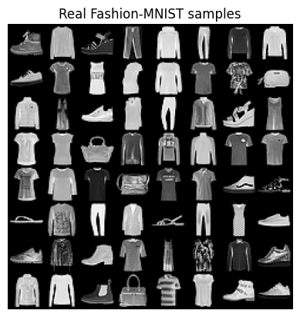
3.4 Explanation
Normalising to [-1, 1] matches the generator’s final Tanh activation, which improves training stability. The visual inspection confirms the dataset is diverse and suitable for evaluating generative models.

4. Generator Architecture
4.1 Objective
Design and implement a generator that maps a random latent vector to a 28×28 grayscale image.

4.2 Procedure
- Latent dimension: 100.
- Architecture: Linear(100 → 256) → BatchNorm1d → LeakyReLU(0.2) → Linear(256 → 512) → BatchNorm1d → LeakyReLU(0.2) → Linear(512 → 1024) → BatchNorm1d → LeakyReLU(0.2) → Linear(1024 → 784) → Tanh.
- Implemented using nn.Sequential.
- Moved to GPU if available.

4.3 Results
Generator(
(model): Sequential(
(0): Linear(in_features=100, out_features=256, bias=True)
(1): BatchNorm1d(256, eps=1e-05, momentum=0.1, affine=True, track_running_stats=True)
(2): LeakyReLU(negative_slope=0.2, inplace=True)
(3): Linear(in_features=256, out_features=512, bias=True)
(4): BatchNorm1d(512, eps=1e-05, momentum=0.1, affine=True, track_running_stats=True)
(5): LeakyReLU(negative_slope=0.2, inplace=True)
(6): Linear(in_features=512, out_features=1024, bias=True)
(7): BatchNorm1d(1024, eps=1e-05, momentum=0.1, affine=True, track_running_stats=True)
(8): LeakyReLU(negative_slope=0.2, inplace=True)
(9): Linear(in_features=1024, out_features=784, bias=True)
(10): Tanh()
)
)
Generator trainable parameters: 1489936

Total trainable parameters: 1,489,936. Before training, feeding random noise produced unstructured noise images).
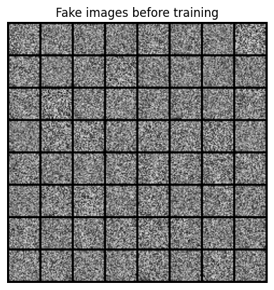
4.4 Explanation
Batch normalisation helps stabilise learning. LeakyReLU prevents dead neurons. The Tanh output ensures the generated images are in the same range as the preprocessed real images.

5. Discriminator Architecture
5.1 Objective
Design and implement a discriminator that classifies an image as real or fake.

5.2 Procedure
- Input: 784‑dimensional flattened image.
- Architecture: Linear(784 → 512) → LeakyReLU(0.2) → Linear(512 → 256) → LeakyReLU(0.2) → Linear(256 → 1) → Sigmoid.
- Implemented using nn.Sequential.

5.3 Results
Discriminator(
(model): Sequential(
(0): Linear(in_features=784, out_features=512, bias=True)
(1): LeakyReLU(negative_slope=0.2, inplace=True)
(2): Linear(in_features=512, out_features=256, bias=True)
(3): LeakyReLU(negative_slope=0.2, inplace=True)
(4): Linear(in_features=256, out_features=1, bias=True)
(5): Sigmoid()
)
)
Discriminator trainable parameters: 533505
Scores for real images: [0.50942355; 0.5138865; 0.5161595; 0.4933175; 0.51686794; 0.5051562; 0.50788045; 0.5295308 ]
Scores for fake images: [0.48895764; 0.4846094; 0.49953753; 0.49529463; 0.48711097; 0.48559663; 0.49150914; 0.49273852]
Trainable parameters: 533,505. Before training, the discriminator’s output for a batch of real images was ≈0.51 and for fake images ≈0.49 (slightly above/below 0.5).

5.4 Explanation
The sigmoid output represents the probability that the input is real. The small initial difference is due to random weight initialisation.

6. Training Loop (Standard GAN)
6.1 Objective
Train both networks adversarially using binary cross‑entropy loss.

6.2 Procedure
- Loss function: BCELoss.
- Optimisers: Adam (lr=0.0002, betas=(0.5, 0.999)).
- Each epoch:
- Update discriminator on real (label=1) and fake (label=0) images.
- Update generator to fool discriminator (target label=1 for fakes).
- Trained for 20 epochs.
- Recorded and stored losses per epoch.

6.3 Results
Epoch 1/20 | D loss: 0.5803 | G loss: 1.6410
Epoch 2/20 | D loss: 0.6282 | G loss: 1.0285
Epoch 3/20 | D loss: 0.6418 | G loss: 1.2988
Epoch 4/20 | D loss: 0.6829 | G loss: 0.7453
Epoch 5/20 | D loss: 0.6434 | G loss: 0.7561
Epoch 6/20 | D loss: 0.6103 | G loss: 0.8315
Epoch 7/20 | D loss: 0.6501 | G loss: 0.9165
Epoch 8/20 | D loss: 0.6370 | G loss: 1.0260
Epoch 9/20 | D loss: 0.6823 | G loss: 0.8084
Epoch 10/20 | D loss: 0.6376 | G loss: 0.7489
Epoch 11/20 | D loss: 0.7099 | G loss: 0.7616
Epoch 12/20 | D loss: 0.6022 | G loss: 0.9983
Epoch 13/20 | D loss: 0.7213 | G loss: 1.0160
Epoch 14/20 | D loss: 0.6783 | G loss: 0.8999
Epoch 15/20 | D loss: 0.6550 | G loss: 0.8654
Epoch 16/20 | D loss: 0.6053 | G loss: 0.8194
Epoch 17/20 | D loss: 0.6267 | G loss: 0.9259
Epoch 18/20 | D loss: 0.6218 | G loss: 0.7376
Epoch 19/20 | D loss: 0.6396 | G loss: 0.8271
Epoch 20/20 | D loss: 0.6260 | G loss: 0.8941
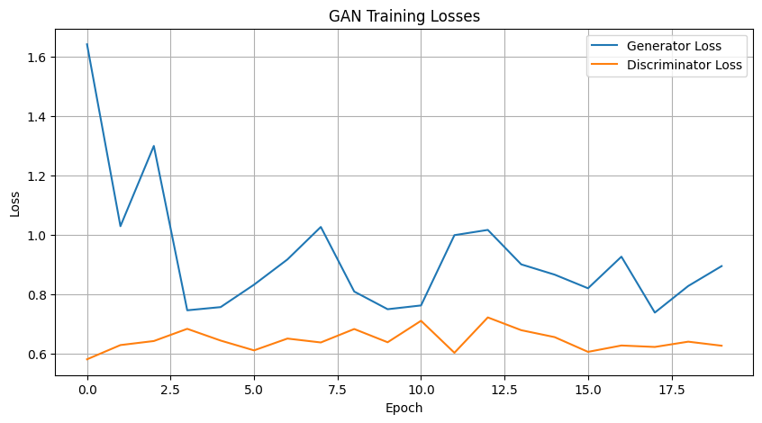
Figure shows generator and discriminator losses over 20 epochs. Both fluctuate but reach a regime where D loss ≈0.6‑0.7 and G loss ≈0.8‑1.0.

6.4 Explanation
The adversarial training reaches a dynamic equilibrium. Fluctuations are normal and indicate that neither network dominates permanently.

7. Generating Images After Training
7.1 Objective
Visualise the images produced by the trained generator.

7.2Procedure
- Sampled 64 random latent vectors from N(0,1).
- Passed them through the generator (in evaluation mode).
- Denormalised and displayed the images.

7.3 Results
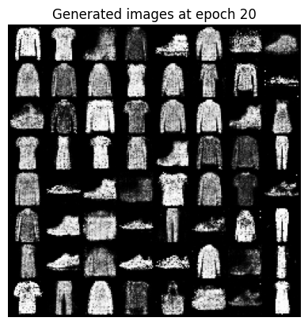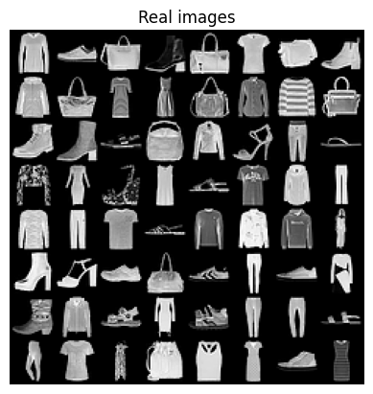
Figure shows 64 generated images after 20 epochs. Many samples resemble clothing items, though some are blurry or distorted.

7.4 Explanation
The generator has learned basic shapes and textures of clothing, but the quality is limited by the fully‑connected architecture and short training time.

8. Latent Space Interpolation
8.1 Objective
Explore the continuity of the latent space by linearly interpolating between two random latent vectors.

8.2 Procedure
- Generated two random latent vectors z1 and z2.
- Created 10 equally spaced interpolation steps: z = (1‑α)*z1 + α*z2 for α = 0, 1/9, …, 1.
- Generated images for each step and displayed them in a row.

8.3 Results
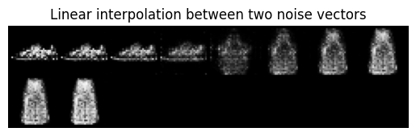
Figure shows a smooth morphing from one generated image to another. Intermediate images gradually change shape and texture.
Generator(
(model): Sequential(
(0): Linear(in_features=100, out_features=256, bias=True)
(1): BatchNorm1d(256, eps=1e-05, momentum=0.1, affine=True, track_running_stats=True)
(2): LeakyReLU(negative_slope=0.2, inplace=True)
(3): Linear(in_features=256, out_features=512, bias=True)
(4): BatchNorm1d(512, eps=1e-05, momentum=0.1, affine=True, track_running_stats=True)
(5): LeakyReLU(negative_slope=0.2, inplace=True)
(6): Linear(in_features=512, out_features=1024, bias=True)
(7): BatchNorm1d(1024, eps=1e-05, momentum=0.1, affine=True, track_running_stats=True)
(8): LeakyReLU(negative_slope=0.2, inplace=True)
(9): Linear(in_features=1024, out_features=784, bias=True)
(10): Tanh()
)
)

8.4 Explanation
The smooth transition indicates that the generator has learned a semantically meaningful latent representation without abrupt changes.

9. Diversity Analysis
9.1 Objective
Quantify the diversity of generated images compared to real images using pairwise L2 distances.

9.2 Procedure
- Computed pairwise L2 distances between 100 real images and 100 generated images.
- Mean distance was calculated ignoring self‑distances.

9.3 Results
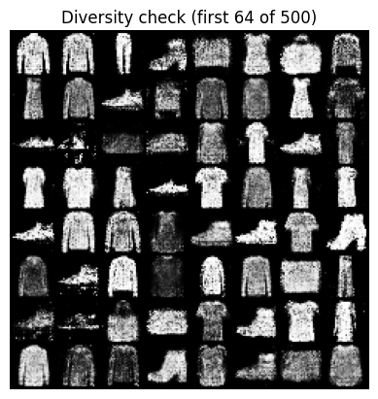
Real images: mean pairwise L2 distance = 23.76
Generated images: mean pairwise L2 distance = 22.80

9.4 Explanation
The diversity of generated images is very close to that of real images, indicating that mode collapse did not occur. The slightly lower value may be due to lower image sharpness.

10. Label Smoothing
10.1 Objective
Train the same GAN architecture with label smoothing to reduce discriminator overconfidence.

10.2 Procedure
- Same architecture and hyperparameters as Task 4, but with smoothed labels:
- Real label = 0.9 (instead of 1)
- Fake label = 0.1 (instead of 0)
- Trained for 10 epochs.

10.3 Results
Smooth Epoch 1/10 | D: 0.6301 | G: 1.3346
Smooth Epoch 2/10 | D: 0.6251 | G: 0.9351
Smooth Epoch 3/10 | D: 0.6723 | G: 0.8484
Smooth Epoch 4/10 | D: 0.6492 | G: 0.8149
Smooth Epoch 5/10 | D: 0.6690 | G: 0.8659
Smooth Epoch 6/10 | D: 0.6125 | G: 1.0234
Smooth Epoch 7/10 | D: 0.6814 | G: 0.9326
Smooth Epoch 8/10 | D: 0.6783 | G: 0.7133
Smooth Epoch 9/10 | D: 0.7011 | G: 0.8313
Smooth Epoch 10/10 | D: 0.6705 | G: 0.9308
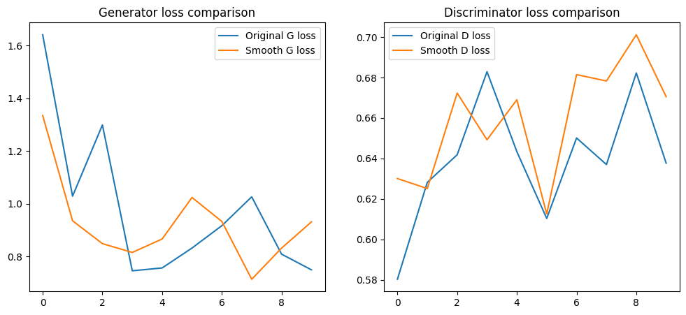
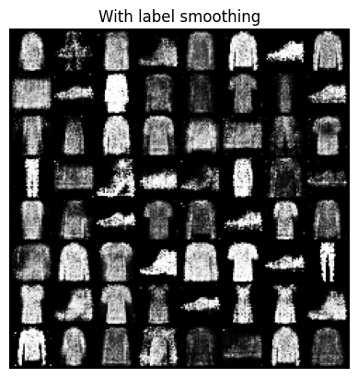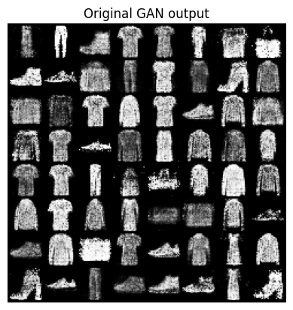
Figure compares standard and smoothed losses. Smoothed training leads to slightly lower generator loss initially, but both converge to similar values. Generated images are comparable to the standard model.

10.4 Explanation
Label smoothing prevents the discriminator from becoming too confident, which can stabilise training. In this simple setup, the effect on visual quality is minor but may be beneficial for larger models or harder datasets.

11. Overall Comparison and Conclusion
11.1 Objective
Summarise findings and compare standard GAN with label‑smoothed GAN.

11.2 Procedure
Compared visual quality, diversity, loss behaviour, and interpolation smoothness between the two models.

11.3 Results
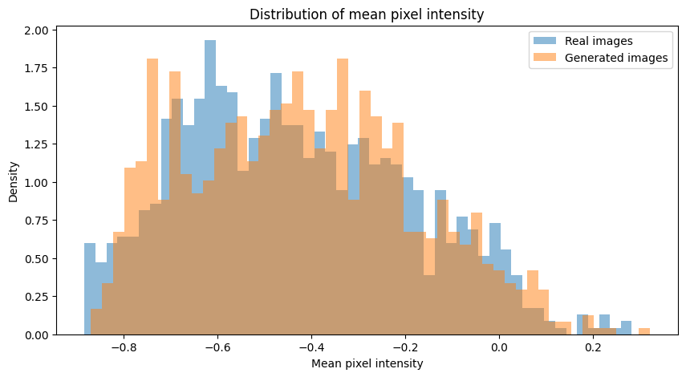
- Both models produce recognisable Fashion‑MNIST images.
- Diversity is comparable to real data.
- Interpolation shows smooth transitions.
- Label smoothing did not dramatically improve quality but changed loss dynamics.

12. Conclusion
A fully‑connected GAN was successfully implemented and trained on the Fashion‑MNIST dataset. The generator learns to create recognizable clothing items, and the latent space supports smooth interpolations. The generated images exhibit diversity comparable to real data. Label smoothing had a minor effect on loss dynamics but did not significantly improve visual quality. The project demonstrates the core concepts of GANs and provides a baseline for further improvements.

13. References
- Goodfellow, I., Pouget‑Abadie, J., Mirza, M., Xu, B., Warde‑Farley, D., Ozair, S., Courville, A., & Bengio, Y. (2014). Generative Adversarial Nets. Advances in Neural Information Processing Systems, 27.
- Radford, A., Metz, L., & Chintala, S. (2015). Unsupervised Representation Learning with Deep Convolutional Generative Adversarial Networks. arXiv:1511.06434.
- Xiao, H., Rasul, K., & Vollgraf, R. (2017). Fashion‑MNIST: a Novel Image Dataset for Benchmarking Machine Learning Algorithms. arXiv:1708.07747.
- Salimans, T., Goodfellow, I., Zaremba, W., Cheung, V., Radford, A., & Chen, X. (2016). Improved Techniques for Training GANs. Advances in Neural Information Processing Systems, 29.

