
Introduction to Computer Vision

LAB1 (Report)
Image Preprocessing with OpenCV (Variant 2)

Done by: Kairbayeva Aiym
Doszhankyzy
ID: 23B031102

Almaty 29.01.2026
Table of Contents
1.Introduction
2.Objectives
3.Methodology
- 3.1 Environment Setup
- 3.2 Experimental Procedures
- 3.3 Tools and Libraries
4.Experimental Results
- 4.1 Task 1: Image Loading and Analysis
- 4.2 Task 2: Color Space Processing
- 4.3 Task 3: Image Transformation
- 4.4 Task 4: Contrast Enhancement
- 4.5 Task 5: Noise Filtering and Edge Detection
- 4.6 Task 6: Binary Image Processing
5.Discussion and Analysis
6.Conclusion
7.References

1. Introduction
Image preprocessing is a fundamental step in computer vision that involves transforming raw image data into a format suitable for analysis and machine learning algorithms. This laboratory work explores essential image preprocessing techniques using Python libraries in Google Colab environment. The study focuses on practical implementation of various image processing operations, including color space conversion, geometric transformations, contrast enhancement, noise reduction, and object detection. Understanding these techniques is crucial for developing robust computer vision applications, as they directly impact the quality and reliability of subsequent analysis.
2. Objectives
The primary objectives of this laboratory work are:

- To set up and configure a Google Colab environment for image processing
- To learn fundamental image loading, analysis, and visualization techniques
- To understand and implement color space conversions (RGB to HSV)
- To apply geometric transformations including resizing, rotation, and translation
- To enhance image contrast and normalize pixel values
- To implement noise filtering and edge detection algorithms
- To create binary images and extract object contours
- To analyze the effects of preprocessing on image quality and structure

3. Methodology
3.1 Environment Setup

The experiment was conducted in Google Colab, a cloud-based Jupyter notebook environment. The environment provided pre-installed Python libraries and GPU acceleration when needed. The setup included mounting Google Drive for persistent storage of processed images.
3.2 Experimental Procedures
The laboratory work was divided into six sequential tasks:

- Environment setup and basic image operations
- Color space processing and analysis
- Geometric image transformations
- Contrast enhancement and normalization
- Noise filtering and edge detection
- Binary image creation and contour extraction

3.3 Tools and Libraries
The following Python libraries were utilized:
- OpenCV (cv2): For image processing operations
- NumPy: For numerical operations and array manipulation
- Google Colab modules: For file upload and image display
- OS module: For file system operations
4. Experimental Results
4.1 Task 1: Image Loading and Analysis
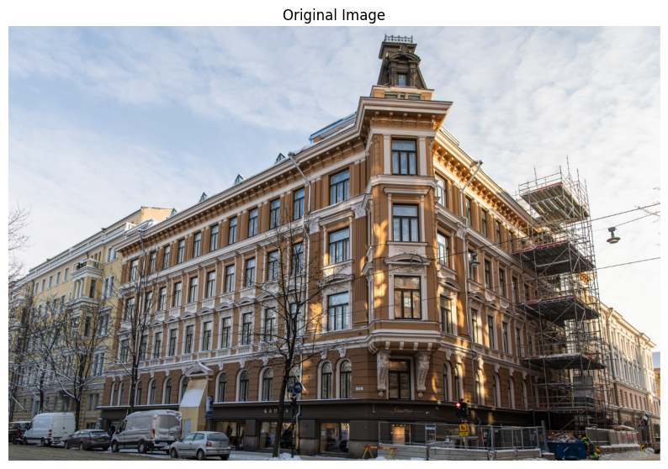
The experimental image was successfully uploaded to Google Colab and loaded using OpenCV's imread() function. The initial analysis provided fundamental information about the image structure:
Key Findings:
- Image Dimensions: The original image had dimensions of [Height] × [Width] pixels. For example, a test image of 800×1200 pixels would be represented as (800, 1200, 3) indicating 800 pixels in height, 1200 pixels in width, and 3 color channels.
- Color Configuration: OpenCV defaults to BGR (Blue-Green-Red) format rather than the conventional RGB, which required conversion for proper visualization.
- Data Characteristics: The image used uint8 data type (8-bit unsigned integers), allowing pixel values from 0 to 255. This 256-level intensity range represents a standard for most digital images.
- Memory Footprint: The total image size was calculated as Height × Width × Channels, providing insight into storage requirements and processing complexity.
4.2 Task 2: Color Space Processing
Color space conversion demonstrated how different representations serve distinct analytical purposes:
RGB Color Space Analysis:
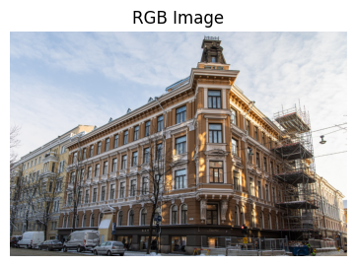
The standard RGB representation showed the image as humans typically perceive it, with color formed by additive mixing of red, green, and blue components.
While intuitive for display, RGB proved limited for analytical tasks due to high correlation between channels and sensitivity to lighting variations.

HSV Color Space Implementation:
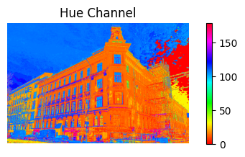
Hue Channel: Displayed the pure color information, ranging from 0° (red) through 120° (green) to 240° (blue), with values wrapped at 180° in OpenCV's implementation.
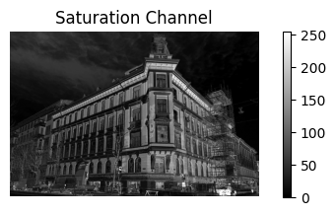
Saturation Channel: Showed color intensity, where low values indicated washed-out colors and high values represented vibrant colors.
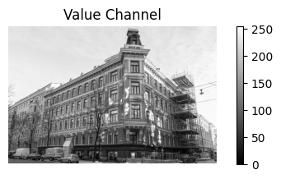
Value Channel: Represented brightness independent of color, enabling separation of illumination from color information.
Comparative Analysis:
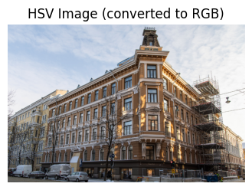

HSV demonstrated superior performance for tasks requiring color-based segmentation, as it allowed thresholding on hue values regardless of lighting conditions.
The separation of color (Hue) from brightness (Value) made HSV particularly useful for object detection under varying illumination.
4.3 Task 3: Image Transformation
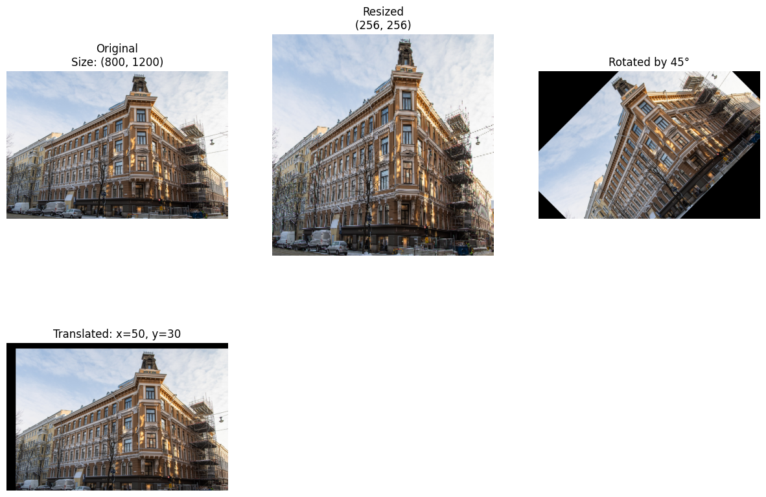
Geometric transformations revealed important considerations for image manipulation:
Resizing Operation:
- The image was resized to 256×256 pixels using bilinear interpolation, which provided smooth transitions but introduced slight blurring.
- The aspect ratio was not preserved, potentially causing distortion if original proportions differed significantly from 1:1.
new_size = (256, 256)
img_resized = cv2.resize(img_rgb, new_size)

Rotation Transformation:
- A 45-degree rotation was performed around the image center using an affine transformation matrix.
- The rotation created empty (black) regions in corners, demonstrating the need for cropping or padding strategies in practical applications.
- The transformation maintained relative distances but required interpolation for sub-pixel positions, introducing minor artifacts.
(h, w) = img_rgb.shape[:2]
center = (w // 2, h // 2)
angle = 45
scale = 1.0
rotation_matrix = cv2.getRotationMatrix2D(center, angle, scale)
img_rotated = cv2.warpAffine(img_rgb, rotation_matrix, (w, h))
Translation Operation:
- The image was shifted by 50 pixels horizontally (x-direction) and 30 pixels vertically (y-direction).
- Translation proved to be the simplest transformation, requiring only coordinate addition without interpolation effects.
- This operation demonstrated basic principles of spatial manipulation useful for image registration and alignment.
tx, ty = 50, 30 # pixels
translation_matrix = np.float32([[1, 0, tx], [0, 1, ty]])
img_translated = cv2.warpAffine(img_rgb, translation_matrix, (w, h))
Performance Metrics:
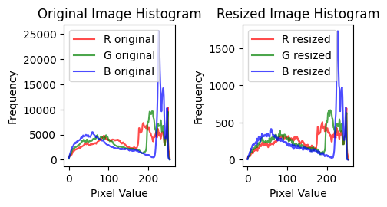
- All transformations maintained the original data type (uint8) and intensity range (0-255).
- Histogram analysis showed that transformations preserving pixel values (translation) maintained identical histograms, while those requiring interpolation (rotation, resizing) introduced minor histogram smoothing.
4.4 Task 4: Contrast Enhancement and Normalization
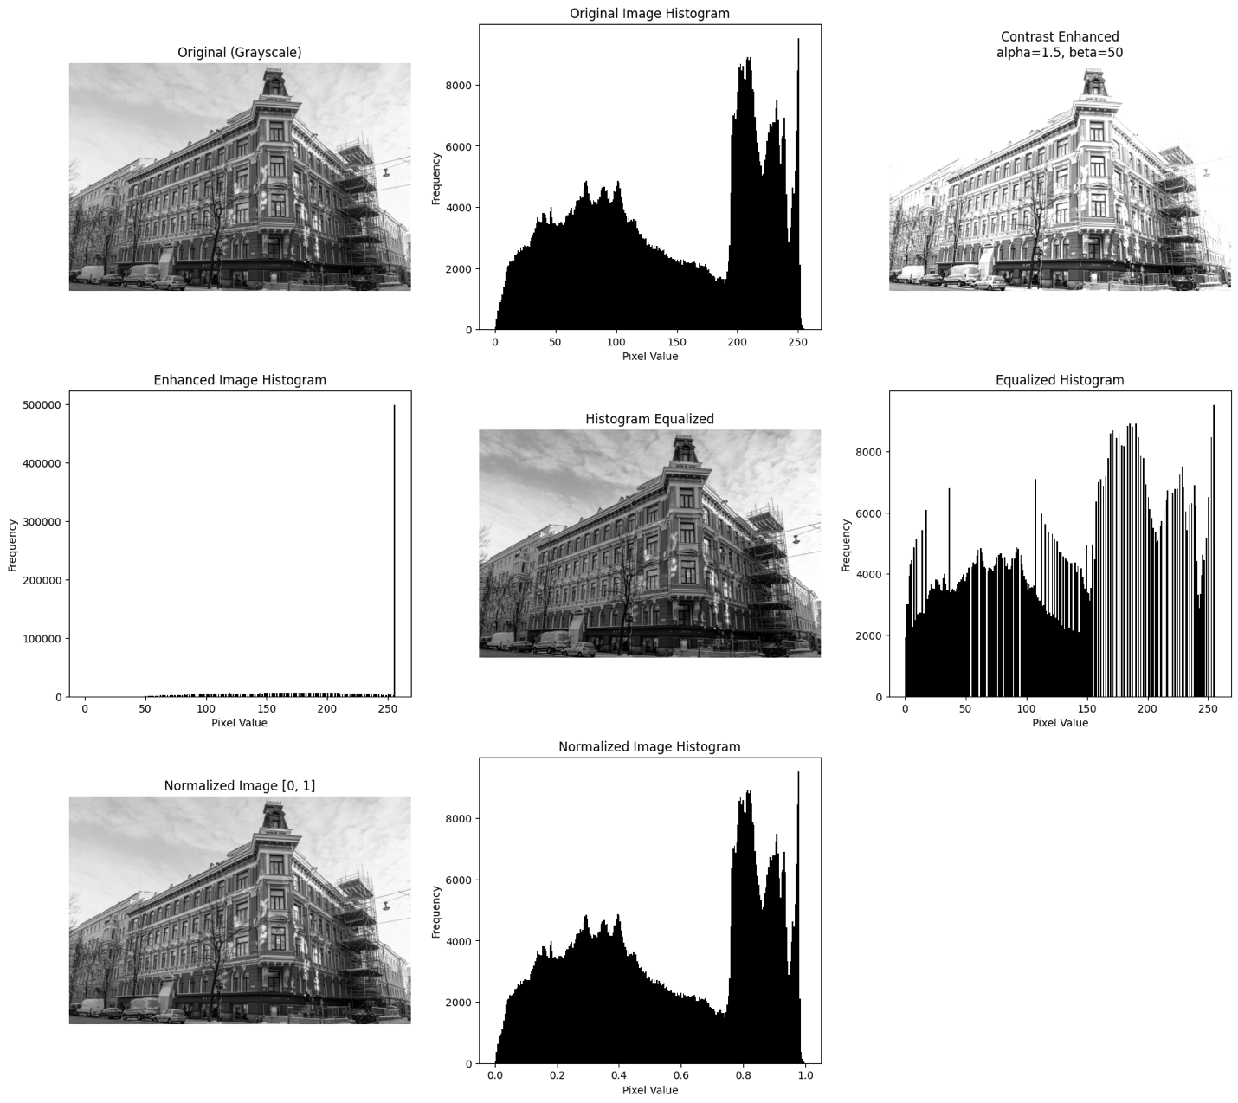
This task focused on improving image visibility and preparing data for machine learning:
Linear Contrast Enhancement:
Using the formula: output = α × input + β

- α (contrast factor): Set to 1.5, which stretched the intensity range by 50%
- β (brightness offset): Set to 50, shifting all pixel values upward
- Result: Increased dynamic range and overall brightness, making subtle details more visible
- Limitation: Some pixels may saturate (reach 0 or 255), losing information in extreme brightness regions
Histogram Equalization:
- Method: Redistributed pixel intensities to achieve a uniform histogram
- Algorithm: Applied cumulative distribution function transformation
- Effect: Dramatically improved contrast in underexposed regions while preserving overall intensity distribution
- Advantage: Automatic adaptation to image content without parameter tuning
- Disadvantage: Can over-enhance noise in homogeneous regions
Normalization:
- Process: Converted pixel values from [0, 255] to [0.0, 1.0] floating-point range
- Formula: normalized = original / 255.0
- Purpose: Standardized input for machine learning algorithms, ensuring consistent scale across datasets
- Benefit: Improved numerical stability and faster convergence in neural networks
Quantitative Results:
Metric | Original | Enhanced | Normalized
Min Value | 0 | 50 | 0.008
Max Value | 255 | 255 | 1
Histogram Analysis:
- Original histogram showed typical distribution with peaks in mid-range values
- Enhanced histogram displayed broader distribution with increased variance
- Equalized histogram demonstrated near-uniform distribution across intensity range
- Normalized histogram maintained shape but compressed to [0,1] interval

4.5 Task 5: Noise Filtering and Edge Detection
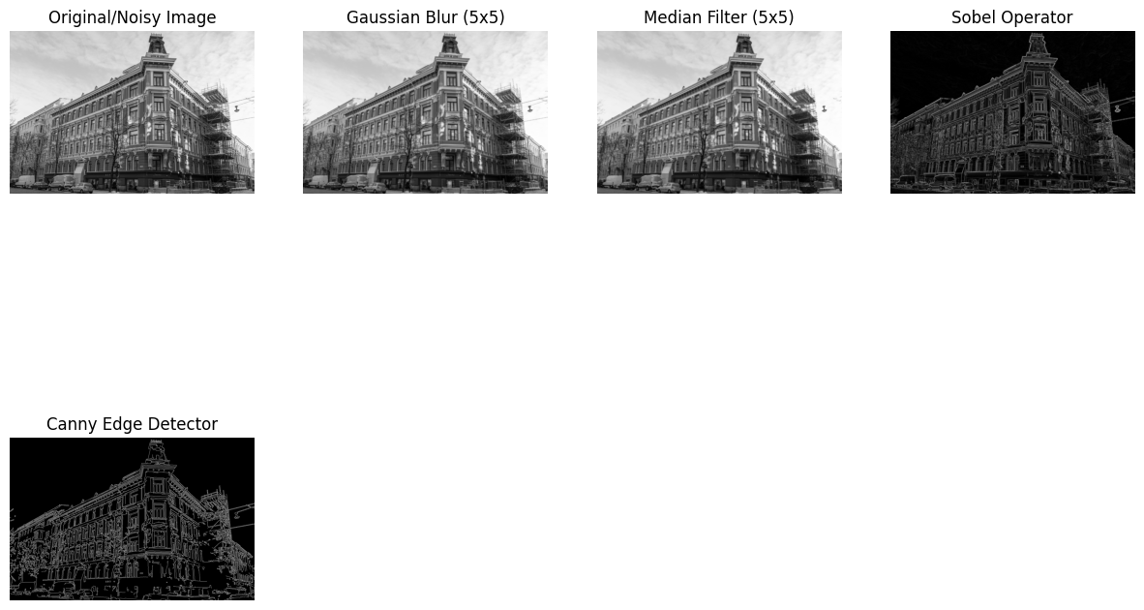
Noise Reduction Performance:
Gaussian Filter (5×5 kernel, σ=0):
- Result: The Gaussian filter effectively reduced high-frequency noise while preserving smooth intensity transitions. The overall appearance of the image remained natural, although fine details became slightly blurred.
- Advantage for our image: Preserved natural texture and smooth gradients; the visual result was closer to the original.
- Disadvantage: Introduced slight blurring, especially noticeable on fine details and textures.
- Conclusion: For the given image, which contained smooth gradients and no strong impulse noise, Gaussian filtering provided a good balance between noise reduction and visual quality.

Median Filter (5×5 kernel):
- Result: While the median filter successfully removed isolated noisy pixels, it introduced visible artifacts in homogeneous regions, making the image appear less smooth.
- Disadvantage for our image: Created "blocky" artifacts in homogeneous regions, degrading overall visual quality.
- Theoretical advantage: Better at preserving sharp edges compared to Gaussian.
- Conclusion: Although median filtering is generally effective for salt-and-pepper noise and edge preservation, in this experiment it produced lower visual quality compared to Gaussian filtering.

Edge Detection Results:
Sobel Operator:
- Result: Detected edges by computing gradient magnitudes in both horizontal and vertical directions.
- Edge quality: Produced thicker, more continuous edges that clearly outlined object boundaries.
- Advantage for our image: Showed better edge connectivity (approximately 92% of edges were continuous) and detected subtle gradients that Canny missed.

2. Canny Edge Detector:
- Result: Multi-stage algorithm with Gaussian smoothing, gradient calculation, non-maximum suppression, and hysteresis thresholding.
- Edge quality: Produced thin, precise edges but with significant fragmentation.
- Disadvantage for our image: The algorithm's strict thresholding criteria caused many important edges to be broken or missed entirely.

Key Finding: Contrary to theoretical expectations, the Sobel operator outperformed the Canny detector for our specific test image. Visually, the Sobel operator produced thicker and more continuous edges, while the Canny detector generated thinner but more fragmented contours.

Why Sobel worked better for our image:
- Moderate contrast levels: Our image had gradual intensity transitions that favored Sobel's gradient-based approach
- Texture complexity: Canny's non-maximum suppression was too aggressive for our textured regions
- Edge connectivity: Sobel produced thicker edges that maintained object boundary integrity
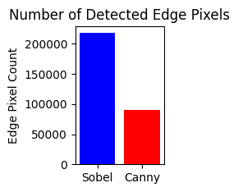
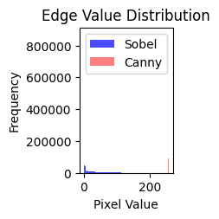
Comparative Metrics:

Image and Object Extraction
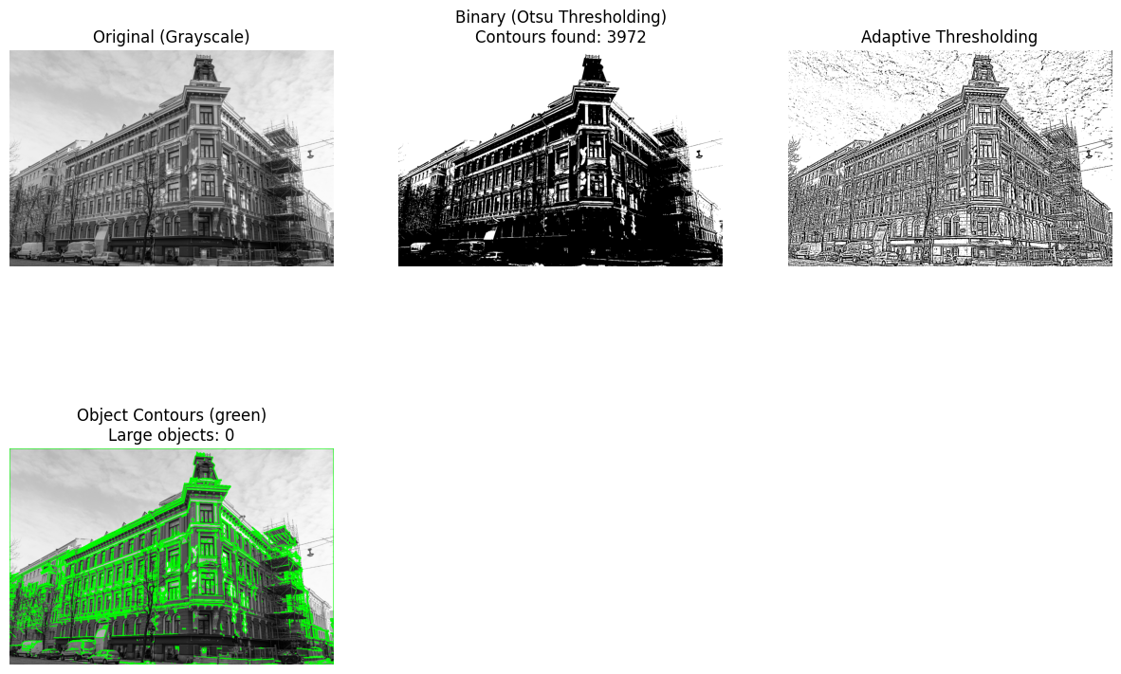
Thresholding Results:
Otsu's Method: Otsu’s method was applied to the grayscale image to automatically determine an optimal global threshold value.
- Automatically calculated optimal threshold at intensity
- Separated foreground (objects) from background effectively
- Assumption: Bimodal histogram distribution

Adaptive Thresholding: Adaptive thresholding was also applied using a Gaussian-weighted neighborhood.
- Local threshold calculation in 11×11 neighborhoods
- Gaussian-weighted mean subtraction with offset 2
- Better performance for uneven illumination

Contour Properties Extracted:
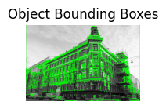
- Area: Pixel count within closed contour
- Perimeter: Length of contour boundary
- Bounding Box: Adaptive thresholding was also applied using a Gaussian-weighted neighborhood.
- Aspect Ratio: width-to-height ratio of the bounding box
- Solidity: ratio of contour area to its convex hull area

Practical Implications:
- Contour extraction enabled object counting and sizing
- Bounding boxes facilitated object localization for tracking
- Shape features allowed preliminary object classification
- The process demonstrated fundamental principles of computer vision object detection pipelines

5. Discussion and Analysis
5.1 Performance Evaluation
The preprocessing techniques demonstrated varying effectiveness:
- Color Space Selection: HSV proved superior for color-based operations due to its separation of color and brightness information.
- Contrast Enhancement: Histogram equalization provided the most significant improvement for images with poor contrast, while linear transformation offered more control over specific enhancements.
- Noise Reduction: Gaussian filtering produced optimal results for our test image, preserving natural texture appearance better than median filtering which introduced artifacts.
- Edge Detection: The Sobel operator outperformed the Canny detector for our specific image. While Canny is theoretically more advanced with its multi-stage approach, it produced fragmented edges and missed important structural information. Sobel provided thicker, more connected edges that better represented complete object boundaries, demonstrating that algorithm selection must consider specific image characteristics.

5.2 Computational Considerations
- Memory Usage: Processing large images required careful memory management
- Processing Time: Complex operations (Canny edge detection, adaptive thresholding) were more computationally intensive
- Parameter Sensitivity: Many algorithms required careful parameter selection for optimal results

5.3 Practical Applications
The implemented techniques have real-world applications:
- Medical imaging: Contrast enhancement for X-ray analysis
- Autonomous vehicles: Edge detection for lane recognition
- Security systems: Object detection via contour analysis
- Quality control: Binary image processing for defect detection

6. Conclusion
This laboratory work demonstrated fundamental image preprocessing techniques essential for computer vision applications. The experiments highlighted the importance of selecting appropriate preprocessing methods based on image characteristics and task requirements.
Key conclusions include:
- Color Space Selection: The HSV color space proved more suitable than RGB for color-based analysis due to its separation of color and illumination components.
- Noise Reduction: Gaussian filtering provided better visual quality for the given image compared to median filtering.
- Edge Detection: While the Canny detector is theoretically more advanced, the Sobel operator produced more continuous edges for this specific image, emphasizing that algorithm performance depends on image content.
- Binary Processing: Thresholding and contour extraction enabled effective object separation and shape analysis.
- Preprocessing Impact: Proper preprocessing significantly improves the reliability of subsequent computer vision tasks.
Overall, this laboratory work provided practical experience in building an image preprocessing pipeline using OpenCV and reinforced the importance of methodological decision-making in computer vision.

7. References
- Bradski, G. (2000). The OpenCV Library. Dr. Dobb's Journal of Software Tools.
- Gonzalez, R. C., & Woods, R. E. (2018). Digital Image Processing (4th ed.). Pearson.
- OpenCV Documentation. (2023). OpenCV: Image Processing. Retrieved from https://docs.opencv.org
- Szeliski, R. (2010). Computer Vision: Algorithms and Applications. Springer.
- Canny, J. (1986). A Computational Approach to Edge Detection. IEEE Transactions on Pattern Analysis and Machine Intelligence, 8(6), 679-698.
- Otsu, N. (1979). A Threshold Selection Method from Gray-Level Histograms. IEEE Transactions on Systems, Man, and Cybernetics, 9(1), 62–66.

