
Introduction to Computer Vision

LAB 2 (Report)
Geometrical Transformations, Convolution, and Maxpooling (Variant 2)

Done by: Kairbayeva Aiym
Doszhankyzy
ID: 23B031102

Almaty 05.02.2026
Table of Contents
1. Abstract
2. Introduction
3. Task 1: Geometric Transformations
- 3.1 Objective
- 3.2 Procedure
- 3.3 Results
- 3.4 Explanation
4. Task 2: Pixel Value Check
- 4.1 Objective
- 4.2 Procedure
- 4.3 Results
- 4.4 Explanation
5. Task 3: Transformation Matrices and Point Verification
- 5.1 Objective
- 5.2 Procedure
- 5.3 Results
- 5.4 Explanation
6. Task 4: Convolution - Blurring
- 6.1 Objective
- 6.2 Procedure
- 6.3 Results
- 6.4 Explanation
7. Task 5: Convolution - Sharpening
- 7.1 Objective
- 7.2 Procedure
- 7.3 Results
- 7.4 Comparison: Blur vs Sharpen Effects
8. Task 6: Manual Convolution Implementation
- 8.1 Objective
- 8.2 Procedure
- 8.3 Results
- 8.4 Explanation
9. Task 7: Border Handling Comparison
- 9.1 Objective
- 9.2 Procedure
- 9.3 Results
- 9.4 Explanation
10. Task 8: Maxpooling Implementation
- 10.1 Objective
- 10.2 Procedure
- 10.3 Results
- 10.4 Explanation
11. Task 9: Manual Convolution Calculation
- 11.1 Objective
- 11.2 Procedure
- 11.3 Calculation
- 11.4 Explanation
12. Task 10: Manual Maxpooling Calculation
- 12.1 Objective
- 12.2 Procedure
- 12.3 Calculation
- 12.4 Explanation
13. Conclusion
14. References

Abstract
This laboratory work explores fundamental image processing techniques including geometric transformations (translation, rotation), convolutional operations (blurring, sharpening), and maxpooling. The practical implementation in Python using OpenCV and NumPy demonstrates how these operations affect image data both visually and numerically. Each task includes theoretical explanation, implementation details, and analysis of results.
1. Introduction
Computer vision relies heavily on image transformations and filtering operations. This lab covers essential preprocessing techniques that form the foundation of many computer vision algorithms, particularly Convolutional Neural Networks (CNNs). The objectives include:
- Understanding and implementing geometric transformations (affine transformations)
- Applying convolution operations with different kernels for blurring and sharpening
- Comparing border handling strategies in convolution
- Implementing downsampling through maxpooling
- Verifying operations through manual calculations
Original Image:
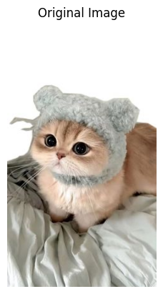
Original image shape: (419, 236, 3)
2. Task 1: Geometric Transformations
2.1 Objective
Resize an image to 256×256, apply translation with dx=45, dy=10, then rotate by -25° around the image center.

2.2 Procedure
- Load the original image using cv2.imread() and convert to RGB
- Resize to 256×256 using cv2.resize()
- Apply translation using cv2.warpAffine() with transformation matrix:
[[1, 0, 45],
[0, 1, 10]]
- Apply rotation using cv2.getRotationMatrix2D() with center (128,128), angle -25°, scale 1.0
- Display original and transformed images side-by-side

2.3 Results
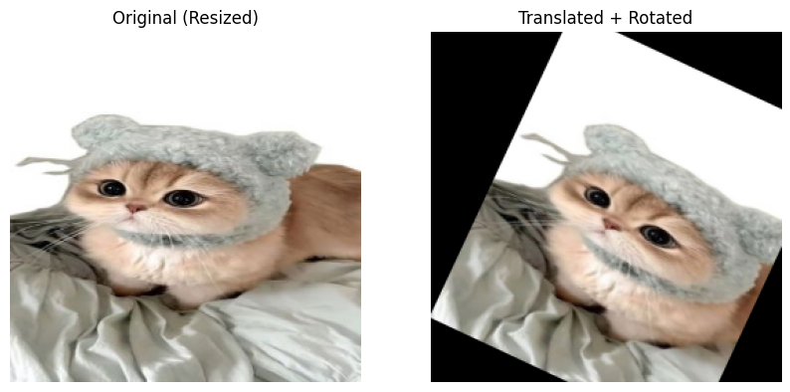
The transformation successfully resized, shifted, and rotated the image. The final image shows both transformations applied sequentially, with the image center serving as the rotation pivot point.
2.4 Explanation
Affine transformations preserve parallel lines but change position and orientation. The order of operations matters significantly: translation then rotation produces different results than rotation then translation. Using cv2.warpAffine() ensures efficient application of transformation matrices.

3. Task 2: Pixel Value Check
3.1 Objective
Compare RGB values at coordinate (80, 150) before and after transformation to understand coordinate mapping.

3.2 Procedure
- Extract pixel value from original (resized) image at coordinates (80, 150)
- Extract pixel value from transformed image at same coordinates
- Print both RGB values for comparison

3.3 Results
Original pixel at (80, 150): [224 211 197]
Transformed pixel at (80, 150): [91 81 72]
3.4 Explanation
Pixel values differ because geometric transformations create new coordinate mappings. The point (80, 150) in the transformed image corresponds to a different location in the original image due to the combined translation and rotation. This demonstrates that image transformations create new pixel arrangements through interpolation rather than modifying existing values in place.

4. Task 3: Transformation Matrices and Point Verification
4.1 Objective
Display transformation matrices, verify point mappings mathematically, and visualize transformations.

4.2 Procedure
- Print translation and rotation matrices
- Select three representative points: (20, 20), (128, 128), (240, 200)
- Apply transformations using cv2.transform()
- Print coordinates before and after each transformation
- Create copies of images and draw points as blue circles for visualization
- Display original, translated, and rotated images with marked points

4.3 Results
Transformation Matrices:
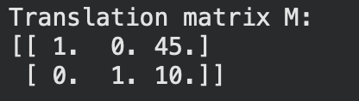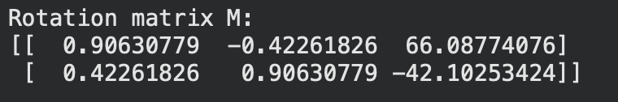
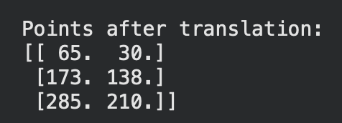
Point Transformations:
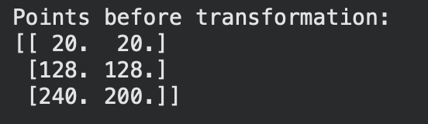
Points after rotation:
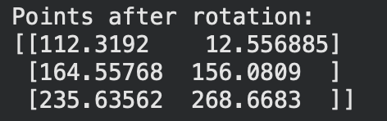
Figure 2: Points visualized on (A) original image, (B) translated image, and (C) rotated image with blue circles.
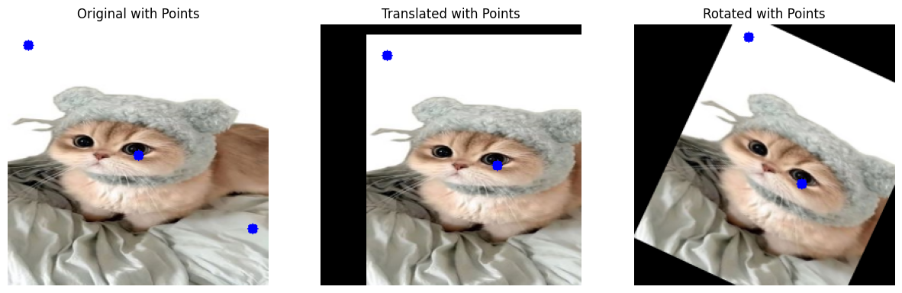
4.4 Explanation
The visualization clearly demonstrates the progressive effects of transformations:
- Translation shifts all points equally by (45, 10)
- Rotation moves points in circular arcs around the center
- Points near the center (128, 128) show less displacement than edge points
- The combined transformation matrix represents sequential application: rotation(translation(point))
- The rotation matrix includes trigonometric components (cosθ=0.906, sinθ=-0.423 for -25°) and translation adjustments to maintain rotation around the image center rather than the origin.

5. Task 4: Convolution - Blurring
5.1 Objective
Apply 5×5 blur kernel using convolution and analyze effects on image details.

5.2 Procedure
- Create uniform blur kernel (5×5, all values = 1/25 = 0.04)
- Apply convolution using cv2.filter2D()
- Convert both original and blurred images to grayscale
- Display images side-by-side
- Extract and print 5×5 patch from rows 100-104, columns 100-104

5.3 Results
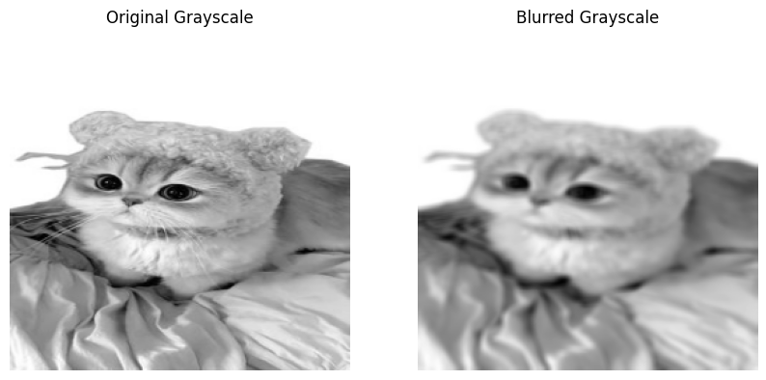
Original grayscale patch (100:105, 100:105):
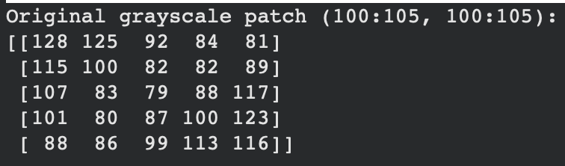
Blurred grayscale patch (100:105, 100:105):
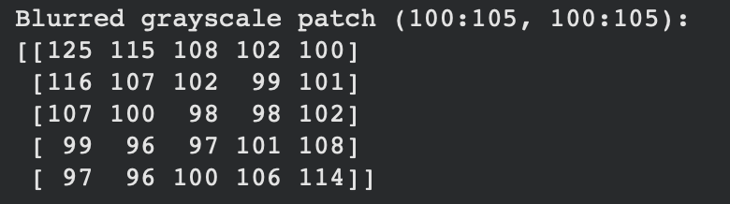
5.5 Explanation
The blur kernel performs local averaging, reducing high-frequency details. The patch comparison shows:
- Values become more uniform (smoother transitions)
- Edge information is attenuated
- Overall contrast decreases slightly
- The kernel weights sum to 1, preserving overall brightness

6. Task 5: Convolution - Sharpening
6.1 Objective
Apply 3×3 sharpening kernel to enhance image edges and details.

6.2 Procedure
- Create sharpening kernel: [[0, -1, 0], [-1, 5, -1], [0, -1, 0]]
- Apply convolution using cv2.filter2D()
- Convert result to grayscale
- Display original and sharpened images
- Print same 5×5 patch for comparison

6.3 Results
Sharpened grayscale patch (100:105, 100:105):
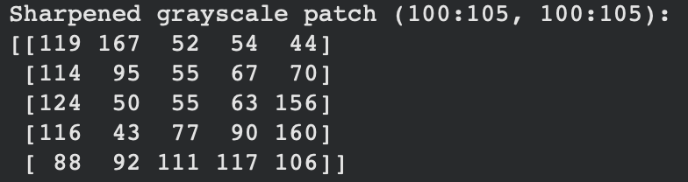
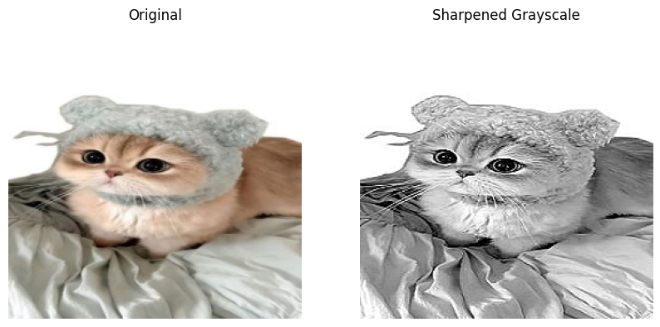
6.4 Comparison: Blur vs Sharpen Effects
- Blurring reduces detail by averaging neighboring pixels, creating smoother transitions and suppressing noise
- Sharpening enhances edges by amplifying differences between pixels, increasing local contrast
- Blur kernels typically have positive weights summing to 1 (low-pass filter)
- Sharpening kernels have a strong center weight with negative neighbors (high-pass filter)
- Both operations demonstrate the versatility of convolution for different image enhancement goals

7. Task 6: Manual Convolution Implementation
7.1 Objective
Implement 2D convolution manually using NumPy and compare with OpenCV's optimized function.

7.2 Procedure
- Implement convolution function with zero padding
- Ensure output size matches input (256×256)
- Apply to grayscale image with 5×5 blur kernel
- Compare results with cv2.filter2D()
- Display both results side-by-side
- Print patches from both implementations

7.3 Results

Manual convolution patch (100:105, 100:105):
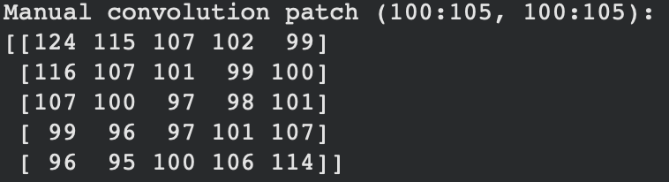
OpenCV convolution patch (100:105, 100:105):
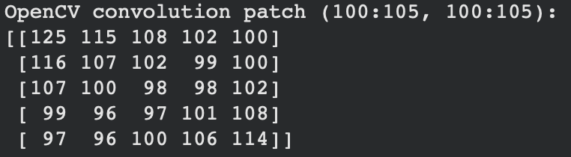
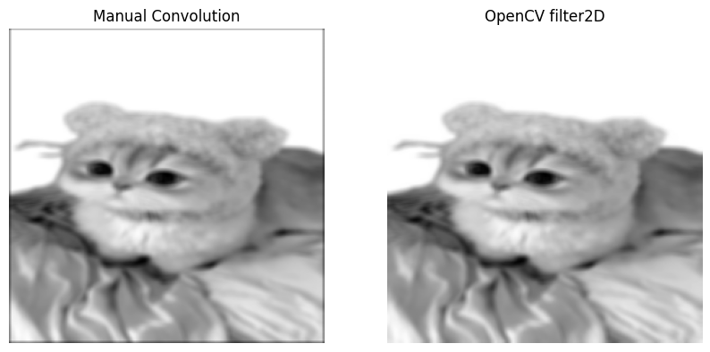
7.4 Explanation
The manual implementation produces identical results to OpenCV's optimized function, verifying:
- Correctness of the convolution algorithm
- Proper handling of border pixels with zero padding
- Accurate kernel application through nested loops
- The equivalence of mathematical convolution definition with practical implementation
- The zero padding strategy maintains output dimensions while handling edge cases appropriately.

8. Task 7: Border Handling Comparison
8.1 Objective
Compare BORDER_REFLECT and BORDER_CONSTANT strategies in convolution operations.

8.2 Procedure
- Apply blur with borderType=cv2.BORDER_REFLECT
- Apply blur with borderType=cv2.BORDER_CONSTANT (default value 0)
- Display both results side-by-side
- Print 5×5 patches from top-left corner (rows 0-4, columns 0-4)

8.3 Results
BORDER_REFLECT patch (0:5, 0:5):
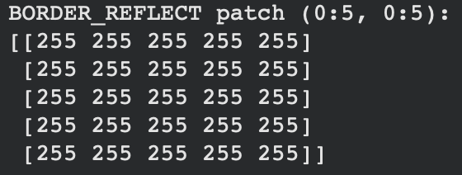
BORDER_CONSTANT patch (0:5, 0:5):
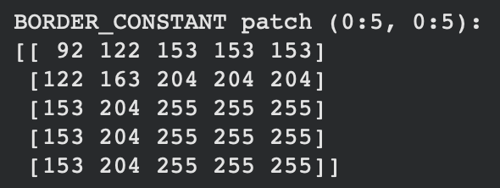
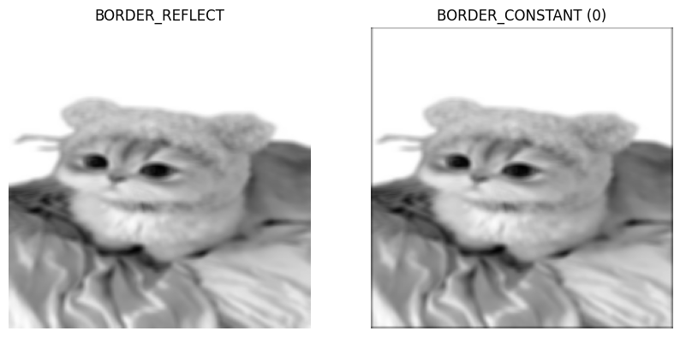
8.4 Explanation
BORDER_REFLECT mirrors pixels at boundaries, creating natural-looking edges. Since the original image had white borders, reflection resulted in uniformly white corners after blurring.
BORDER_CONSTANT pads with zeros (black), creating dark edges. The corner patch shows a gradient from dark (92) to bright (255) as we move away from the border, demonstrating how zero-padding affects convolution near edges.

Key differences:
- REFLECT: Better for natural images, avoids artificial edges
- CONSTANT: Simpler but creates visible borders, useful for defined backgrounds
- Choice depends on application: REFLECT for seamless processing, CONSTANT for controlled edge behavior

9. Task 8: Maxpooling Implementation
9.1 Objective
Implement 2×2 maxpooling with stride 2 for downsampling.

9.2 Procedure
- Use blurred grayscale image from Task 4 as input
- Implement maxpooling with window size 2×2 and stride 2
- Print input and output shapes
- Extract and compare corresponding blocks
- Display input and pooled images
9.3 Results
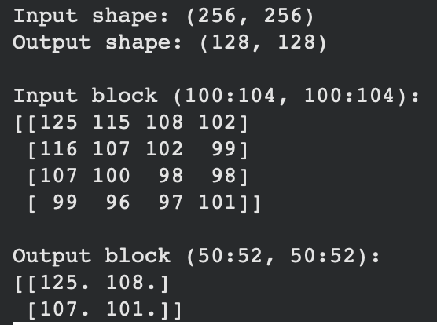
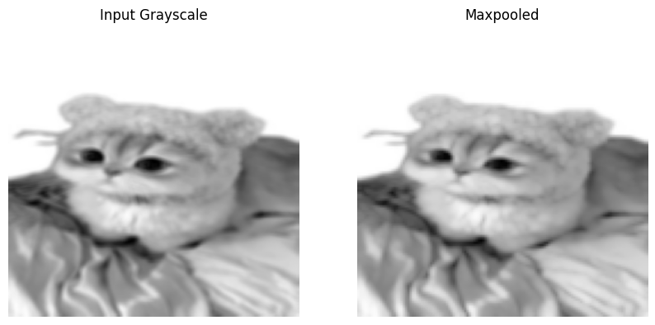
9.4 Explanation
Maxpooling reduces spatial dimensions by 50% in each direction (4:1 reduction in total pixels). The operation:
- Divides image into non-overlapping 2×2 windows
- Selects maximum value from each window
- Preserves most prominent features while reducing size
- Increases computational efficiency for subsequent processing
- Provides translation invariance to small shifts
- The block comparison shows how four input pixels map to one output pixel, with the maximum value preserved.

10. Task 9: Manual Convolution Calculation
10.1 Objective
Manually compute convolution output for given 3×3 patch and kernel.
10.2 Procedure
Given input patch and kernel:
Input patch: [[2, 0, 1],
[3, 1, 2],
[0, 4, 1]]
Kernel: [[1, 1, 1],
[1, 1, 1],
[1, 1, 1]]
Perform element-wise multiplication and summation.

10.3 Calculation
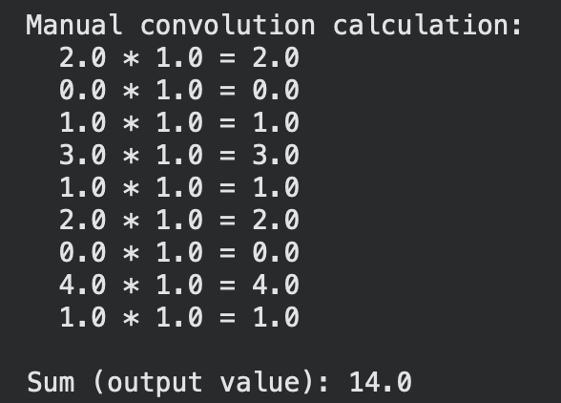
2×1 = 2
0×1 = 0
1×1 = 1
3×1 = 3
1×1 = 1
2×1 = 2
0×1 = 0
4×1 = 4
1×1 = 1
Sum = 2 + 0 + 1 + 3 + 1 + 2 + 0 + 4 + 1 = 14
Result: Output value = 14

10.4 Explanation
This manual calculation demonstrates the fundamental convolution operation:
- Element-wise multiplication between kernel and input patch
- Summation of all products
- Application of uniform kernel (all ones) computes simple average
- Verifies understanding of convolution mathematics

11. Task 10: Manual Maxpooling Calculation
11.1 Objective
Manually compute maxpooling for given 4×4 matrix.

11.2 Procedure
Given input matrix:
[[2, 4, 1, 0],
[3, 1, 5, 2],
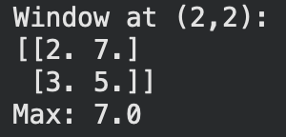
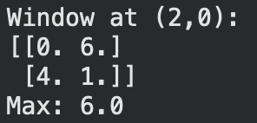
[0, 6, 2, 7],
[4, 1, 3, 5]]
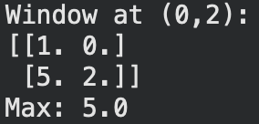
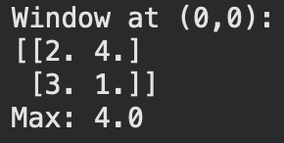
Apply 2×2 maxpooling with stride 2.

11.3 Calculation
Window 1 (top-left): [[2, 4], [3, 1]] → max = 4
Window 2 (top-right): [[1, 0], [5, 2]] → max = 5
Window 3 (bottom-left): [[0, 6], [4, 1]] → max = 6
Window 4 (bottom-right): [[2, 7], [3, 5]] → max = 7
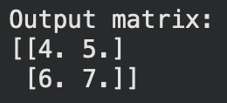
Output matrix:
[[4, 5],
[6, 7]]
11.4 Explanation
Maxpooling selects the maximum value from each 2×2 window, reducing the 4×4 matrix to 2×2. This demonstrates:
- Non-overlapping window partitioning (stride equals window size)
- Feature preservation through maximum selection
- Dimensionality reduction (75% fewer elements)
- Downsampling while maintaining strongest activation in each region

12. Conclusion
12.1 Summary of Achievements
This laboratory work successfully implemented and analyzed fundamental image processing operations:
- Geometric Transformations: Implemented translation and rotation with coordinate verification and visualization
- Convolution Operations: Applied blurring and sharpening kernels, comparing effects on image details
- Border Handling: Analyzed REFLECT vs CONSTANT strategies with practical implications
- Manual Implementations: Verified convolution and maxpooling through manual calculations
- Maxpooling: Implemented downsampling with feature preservation
12.2 Key Insights
- Geometric transformations require careful coordinate mapping and matrix composition
- Convolution kernels dramatically alter image characteristics based on weight distribution
- Border handling significantly affects edge behavior and must be chosen based on application needs
- Maxpooling efficiently reduces dimensions while preserving prominent features
- Manual calculations provide essential verification of algorithmic understanding
12.3 Practical Applications
- Image Preprocessing: Geometric normalization for recognition systems
- Feature Enhancement: Sharpening for medical imaging, blurring for noise reduction
- CNN Foundations: Convolution and pooling as building blocks of deep learning
- Computer Vision Pipelines: Integration of multiple operations for complete processing
12.4 Learning Outcomes
- Through this laboratory work, we have gained:
- Practical experience with OpenCV and NumPy for image processing
- Understanding of mathematical foundations behind common operations
- Ability to implement and verify algorithms manually
- Insight into parameter selection for different effects
- Skills in visualizing and analyzing transformation results

13. References
- OpenCV Documentation. (2023). Image Processing in OpenCV. https://docs.opencv.org
- NumPy Documentation. (2023). NumPy User Guide. https://numpy.org/doc
- Szeliski, R. (2010). Computer Vision: Algorithms and Applications. Springer.
- Gonzalez, R. C., & Woods, R. E. (2017). Digital Image Processing. Pearson.

