
Introduction to Computer Vision

LAB 5 (Report)
Image Segmentation

Done by: Kairbayeva Aiym
Doszhankyzy
ID: 23B031102

Almaty 24.02.2026
Table of Contents
1. Abstract
2. Introduction
3. Task 1: K-means segmentation in color space
4. Task 2: Color space-based segmentation
5. Task 3: Region based segmentation using watershed
6. Task 4: Superpixel segmentation
7. Task 5: Segmentation result comparison
8. Final Conclusions

1. Abstract

This laboratory work investigates various image segmentation techniques, focusing on region-based and clustering-based methods. Using Python and computer vision libraries (OpenCV, scikit-image), four primary algorithms are applied and analyzed: K-means clustering, HSV color space thresholding, Watershed segmentation, and SLIC superpixels. Finally, a comparative analysis is conducted between K-means and HSV segmentation masks to understand their distinct approaches to object isolation.

2. Introduction
Image segmentation is a fundamental task in computer vision that involves partitioning an image into multiple segments (sets of pixels) to simplify its representation and make it more meaningful and easier to analyze. This lab explores different strategies:
- Clustering-based: Grouping pixels based on their proximity in color space (K-means, SLIC).
- Color-based: Isolating specific channels that are robust to lighting changes (HSV thresholding).
- Region-based: Treating pixel intensities as a topographic map to find object boundaries (Watershed).
The objective is to understand the implementation, strengths, and optimal use cases for each method.
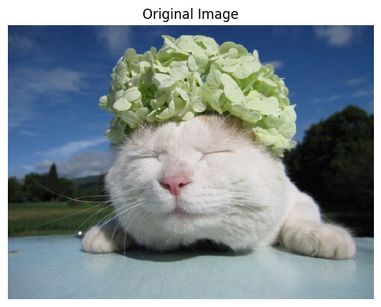

3. Task 1: K-means segmentation in color space
3.1 Objective
Load an RGB image, reshape it into a 2D array, and apply K-means clustering to segment the image into K regions (K=2, 5, 10). Display the reconstructed images, print cluster centers, and explain the effect of changing K.

3.2 Procedure
- Load the image and convert it from BGR to RGB format using cv2.cvtColor.
- Reshape the image array to a 2D array of pixels with 3 color channels (N, 3) and convert it to np.float32.
- Define the stopping criteria for the algorithm (maximum iterations and epsilon).
- Loop through K values (2, 5, 10), apply cv2.kmeans(), and map the resulting labels back to their respective cluster center colors.
- Reshape the segmented 1D array back to the original image dimensions and display the result.

3.3 Results
Cluster centers for K=2:
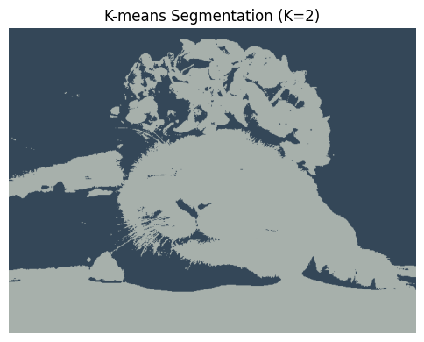
Cluster centers for K=5:
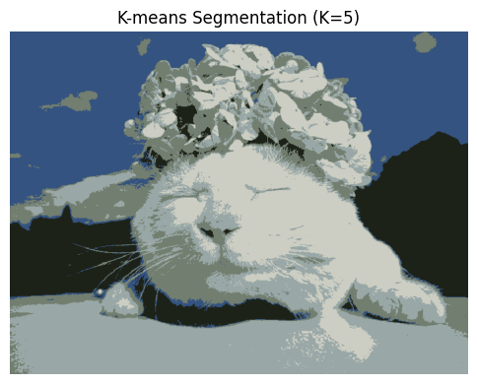
Cluster centers for K=10:
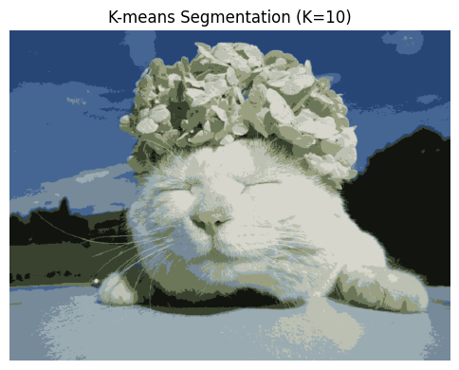

3.4 Explanation
Changing the value of K directly affects the segmentation granularity. For a low value (e.g., K=2), the image is broadly separated into main regions based on dominant colors/brightness (often resulting in a simple foreground/background split). As K increases (e.g., K=10), the algorithm becomes more sensitive to subtle color variations, resulting in a highly detailed but potentially over-segmented image where smooth gradients or shadows are split into distinct bands.

4. Task 2: Color space based segmentation

4.1 Objective
Convert the image to the HSV color space, isolate a specific color region by thresholding the Hue channel, display the masks, and print the selected Hue range along with the pixel count.

4.2 Procedure
- Convert the original RGB image to HSV using cv2.cvtColor.
- Extract the Hue channel (index 0).
- Define lower_hue and upper_hue boundaries using NumPy arrays to target a specific color (e.g., the color of the headpiece in the image).
- Use cv2.inRange() to create a binary mask.
- Apply the mask to the original image using cv2.bitwise_and().

4.3 Results
- Selected Hue range: 35 to 85
- Number of pixels in the segmented region: 41 4 39

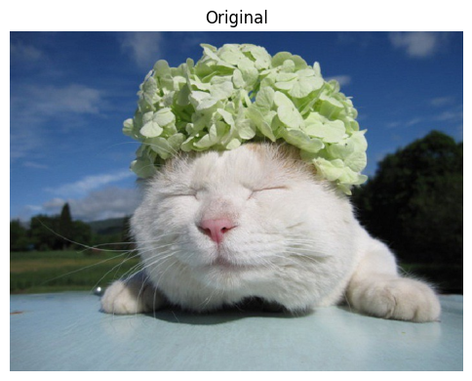
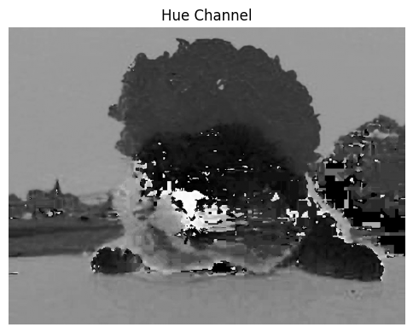
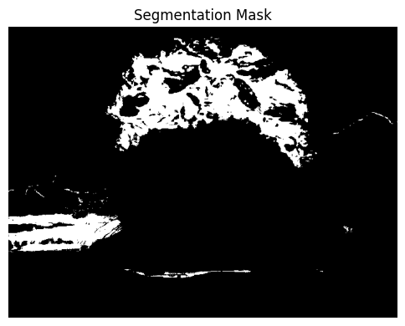
4.4 Explanation
The HSV (Hue, Saturation, Value) color space is superior to RGB for color-based segmentation because it separates chromaticity (Hue) from illumination (Value). By thresholding only the Hue channel, we can reliably isolate objects of a specific color even if shadows or highlights alter their brightness in the original image.

5. Task 3: Region based segmentation using watershed
5.1 Objective
Apply Watershed segmentation using a distance transform and markers. Display the marker image and the final colored regions, and print the total number of segmented regions.

5.2 Procedure
- Convert the image to grayscale and apply Otsu's binary thresholding.
- Use morphological opening to remove small noise.
- Compute the distance transform (cv2.distanceTransform) to find the "sure foreground" (centers of objects).
- Dilate the binary image to find the "sure background".
- Subtract the foreground from the background to define the "unknown" region.
- Label the sure foreground regions using cv2.connectedComponents to create markers.
- Apply cv2.watershed() and mark the boundaries in red on the original image.

5.3 Results
Number of segmented regions: 3
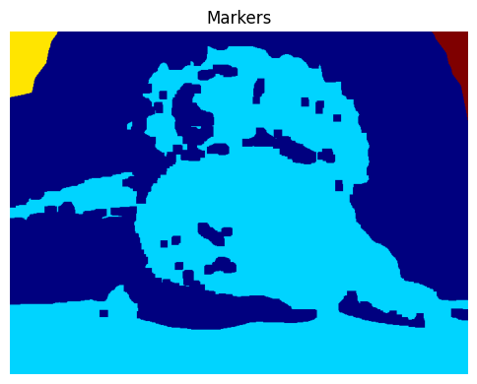

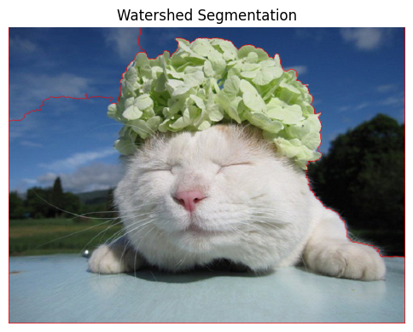

5.4 Explanation

The Watershed algorithm treats the image like a topographic map, where high intensity denotes peaks and low intensity denotes valleys. The distance transform is crucial as it helps identify the precise center of overlapping or touching objects. By placing markers at these centers, the watershed algorithm "floods" the valleys to find natural, accurate boundaries without merging adjacent objects.

6. Task 4: Superpixel segmentation
6.1 Objective
Apply the SLIC (Simple Linear Iterative Clustering) algorithm. Display the superpixel boundaries and explain the conceptual difference between superpixels and pixel-level segmentation.

6.2 Procedure
- Use the slic function from skimage.segmentation on the RGB image, specifying the desired number of segments (e.g., n_segments=200) and compactness.
- Use mark_boundaries to overlay the resulting superpixel borders onto the original image.

6.3 Results
Actual number of superpixels generated:161
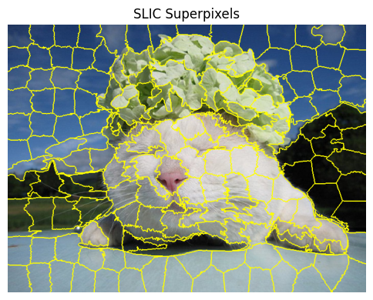

6.4 Explanation
Unlike traditional pixel-level segmentation—which evaluates every single pixel on a rigid grid independently—superpixel algorithms group neighboring pixels into perceptually meaningful clusters based on similarities in color, texture, and location. This significantly reduces the complexity of the image for subsequent processing steps while preserving the actual structural boundaries of objects.

7. Task 5: Segmentation result comparison
7.1 Objective
Select two distinct segmentation methods (K-means and HSV Thresholding), extract binary masks for a chosen object, and compare their performance.

7.2 Procedure
- Extract the binary mask generated by the K-means algorithm (from Task 1, using K=2).
- Retrieve the binary mask generated by the HSV thresholding (from Task 2).
- Display both masks side-by-side for visual evaluation.

7.3 Results
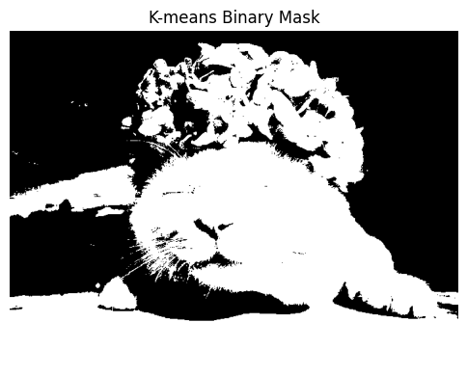
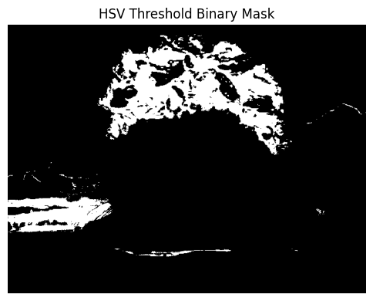

7.4 Explanation
The K-means clustering algorithm and HSV thresholding demonstrated fundamentally different approaches to segmentation.
- The K-means method (K=2) successfully separated the main foreground subject (the animal and its headpiece) from the background. It grouped pixels based on overall intensity and color proximity, making it excellent for general foreground-background separation when their brightness levels differ significantly.
- The HSV color space segmentation was highly specific. It isolated only the vividly colored object on the animal's head, completely ignoring the white fur due to its low saturation.
Neither method is universally "better". K-means is preferable for general object extraction based on holistic clusters, while HSV thresholding is superior for isolating targeted objects of a specific hue, regardless of the overall scene illumination.

8. Final Conclusions
Through this laboratory work, various approaches to image segmentation were successfully implemented and evaluated:
- K-means provided an intuitive way to quantize colors and separate main regions, though it is sensitive to lighting variations.
- HSV Thresholding proved highly effective for isolating objects based on pure color properties, immune to shadows.
- Watershed segmentation highlighted the importance of spatial and morphological operations, particularly excelling at separating touching objects using distance transforms.
- SLIC Superpixels demonstrated how images can be simplified into perceptually meaningful regions, reducing computational load for complex vision pipelines.
Understanding the specific strengths of each algorithm allows for selecting the right tool depending on whether the task requires color isolation, structural boundary detection, or general scene simplification.

9. References
- OpenCV Documentation: Image Segmentation with Watershed Algorithm.
- OpenCV Documentation: K-Means Clustering in OpenCV.
- scikit-image Documentation: Segmentation (SLIC).

