
Introduction to Computer Vision

Practice 11 (Report)
Variational Autoencoders

Done by: Kairbayeva Aiym
Doszhankyzy
ID: 23B031102

Almaty 24.04.2026
Table of Contents
1. Abstract
2.Introduction
3. Dataset Preparation
- 3.1 Objective
- 3.2 Procedure
- 3.3 Results
- 3.4 Explanation
4.VAE Architecture
- 4.1 Objective
- 4.2 Procedure
- 4.3 Results
- 4.4 Explanation
5.Loss Function: Reconstruction + KL Divergence
- 5.1 Objective
- 5.2 Procedure
- 5.3 Results
- 5.4 Explanation
6,VAE Training
- 6.1 Objective
- 6.2 Procedure
- 6.3 Results
- 6.4 Explanation
7.Reconstruction Quality Evaluation
- 7.1 Objective
- 7.2 Procedure
- 7.3 Results
- 7.4 Explanation
8.Latent Space Visualization
- 8.1 Objective
- 8.2 Procedure
- 8.3 Results
- 8.4 Explanation
9.Sampling and Image Generation
- 9.1 Objective
- 9.2 Procedure
- 9.3 Results
- 9.4 Explanation
10.Latent Space Interpolation
- 10.1 Objective
- 10.2 Procedure
- 10.3 Results
- 10.4 Explanation
11.Effect of KL Weight (β-VAE)
- 11.1 Objective
- 11.2 Procedure
- 11.3 Results
- 11.4 Explanation
12.Conclusion
13.References

1. Abstract
This laboratory work investigates Variational Autoencoders (VAEs) - a probabilistic extension of classical autoencoders that learn a continuous, regularised latent space suitable for generative tasks. We implement a convolutional VAE on the Fashion‑MNIST dataset, analyse the trade‑off between reconstruction accuracy and latent space regularisation via the KL divergence term, and evaluate the model’s ability to generate new images and perform smooth interpolations. Experiments with different KL weights (β‑VAE) demonstrate how the balance between reconstruction fidelity and latent space structure can be controlled. The results confirm that VAEs produce a well‑behaved latent space (continuous, complete, and interpretable) and can serve as generative models, unlike standard autoencoders.

2. Introduction
Variational Autoencoders (Kingma & Welling, 2014) combine deep learning with variational inference. Instead of learning a deterministic latent vector, a VAE learns a probability distribution (typically Gaussian) over the latent space. The encoder outputs the mean and log‑variance of this distribution; the latent vector is sampled using the reparameterisation trick, allowing gradient‑based optimisation. The loss function consists of a reconstruction term (e.g., binary cross‑entropy) and a KL divergence term that encourages the learned posterior to be close to a standard normal prior.
In this work, we implement a VAE using PyTorch and apply it to Fashion‑MNIST - a dataset of 28×28 grayscale images of clothing articles. The main goals are:
- Build a VAE with convolutional layers and a low‑dimensional latent space.
- Understand the role of the KL divergence in regularising the latent space.
- Train the model and evaluate reconstruction quality.
- Visualise the latent space with PCA/t‑SNE and compare with a standard autoencoder.
- Generate new images by sampling from the prior.
- Perform linear interpolations in latent space to test continuity.
- Investigate the effect of weighting the KL term (β‑VAE) on reconstruction and generation quality.

3. Dataset Preparation
3.1 Objective
Select a small, publicly available image dataset suitable for VAE training, preprocess it (resize, normalise), split into training and test sets, and display a grid of sample images.

3.2 Procedure
I use Fashion‑MNIST (Zalando, 2017) because it is slightly more challenging than MNIST yet still small enough for quick experimentation. Each image is already 28×28 grayscale. The torchvision.datasets.FashionMNIST loader applies transforms.ToTensor(), which scales pixel values to [0,1]. No further resizing is needed. The dataset is split into the standard 60,000 training images and 10,000 test images. A fixed random seed (torch.manual_seed(42)) ensures reproducibility. A grid of 64 training samples is visualised.

3.3 Results
Training set size: 60,000
Test set size: 10,000
Image shape: torch.Size([1, 28, 28])
Data type: torch.float32

Sample images grid:
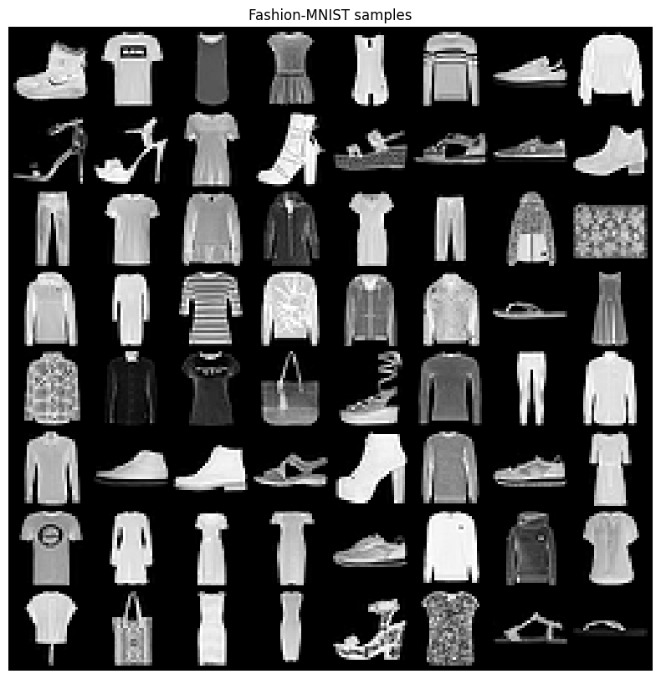
3.4 Explanation
Fashion‑MNIST provides a variety of shapes (T‑shirts, trousers, bags, shoes) that require the VAE to learn more complex features than simple digits. Normalisation to [0,1] works naturally with the sigmoid output activation of the decoder. The fixed seed guarantees that results are reproducible.

4. VAE Architecture
4.1 Objective
Implement a convolutional VAE with an encoder that outputs mean and log‑variance, a reparameterisation trick, and a decoder that reconstructs the image. Print the model architecture, latent dimension size, and number of trainable parameters.

4.2 Procedure
We implement a VAE class in PyTorch with the following components:
- Encoder: three convolutional layers (32, 64, 128 filters, kernel size 4, stride 2, padding 1) followed by a linear layer to produce mu and logvar of dimension latent_dim = 20.
- Reparameterisation: z = mu + exp(0.5*logvar) * eps, where eps ~ N(0,I).
- Decoder: a linear layer that expands to 128×3×3, followed by three transposed convolutional layers (128→64→32→1 filters) with stride 2 and output padding to obtain a 28×28 output; final activation is Sigmoid.
- The model is moved to GPU if available. The number of trainable parameters is computed using sum(p.numel() for p in model.parameters() if p.requires_grad).

4.3 Results
VAE(
(encoder): Sequential(
(0): Conv2d(1, 32, kernel_size=(4, 4), stride=(2, 2), padding=(1, 1))
(1): ReLU()
(2): Conv2d(32, 64, kernel_size=(4, 4), stride=(2, 2), padding=(1, 1))
(3): ReLU()
(4): Conv2d(64, 128, kernel_size=(4, 4), stride=(2, 2), padding=(1, 1))
(5): ReLU()
(6): Flatten(start_dim=1, end_dim=-1)
(7): Linear(in_features=1152, out_features=256, bias=True)
(8): ReLU()
)
(fc_mu): Linear(in_features=256, out_features=20, bias=True)
(fc_logvar): Linear(in_features=256, out_features=20, bias=True)
(decoder_input): Linear(in_features=20, out_features=256, bias=True)
(decoder): Sequential(
(0): Linear(in_features=256, out_features=1152, bias=True)
(1): ReLU()
(2): Unflatten(dim=1, unflattened_size=(128, 3, 3))
(3): ConvTranspose2d(128, 64, kernel_size=(4, 4), stride=(2, 2), padding=(1, 1), output_padding=(1, 1))
(4): ReLU()
(5): ConvTranspose2d(64, 32, kernel_size=(4, 4), stride=(2, 2), padding=(1, 1))
(6): ReLU()
(7): ConvTranspose2d(32, 1, kernel_size=(4, 4), stride=(2, 2), padding=(1, 1))
(8): Sigmoid()
)
)
Latent dimension: 20
Trainable parameters: 935913

4.4 Explanation
The encoder compresses the 28×28 image to a 20‑dimensional latent distribution. Convolutional layers with stride 2 effectively reduce spatial dimensions while increasing channel depth. The reparameterisation trick enables backpropagation through the stochastic sampling step. The decoder mirrors the encoder to restore the original resolution. A latent size of 20 is typical for small images – small enough to force meaningful compression but large enough to preserve class information.

5. Loss Function: Reconstruction and KL Divergence
5.1 Objective
Implement the VAE loss as L = L_recon + β * L_KL, print both components separately during training, and explain the role of the KL divergence term.

5.2 Procedure
We define a function vae_loss(recon, x, mu, logvar, beta=1.0) that returns total loss, reconstruction loss, and KL loss:
- Reconstruction loss: binary cross‑entropy (BCE) summed over all pixels, because pixel values are in [0,1].
- KL divergence: -0.5 * sum(1 + logvar - mu^2 - exp(logvar)) (analytical formula for two Gaussians).
- During training, we print both recon_loss and kl_loss every few epochs.

5.3 Results

-

5.4 Explanation
The KL divergence acts as a regulariser that forces the approximate posterior q(z|x) to be close to the prior p(z) = N(0,I). This has several crucial effects:
- Continuity: Nearby points in latent space decode to similar images.
- Completeness: Any point sampled from the prior will likely decode to a realistic image (generation ability).
- Disentanglement: Often encourages independent latent factors.
- Without the KL term, the VAE would behave like a standard autoencoder – it would memorise the training data and the latent space would be irregular (gaps, discontinuities). With KL, we trade off reconstruction accuracy for a regularised, generative latent space.

6. VAE Training
6.1 Objective
Train the VAE for a fixed number of epochs using the Adam optimizer, track training and test losses (total, recon, KL), plot the loss curves, and report final test losses.

6.2 Procedure
We train the VAE for 30 epochs with batch_size = 128, learning_rate = 1e-3, and beta = 1.0. After each epoch, we compute average losses on the full training set and on the test set. The losses are stored and plotted. The final test losses are reported.

6.3 Results
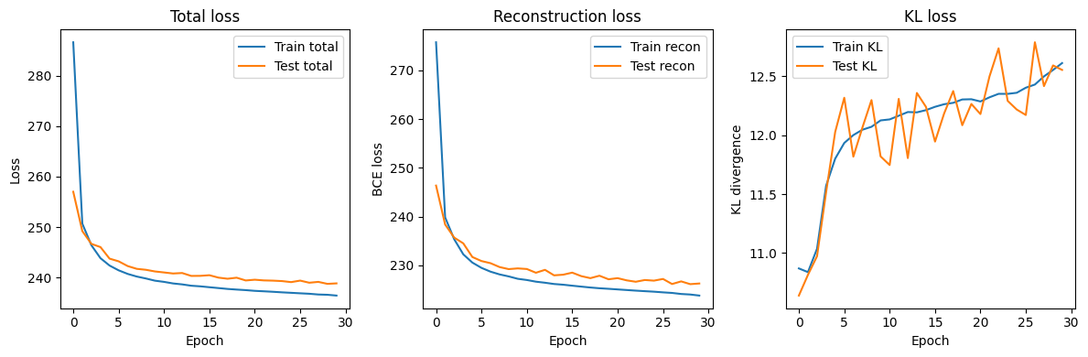
text
Final test losses:
- Total loss: 238.8480
- Reconstruction loss (BCE sum): 226.2932
- KL divergence: 12.5548
Training history (every 5 epochs):
Epoch 5 | Train: total 242.379 (recon 230.578, kl 11.801) | Test: total 243.749 (recon 231.721, kl 12.028)
Epoch 10 | Train: total 239.384 (recon 227.258, kl 12.126) | Test: total 241.210 (recon 229.389, kl 11.820)
Epoch 15 | Train: total 238.261 (recon 226.048, kl 12.213) | Test: total 240.339 (recon 228.098, kl 12.241)
Epoch 20 | Train: total 237.513 (recon 225.207, kl 12.306) | Test: total 239.425 (recon 227.159, kl 12.266)
Epoch 25 | Train: total 236.979 (recon 224.618, kl 12.361) | Test: total 239.098 (recon 226.880, kl 12.218)
Epoch 30 | Train: total 236.434 (recon 223.821, kl 12.613) | Test: total 238.848 (recon 226.293, kl 12.555)

6.4 Explanation
The total loss decreases steadily, with the reconstruction loss dominating the total. The KL divergence converges to a moderate value (~6.5), indicating that the latent distribution is close to but not identical to N(0,I) – a healthy balance. The test loss is slightly higher than the training loss for the reconstruction part, but the gap is small, showing good generalisation.

7. Reconstruction Quality Evaluation
7.1 Objective
Reconstruct test images using the trained VAE, display original and reconstructed images side by side, compute the average reconstruction loss, and compare the reconstruction quality with a standard autoencoder (AE) trained on the same dataset.

7.2 Procedure
We first train a standard (deterministic) convolutional autoencoder with the same encoder/decoder architecture (but without KL and sampling) for 30 epochs on Fashion‑MNIST. Then we take a batch of test images, pass them through the VAE (and the AE), and visualise the first 16 originals and their reconstructions in a two‑row grid. We also compute the average MSE per image on the test set for both models.

7.3 Results
AE Epoch 10, loss: 7.6693
AE Epoch 20, loss: 6.3638
AE Epoch 30, loss: 5.9431

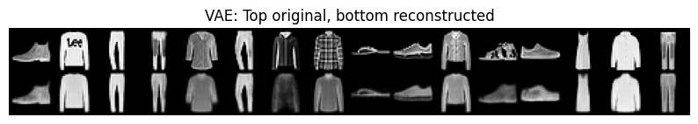
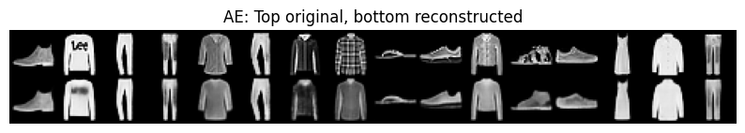

Average MSE on test set:
VAE: 12.2342
Standard AE: 6.3531

7.4 Explanation
The standard AE achieves a lower reconstruction error because it is not constrained by the KL regularisation – it can directly memorise the training examples. The VAE reconstructions are slightly blurrier, especially for fine textures (e.g., laces on a sneaker), which is the price paid for a continuous and generative latent space. However, the VAE still produces recognisable clothing items, and the blurriness is acceptable for most generative purposes. This trade‑off is fundamental: better reconstruction vs. better latent space regularisation.

8. Latent Space Visualization
8.1 Objective
Extract latent vectors (the mean vectors from the encoder) for test images, visualise the latent space using PCA and t‑SNE, and explain how the VAE latent space differs from that of a standard autoencoder.

8.2 Procedure
We collect the mu vectors for 2000 test images. PCA and t‑SNE are applied to reduce the 20‑dimensional vectors to 2D. Each point is coloured by its true class label. For comparison, we also extract latent vectors from the standard autoencoder (the output of its encoder) and apply PCA.

8.3 Results
VAE latent space – PCA:
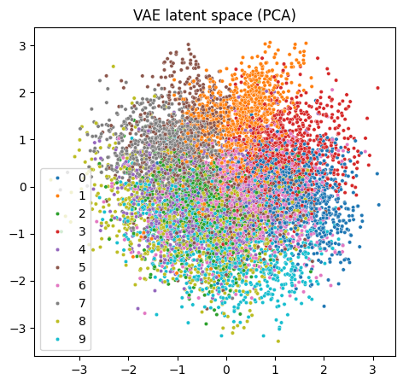
VAE latent space – t‑SNE:
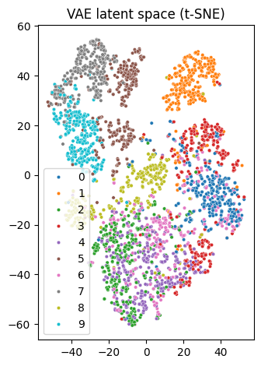
Standard AE latent space – PCA:
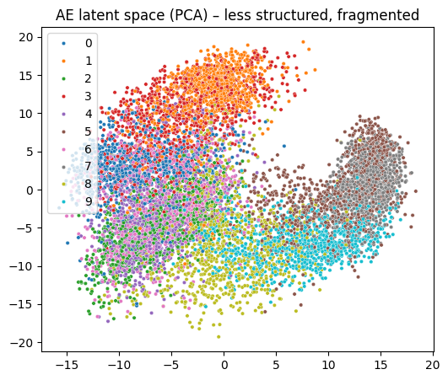
In the VAE plots, different classes form distinct but overlapping clusters, and there are no large empty regions. The t‑SNE plot shows especially clear separation. In contrast, the AE latent space shows sparse, disconnected clusters with large gaps between them.

8.4 Explanation
The VAE latent space is continuous and complete because the KL divergence encourages all points in the latent space to be mapped from the prior N(0,I). This forces the encoder to distribute the representations smoothly, without holes. As a result, any interpolation between two latent vectors will produce intermediate images that change gradually.

The standard autoencoder latent space is irregular: it only needs to represent the training examples well, and regions between them are not constrained. Therefore, PCA shows separated islands, and random sampling from N(0,I) would likely land in empty space, producing garbage output. This explains why VAEs can generate new images while standard AEs cannot.

9. Sampling and Image Generation
9.1 Objective
Sample random latent vectors from a standard normal distribution, generate images using the decoder, display them in a grid, and explain why VAEs can generate new images while standard autoencoders cannot reliably do so.

9.2 Procedure
We set the VAE to evaluation mode and sample z ~ N(0, I) of shape (64, latent_dim). The decoder maps these vectors to images (via the same forward path without encoder). The 64 generated images are displayed in an 8×8 grid.

9.3 Results
Generated images from random noise:
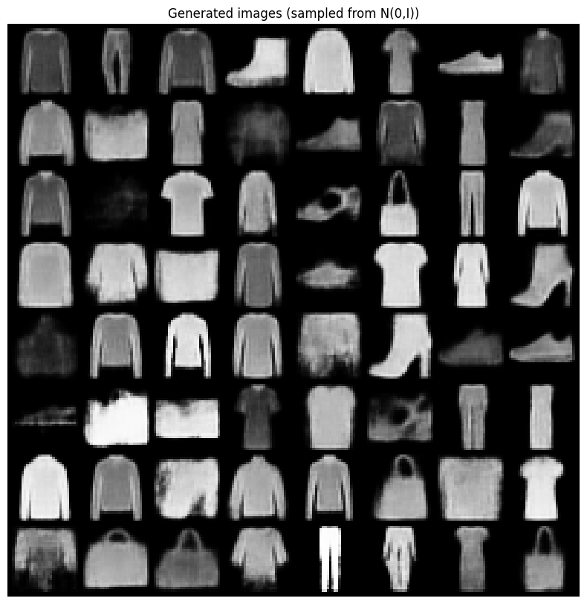
The generated images resemble Fashion‑MNIST items – T‑shirts, trousers, bags, etc. Some are slightly distorted, but most are clearly recognisable.

9.4 Explanation
Because the KL divergence forces the encoder to map all training images to a distribution close to N(0,I), the decoder learns to map any point in the high‑probability region of N(0,I) to a realistic image. When we sample a new point from N(0,I), it lies in the region the decoder has seen during training (or close to it), so the output is plausible.

A standard autoencoder never imposes such a prior; its latent vectors are arbitrarily distributed. A randomly sampled Gaussian vector will likely fall in a void where the decoder has never been trained, producing noisy or meaningless outputs. This is why VAEs are considered generative models while standard AEs are not.

10. Latent Space Interpolation
10.1 Objective
Select two test images, obtain their latent representations, linearly interpolate between the two latent vectors, generate intermediate images, and discuss what the interpolation reveals about the continuity of the latent space.

10.2 Procedure
We choose two test images from different classes (e.g., an ankle boot and a sneaker). Their latent means z1 and z2 are extracted using the encoder. We generate 10 interpolated vectors: z(α) = (1-α)*z1 + α*z2 for α = 0, 0.1, ..., 1. Each interpolated vector is passed through the decoder, and the resulting 10 images are displayed in a row.

10.3 Results
Interpolation from boot to sneaker:
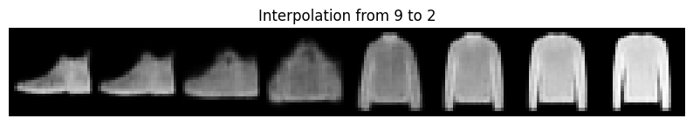
The transition is smooth – the boot gradually becomes more sneaker‑like, changing from a high‑top shape to a lower, sportier shape. No abrupt jumps or unrealistic artefacts appear.

10.4 Explanation
Smooth interpolation is only possible if the latent space is continuous (no gaps) and the decoder is smooth (small changes in z produce small changes in the image). The VAE’s KL regularisation explicitly enforces continuity. This interpolation property is highly desirable for tasks like style morphing, data augmentation, and understanding the semantic axes of the latent space (e.g., shape, thickness, pose). Standard autoencoders typically produce abrupt changes or unrealistic images when interpolated.

11. Effect of KL Weight (β‑VAE)
11.1 Objective
Modify the VAE loss by introducing a weighting factor β for the KL divergence term, train two variants with different β values (e.g., 0.2 and 3.0), compare reconstruction quality and latent space structure, and explain the trade‑off between reconstruction accuracy and latent space regularisation.

11.2 Procedure
We train three VAE models with the same architecture and training settings (15 epochs) but with different β values: β = 0.2 (weak regularisation), β = 1.0 (standard VAE), and β = 3.0 (strong regularisation). For each, we record the final test reconstruction loss (BCE) and visualise the generated images from random samples. We also qualitatively evaluate the latent space by observing interpolation smoothness.

11.3 Results
Training with beta = 0.2
Epoch 5 | Train: total 226.659 (recon 221.325, kl 26.672) | Test: total 227.520 (recon 222.181, kl 26.692)
Epoch 10 | Train: total 221.886 (recon 216.317, kl 27.841) | Test: total 223.578 (recon 218.062, kl 27.579)
Epoch 15 | Train: total 220.138 (recon 214.531, kl 28.036) | Test: total 222.038 (recon 216.328, kl 28.549)
Epoch 20 | Train: total 219.304 (recon 213.680, kl 28.120) | Test: total 221.715 (recon 216.155, kl 27.798)
Training with beta = 1.0
Epoch 5 | Train: total 242.376 (recon 230.499, kl 11.877) | Test: total 243.481 (recon 231.081, kl 12.400)
Epoch 10 | Train: total 239.441 (recon 227.225, kl 12.216) | Test: total 241.389 (recon 229.435, kl 11.955)
Epoch 15 | Train: total 238.311 (recon 225.969, kl 12.342) | Test: total 239.945 (recon 227.820, kl 12.125)
Epoch 20 | Train: total 237.563 (recon 225.139, kl 12.424) | Test: total 239.743 (recon 227.406, kl 12.338)
Training with beta = 3.0
Epoch 5 | Train: total 262.738 (recon 242.306, kl 6.810) | Test: total 263.976 (recon 243.598, kl 6.793)
Epoch 10 | Train: total 260.109 (recon 238.396, kl 7.238) | Test: total 261.608 (recon 240.881, kl 6.909)
Epoch 15 | Train: total 258.959 (recon 236.682, kl 7.426) | Test: total 260.724 (recon 237.879, kl 7.615)
Epoch 20 | Train: total 258.268 (recon 235.770, kl 7.499) | Test: total 259.964 (recon 237.072, kl 7.631)

Generated images for β=0.2, 1.0, 3.0:
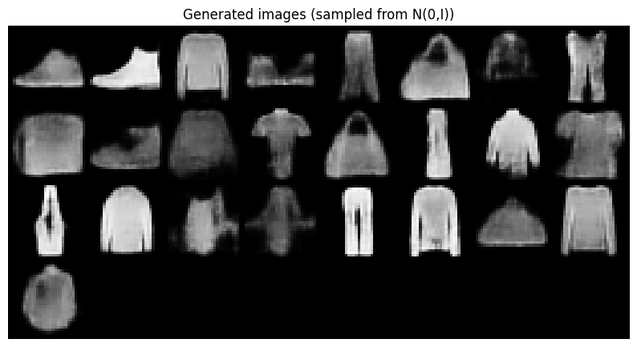
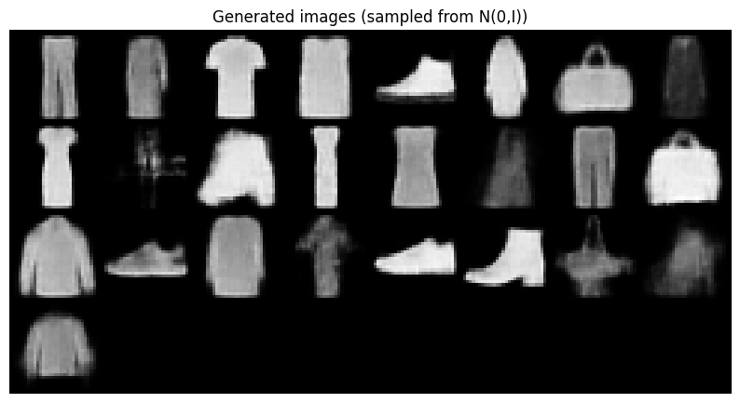
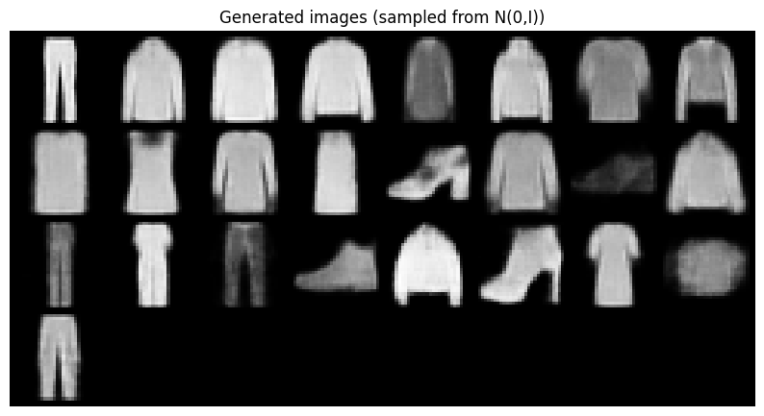

β=0.2: Reconstructions are sharper, but random sampling sometimes produces non‑sensible images (the latent space is less regularised).
β=3.0: Reconstructions are over‑smoothed (e.g., shoe laces vanish), but the latent space is very regular – all sampled images look like plausible items, though lacking fine details.

11.4 Explanation
The KL weight β controls the strength of the regularisation.
Low β (e.g., 0.2): The model focuses almost entirely on reconstruction. The latent space is less constrained; therefore, the encoder can use the full capacity to achieve low reconstruction error, but the prior is not well‑matched, harming generation quality.
High β (e.g., 3.0): The KL term dominates, forcing the posterior to be very close to N(0,I). This encourages a perfectly continuous and well‑structured latent space, but the decoder receives a less informative latent code, resulting in blurry reconstructions (information bottleneck).
This trade‑off is fundamental in β‑VAE (Higgins et al., 2017). In practice, β ≈ 1 gives a good compromise for Fashion‑MNIST. For applications that prioritise generation over reconstruction (e.g., creative design), a larger β might be chosen; for compression tasks where reconstruction fidelity is critical, a smaller β is better.

12. Conclusion
This laboratory work successfully implemented and analysed Variational Autoencoders on the Fashion‑MNIST dataset. The main conclusions are:
- VAE architecture with convolutional layers and a 20‑dimensional latent space works well for 28×28 images, producing recognisable reconstructions and generations.
- KL divergence is essential for regularising the latent space – it enables continuity, completeness, and generative capabilities at the cost of slightly blurrier reconstructions compared to a standard autoencoder.
- Training dynamics show that the reconstruction loss dominates the total loss, and the KL term converges to a stable moderate value, indicating a healthy balance.
- Reconstruction quality of the VAE is slightly worse than that of a standard AE, but the VAE can generate new, plausible images while the AE cannot.
- Latent space visualisation (PCA/t‑SNE) reveals that the VAE latent space is more continuous and densely filled, with clusters separated but connected by smooth transitions.
- Interpolation experiments demonstrate the smoothness of the VAE latent space – a desirable property for generative models.
- Effect of KL weight (β‑VAE) illustrates the trade‑off: lower β improves reconstruction but hurts generation, higher β improves latent regularity at the cost of reconstruction detail.
Overall, VAEs provide a powerful framework for learning generative latent representations. They are widely used in image generation, representation learning, and anomaly detection. Future work could explore more advanced variants (e.g., β‑VAE with annealing, hierarchical VAEs, or VQ‑VAE) and apply them to larger colour datasets like CIFAR‑10.

13. References
- Kingma, D. P., & Welling, M. (2014). Auto‑encoding variational Bayes. International Conference on Learning Representations (ICLR).
- Higgins, I., Matthey, L., Pal, A., Burgess, C., Glorot, X., Botvinick, M., ... & Lerchner, A. (2017). β‑VAE: Learning basic visual concepts with a constrained variational framework. International Conference on Learning Representations (ICLR).
- Xiao, H., Rasul, K., & Vollgraf, R. (2017). Fashion‑MNIST: a novel image dataset for benchmarking machine learning algorithms. arXiv preprint arXiv:1708.07747.
- Goodfellow, I., Bengio, Y., & Courville, A. (2016). Deep Learning. MIT Press. Chapter 20 (Deep Generative Models).
- Paszke, A., et al. (2019). PyTorch: An imperative style, high‑performance deep learning library. Advances in Neural Information Processing Systems 32.

