
Introduction to Computer Vision

Project (Report – 1st checkpoint)

Done by: Tolkynbekova S., Kayirbayeva A.,
Kyzaibayev B., Talgat T.

Almaty 10.03.2026

Table of Contents
- Introduction
- Objective of the Project
- Dataset Description and Experimental Setup
3.1 Selected Dataset
3.2 Dataset Structure
3.3 Data Splitting Strategy
3.4 Software Environment and Libraries
- Dataset Preparation and Analysis
4.1 Dataset Structure
4.2 Class Distribution
4.3 Annotation Format
- Preprocessing Pipeline
5.1 Image Resizing
5.2 Data Augmentation
5.3 Dataset Normalization
5.4 Visualization of Training Samples
- Object Detection Model
6.1 Model Architecture
6.2 Pretrained Model
- Training Procedure and Evaluation Metrics
7.1 Training Configuration
7.2 Detection Metrics
7.3 Initial Training Results
- Prediction Analysis
8.1 Example Predictions
8.2 Detection Quality Analysis
- Calorie Estimation Concept
- Conclusion
- References

1. Introduction
Monitoring daily food intake is an important aspect of maintaining a healthy lifestyle. However, accurately tracking food consumption and calorie intake can be difficult for many people. Most existing calorie-tracking applications require users to manually enter the names of foods and portion sizes, which can be time-consuming and prone to human error.
Recent advances in computer vision and deep learning have enabled automatic analysis of visual data. Using modern object detection models, it is possible to recognize food items directly from images. This allows the development of intelligent systems that can automatically identify food and estimate its nutritional properties.
Although several commercial applications already exist, their accuracy is often limited and many rely on proprietary technologies. Developing our own detection system allows us to better understand modern computer vision methods and explore how they can be applied to real-world problems.
In this project, we aim to build a system capable of detecting food items in images and estimating their approximate calorie content. The detection component of the system is implemented using YOLOv8, a modern deep learning architecture designed for fast and accurate object detection.

2. Objective of the Project
The objective of this project is to develop a computer vision system capable of detecting food items in images and estimating their approximate calorie content.
The main goals of the project are:
- to prepare and analyze a labeled food dataset;
- to train an object detection model for food recognition;
- to evaluate model performance using object detection metrics;
- to visualize prediction results;
- to provide a conceptual framework for calorie estimation based on detected food categories.

3. Dataset Description and Experimental Setup

3.1 Selected Dataset
For this project, a labeled food detection dataset was used. The dataset was obtained using Roboflow, which provides tools for managing and preparing datasets for computer vision tasks.
The dataset contains images of different food items with corresponding annotations. Each food object in an image is labeled using a bounding box.
These annotations allow the model to learn both object localization and classification.

3.2 Dataset Structure
The dataset follows the standard YOLO format.
It contains:
- training images
- validation images
- label files with bounding box coordinates
- configuration file data.yaml
Each label file contains the following format:
class_id x_center y_center width height
These values represent normalized bounding box coordinates relative to image size.

3.3 Data Splitting Strategy
The dataset is divided into two subsets:
Training dataset – used for model learning.
Validation dataset – used for evaluating the model during training.
The training dataset contains the majority of the images, while the validation dataset is used to monitor generalization performance.

3.4 Software Environment and Libraries
The experi
ments were conducted using Python.
The following libraries were used:
- Ultralytics (YOLOv8 implementation)
- PyTorch
- NumPy
- OpenCV
- Matplotlib
The model training was performed in Google Colab with GPU acceleration.

4. Dataset Preparation and Analysis

4.1 Dataset Structure
The dataset contains RGB images representing different food categories. Each image may contain one or more food objects.
All objects are annotated with bounding boxes that define their location within the image.

4.2 Class Distribution
The dataset includes several food categories. Class distribution was analyzed to ensure that the model receives sufficient training examples for each class.
Balanced datasets generally improve training stability and reduce classification bias.

4.3 Annotation Format
Annotations follow the YOLO labeling format. Each image has a corresponding label file containing bounding box coordinates and class identifiers.
This format allows efficient training of YOLO-based detection models.

5. Preprocessing Pipeline

5.1 Image Resizing
All images are resized to a consistent input resolution suitable for YOLO training. Consistent image size ensures stable neural network processing.

5.2 Data Augmentation
To improve model generalization, several data augmentation techniques are applied during training, including:
- horizontal flipping
- scaling
- random cropping
- brightness and color adjustments
These techniques increase dataset diversity.

5.3 Dataset Normalization
Pixel values are normalized to improve numerical stability during training and accelerate model convergence.

5.4 Visualization of Training Samples
Sample images were visualized before training to verify annotation quality.
Bounding boxes correctly correspond to the food objects present in the images.

6. Object Detection Model

6.1 Model Architecture
The object detection model used in this project is YOLOv8.
The architecture includes three main components:
Backbone – extracts visual features from the input image.
Neck – combines features from multiple scales to improve detection of objects of different sizes.
Detection Head – predicts bounding boxes and class labels for detected objects.
This architecture allows the model to detect multiple objects in a single image efficiently.

6.2 Pretrained Model
In this project we used a pretrained YOLOv8 model.
This means the model was previously trained on large datasets containing many object categories. As a result, the model already learned basic visual features such as shapes and textures.
We then fine-tuned this model using our food dataset. This approach significantly reduces training time and improves detection performance.

7. Training Procedure and Evaluation Metrics

7.1 Training Configuration
The model was trained using the following configuration:
Epochs: 15
Batch size: 16
During training, the model processes batches of images and compares predicted bounding boxes with ground truth annotations.

7.2 Detection Metrics
Model performance is evaluated using standard object detection metrics:
Precision – measures how many detected objects are correct.
Recall – measures how many real objects were successfully detected.
mAP (mean Average Precision) – summarizes detection accuracy across all classes.

7.3 Initial Training Results
Training curves demonstrate gradual improvement of the model over epochs.
Loss values decrease during training, indicating that the model learns to detect food objects more
from n params module arguments
0 -1 1 464 ultralytics.nn.modules.conv.Conv [3, 16, 3, 2]
1 -1 1 4672 ultralytics.nn.modules.conv.Conv [16, 32, 3, 2]
2 -1 1 7360 ultralytics.nn.modules.block.C2f [32, 32, 1, True]
3 -1 1 18560 ultralytics.nn.modules.conv.Conv [32, 64, 3, 2]
4 -1 2 49664 ultralytics.nn.modules.block.C2f [64, 64, 2, True]
5 -1 1 73984 ultralytics.nn.modules.conv.Conv [64, 128, 3, 2]
6 -1 2 197632 ultralytics.nn.modules.block.C2f [128, 128, 2, True]
7 -1 1 295424 ultralytics.nn.modules.conv.Conv [128, 256, 3, 2]
8 -1 1 460288 ultralytics.nn.modules.block.C2f [256, 256, 1, True]
9 -1 1 164608 ultralytics.nn.modules.block.SPPF [256, 256, 5]
10 -1 1 0 torch.nn.modules.upsampling.Upsample [None, 2, 'nearest']
11 [-1, 6] 1 0 ultralytics.nn.modules.conv.Concat [1]
12 -1 1 148224 ultralytics.nn.modules.block.C2f [384, 128, 1]
13 -1 1 0 torch.nn.modules.upsampling.Upsample [None, 2, 'nearest']
14 [-1, 4] 1 0 ultralytics.nn.modules.conv.Concat [1]
15 -1 1 37248 ultralytics.nn.modules.block.C2f [192, 64, 1]
16 -1 1 36992 ultralytics.nn.modules.conv.Conv [64, 64, 3, 2]
17 [-1, 12] 1 0 ultralytics.nn.modules.conv.Concat [1]
18 -1 1 123648 ultralytics.nn.modules.block.C2f [192, 128, 1]
19 -1 1 147712 ultralytics.nn.modules.conv.Conv [128, 128, 3, 2]
20 [-1, 9] 1 0 ultralytics.nn.modules.conv.Concat [1]
21 -1 1 493056 ultralytics.nn.modules.block.C2f [384, 256, 1]
22 [15, 18, 21] 1 752872 ultralytics.nn.modules.head.Detect [8, 16, None, [64, 128, 256]]
Model summary: 130 layers, 3,012,408 parameters, 3,012,392 gradients, 8.2 GFLOPs

Transferred 319/355 items from pretrained weights
Freezing layer 'model.22.dfl.conv.weight'
AMP: running Automatic Mixed Precision (AMP) checks...
Downloading https://github.com/ultralytics/assets/releases/download/v8.4.0/yolo26n.pt to 'yolo26n.pt': 100% ━━━━━━━━━━━━ 5.3MB 93.4MB/s 0.1s
AMP: checks passed
train: Fast image access (ping: 0.0±0.0 ms, read: 1724.9±1346.2 MB/s, size: 109.9 KB)
train: Scanning /content/Food_Detection-7/train/labels... 2650 images, 2 backgrounds, 0 corrupt: 100% ━━━━━━━━━━━━ 2650/2650 2.3Kit/s 1.1s
train: New cache created: /content/Food_Detection-7/train/labels.cache
albumentations: Blur(p=0.01, blur_limit=(3, 7)), MedianBlur(p=0.01, blur_limit=(3, 7)), ToGray(p=0.01, method='weighted_average', num_output_channels=3), CLAHE(p=0.01, clip_limit=(1.0, 4.0), tile_grid_size=(8, 8))
val: Fast image access (ping: 0.0±0.0 ms, read: 1627.9±1487.7 MB/s, size: 251.3 KB)
val: Scanning /content/Food_Detection-7/valid/labels... 378 images, 1 backgrounds, 0 corrupt: 100% ━━━━━━━━━━━━ 378/378 1.2Kit/s 0.3s
val: New cache created: /content/Food_Detection-7/valid/labels.cache
optimizer: 'optimizer=auto' found, ignoring 'lr0=0.01' and 'momentum=0.937' and determining best 'optimizer', 'lr0' and 'momentum' automatically...
optimizer: AdamW(lr=0.000833, momentum=0.9) with parameter groups 57 weight(decay=0.0), 64 weight(decay=0.0005), 63 bias(decay=0.0)
Plotting labels to /content/runs/detect/NutriCheck_Project/First_Checkpoint_Success/labels.jpg...
Image sizes 640 train, 640 val
Using 2 dataloader workers
Logging results to /content/runs/detect/NutriCheck_Project/First_Checkpoint_Success
Starting training for 15 epochs...

Epoch GPU_mem box_loss cls_loss dfl_loss Instances Size
1/15 2.02G 1.208 3.036 1.582 41 640: 100% ━━━━━━━━━━━━ 166/166 3.0it/s 55.3s
Class Images Instances Box(P R mAP50 mAP50-95): 100% ━━━━━━━━━━━━ 12/12 1.7it/s 7.0s
all 378 538 0.246 0.37 0.245 0.131

Epoch GPU_mem box_loss cls_loss dfl_loss Instances Size
2/15 2.78G 1.256 2.435 1.589 27 640: 100% ━━━━━━━━━━━━ 166/166 3.3it/s 50.8s
Class Images Instances Box(P R mAP50 mAP50-95): 100% ━━━━━━━━━━━━ 12/12 2.7it/s 4.5s
all 378 538 0.232 0.423 0.246 0.127

Epoch GPU_mem box_loss cls_loss dfl_loss Instances Size
3/15 2.78G 1.268 2.245 1.584 46 640: 100% ━━━━━━━━━━━━ 166/166 3.3it/s 50.3s
Class Images Instances Box(P R mAP50 mAP50-95): 100% ━━━━━━━━━━━━ 12/12 2.8it/s 4.4s
all 378 538 0.272 0.465 0.352 0.191

Epoch GPU_mem box_loss cls_loss dfl_loss Instances Size
4/15 2.78G 1.253 2.134 1.577 41 640: 100% ━━━━━━━━━━━━ 166/166 3.3it/s 50.3s
Class Images Instances Box(P R mAP50 mAP50-95): 100% ━━━━━━━━━━━━ 12/12 3.0it/s 4.1s
all 378 538 0.446 0.476 0.419 0.241

Epoch GPU_mem box_loss cls_loss dfl_loss Instances Size
5/15 2.78G 1.231 1.988 1.541 51 640: 100% ━━━━━━━━━━━━ 166/166 3.2it/s 51.8s
Class Images Instances Box(P R mAP50 mAP50-95): 100% ━━━━━━━━━━━━ 12/12 2.1it/s 5.8s
all 378 538 0.395 0.497 0.427 0.24
Closing dataloader mosaic
albumentations: Blur(p=0.01, blur_limit=(3, 7)), MedianBlur(p=0.01, blur_limit=(3, 7)), ToGray(p=0.01, method='weighted_average', num_output_channels=3), CLAHE(p=0.01, clip_limit=(1.0, 4.0), tile_grid_size=(8, 8))

Epoch GPU_mem box_loss cls_loss dfl_loss Instances Size
6/15 2.78G 1.234 2.139 1.685 12 640: 100% ━━━━━━━━━━━━ 166/166 3.3it/s 50.7s
Class Images Instances Box(P R mAP50 mAP50-95): 100% ━━━━━━━━━━━━ 12/12 2.6it/s 4.5s
all 378 538 0.392 0.479 0.41 0.253

Epoch GPU_mem box_loss cls_loss dfl_loss Instances Size
7/15 2.78G 1.195 1.932 1.646 28 640: 100% ━━━━━━━━━━━━ 166/166 3.5it/s 47.4s
Class Images Instances Box(P R mAP50 mAP50-95): 100% ━━━━━━━━━━━━ 12/12 2.7it/s 4.4s
all 378 538 0.424 0.601 0.504
Model summary (fused): 73 layers, 3,007,208 parameters, 0 gradients, 8.1 GFLOPs
Class Images Instances Box(P R mAP50 mAP50-95): 100% ━━━━━━━━━━━━ 12/12 2.5it/s 4.8s
all 378 538 0.562 0.644 0.646 0.425
cooked_beef 82 108 0.554 0.648 0.611 0.37
cooked_chicken 51 87 0.411 0.391 0.343 0.211
cooked_fish 72 123 0.44 0.553 0.486 0.319
cooked_pork 73 112 0.38 0.348 0.313 0.192
raw_beef 20 22 0.534 0.781 0.828 0.583
raw_chicken 13 13 0.634 1 0.995 0.663
raw_fish 31 34 0.76 0.765 0.773 0.371
raw_pork 35 39 0.786 0.667 0.818 0.691
Speed: 0.2ms preprocess, 2.2ms inference, 0.0ms loss, 3.4ms postprocess per image
Results saved to /content/runs/detect/NutriCheck_Project/First_Checkpoint_Success

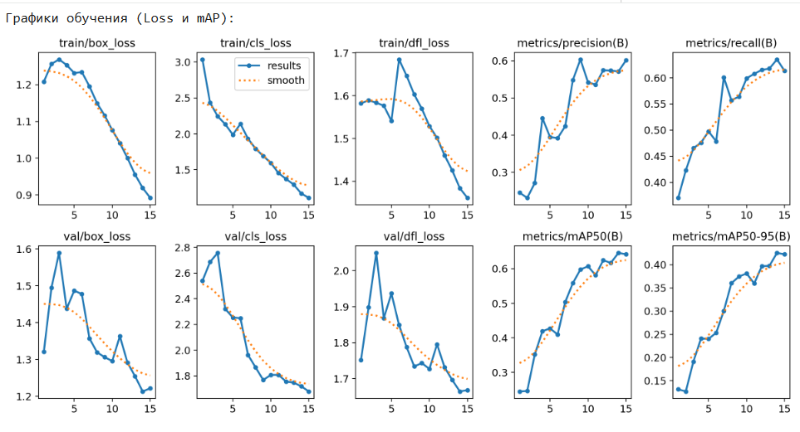

8. Task 5. Prediction Analysis

8.1 Example Predictions
The trained model was used to generate predictions on validation images.
Detected objects are visualized with bounding boxes and predicted class labels.

Тестируем модель на картинке: cooked_fish_009_jpg.rf.97b00c7cb4710d5977734b0bace26115.jpg

image 1/1 /content/Food_Detection-7/valid/images/cooked_fish_009_jpg.rf.97b00c7cb4710d5977734b0bace26115.jpg: 640x448 1 cooked_fish, 1 cooked_pork, 40.6ms
Speed: 2.3ms preprocess, 40.6ms inference, 1.4ms postprocess per image at shape (1, 3, 640, 448)
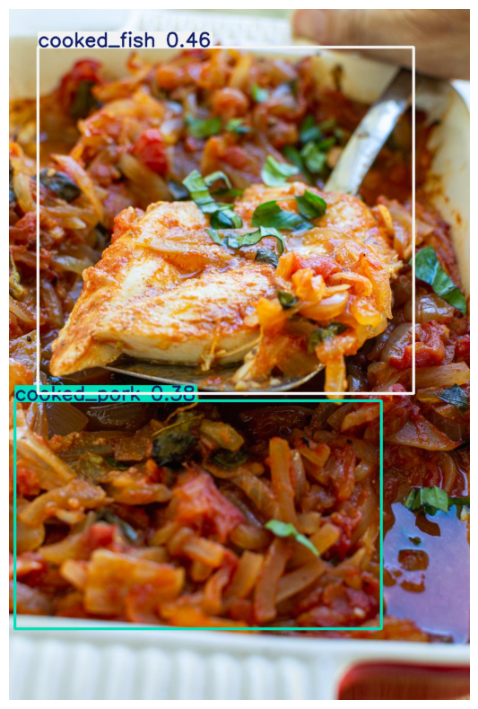

8.2 Detection Quality Analysis
Most food objects were successfully detected.
However, some detection errors occur when:
- objects overlap;
- lighting conditions vary;
- objects are partially occluded.
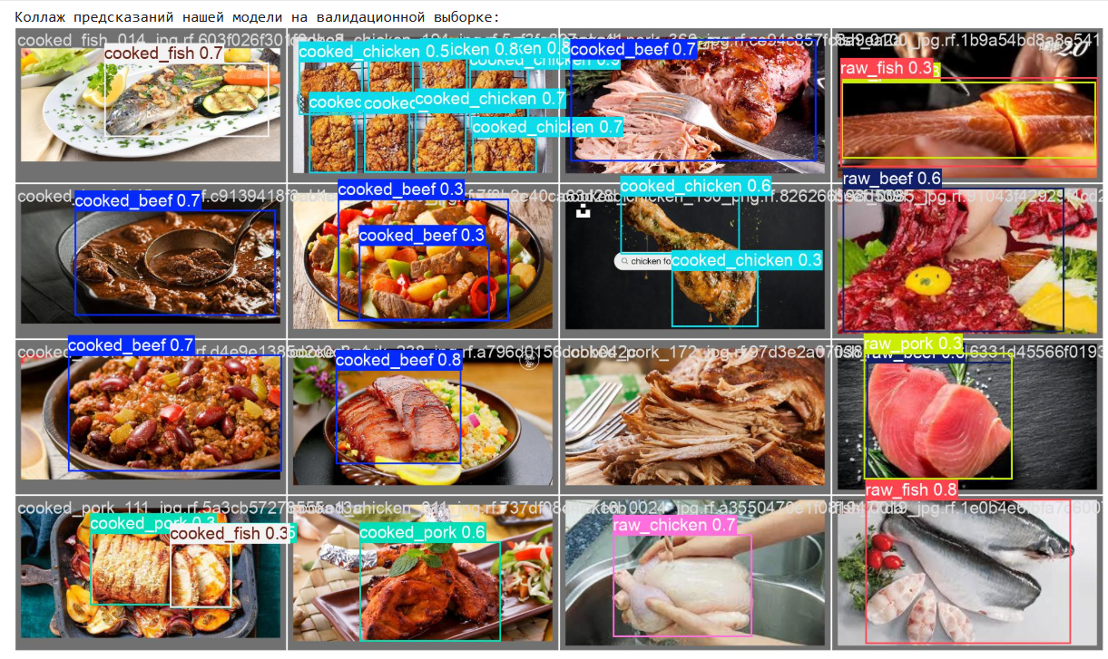
Матрица ошибок (Confusion Matrix):
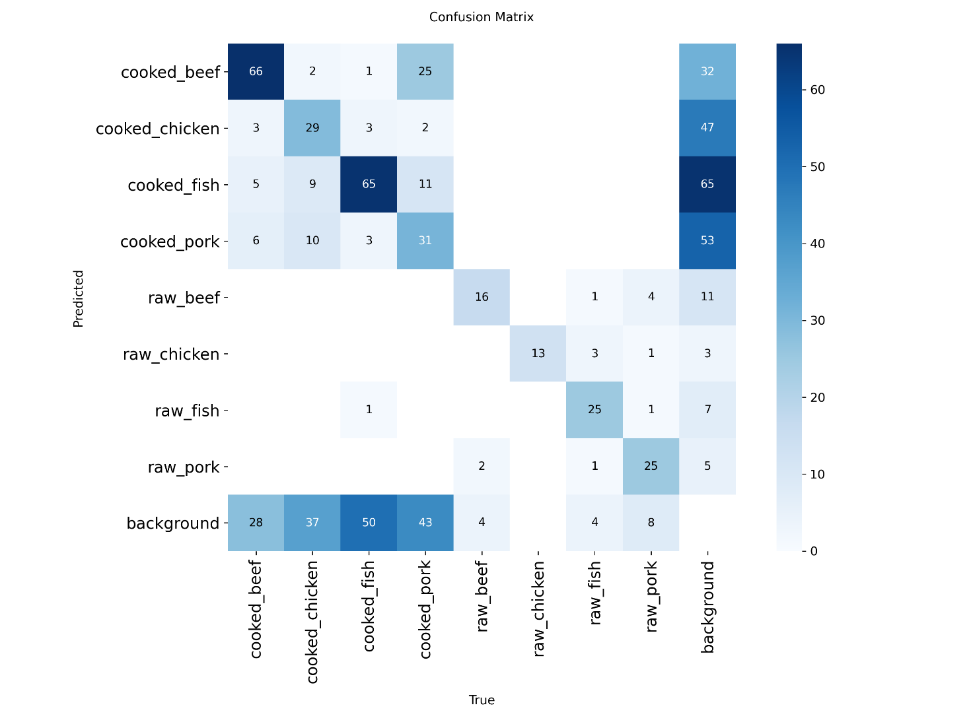

9. Calorie Estimation Concept
After detecting the food category, an approximate calorie value can be assigned using nutritional information for that specific food type.
For example:
apple → lower calorie value
burger → higher calorie value
This step allows the system to estimate total calorie intake based on detected food items.

10. Conclusion
In this project, a computer vision system for food detection was developed using the YOLOv8 object detection model.
The dataset was prepared and analyzed, and an object detection model was trained to identify food items in images. Initial experiments demonstrate that the model can successfully detect food objects and provide the foundation for further system development.
Since this report represents the first checkpoint of the project, future work will focus on improving model performance and expanding the system functionality. In particular, we plan to:
- increase the dataset size and improve annotation quality;
- train the model for more epochs and experiment with different YOLO model variants;
- implement a more advanced calorie estimation module;
- evaluate the system using additional performance metrics.
These improvements will allow the development of a more accurate and practical food recognition system.

11. References
YOLOv8 Documentation
PyTorch Documentation
Roboflow Dataset Platform
OpenCV Documentation

