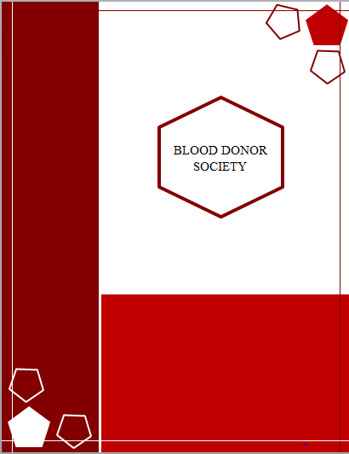

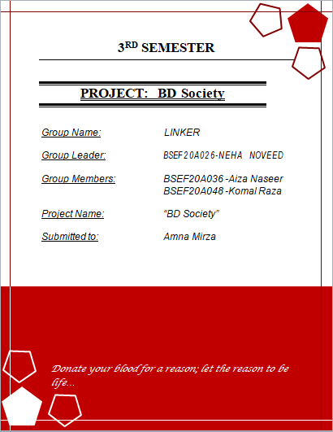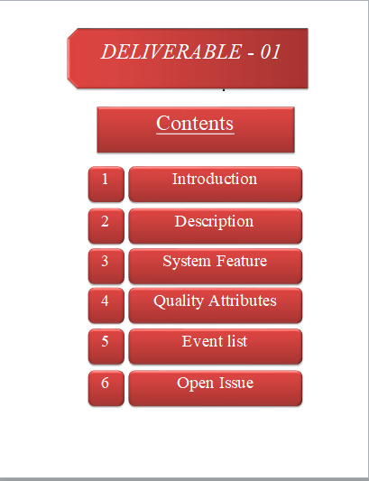 Introduction

# *Business requirements*

## Background

The system “blood donor society “ is aimed to develop to maintain the day-to-day state of the blood transfusion process between donor and receiver(hospitals, blood bank) according to the policies provided by the health organization.

Blood Donor Society (BDS) system connects donor and receiver, monitors blood bank data, bloodstock, donor list, and maintains statistical data.

## Business opportunity

As our system is developed by enhancing the existing systems. But our new features /functions will give us an opportunity to stand in the market. Our newly introduce functions will provide easy access to the system, better understanding (Urdu/English), work and connect with a secure and safe institute licensed by the health organization of Pakistan.

## Business objectives

* To computerize all details regarding donor detail & receiver detail
* Connect the donor and receiver efficiently and effectively.
* Users can take general information about blood donation from our system INFO DEST.
* It can handle the blood test reports of donors and save them in logical order.
* Request for a particular donor will be hold-up (temporarily) between two blood transfusions for 4 to 3 months.
* The donor will be notified about his/her donation acceptance (if a blood test is negative) or rejection (if blood tests are positive).
* The system will be linked (interconnected) with other blood donation societies.
* The information of the user should be kept up to date and their record should be kept in the system for historical purposes.

## Success metrics

## The three success metrics for a project are cost, scope, and time. For this, the training is being conducted successfully to the appropriate teams. To make sure to complete the project within the allocated budget. Achieving the customer satisfaction target. Effectively raising customer and team awareness about the project to the appropriate level

## Vision statement

Our vision for this project is to develop and implement the proposed system in all areas of Pakistan and examine its effect on the blood donation process and blood transfusion service in blood donation centers and health organizations across Pakistan.

## Business risks

For using the navigation system of our system to track the location and required time of the donor both parties (donor and receiver) must have an internet connection. The system can crash in case of database failure. our system also has competition risk, perhaps a new organization emerged on the market, targeting the same statistical data as we do and offering a similar product.

## Business assumptions and dependencies

It is assumed the system developed will work perfectly. It’s assumed that the client won’t change the decision on the next phases of the software development. If in case of any difficulties, SRS should be flexible enough to change accordingly.

# *Scope and limitations*

## Major features

## The major feature of our system is

* Register as donor or receiver
* Send request
* Find appropriate donor
* Track the location of the donor on Google map
* Share statistical data with a health organization.

## Scope of initial releases

The system will be used in any hospital, clinic, and blood bank. The system is user appropriate, easy to use, provides easy recovery of errors, and has an overall end-user high subjective satisfaction. It stores information of donor, receiver, and blood bank, etc. and provides an updated list of donors within a reasonable timeframe, and connects a large number of appropriate donors and receivers to facilitate the blood transfusion process.

## Scope of a subsequent release

In the future, we will release feature of loan (in case donor or receiver don’t have balance then we will give loan for efficient communications)

## Limitations and exclusions

* For tracking location and time of donor, receiver and donor must have internet connections.
* The presents of competitors in the market limit the use of our system.
* Donor’s late response limits the system's performance.
* Size of database increase day-by-day, increasing the load on the database back up and data maintenance activity
* The user must know how to operate the system.

# *Business context*

## Stakeholder

|  |  |
| --- | --- |
| Primary | Secondary |
| administrator | Health organizations |
| Receiver | SBTP |
| donor | BTA |
|  | Blood banks |
|  | Hospitals |
|  | Blood donation societies |
|  | Surveyors institute |

## Project priorities

Our priorities are

* To best quality product that fulfill all requirements
* To being able to execute all required functions
* To organized team of experienced and cooperative staff that they will work together to develop satisfactorily product.
* To finishing a project within deadline

## Deployments considerations

As we are developing a app based system so, user are able to use the system as an application installed on their smartphones to help them complete the blood donation process with minimal effort and time. This is available 24hours and responds more quickly and gives satisfactory response to user demand

**Context diagram**

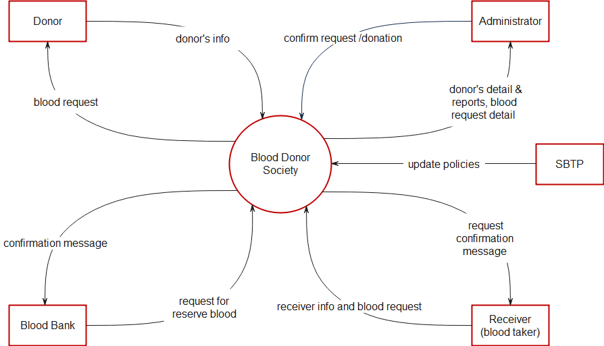

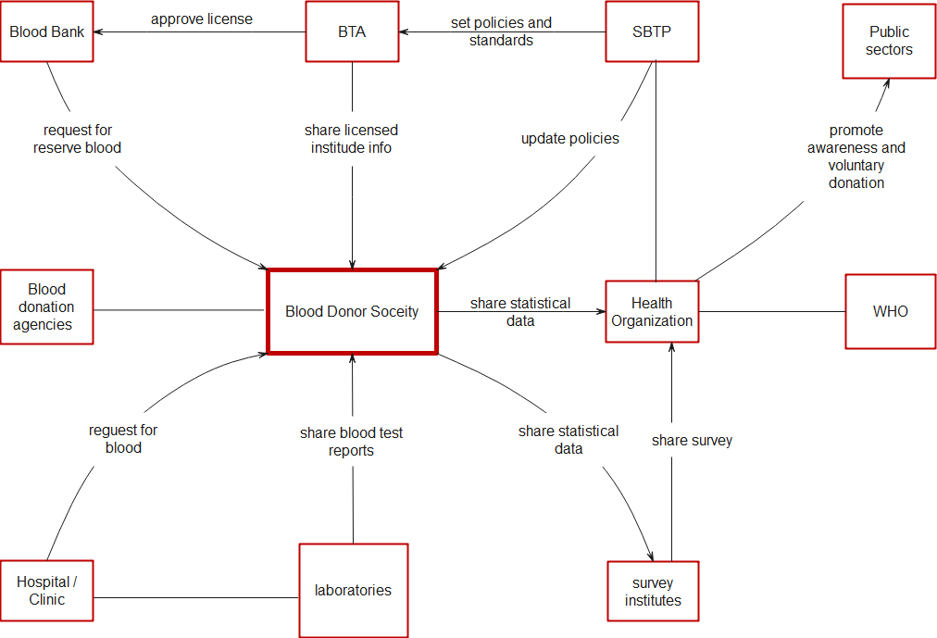

Ecosystem map

Description

# Product perspective

# Blood Donor Society (BDS) is a fully functional automated Blood Donation System that will facilities the blood transfusion process by providing a reliable, efficient and secure website. The usage of a database to store donors, blood banks, hospitals, and receiver detail, will accommodate easy and secure access.

# Operating environment

Our system is available as an app

* Android
* iOS
* window phone

# Design and implementation constraints

The design and implementation constraints of our blood donor society (BDS) system are

* The system is wirelessly networked with an encryption
* The system is only accessible to people who are involved in the blood transfusion process.
* The database is password protected.
* Donor registration will be canceled if his /her blood tests are positive.
* The only licensed Blood bank will be registered in our system.
* Each donor and blood bank should have an individual ID and password.
* Only administrators can access the whole system.

# Assumptions and dependencies

* Each user (donor, receiver, bank, etc.)must have a valid ID and password
* Users must log in to the system to access any record or function.

# Elicitation techniques

|  |  |
| --- | --- |
| Techniques | reasons |
| Questionnaires | As we are dealing with a large group of people |
| Software interface analysis | As it reveals functional requirements regarding the exchange of data and services between systems |
| User interface analysis | As we are enhancing the existing system |

# Stakeholder profiles

|  |  |
| --- | --- |
| Stakeholder | Detail |
| Administrator | Who controls and maintain the system |
| Donor | The user who register in our system to donate blood |
| Receiver | Blood takers can be patients or relatives or other |
| Hospitals, laboratories | Give vein-to-vein treatment in the blood transfusion process and share blood test reports. |
| Blood bank | Banks that are licensed by BTA and stock reserve blood. |
| Blood donation societies | Agencies that work voluntarily in blood donation. |
| Surveyors institute | Healthcare surveyors who survey and share the data with health organizations or with government |
| BTA | Institute which does inspection and issues license. |
| SBTP | Institute which set regulations and policies |
| Health organizations | An organization that deals, maintain, and works for public health. |

System feature

# Features (hierarchical textual labeling)

**Registration**

Registration . Donor

Registration. Receiver

**Login**

Login.ID

Login. Email

Login. Forgot Password

Login. Forgot Password . Reset Password

**Blood Request**

Blood Request. Add

Blood Request. Edit

Blood Request. Delete

Blood request .Track Donor

Blood request .Track Donor. Location

Blood request .Track Donor. Time

Blood request .Chat

Blood request .Chat. Message

Blood request .Chat. Call

**Donor**

Donor. Profile

Donor. profile. Change password (password must be 8 character long and must have a special character)

Donor. check notification

Donor. Accept request

Donor . share request

Donor. chat

Donor. Chat. Message

Donor. Chat. Call

Donor. Blood test reports

Donor . my history

**Blood bank**

Blood bank .accept request

Blood bank . send request ( for reverse blood stock)

Blood bank .confirmation message

Blood bank .chat

Blood bank .chat. Message

Blood bank .chat. Call

**Fact**

Fact. Statistical data

Fact .donation detail

Fact .donation guides

Fact .donation guides. frequently ask questions

Fact .donation guides. Live chat (ask questions)

**Setting**

Setting. Language (Urdu/English)

Setting. Invite friends (through social media etc.)

Setting. privacy

Setting. about us (detail term and condition of product)

Setting. rate us

Setting. Log out

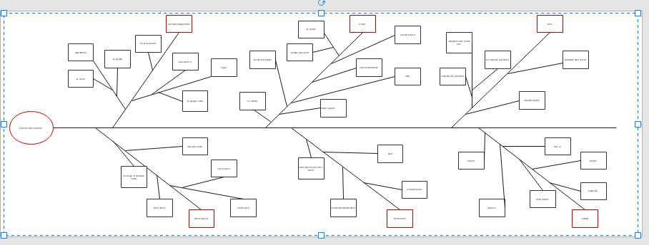

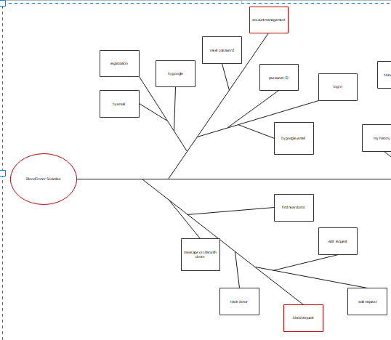

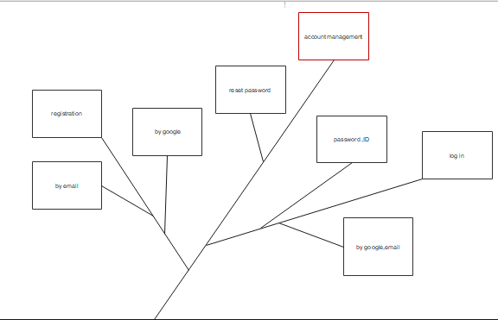 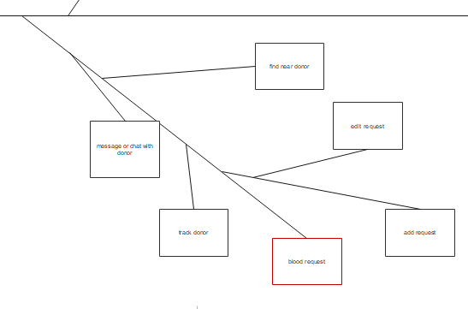 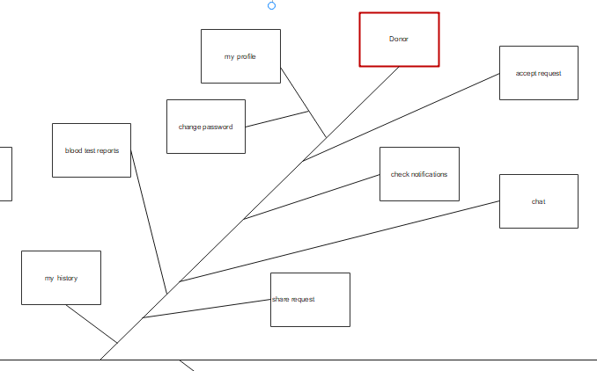 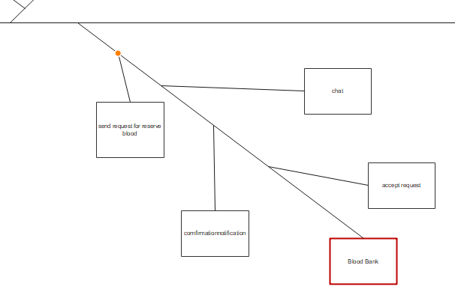 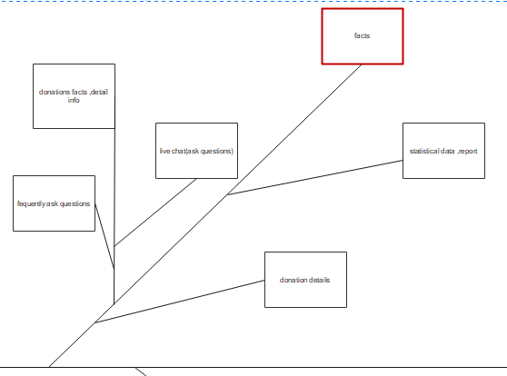 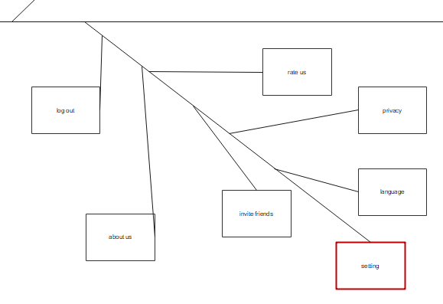

# Functional requirements

|  |  |
| --- | --- |
| function | description |
| Registration | user must have to register into the system |
| register as donor | If the user is register as donor then user must prove detail information (personal info, blood info, health info) |
| register as receiver | Is the user register as blood taker then user have to give personal info |
| Validate account | Account must be verified by sending message to email |
| Add request | Receiver send request to the donor specify the blood group and amount |
| Display request | Receiver request will be share and display to a appropriate donor. |
| Accept request | After viewing the request donor will accept or reject (any personal reason) the request. |
| track donor | Receiver can view donor location through Google map and the estimated time to reach the destination. |
| Previous request | User can see all previous requests as record. |
| Delete request | After the successful blood transfusion receiver will delete the request. |
| Manage reports | Donor’s blood test reports will be store and manage in donor database. |
| History log | User can see his/her previous activities in history log. |
| Log out | After successfully completion of user demand user will logout through the system |

Quality attributes

# Usability

The system can be used again and again without distortion.

# Performance

* Performance . display

The system will give responses within 1 second after checking the donor information and other details

* Performance . user

System support 1000 people at a time

* Performance . task performed

99% of the task will be performed In less than 1s.

# Security

All the administrative and data entry operators (donor, receiver, blood bank, etc.) have unique logins so the system can understand who is login into the system right now no intruders are allowed except system administrative nobody cannot record and valuable data( personal details, reports, record.

System will maintain history logs.

# Safety

If a wide portion of the database is damaged due to system failure, the recovery method restores a past copy of the database that was backed up to archival storage.

# Availability

The system shall be available all the time

# Accessibility

Administrators and many other users (donor, receiver, hospitals, etc.) can access the system but the access level is controlled for each user according to their work scope.

# Stability

The system won’t change from time to time. But some new maybe add in the existing system.

# Maintainability

The system will be maintained, have up-to-date information and policies of SBTP, update fix problems of the system.

Event list

|  |  |
| --- | --- |
| lists | feature |
| notification | Request notification |
| chat | Live chat, messages, or call between donor and receiver |
| remainder | Remainder of request |

Open issue

* If the users don’t have a balance or network connection then they will be unable to communicate with each other.
* For tracking location and time of donor, receiver and donor must have internet connections.
* Size of database increase day-by-day, increasing the load on the database back up and data maintenance activity