|  |  |
| --- | --- |
|  | **2023** |
|  | Code Coverage Analysis[Type the author name] |

**Question # 01**

**Explore the tool of code coverage with some sample code and briefly present the results with snapshots.**

• Pytest-cov

**Solution:**

Here is the exploration details of “**Pytest-cov”.** I am using this because it is compatible with PYCHARM and I already have installed PYCHARM.

To install Pytest-cov use command **“pip install pytest-cov”** in **PYCHARM terminal.**

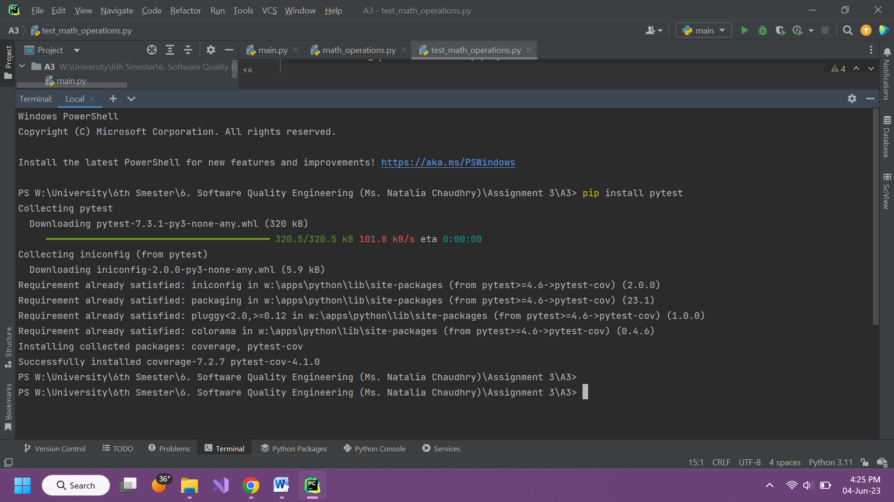

**Sample Code:**

This is a **basic calculation code** (+, -, /, *) in python language

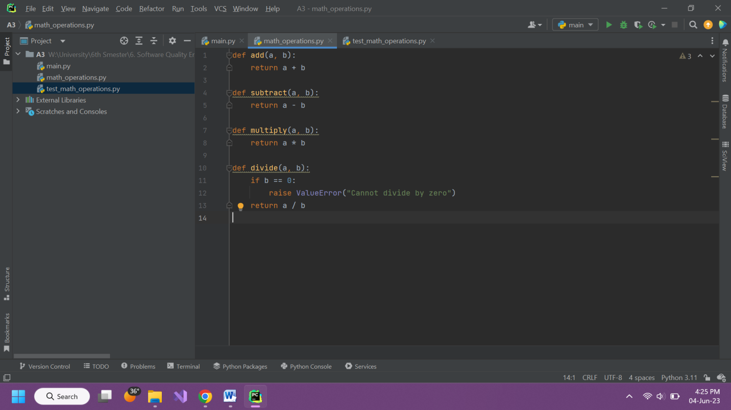

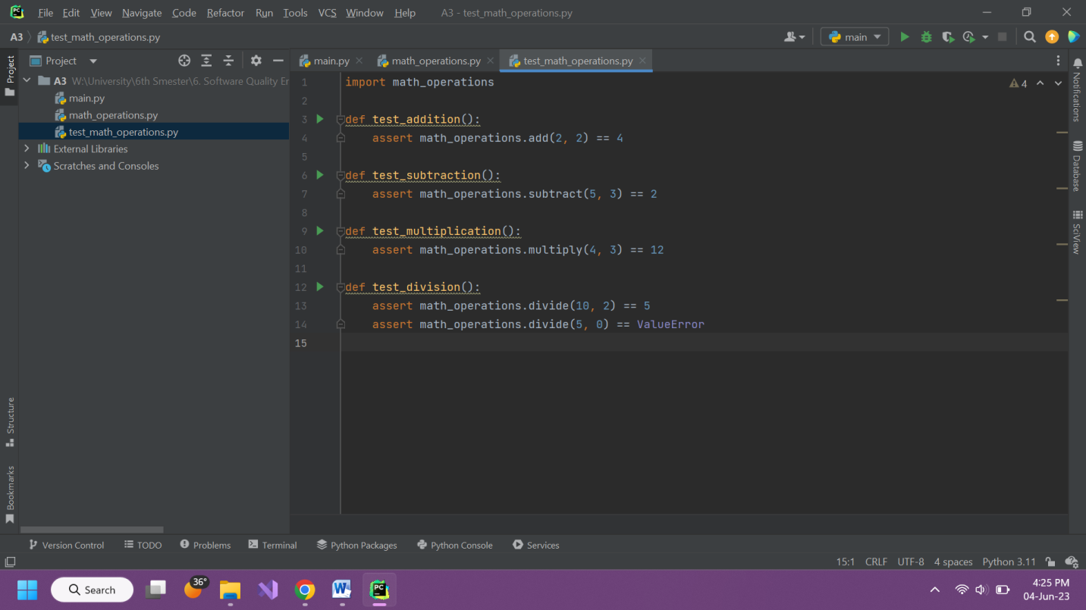

**Results:**

To run Pytest-cov on this code use command **pytest --cov=.** (**.** Represent current directory, we can also use file name)

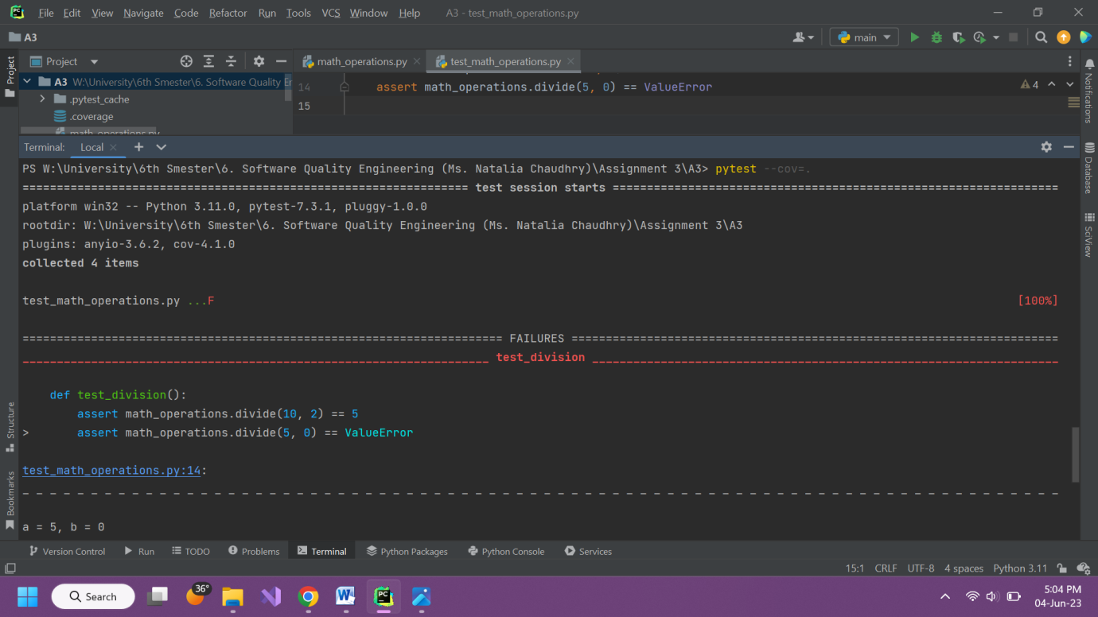

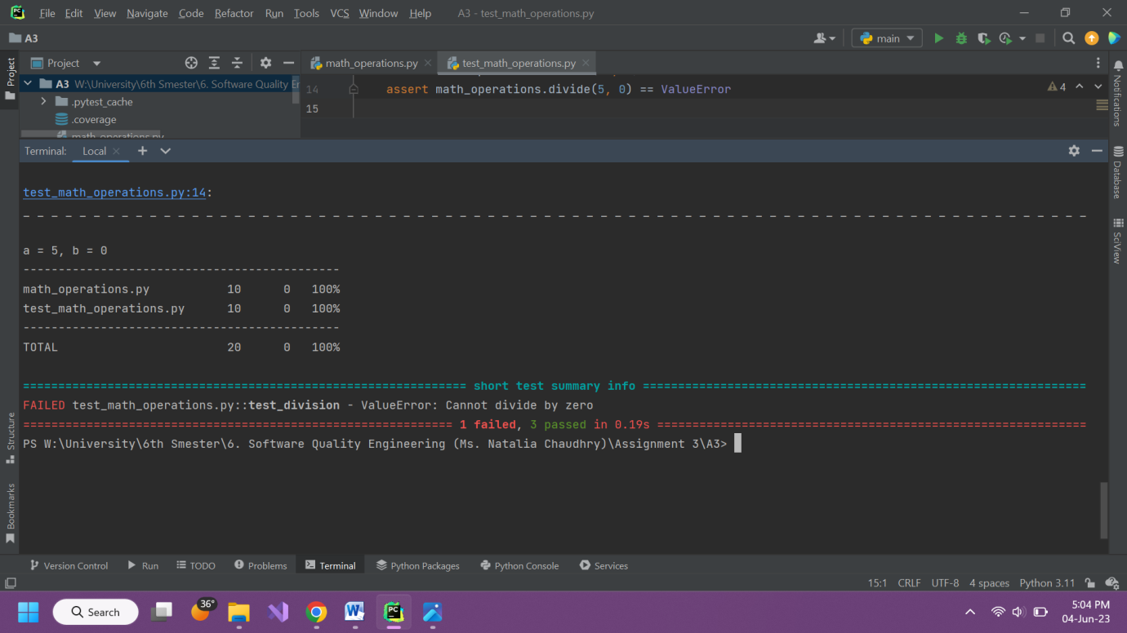

**After Zero Division Error Correction:**

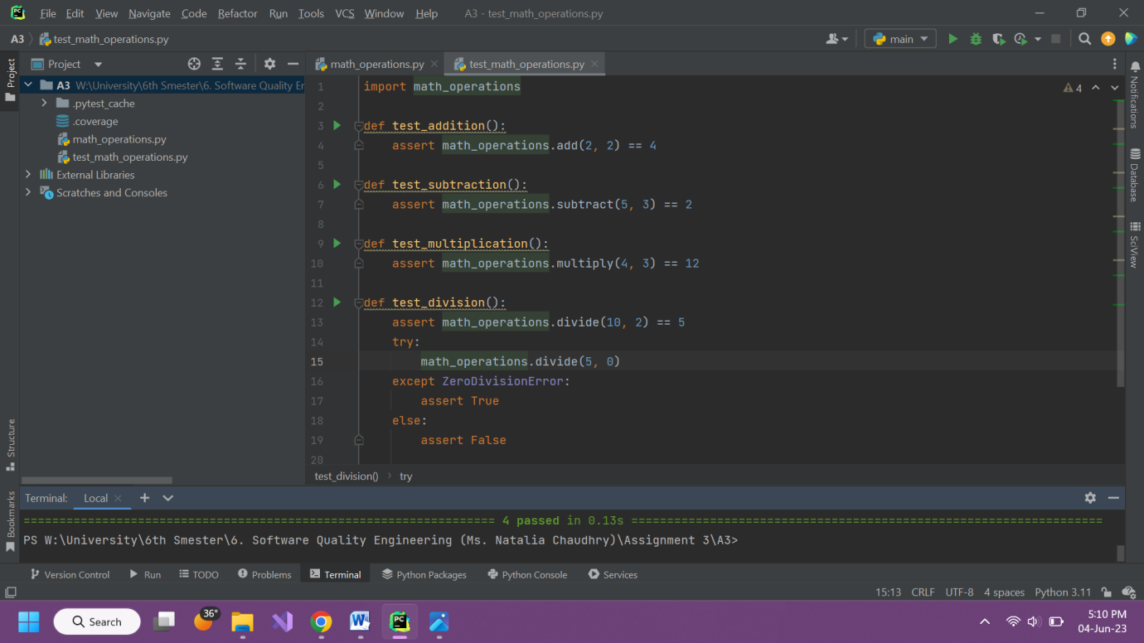

**Results:**

